Supplementary Figure 1: Identification of ex vivo c-Kit^{high} and c-Kit^{low} ILC2s and their fold change after expansion.

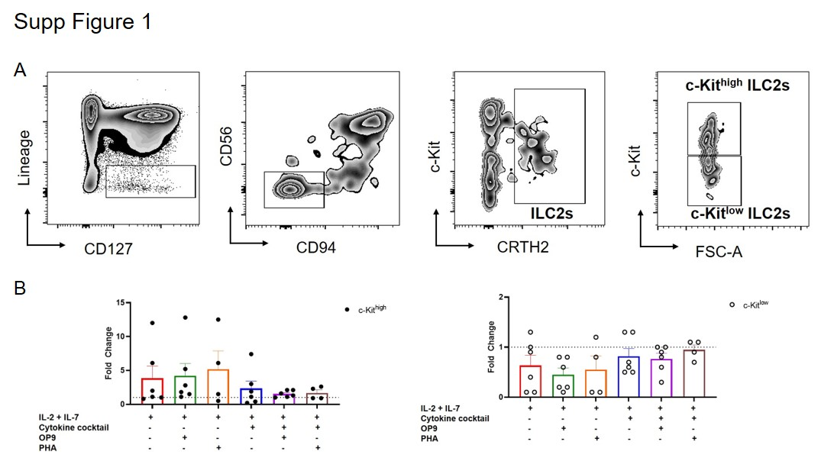

(A) Gating strategy used to identify ILC2s ex vivo.
(B) Fold change of c-Kit^{high} and c-Kit^{low} ILC2s after the expansion for each condition (n=4/6 HD samples from 4 independent experiments). The dashed line represents the ex vivo values.

Supplementary Figure 2: Some marker expression was not affected by the culture conditions.
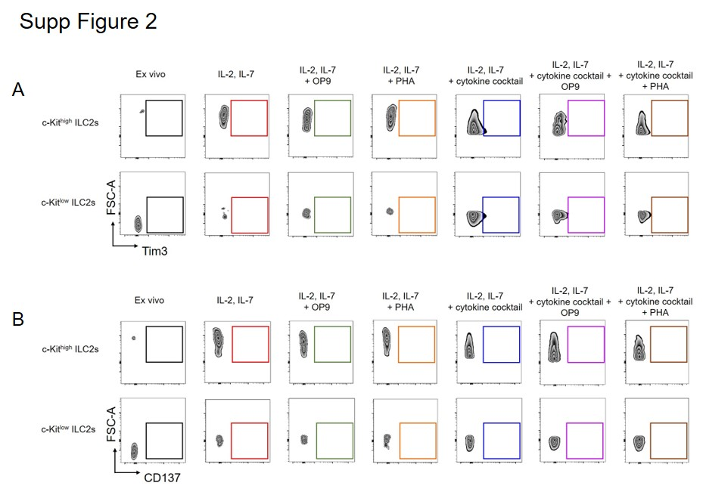

Tim3 (A) and CD137 (B) were not detected in expanded HD ILC2s.

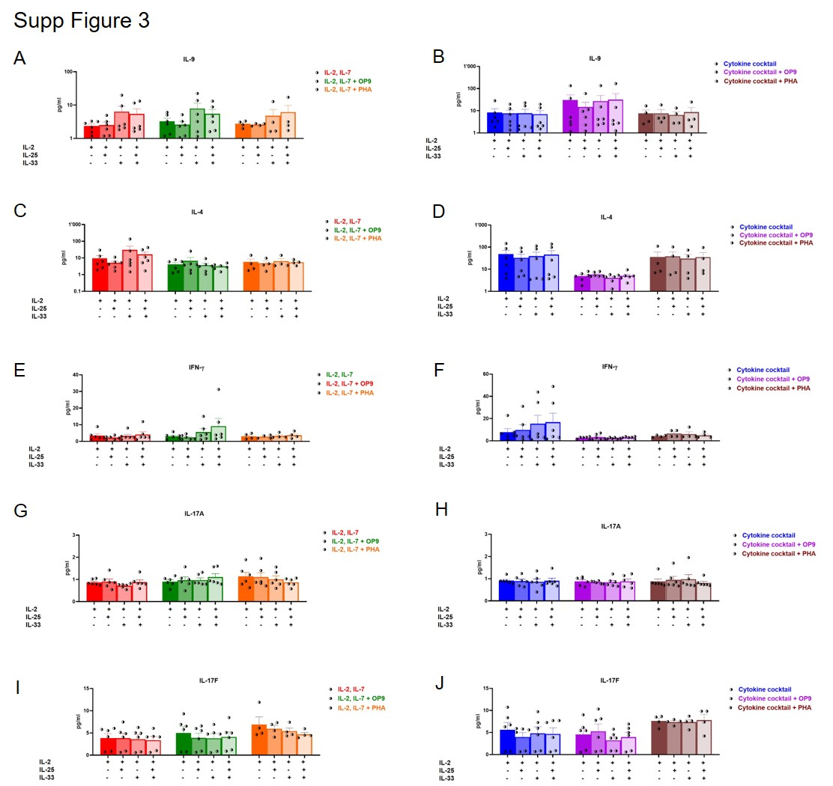
Supplementary Figure 3: Other type 2, type 1 and type 3 cytokines were not secreted by expanded ILC2s.

IL-9 (A-B) and IL-4 (C-D) secretions were not significantly modulated upon the stimulations.
ILC2s expanded with the different culture conditions (n=4/6 HD samples from 4 independent experiments) did not modulate IFN-γ (E-F), IL-17A (G-H) nor IL-17F (I-J) secretion.

Supplementary Figure 4: Patient ILC2s expanded with the mitogen displayed the highest proliferation.
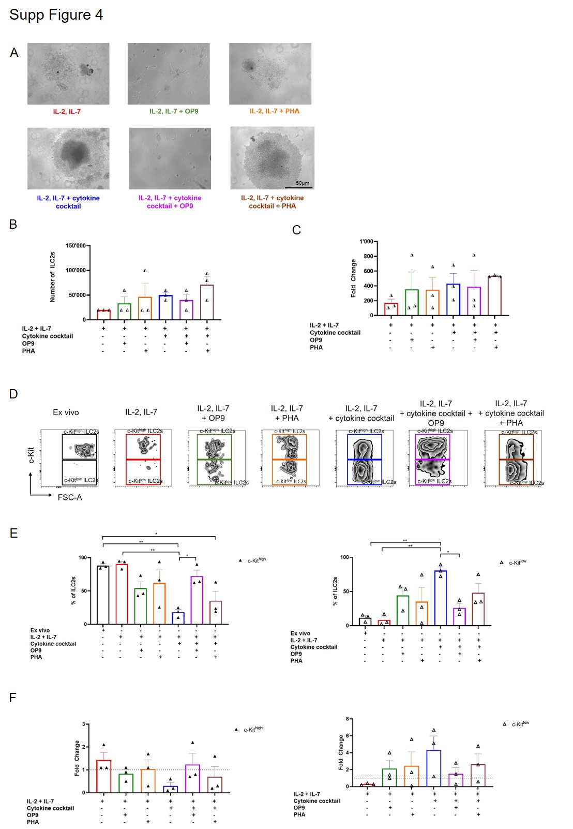

(A) Representative examples of expanded ILC2s (n=3 allergic patient samples from 2 independent experiments) in the different culture conditions (magnification = 10x).
(B) Quantification of the patient ILC2s (n=3 allergic patient samples from 2 independent experiments) counted after 17-19 days of expansion for each culture condition.
(C) Fold change of patient ILC2s (n=3 allergic patient samples from 2 independent experiments) after the culture relative to initially plated cells.
(D) Representative dotplots of patient c-Kit^{high} and c-Kit^{low} ILC2 populations ex vivo and after expansion in each culture condition (n=3 allergic patient samples from 2 independent experiments).
(E) Quantification of patient c-Kit^{high} and c-Kit^{low} ILC2 populations ex vivo and after expansion in each culture condition (n=3 allergic patient samples from 2 independent experiments).
(F) Fold change of patient c-Kit^{high} and c-Kit^{low} ILC2s after the expansion for each condition (n=3 allergic patient samples from 2 independent experiments). The dashed line represents the ex vivo value. Data are shown as mean ± standard error of the mean (SEM). Significance was calculated using one-way ANOVA where *P<0.05, **P<0.01
Supplementary Figure 5: Patients ILC2s expanded with OP9 cells downregulated the expression of a selection of markers.
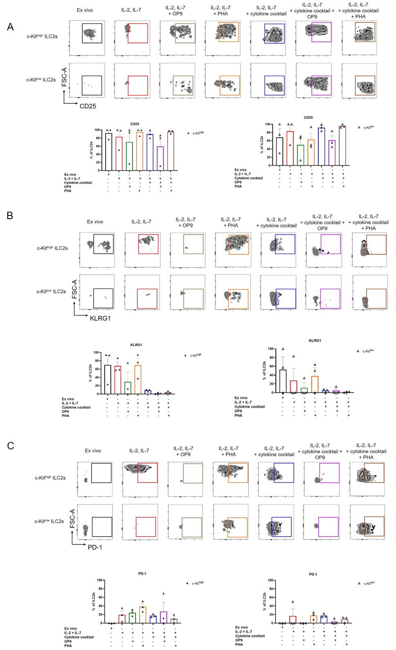

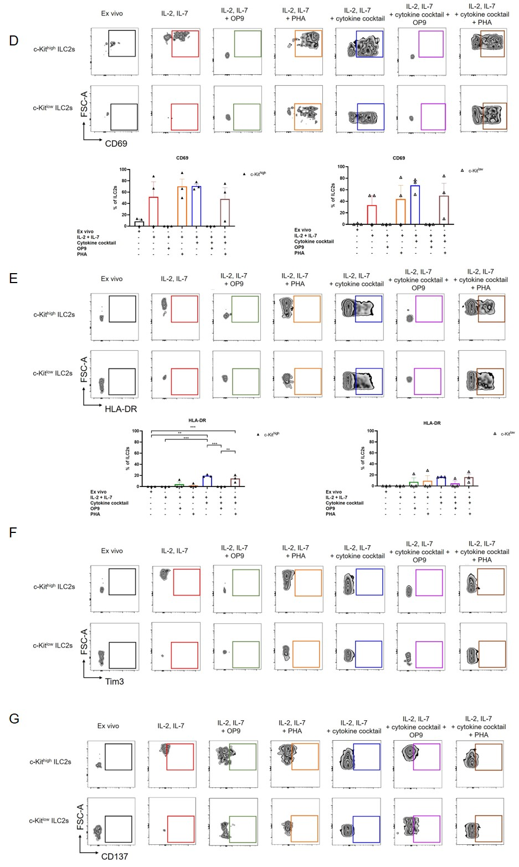

Representative dotplots and quantification of CD25 (A), KLRG1 (B), PD-1 (C), CD69 (D) and HLA-DR (E) in ex vivo and in vitro expanded patient ILC2s (n=3 allergic patient samples from 2 independent experiments) across different culture conditions.
Tim3 (F) and CD137 (G) were not detected in expanded patient ILC2s. Data are shown as mean ± standard error of the mean (SEM). Significance was calculated using two-way ANOVA where *P<0.05, **P<0.01, ***P<0001.
Supplementary Figure 6: The presence of OP9 cells during the expansion tended to impair patient ILC2 function.
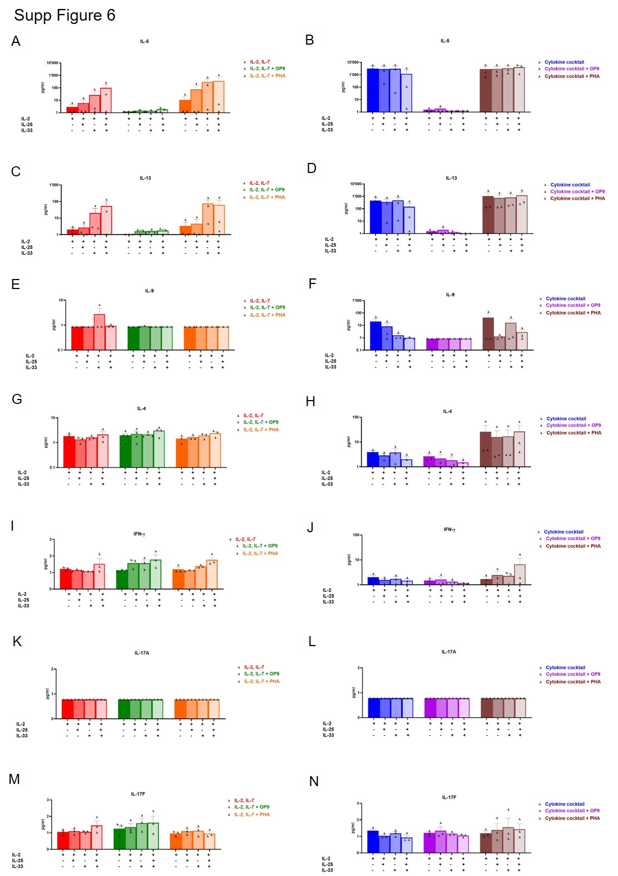
IL-5 and IL-13 secretion tended to be impaired by patient ILC2s (n=3 allergic patient samples from 2 independent experiments) expanded with IL-2, IL-7 and OP9 cells (A-B) and with the cytokine cocktail and OP9 cells (C-D).
IL-9 (E-F) and IL-4 (G-H) were not significantly modulated by expanded patient ILC2s (n=3) upon stimulations. IFN-γ (I-J), IL-17A (K-L) and IL-17F (M-N) were not secreted by expanded patient ILC2s (n=3 allergic patient samples from 2 independent experiments) upon the different stimulations. Data are shown as mean ± standard error of the mean (SEM).

Supplementary table 1: patient characteristics

Patient | Age | Gender | Rhinitis | Polyposis | Conjunctivitis | Asthma | Eosinophiles G/l | Allergy | Date | Acute crisis | Treatment | Comorbidity
NPM | 37 | f | 1 | 0 | 1 | 1 | 0,12 | grass pollen | 05.02.2020 | no | No acute treatment. Stable asthma under ICS and LABA (formoterol and budesonide) on demand. Blood sample taken before starting allergen immunotherapy. | No
ZL | 63 | m | 1 | 1 | 0 | 1 | 0,19 | grass pollen | 05.02.2020 | no | No acute treatment. Stable asthma under ICS and LABA (formoterol and budesonide) on demand. Blood sample taken before starting allergen immunotherapy. | Benign prostatic hyperplasia, hypercholesterolemia
AP | 67 | m | 1 | 0 | 1 | 1 | 0,18 | tree (birch, ash), grass, house dust mites, cat and dog dander | 13.02.2020 | no | Stable moderate asthma under ICS and LABA (formoterol and budesonide), desloratadine 5 mg 1x/day p.os, intranasal azelastine and fluticasone. Blood sample taken before starting omalizumab. | No

