Supplementary Material

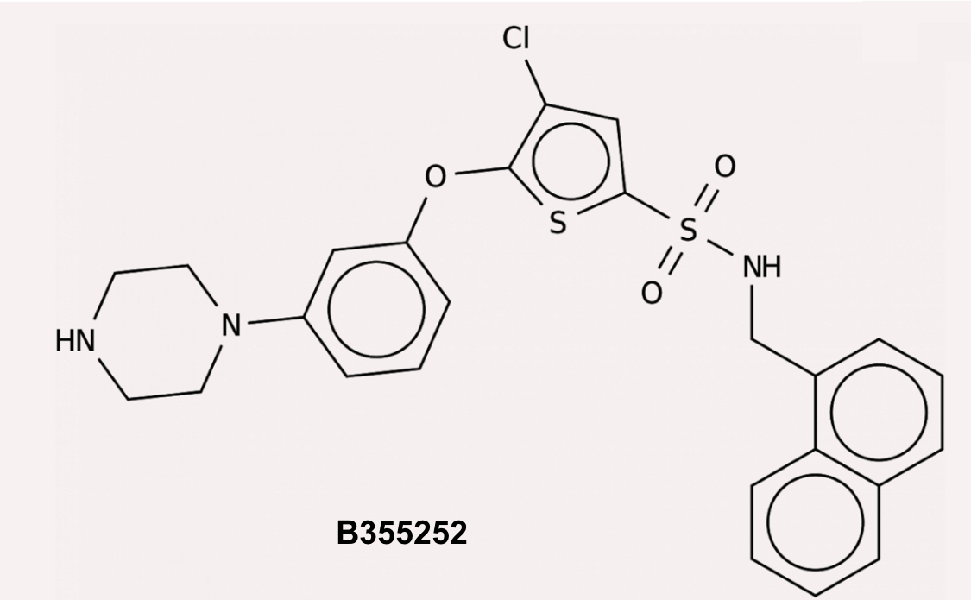
Supplementary Figure 1. Two-D structure of B355252, a novel phenoxy thiophene small molecule.

