Supplementary Figures
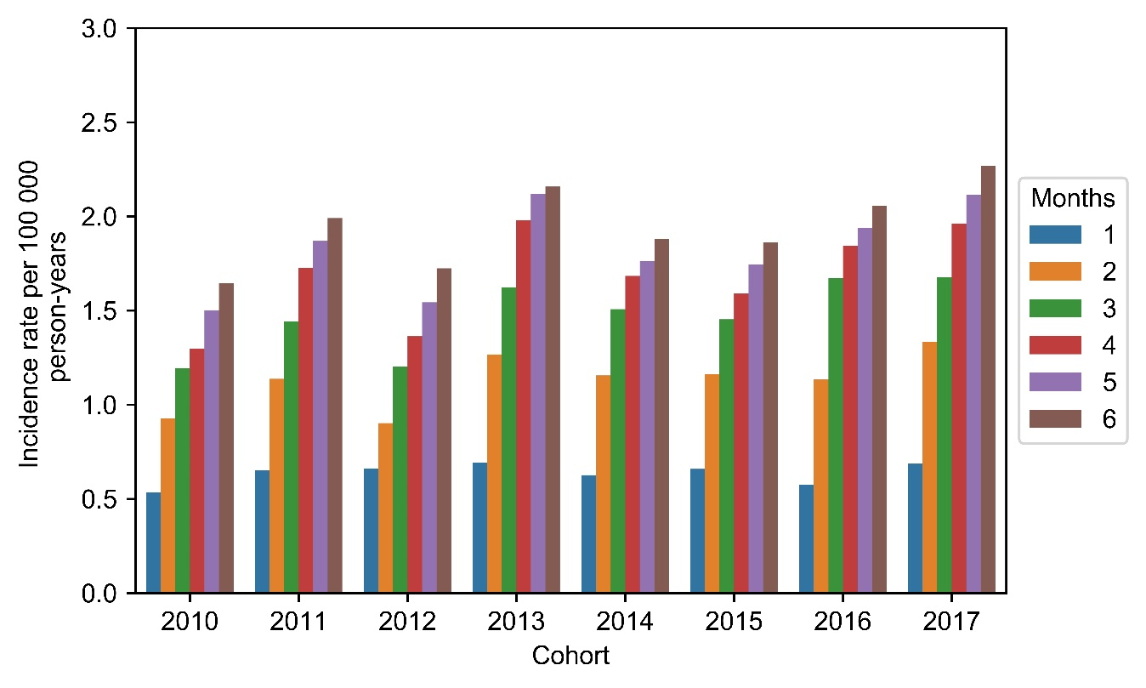
Figure S 1 Change in CD incidence when varying the inclusion window of IBD prescriptions. In the base case definition patients were included if they had an IBD prescription two months or less prior to their first IBD visit.
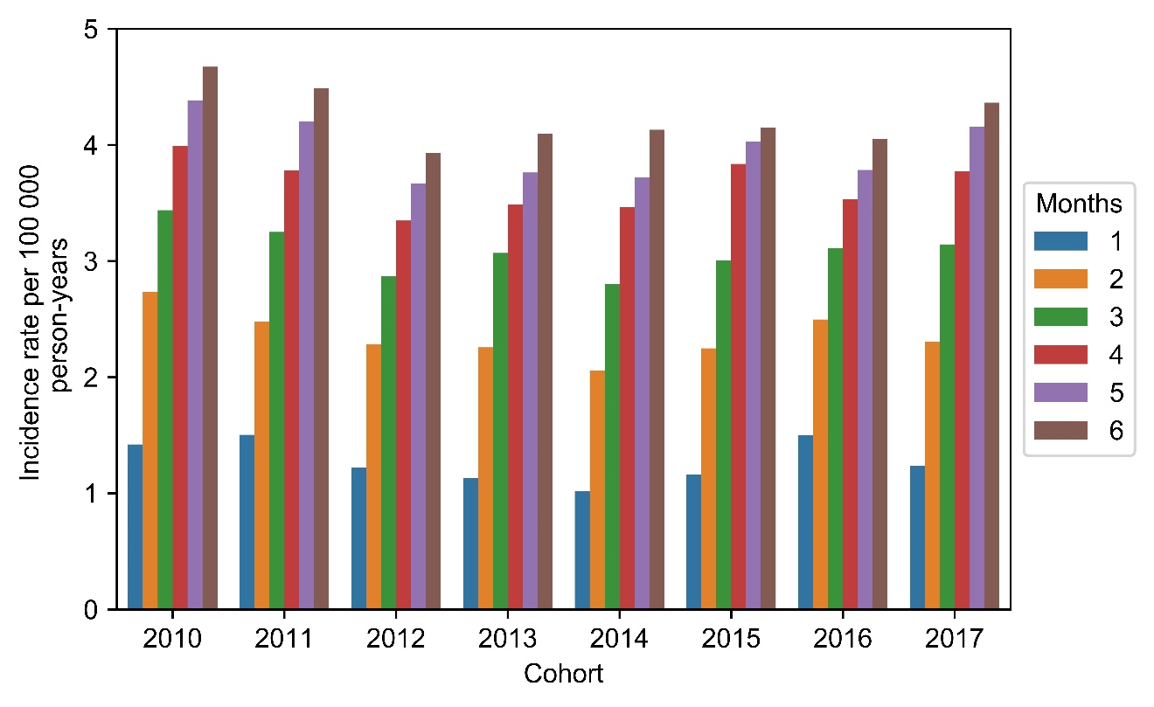
Figure S 2 Change in UC incidence when varying the inclusion window of IBD prescriptions. In the base case definition patients were included if they had an IBD prescription two months or less prior to their first IBD visit.
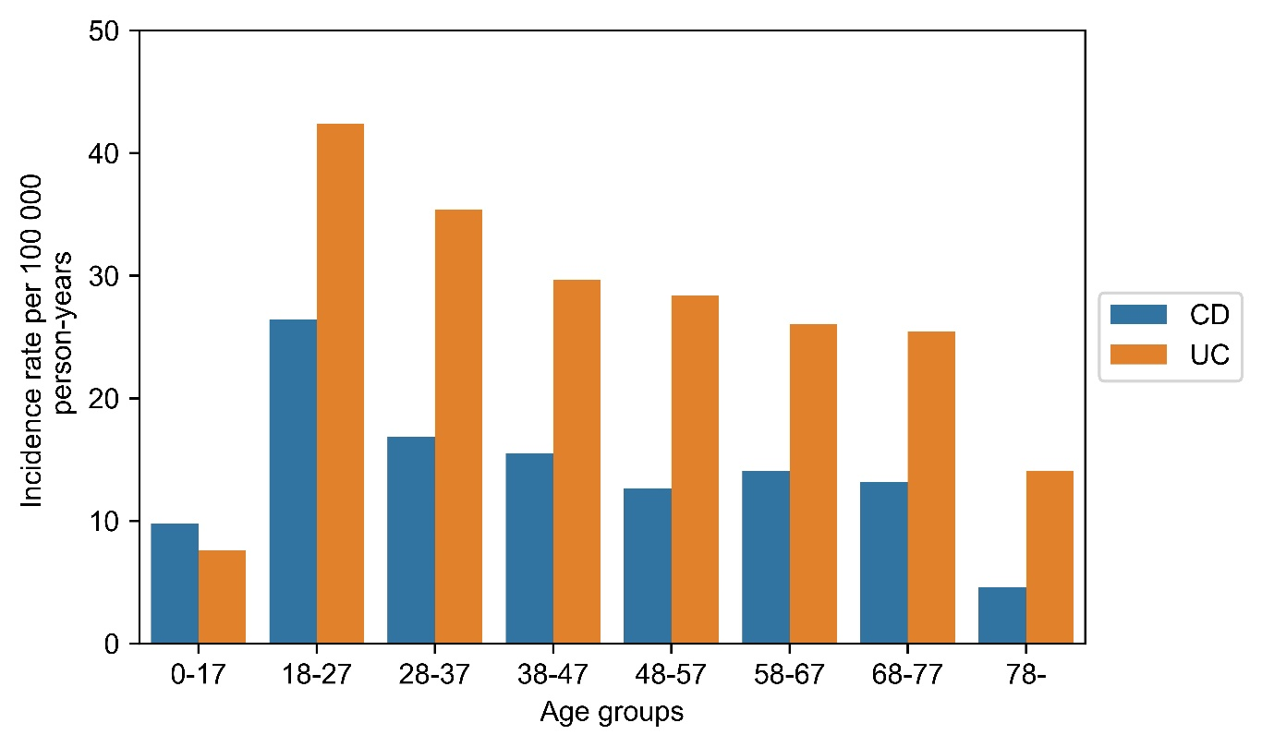
Figure S 3 Age-specific incidence.
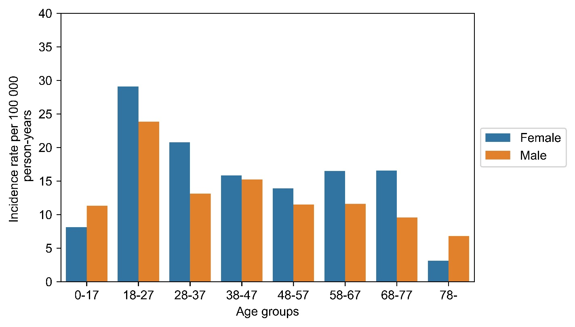
Figure S 4 CD incidence by gender.
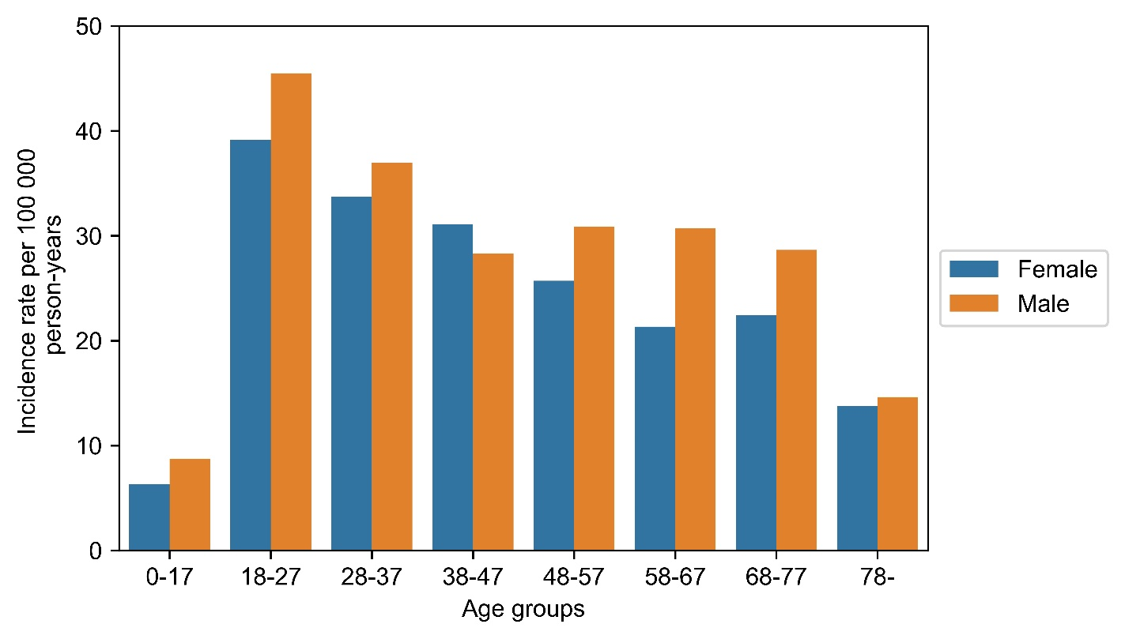
Figure S 5 UC incidence by gender.
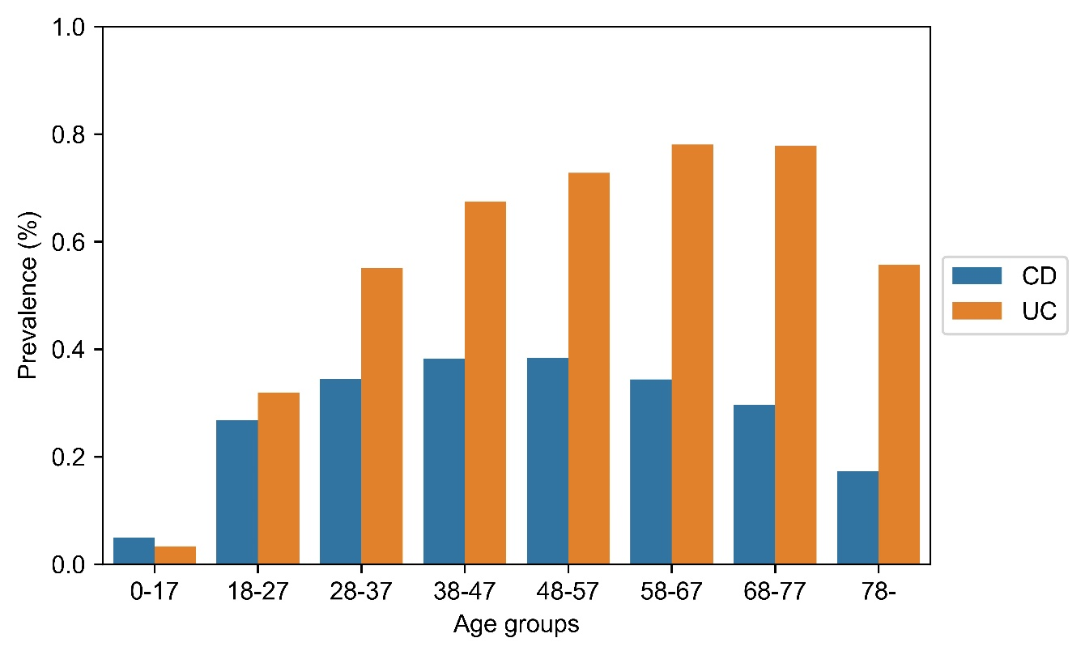
Figure S 6 Age-specific prevalence.
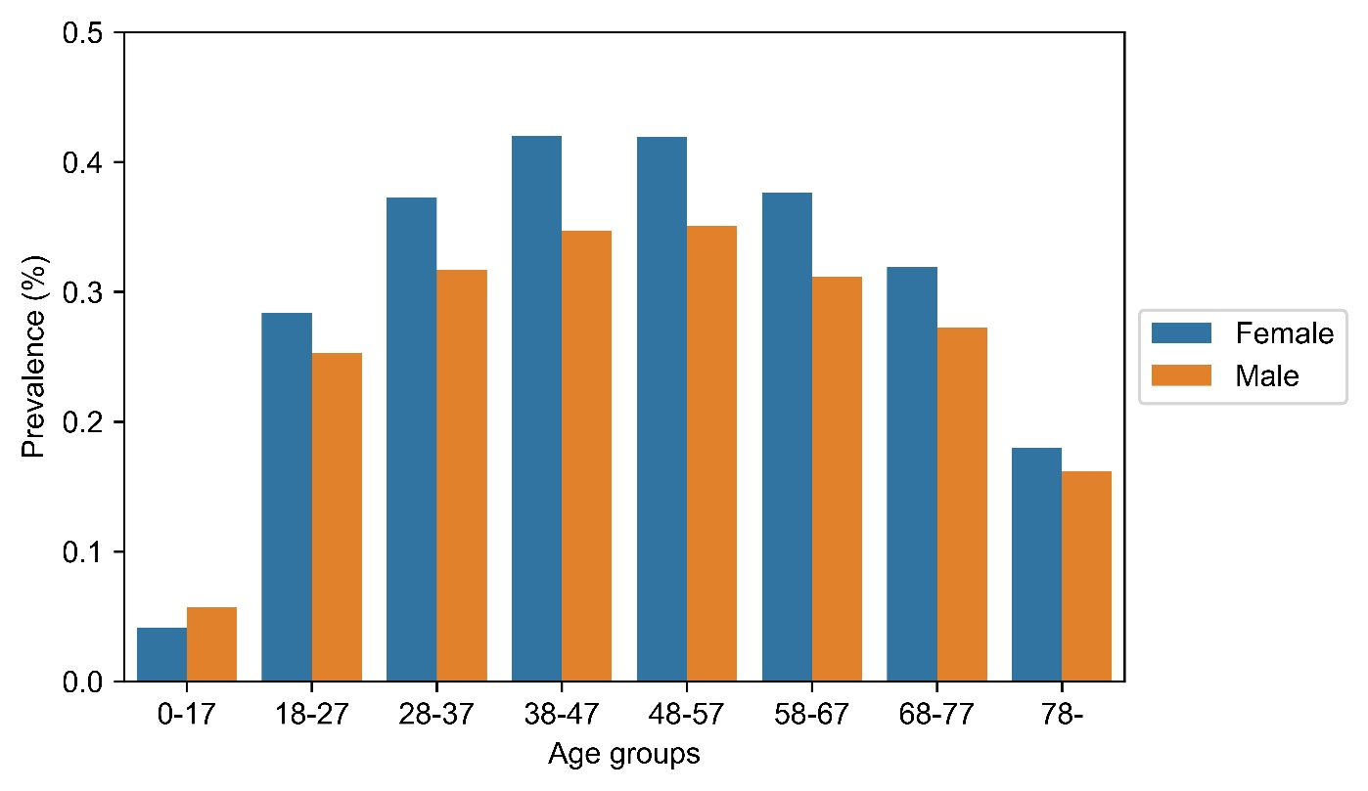
Figure S 7 CD prevalence by gender.
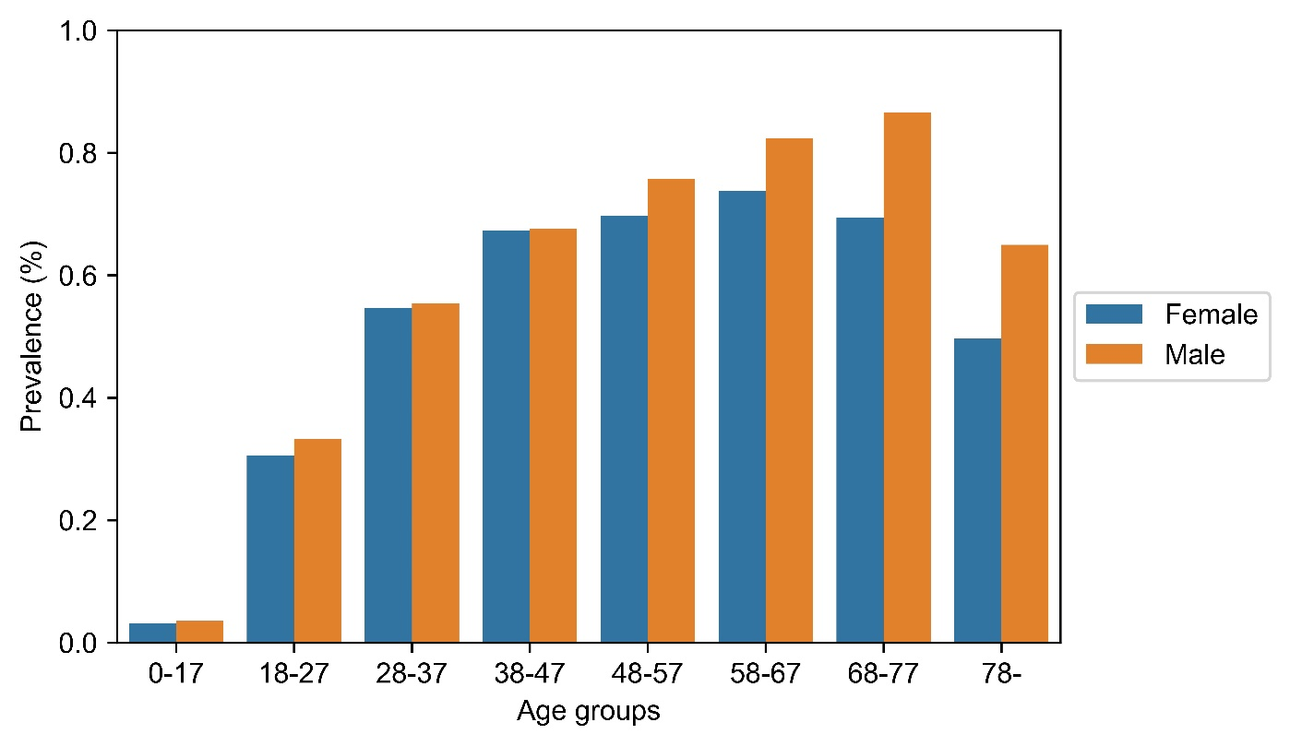
Figure S 8 UC prevalence by gender.
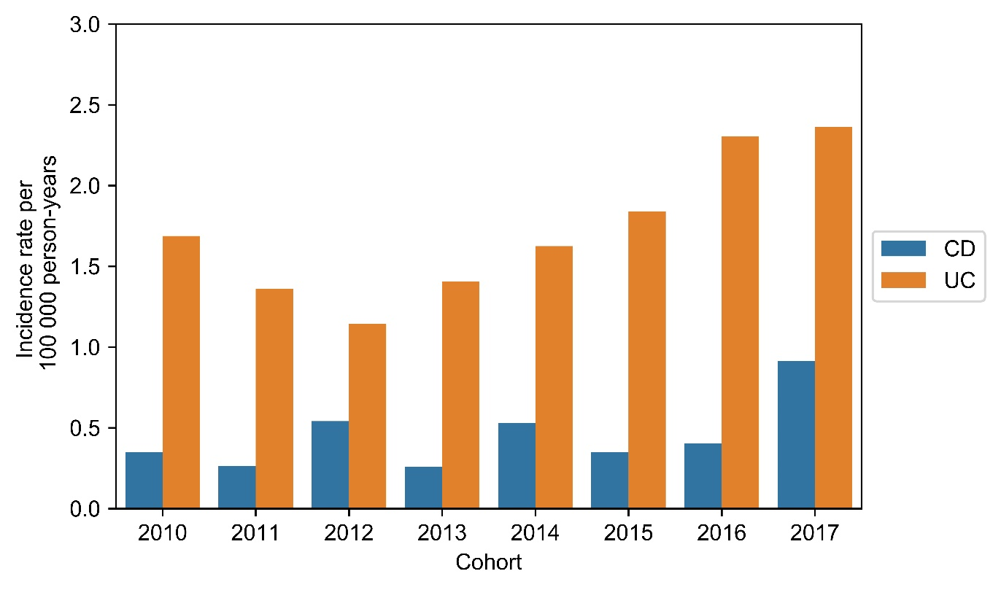
Figure S 9 The incidence of IBD for patients with exactly one IBD hospital visit and one IBD prescription
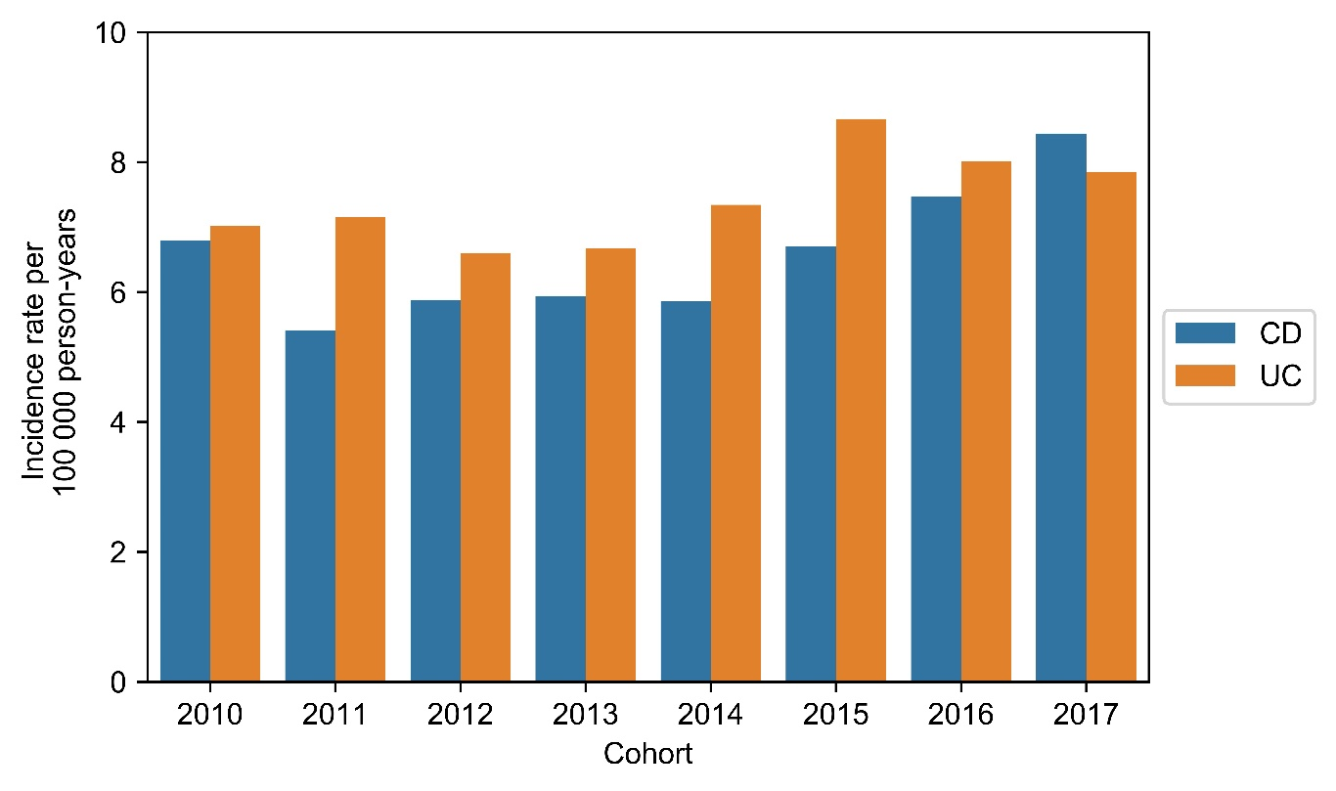

Figure S 10 The incidence of IBD for patients with a single IBD hospital visit and no IBD prescriptions.

