Supplementary materials

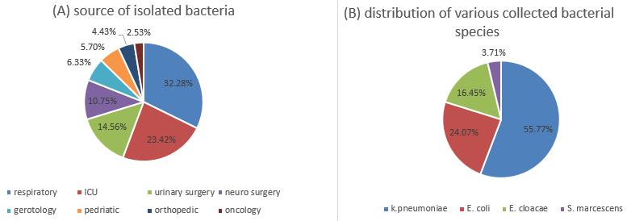
Supplement Figure 1. A represents the source of isolated bacteria, and B represents the distribution of various collected bacterial species.

Supplement Figure 2. Represents the distribution source of bacterial species.

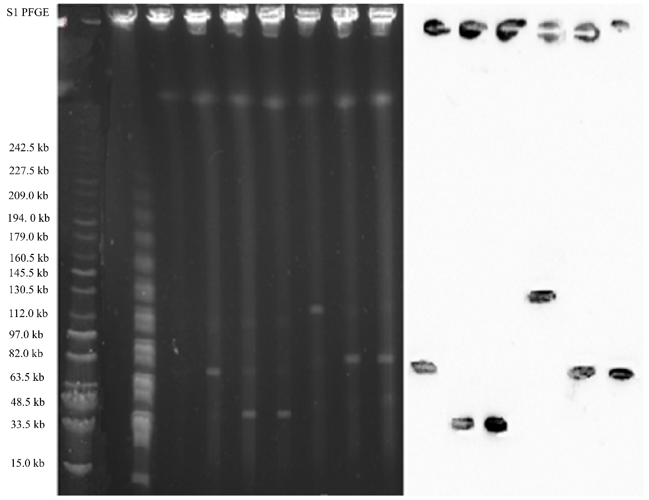
Supplement Figure 3. S1-nuclease pulsed-ﬁeld gel electrophoresis proﬁles of six and Southern Blot hybridization of six isolates carrying the mcr-1 plasmid. Reading from left to right 1= 70 kb IncFIIk, 2= 35 kb IncFII, 3=35 kb IncFII, 4=120 kb IncFIIK, 5= 70kb IncF 6=70 kb IncF.
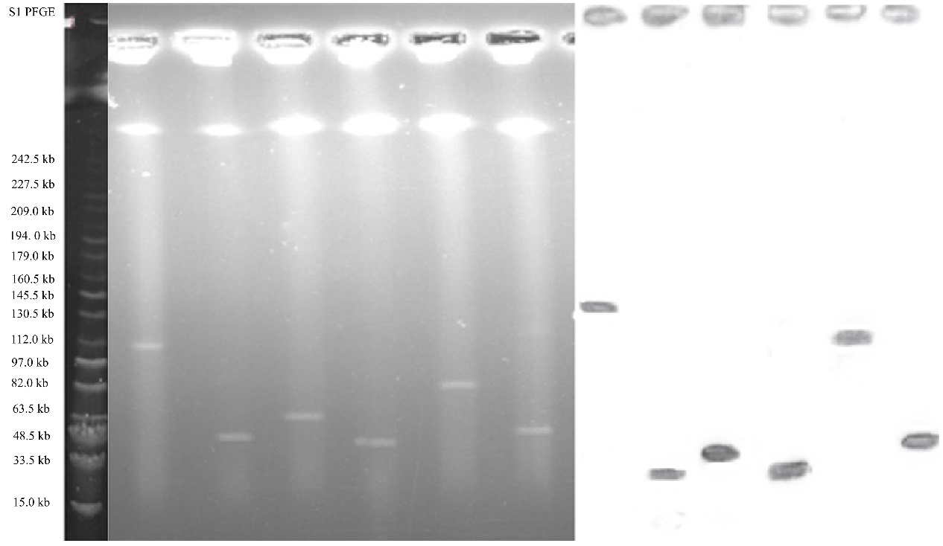

Supplement Figure 4. S1-nuclease pulsed-ﬁeld gel electrophoresis proﬁles of six and Southern Blot hybridization of six isolates carrying the bla_{KPC-2} plasmid. Reading from left to right 1= IncR 100 kb, 2=35 kb IncFII, 3= 50 kb IncA/C 4= 35 kb IncFII 5= 70 kb IncFIIK 6= 35 kb IncFII.
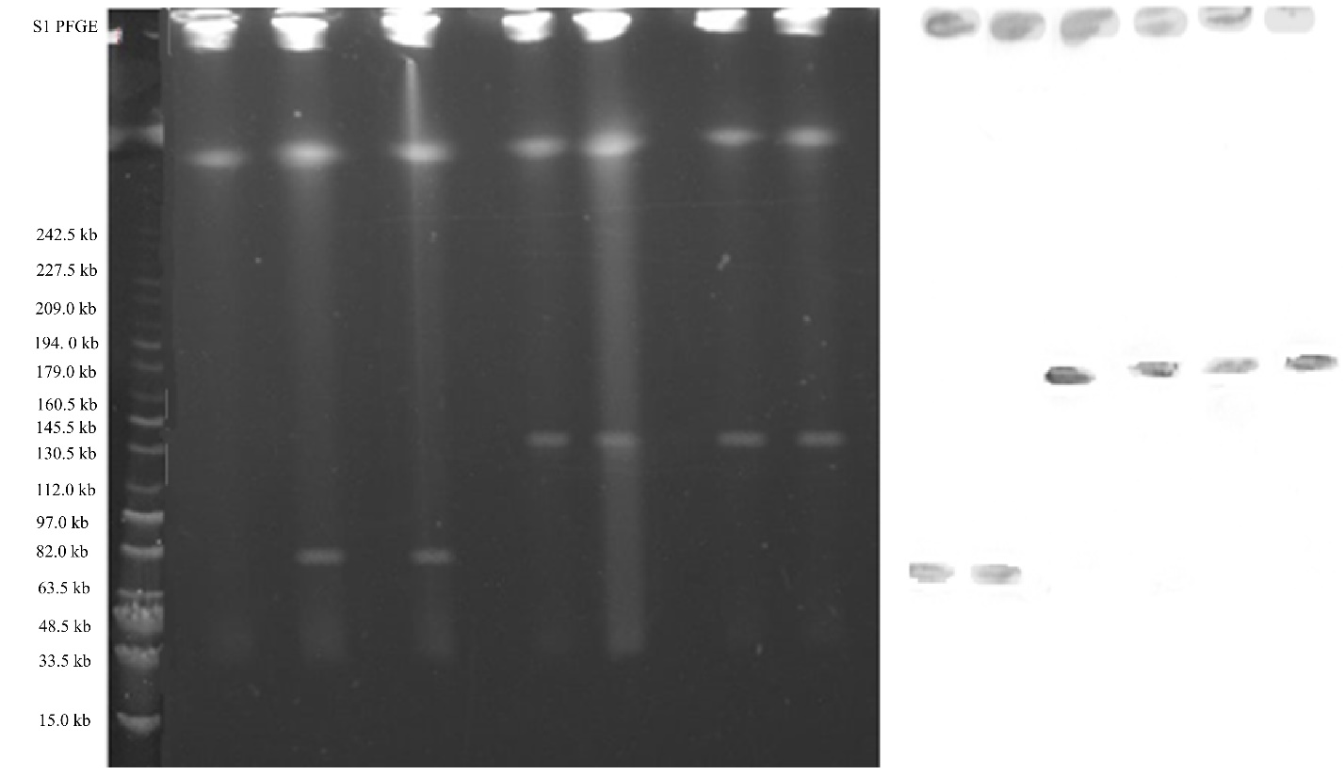
Supplement Figure 5. S1-nuclease pulsed-ﬁeld gel electrophoresis proﬁles of six and Southern Blot hybridization of six isolates carrying the bla_{NDM-1} plasmid. Reading from left to right 1=70kb IncFII, 2=70 kb IncFII, from three to six, all are 120 kb IncHI2.

Supplement Table 1. Isolation and prevalence of bacterial isolates from various collection units
Collection Units | N (%) | Klebsiella pneumoniae | Escherichia coli | Enterobacter cloacae | Serratia marcescens
Reparatory medicines | 51(32.2) | 33 | 11 | 4 | 3
Intensive care unit | 37(23.4) | 28 | 3 | 5 | 1
Urinary surgery | 23(14.4) | 3 | 10 | 8 | 2
Neurosurgery | 17(10.7) | 11 | 4 | 2 | -
Gerontology | 10(6.3) | 5 | 3 | 2 | -
Pediatric | 9(5.6) | 4 | 4 | 1 | -
Orthopedic | 7(4.4) | 2 | 2 | 3 | -
Oncology | 4(2.5) | 2 | 1 | 1 | -
Total | 158 | 88 | 38 | 26 | 6

Supplement Table 2. Representing the primers used in our study.

Primers | Sequence (5`-3`) | Annealing temperature | Amplicon size (bp) | Reference
Mcr-1 F  Mcr-1 R | CGGTCAGTCCGTTTGTTC  CTTGGTCGGTCTGTAGGG | 58º | 309 | [1]
bla_{KPC-2} F  bla_{KPC-2} R | TGTTGCTGAAGGAGTTGGGC  ACGACGGCATAGTCATTTGC | 56º | 340 | [2]
bla_{NDM-1}F  bla_{NDM-1}R | GGTTTGGCGATCTGGTTTTC  CGGAATGGCTCATCACGATC | 56º | 621 | [3]
bla_{CTXM} F  bla_{CTXM} R | CGCTTTGCGATGTGCAG  ACCGCGATATCGTTGGT | 55º | 550 | [4]
bla_{OXA} F  bla_{OXA} R | GCGTGGTTAAGGATGAACAC  CATCAAGTTCAACCCAACCG | 56º | 438 | [1]
fosA3 F  fosA3R | GCGTCAAGCCTGGCATTT  GCCGTCAGGGTCGAGAAA | 56º | 282 | [5]
16s F  16s R | GGTTGGCCAATCTACTCCCAGG  TGGTCTCCTTAAACCTGTCTTG | 55º | 1500 | [6]

[1] Kiaei S, Moradi M, Hosseini-Nave H, Ziasistani M, Kalantar-Neyestanaki DJI, resistance d Endemic dissemination of different sequence types of carbapenem-resistant Klebsiella pneumoniae strains harboring blaNDM and 16S rRNA methylase genes in Kerman hospitals, Iran, from 2015 to 2017. 2019; 12: 45.
[2] Talebi M, Najar-Peerayeh S, Bakhshi BJGR Hidden carbapenem resistance in the community-and hospital-associated OXA-48 gene-carrying uropathogenic Escherichia coli. 2020; 21: 100897.
[3] Shariati A, Azimi T, Ardebili A et al. Insertional inactivation of oprD in carbapenem-resistant Pseudomonas aeruginosa strains isolated from burn patients in Tehran, Iran. 2018; 21: 75-80.
[4] Bhattacharjee A, Sen MR, Prakash P, Anupurba SJJoac Role of β-lactamase inhibitors in enterobacterial isolates producing extended-spectrum β-lactamases. 2008; 61: 309-14.
[5] White BP, Stover KR, Barber KE, Galloway RC, Sullivan DC, King STJIjoaa Mechanisms of fosfomycin resistance in carbapenem-resistant Enterobacter sp. 2017; 50: 690-2.
[6] Kai S, Matsuo Y, Nakagawa S et al. Rapid bacterial identification by direct PCR amplification of 16S rRNA genes using the MinION™ nanopore sequencer. 2019; 9: 548-57.

