Table. 1 The complete characteristic of primers used in RT-qPCR.
Gene | Primer Sequence 5'-3' | Annealing Temperature [˚C] | Accesion No. of sequence
Bcl-2 | F:ATCGCCCTGTGGATGACTGAG | 58,8 | NM_000633.2
Bcl-2 | R:CAGCCAGGAGAAATCAAACAGAGG | 58,8 | NM_000633.2
Bax | F:ACCAAGAAGCTGAGCGAGTGTC | 58,8 | NM_001291428.1
Bax | R:ACAAAGATGGTCACGGTCTGCC | 58,8 | NM_001291428.1
Bad | F:ACATTCATCAGCAGGGACGG | 63,5 | NM_007522.3
Bad | R:ATCCCTTCATCCTCCTCGGT | 63,5 | NM_007522.3
Mmp-9 | F:GATGCCAACCTCCTCAACGA | 60 | NM_053056.2
Mmp-9 | R:GGAAGCGGTCCAGGTAGTTC | 60 | NM_053056.2
Runx-2 | F:TCCGAAATGCCTCTGCTGTT | 58,8 | NM_001271630.1
Runx-2 | R:GCCACTTGGGGAGGATTTGT | 58,8 | NM_001271630.1
Coll-1 | F:CAGGGTATTGCTGGACAACGTG | 61,4 | NM_007742.4
Coll-1 | R:GGACCTTGTTTGCCAGGTTCA | 61,4 | NM_007742.4
Ca-II | F:TCAGGGAGCCCATTACTGTC | 60 | XM_006509945.3
Ca-II | R:TCCAAATCACCCAGCCTAAC | 60 | XM_006509945.3
Ctsk | F: TAACAGCAAGGTGGATGAAATCT | 60 | NM_011613.3
Ctsk | R: CTGTAGGATCGAGAGGGAGGTAT | 60 | NM_011613.3
Gapdh | F:GTCAGTGGTGGACCTGACCT | 58,8 | NM_001289746.1
Gapdh | R:CACCACCCTGTTGCTGTAGC | 58,8 | NM_001289746.1
iNOS | F:GACAAGCTGCATGTGACATC | 59 | NM_010927.4
iNOS | R:GCTGGTAGGTTCCTGTTGTT | 59 | NM_010927.4
TNF-α | F:GAACTGGCAGAAGAGGCACT | 59 | NM_013693.3
TNF-α | R:AGGGTCTGGGCCATAGAACT | 59 | NM_013693.3
TGF-β | F:GGAGAGCCCTGGATACCAAC | 59 | NM_011577.2
TGF-β | R:CAACCCAGGTCCTTCCTAAA | 59 | NM_011577.2
IL-1β | F:AAGCCTCGTGCTGTCGGACC | 59 | NM_008361.4
IL-1β | R:TGAGGCCCAAGGCCACAGGT | 59 | NM_008361.4

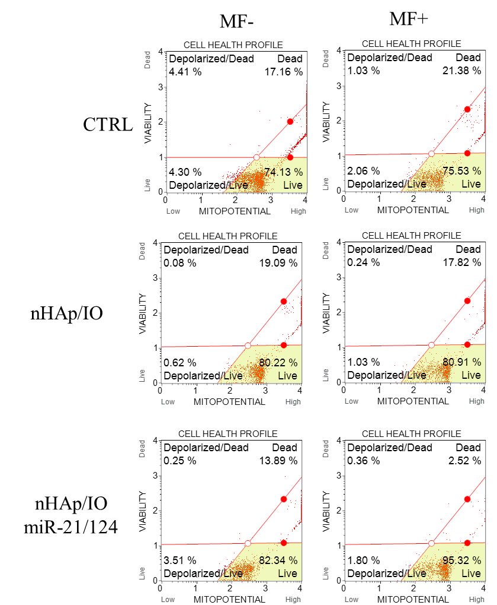
Mitochondrial membrane potential
of MC3T3-E1 pre-osteoblasts

Figure 1S. The representative dot plots, showing the distribution of MC3T3-E1 cells based on mitochondrial membrane potential. The influence of nHAp/IO and nHAp/IO/miR-21/124 on mitochondrial metabolism of pre-osteoblasts cultures monitored without and under magnetic field influence (MF-, MF+, respectively).

Mitochondrial membrane potential
of 4B12 pre-osteoclasts

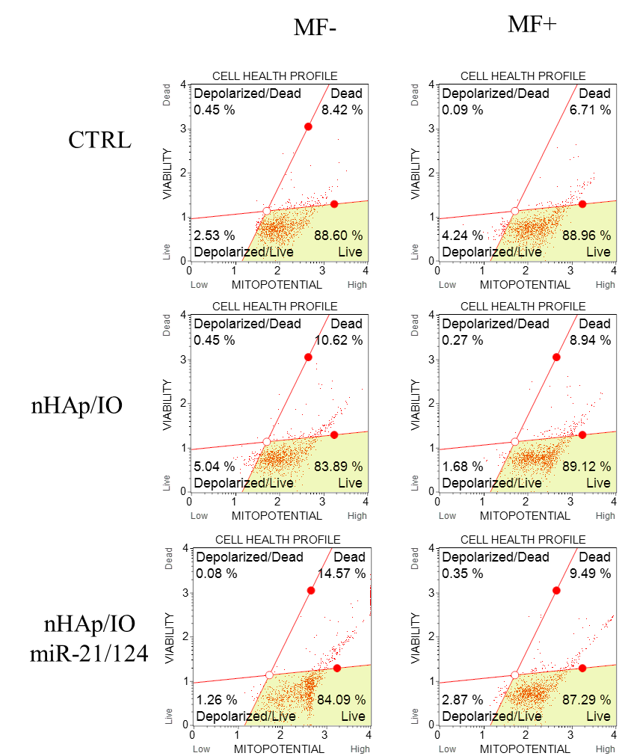

Figure 2S. The representative dot plots, showing the distribution of 4B12 cells based on mitochondrial membrane potential. The influence of nHAp/IO and nHAp/IO/miR-21/124 on mitochondrial metabolism of pre-osteoclasts cultures monitored without and under magnetic field influence (MF-, MF+, respectively).

