Supplementary Appendix
for
Predicting future health risk in Chronic Obstructive Pulmonary Disease:
Differential impact of disease specific and multi-morbidity based risk stratification.

Appendix S1. The John Hopkins Adjusted Clinical Groups© (ACG) System [v11-2]
Table S1a ACG System MEDC descriptions | Page 6
Appendix S2. Data Linkage
Figure S2a Distribution of CPRD practices by region in England, Wales, Scotland and Northern Ireland | Page 7
Appendix S3. Codelists
Table S3a List of validated COPD medcodes and Read codes used for data extraction | Page 9
Table S3b ICD-10 codes used for diseases of the respiratory system | Page 9
Table S3c COPD medications (extract from full list of 1024) | Page 9
Table S3d Medcodes used to detect vaccinations | Page 10
Table S3e Anaemia example codes | Page 11
Table S3f Anxiety example codes | Page 11
Table S3g Cancer example codes | Page 11
Table S3h Falls-related example codes | Page 12
Table S3i Kidney disease example codes | Page 12
Table S3j Social services involvement example codes | Page 12
Appendix S4. Missing data
Table S4a Missing counts for four key variables showing how missingness occurs together | Page 13
Figure S4a An example margin plot created from the R package VIM | Page 14
Table S4b Investigation of co-occurrence of ‘being missing’ by treating missingness as a binary variable | Page 14
Appendix S5. Dataflow
Figure S5a Data flow diagram layout with colour coded process elements | Page 16
Figure S5b DFD showing data extraction to produce CPRD, HES and ONS mortality data | Page 17
Figure S5c DFD showing constituent processes for exploratory analysis and model data assembly | Page 18
Figure S5d DFD showing data partitioning and modelling processes | Page 19
Figure S5e DFD showing ACG-related processing and analysis | Page 20
Appendix S6. Graphs
Figure S6a Example graphs | Page 21
Figure S6b 12mth all-cause mortality (actual and log-odds) for age and FEV1pp | Page 22
Figure S6c All-cause mortality % by age decile and fitted cubic spline | Page 22
Figure S6d All-cause mortality % by DEV1pp decile and fitted cubic spline | Page 22
Appendix S7. Model details
Table S7a Logistic regression models for all-cause mortality within 12mths (test data) | Page 23
Table S7b Pearson product-moment correlations | Page 24
Table S7c Logistic regression models for all-cause hospitalisation within 12mths (test data) | Page 25
Table S7d ACG Grouper Outputs used for tailored ACG method | Page 26
Table S7e ACG regression models (test data) | Page 27
Figure S7e ROC on test data for logistic regression 12mth all-cause mortality model | Page 27
Table S7f Cox regression models | Page 28
Figure S7f Survival curves from Cox regression models | Page 28

Appendix S1. The John Hopkins Adjusted Clinical Groups® (ACG) system [v11-2]

Developed in the 1980s at Johns Hopkins University in Baltimore as a means of analysing the relationship between morbidity and healthcare utilisation, the ACG system integrates primary and secondary care data to summarise the morbidity profile and estimate risk of high cost or hospitalisation. Continuously refined and used in the NHS since 2009, it was designed as a way to measure the medical need of populations, recognizing that patients usually present with “morbidity profiles”, not a single specific disease. ACG considers an International Classification of Diseases (ICD-10) coded condition such as COPD as a unitary entity without stratifying the condition by its severity. However, the ACG system will know if the patient has “Chronic respiratory failure” or has had an episode of “Acute respiratory failure” in the last 12 months, and also how many emergency admissions to hospital there were in the last year. These items are likely be triggered by a patient’s severe COPD and will feed in to predictive risk scores.

The validity of its predictive models has been tested in numerous health systems worldwide and in the UK and it is in routine use in 42 Clinical Commissioning Groups. It has been used to support basic and complex applications in finance, administration, care delivery, and both retrospective and prospective research for over two decades. Taking into account all previous diagnoses and comorbidities, individuals are assigned to groups with a similar level of morbidity. Hospitalisation risk is calculated using ACG’s previously developed logistic regression models of NHS data using a UK population of about 450,000.

Input
This consists of 3 files relating to patients, medical services and pharmacy:

1) Patient data (consisted of the following in relation to the previous year)
- ID, matching that used in the other files
- Age in years
- Gender
- Number of inpatient admissions excluding trauma
- Number of inpatient admissions (all-cause)
- Number of emergency visits to hospital not resulting in a subsequent inpatient stay
- Use of a dialysis service
- Use of a nursing home service
- Having undergone any major procedure using as reference an ACG list of 4064 Office of Population Censuses and Surveys (OPCS) codes for recognised major procedures.
- Having undergone cancer treatment
- The number of inpatient days
- The number unplanned inpatient admissions
- The number of readmissions within 30 days of discharge
- The number of unplanned readmissions within 30 days of discharge

2) Medical services data
Intended to gain an accurate picture of morbidity status. It consists of all long-term conditions recorded for the patient in the previous 12 months using as reference list of 2279 ICD-10 codes.

3) Pharmacy data
Prescribing information from the previous 12 months.

Output
A varied range of information is produced for each patient relating to medical risk and healthcare usage.
1) ACG® System Aggregated Diagnostic Groups (ADGs)
A patient’s diagnosis is associated with one of 32 ADGs. A particular ADG corresponds to diagnoses with similar specific clinical criteria with the focus being potential demand on resources. That is,
- Duration of condition (acute, recurrent, chronic)
- Severity (e.g. minor & stable, major & unstable)
- Diagnostic certainty
- Aetiology (e.g. infectious, injury)
- Speciality care involvement
A patient can be assigned to more than one ADG as they can have more than one condition. Eight ADGs are known as ‘major’ corresponding to more serious, resource demanding conditions.

2) ACG® System Adjusted Clinical Group (ACG) and Resource Utilisation Band (RUB)
As there are 4.3 billion possible ADG combinations and the goal of the ACG algorithm is to assign each patient to a single morbidity group (i.e. an ACG), ADGs are first grouped into 12 Collapsed ADGs (CADGs). For example, CADG1 corresponds to ADGs 1, 2, 21, 26 and CADG2 to ADGs 3, 4, 22, 27, 28. The particular combination of CADGs is then used to derive a Mutually Exclusive Category (MAC). The final step is to divide each MAC into one of 93 terminal groups, the actuarial cells known as ACGs. MACs are split into ACGs using a combination of decision tree development (on age, sex and ADG combination) and clinical insight. Individuals in the same ACG have a similar expected pattern of morbidity and resource consumption. From their ACG, each patient is assigned to one of six (low to high) RUBs.

3) ACG® System Expanded Diagnosis Clusters (EDCs) and Major Expanded Diagnosis Clusters (MEDCs)
These are used to categorize cases with similar diseases or conditions and a patient is placed into one or more of 282 EDCs. EDCs are broad groupings of diagnosis codes designed to remove differences in coding behaviour between practitioners. Conditions within an EDC share similar clinical characteristics and evoke similar types of diagnostic and therapeutic responses. EDCs and ADGs are aggregations of diagnosis codes but ADGs are groups of diagnoses with similar expected healthcare need, while EDCs are clinically similar clusters. The main criterion used for the diagnosis-to-EDC assignment is diagnostic similarity, whereas the diagnosis-to-ADG assignments are based on a unique set of clinical criteria that captures various dimensions of the range and severity of an individual’s co-morbidity. EDCs are organised into 27 Major Expanded Diagnosis Clusters (MEDCs) corresponding to Table A1.
4) ACG® System Rx-MG grouping and Major Rx-MGs (MRx-MGs)
Another output from the system is Rx-MG grouping. These groups (of which there are 64) are formed from medication-based morbidity classification based on pharmacy prescriptions. Each patient is placed in one or more groups and factors characterising groups are the primary physiological system targeted by the medication, the expected duration and morbidity severity. These are grouped into 27 Major Rx-MGs similarly to EDCs.

5) ACG® System Frailty flag
The frailty flag represents a set of diagnosis codes that describe clinically frail individuals who are at least 18 years of age and have marked functional limitations. Such conditions include absence of faecal control, pressure sores, dementia, difficulty in walking, a history of falling, loss of weight, major problems of urine retention, malnutrition, severe vision impairment, and requiring social support.

6) Risk measures
- Total cost predicted risk
- Probability persistent high user
- Probability of hospital admission within 6 months
- Probability of hospital admission within 12 months

The ACG model we used had been recalibrated in 2016 using a UK population of 450 000. Hospital admission risk is estimated using separate logistic regression models with a combination of demographic, diagnostic and pharmacy related independent variables. The first model uses data for patients who have had a hospitalization in the prior time period, as this is known to increase risk. In the absence of a prior hospitalization, a secondary criterion relates to the age of a person. Older people are known to have an increased likelihood of hospitalization, so the ACG System uses age 55 as the threshold for separation into two hospitalization risk groups for further models.

7) ACG® System Hospital dominant morbidity count
Hospital dominant morbidity types are based on diagnoses that, when present, are associated with a markedly greater probability of hospitalisation in the next year. This is a count of the number of ADGs containing at least one hospital dominant diagnosis. Example ICD-10 codes considered hospital dominant are-C34.1 (Malignant Neoplasm, Upper Lobe, Bronchus or Lung), D73.1 (Hypersplenism), A40 (Streptococcal Septicaemia).

8) ACG® System Major ADG count
The number of ADGs set from a subgroup associated with high resource usage.

9) Number of chronic conditions
The number of EDCs set from a subgroup corresponding to conditions expected to last at least a year with or without medical intervention. Examples are acute hepatitis, acute leukaemia and acute lower respiratory infection.

10) Diagnoses used
The number of separate diagnoses used in producing the ACG assignment.

Table S1a ACG System MEDC descriptions
ADM | Admin | GSI | General symptoms | NUR | Neurological
ALL | Allergy | GSU | General surgery | NUT | Nutrition
CAR | Cardiovascular | GTC | Genetic | PSY | Psychosocial/mental health
DEN | Dental | GUR | Genito-urinary | REC | Reconstructive
EAR | ENT | HEM | Haematological | REN | Renal
END | Endocrine | INF | Infections | RES | Respiratory
EYE | Eye-related | MAL | Malignancies | RHU | Rheumatological
FRE | Female reproductive | MUS | Musculoskeletal | SKN | Skin-related
GAS | Gastrointestinal/hepatic | NEW | Neonatal | TOX | Toxic/adverse effects

Appendix S2. Data Linkage

The Clinical Practice Research Datalink (CPRD) is a UK primary care database containing anonymised digital electronic health records. Since 1993, the CPRD has been collecting routinely collected medical records from GPs who have consented to using their data for research purposes from England, Wales, Scotland and Northern Ireland. Over 98% of the UK population are registered with primary care general practitioners [1] as this is the first points of contact in the UK for non-emergency health related issues.

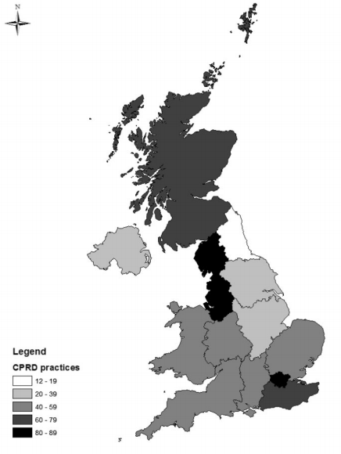

Figure S2a Distribution of CPRD practices by region in England, Wales, Scotland and Northern Ireland [2].

For a subset of the general population who contribute to CPRD data, 58% of all UK CPRD practices have consented to participant linkage eligibility to other data sources [2] such as the Index of Multiple Deprivation (IMD) neighbourhood deprivation data, Office for National Statistics (ONS) mortality data and Hospital Episode Statistics (HES) data from NHS Digital.

2015 Index of Multiple Deprivation (IMD)
The Indices of Deprivation measure neighbourhood deprivation at a small local area level across England. They provide a set of relative measures across England based on seven different domains of deprivation with the following weights:
- Income deprivation (22.5%)
- Employment deprivation (22.5%)
- Education, Skills and Training Deprivation (13.5%)
- Health Deprivation and Disability (13.5%)
- Crime (9.3%)
- Barriers to Housing and Services (9.3%
- Living Environment Deprivation (9.3%)
Combining information from the seven domains produces an overall relative measure of deprivation, the Index of Multiple Deprivation [3].

Office for National Statistics (ONS) mortality data
The Births and Deaths Registration Act (1836) made it a legal requirement for all deaths to be registered from 1 July 1837. The ONS mortality statistics are collected from death registration data. Not all patents in CPRD are eligible to be linked to death data, for example, due to the region in which they usually reside (outside England), or the lack of a valid NHS number [4].

Hospital Episode Statistics (HES) data from NHS Digital
HES is a database containing details of all admissions, A&E attendances and outpatient appointments at NHS hospitals in England [5]. Each HES record contains a wide range of information about an individual patient admitted to an NHS hospital including:
- Clinical information about diagnoses and operations
- Patient information, such as age group, gender and ethnicity
- Administrative information, such as dates and methods of admission and discharge
- Geographical information such as where patients are treated and the area where they live

Appendix S3. Codelists

The following tables list the validated COPD medcodes which were used for data extraction, ICD-10 codes for diseases of the respiratory system, a sample from our list of COPD medications, codes used to detect vaccinations and example comorbidity-related codes.

Note that a medical code will have been entered by a GP or hospital consultant for a patient’s medical condition but there often exists more than one possible code corresponding to the same illness description.

Table S3a List of validated COPD medcodes and read codes used for data extraction
medcode | readcode | description
18476 | 66YL.11 | COPD follow-up
10980 | H322.00 | Centrilobular emphysema
26306 | H320.00 | Chronic bullous emphysema
23492 | H320z00 | Chronic bullous emphysema NOS
998 | H3...11 | Chronic obstructive airways disease
5710 | H3z..00 | Chronic obstructive airways disease NOS
1001 | H3...00 | Chronic obstructive pulmonary disease
37247 | H3z..11 | Chronic obstructive pulmonary disease NOS
11287 | 66YM.00 | Chronic obstructive pulmonary disease annual review
105457 | 8CMW500 | Chronic obstructive pulmonary disease care pathway
45777 | 8CR1.00 | Chronic obstructive pulmonary disease clinical management plan
45770 | 66Yg.00 | Chronic obstructive pulmonary disease disturbs sleep
45771 | 66Yh.00 | Chronic obstructive pulmonary disease does not disturb sleep
18621 | 66YL.00 | Chronic obstructive pulmonary disease follow-up
38074 | 9Oi4.00 | Chronic obstructive pulmonary disease monitor phone invite
9520 | 66YB.00 | Chronic obstructive pulmonary disease monitoring
28755 | 9Oi0.00 | Chronic obstructive pulmonary disease monitoring 1st letter
34202 | 9Oi1.00 | Chronic obstructive pulmonary disease monitoring 2nd letter
34215 | 9Oi2.00 | Chronic obstructive pulmonary disease monitoring 3rd letter
18792 | 9Oi..00 | Chronic obstructive pulmonary disease monitoring admin
45998 | 66YT.00 | Chronic obstructive pulmonary disease monitoring by doctor
26018 | 66YS.00 | Chronic obstructive pulmonary disease monitoring by nurse
37371 | 66YD.00 | Chronic obstructive pulmonary disease monitoring due
42258 | 9Oi3.00 | Chronic obstructive pulmonary disease monitoring verb invite
794 | H32..00 | Emphysema
33450 | H32z.00 | Emphysema NOS
14798 | H312100 | Emphysematous bronchitis
104608 | H3A..00 | End stage chronic obstructive airways disease
60188 | H320200 | Giant bullous emphysema
42313 | 679V.00 | Health education - chronic obstructive pulmonary disease
10863 | H36..00 | Mild chronic obstructive pulmonary disease
10802 | H37..00 | Moderate chronic obstructive pulmonary disease
104710 | 9NgP.11 | On COPD (chronic obstructive pulmonary disease) supportive care pathway
104985 | 9NgP.00 | On chronic obstructive pulmonary disease supportive care pathway
16410 | H32yz00 | Other emphysema NOS
12166 | H3y..00 | Other specified chronic obstructive airways disease
67040 | H3y..11 | Other specified chronic obstructive pulmonary disease
46578 | H321.00 | Panlobular emphysema
106637 | 9Nk7000 | Seen in chronic obstructive pulmonary disease clinic
9876 | H38..00 | Severe chronic obstructive pulmonary disease
93568 | H39..00 | Very severe chronic obstructive pulmonary disease
65733 | Hyu3100 | [X]Other specified chronic obstructive pulmonary disease

Table S3b ICD-10 codes used for diseases of the respiratory system
code range | description
J00-J06 | Acute upper respiratory infections
J09-J18 | Influenza and pneumonia
J20-J22 | Other acute lower respiratory infections
J30-J39 | Other diseases of upper respiratory tract
J40-J47 | Chronic lower respiratory diseases
J60-J70 | Lung diseases due to external agents
J80-J84 | Other respiratory diseases principally affecting the interstitium
J85-J86 | Suppurative and necrotic conditions of the lower respiratory tract
J90-J94 | Other diseases of the pleura
J95 | Intraoperative and post-procedural complications and disorders of respiratory system, not elsewhere classified

Table S3c COPD medications (extract from full list of 1024)
prod# | BNF chapter | drug substance | groups
8 | unknown | salbutamol | SABA
17 | selective beta 2 agonists | salbutamol sulfate | SABA
31 | bronchodilators | salbutamol | SABA
38 | corticosteroids | beclometasone dipropionate | ICS
44 | corticosteroids | prednisolone | OCS
95 | corticosteroids | prednisolone | OCS
99 | corticosteroids | beclometasone dipropionate | ICS
235 | unknown | terbutaline sulfate | SABA
282 | selective beta 2 agonists | salbutamol sulfate | SABA
454 | corticosteroids | budesonide | ICS
465 | unknown | salmeterol xinafoate | LABA
510 | selective beta 2 agonists | salbutamol sulfate | SABA
534 | antimuscarinic bronchodilators | ipratropium bromide | SAMA
549 | unknown | salmeterol xinafoate | LABA
555 | unknown | aminophylline | THEOPH
556 | unknown | salbutamol sulfate/ipratropium bromide | SABA_SAMA
557 | corticosteroids | prednisolone | OCS
578 | corticosteroids | prednisolone | OCS
590 | theophylline | aminophylline hydrate | THEOPH
638 | selective beta 2 agonists/corticosteroids | salmeterol xinafoate/fluticasone propionate | LABA_ICS
665 | selective beta 2 agonists/corticosteroids | fluticasone propionate/salmeterol xinafoate | LABA_ICS
674 | selective beta 2 agonists | salbutamol sulfate | SABA
696 | selective beta 2 agonists | salbutamol sulfate | SABA
719 | selective beta 2 agonists | salmeterol xinafoate | LABA
743 | macrolides | azithromycin | AZITHRO
746 | antimuscarinic bronchodilators | tiotropium bromide | LAMA
752 | mucolytics | carbocisteine | MUCOLYTICS
856 | selective beta 2 agonists | salbutamol sulfate | SABA
Abbreviations: AZITHRO, Azithromycin (antibiotic); BNF, British National Formulary; ICS, Inhaled corticosteroid; OCS, Oral corticosteroid; SABA/LABA, Short/long acting beta agonist; SAMA/LAMA, Short/long acting muscarinic antagonist; THEOPH, Theophylline (a muscle relaxant).

Table S3d Medcodes used to detect vaccinations
medcode | readcode | description
6 | 65E..00 | Influenza vaccination
11363 | 6572 | Pneumococcal vaccination
12104 | 9OX..11 | Flu vaccination
12336 | ZV04800 | Influenza vaccination
30411 | 9Oo..00 | Pneumococcal vaccination
36826 | 6572000 | Pneumococcal vaccination
53198 | 657K..00 | Booster pneumococcal vaccination
61504 | 657M..00 | Second pneumococcal conjugated vaccination
71121 | 657L.00 | First pneumococcal conjugated vaccination
95092 | 65E1.00 | Second pandemic influenza vaccination
97941 | 65E2.00 | Influenza vaccination given by other healthcare provider
104688 | 65ED.00 | Seasonal influenza vaccination
105195 | 65ED000 | Seasonal influenza vaccination given by pharmacist
107156 | 65EE.00 | Intranasal influenza vaccination

Table S3e Anaemia example codes
medcode | readcode | description
539 | D00..12 | Microcytic - hypochromic anaemia
739 | D21z.00 | Anaemia unspecified
795 | D00..00 | Iron deficiency anaemias
797 | D21z.13 | Macrocytic anaemia of unspecified cause
882 | D00..11 | Hypochromic - microcytic anaemia
1668 | L182500 | Iron deficiency anaemia of pregnancy
1702 | D21z.12 | Normocytic anaemia due to unspecified cause
1771 | L182.00 | Anaemia during pregnancy, childbirth and the puerperium
2054 | L182400 | Anaemia in the puerperium - baby previously delivered
2452 | D014.00 | Protein-deficiency anaemia
2464 | D010.00 | Pernicious anaemia
2482 | D011100 | Vit B12 defic anaemia due to malabsorption with proteinuria
2743 | D211.00 | Acute posthaemorrhagic anaemia

Table S3f Anxiety example codes
medcode | readcode | description
636 | E200.00 | Anxiety states
655 | E200300 | Anxiety with depression
962 | Eu41111 | [X]Anxiety neurosis
1758 | E200400 | Chronic anxiety
3407 | 1466 | H/O: anxiety state
4534 | E200z00 | Anxiety state NOS
4634 | E200500 | Recurrent anxiety
4659 | E200200 | Generalised anxiety disorder
5385 | Eu41.00 | [X]Other anxiety disorders
6221 | E292000 | Separation anxiety disorder
7749 | Eu41211 | [X]Mild anxiety depression
7999 | Z4L1.00 | Anxiety counselling
8205 | Eu41000 | [X]Panic disorder [episodic paroxysmal anxiety]

Table S3g Cancer example codes
medcode | readcode | description
318 | B210.00 | Malignant neoplasm of glottis
319 | B21..00 | Malignant neoplasm of larynx
779 | B49..00 | Malignant neoplasm of urinary bladder
780 | B46..00 | Malignant neoplasm of prostate
782 | B....00 | Neoplasms
1044 | BA06.00 | Neoplasm of unspecified nature of brain
1056 | B5z..00 | Malignant neoplasm of other and unspecified site NOS
1062 | B10..00 | Malignant neoplasm of oesophagus
1220 | B13..00 | Malignant neoplasm of colon
1599 | B4A0.00 | Malignant neoplasm of kidney parenchyma
1800 | B141.00 | Malignant neoplasm of rectum
1918 | B912.00 | Neoplasm of uncertain behaviour of ovary
1952 | B580.00 | Secondary malignant neoplasm of kidney
Table S3h Falls-related example codes
medcode | readcode | description
44119 | 8BIG.00 | Falls caused by medication
109088 | 9Nlf.00 | Seen by community falls team
55743 | 67ID.00 | Falls advice - hip protectors advised
105823 | 9Og5.00 | Primary health care team falls assessment defaulted
58988 | 8HTl.00 | Referral to elderly falls prevention clinic
9951 | 14OC.00 | At risk of falls
105686 | 14OC000 | At high risk of falls
42670 | 8Hk1.00 | Referral to falls service
7970 | U10..00 | [X]Falls
8730 | TCy..00 | Other falls
6815 | TC...00 | Accidental falls
6835 | TCz..00 | Accidental falls NOS
6008 | 16D..00 | Falls

Table S3i Kidney disease example codes
medcode | readcode | description
1599 | B4A0.00 | Malignant neoplasm of kidney parenchyma
1805 | K10..00 | Infections of kidney
1839 | 7B0..00 | Kidney operations
1952 | B580.00 | Secondary malignant neoplasm of kidney
2304 | K070.00 | Atrophy of kidney
2754 | 585B.00 | U-S kidneys
2810 | PD38.00 | Horseshoe kidney
2991 | K13z.00 | Kidney and ureter disease NOS
2997 | 7B00.00 | Transplantation of kidney
3029 | L166500 | Infections of kidney in pregnancy
3303 | A160.00 | Tuberculosis of kidney
3314 | PD02.00 | Congenital absence of kidney
3337 | K132.00 | Acquired cyst of kidney

Table S3j Social services involvement example codes
medcode | readcode | description
4062 | 3875 | Social services case conference
9540 | 9NDA.00 | Report received from social services
9838 | ZL79200 | Referral to social services department care manager
9909 | ZL79100 | Referral to social services department social worker
11239 | 8HHB.00 | Referral to Social Services
21092 | ZV63211 | [V]Delayed discharge - social services
28656 | 9b0k.00 | Social services report
30534 | ZLB8.00 | Seen by social services department care manager
30859 | ZL46300 | Under care of social services occupational therapist
32592 | ZLB9.00 | Seen by social services department duty staff
34884 | ZK4..00 | Social services client assessment
40826 | ZLC3300 | Seen by social services department occupational therapist
43936 | ZK2..00 | Screening by social services department

Appendix S4. Missing data

The variables FEV1pp, BMI, MRC grade, haemoglobin count and eosinophil count each had over 25% missing but they are all highly relevant to outcome so appropriate strategies were formed.

From lung function (spirometry), the patient’s Forced expiratory volume of air in one second (FEV1) is a strong indicator of disease severity. Due to a high degree of missing spirometry data we used FEV1 percent-predicted (FEV1pp) which is estimated from FEV1 and the population average for that patient’s age, sex and build. If FEV1pp itself was absent but if we had FEV1, the predicted value was estimated using the following Association for Respiratory Technology and Physiology formulae with height in metres and age in years [6].

Predicted FEV1 = 4.3 x height – 0.029 x age – 2.49 (for males),
Predicted FEV1 = 3.95 x height – 0.025 x age – 2.6 (for females)
FEV1pp = FEV1 / predicted FEV1 x 100
Where Body Mass Index (BMI) was missing it was calculated, where possible, in the standard way as weight (kg)/]height(m)]².

A high degree of correlation of missingness between variables lends weight to the remedy of case omission but mainly there was little relationship, although haemoglobin and eosinophil were often missing together as they are typically taken at the same patient visit. Margin plots using the R package VIM also determined that there was little relationship between being missing and the value of other key variables. Missing data for the above four variables and BMI was imputed using the R mice package with five datasets and the addition of age, sex, smoking status and number of exacerbations as added predictors. Ethnicity was not used, partly due to missing data, but it played a part in composing a “high-missing” variable. Smoking status was missing in about 4% of cases and a special code was used for this. IMD quintile was missing for only 49 patients and we estimated it using the middle value 3. With the view that there may be underlying reasons for several values being missing, we composed a “high-missing” variable which was set to true if at least four of ethnicity, smoking-status, MRC, FEV1pp, BMI, IMD, haemoglobin and eosinophil were missing. It was later found to have independent significance in some models. At this stage, almost a fifth of cases had imputed values for at least three of the four variables MRC grade, FEV1pp, haemoglobin count, and eosinophil count which we felt would impair model accuracy; therefore these were excluded, leaving 75 022 cases.

The following tables and plots were part of our review of missing data. This was carried out on the 93 374 patients matched to the study-interval and with a year of GP consultations plus a COPD diagnosis.

Table S4a Missing counts for four key variables showing how missingness occurs together
 |  | Percentage missing by variable
 |  | 27% | 39% | 39% | 41%
N patients with this pattern | % | mrc | haem | FEV1pp | eos
29,150 | 31.2 | Pres | Pres | Pres | Pres
18,438 | 19.7 | Pres | Miss | Pres | Miss
11,347 | 12.2 | Pres | Pres | Miss | Pres
9,229 | 9.9 | Miss | Pres | Miss | Pres
7,532 | 8.1 | Pres | Miss | Miss | Miss
7,482 | 8.0 | Miss | Miss | Miss | Miss
5,030 | 5.4 | Miss | Pres | Pres | Pres
2,863 | 3.1 | Miss | Miss | Pres | Miss
1,048 | 1.1 | Pres | Pres | Pres | Miss
489 | 0.5 | Pres | Pres | Miss | Miss
458 | 0.5 | Miss | Pres | Miss | Miss
159 | 0.2 | Miss | Pres | Pres | Miss
96 | 0.1 | Pres | Miss | Pres | Pres
19 | 0.0 | Pres | Miss | Miss | Pres
17 | 0.0 | Miss | Miss | Pres | Pres
17 | 0.0 | Miss | Miss | Miss | Pres

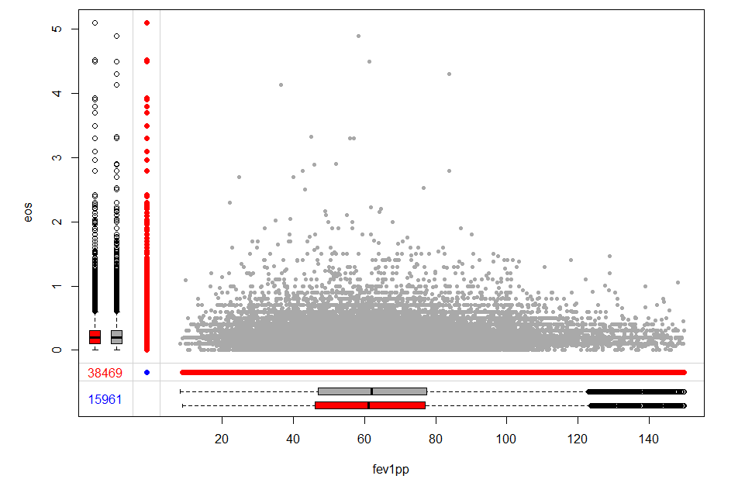

Figure S4a An example margin plot created from the R package VIM, in this case showing that omission of FEV1pp does not depend on the value of eosinophil. This is deduced because the red and grey boxplots are similar. Grey boxplot = distribution where other variable present; red boxplot = distribution where other variable missing.
Red dots: values of one variable for missing values of other; Blue number: missing on both; red number: missing on left axis variable; Grey scatterplot: both variables present.

Table S4b Investigation of co-occurrence of ‘being missing’ by treating missingness as a binary variable
mrc | FEV1pp | haem | eos |  | mrc | FEV1pp | haem | eos |  |  | mrc | FEV1pp | haem | eos
NA | NA | 137 | 0.20 |  | 1 | 1 | 0 | 0 | mrc |  | 1.0 | 0.36 | 0.03 | 0.03
3 | 56.1 | 120 | 0.60 |  | 0 | 0 | 0 | 0 | FEV1pp |  |  | 1.0 | 0.03 | 0.04
2 | NA | NA | NA |  | 0 | 1 | 1 | 1 | haem |  |  |  | 1.0 | 0.95
1 | 57.0 | 141 | 0.10 |  | 0 | 0 | 0 | 0 | eos |  |  |  |  | 1.0
NA | 76.5 | 146 | 0.33 |  | 1 | 0 | 0 | 0
5 | 38.6 | 116 | NA |  | 0 | 0 | 0 | 1
The start of the data is shown (left), corresponding ‘shadow matrix’ (centre) with 1 indicating missing and Pearson correlation coefficients for the shadow matrix (right) showing high likelihood of haemoglobin and eosinophil being missing together, moderate for MRC and FEV1pp and low for others.

Imputation
Missing data for MRC, FEV1pp, haemoglobin count, eosinophil count and BMI was imputed using the R mice package, averaging over five datasets with the addition of age, sex, smoking status and number of exacerbations as added predictors. Sample R code is as follows.

library(mice)
plist<-read.csv("plist.csv", header=TRUE)

# Impute MRC, fev1pp, haemoglobin, eosinophil, BMI.
# Include as an aid to processing, (age, sex, smoking, n exacerbations)

p<-plist[,c("age","sex","smoking","n_exacs","mrc","fev1pp","haemoglobin","eosinophil","bmi")]
imp<-mice(p, m=5, seed=1234)

f1<-complete(imp, action=1)
f2<-complete(imp, action=2)
f3<-complete(imp, action=3)
f4<-complete(imp, action=4)
f5<-complete(imp, action=5)
write.csv(f1, "f1.csv", row.names=FALSE)
write.csv(f2, "f2.csv", row.names=FALSE)
write.csv(f3, "f3.csv", row.names=FALSE)
write.csv(f4, "f4.csv", row.names=FALSE)
write.csv(f5, "f5.csv", row.names=FALSE)

# Above 5 datasets averaged in EXCEL to produce imputed.csv
imputed<-read.csv("imputed.csv", header=TRUE)

# remove variables with missing data
plist<-subset(plist,select=-c(mrc,fev1pp,haemoglobin,eosinophil,bmi))

# add new imputed ones & write new version
plist<-cbind(plist, imputed)

write.csv(plist,"plist2.csv",row.names=FALSE)

Appendix S5. Dataflow

Dataflow diagrams (DFDs) have been used for decades to represent the flow of data within a process or system (usually an information system). They provide, in flowchart form, information about the inputs and outputs of each process and we found them to be an invaluable documentation and reference aid.

There are several recognised notations but we made use of colour with red for computer programs (typically R statistical processing), blue for data and green for annotation, as shown below. Arrows represent data flowing in or out of a process. In a complex system, a process itself can be expanded to form another DFD.
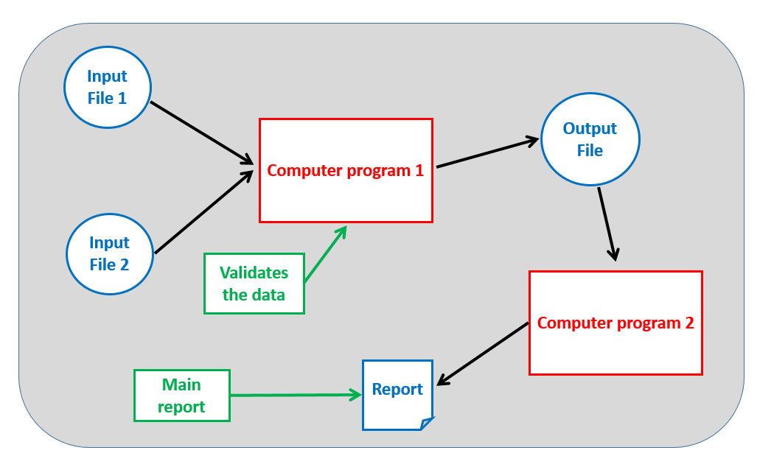
Figure S5a Data flow diagram layout with colour coded process elements.

The following screens show sample DFDs arising from the study.
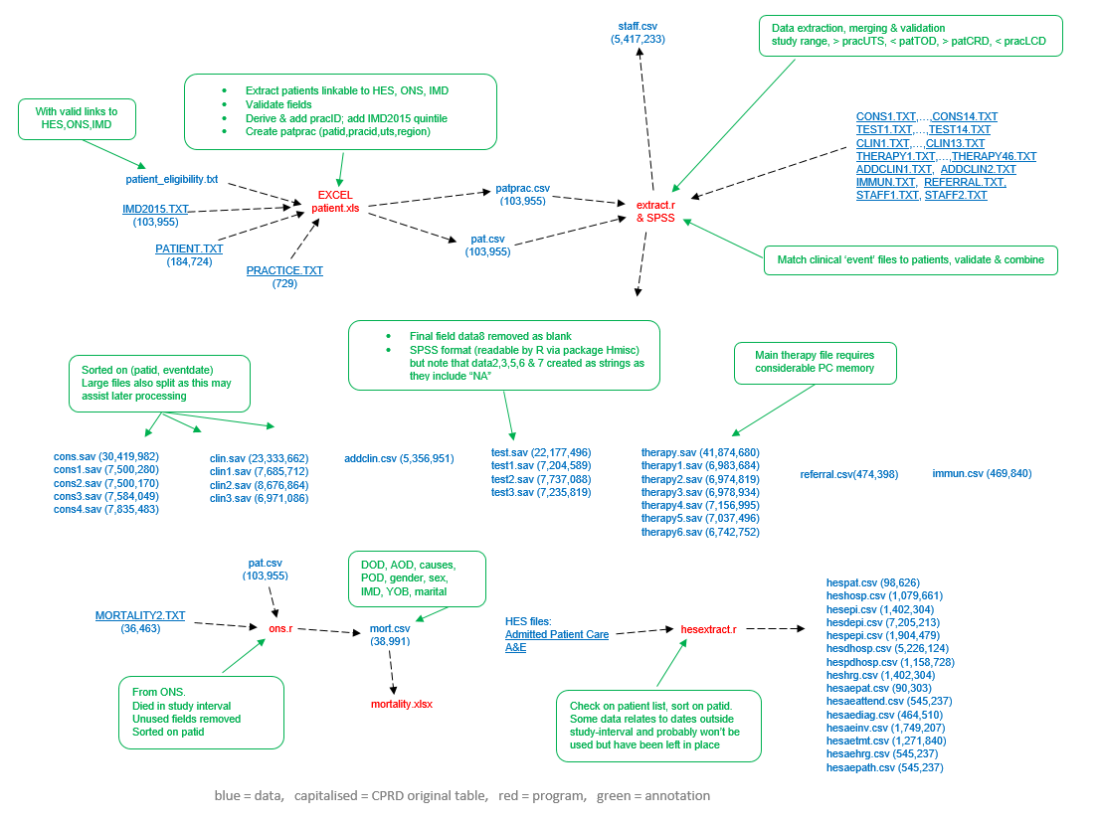

Figure S5b DFD showing data extraction from raw .TXT files to produce CPRD, HES and ONS mortality data in SPSS (.SAV) and comma separated (.CSV) form.

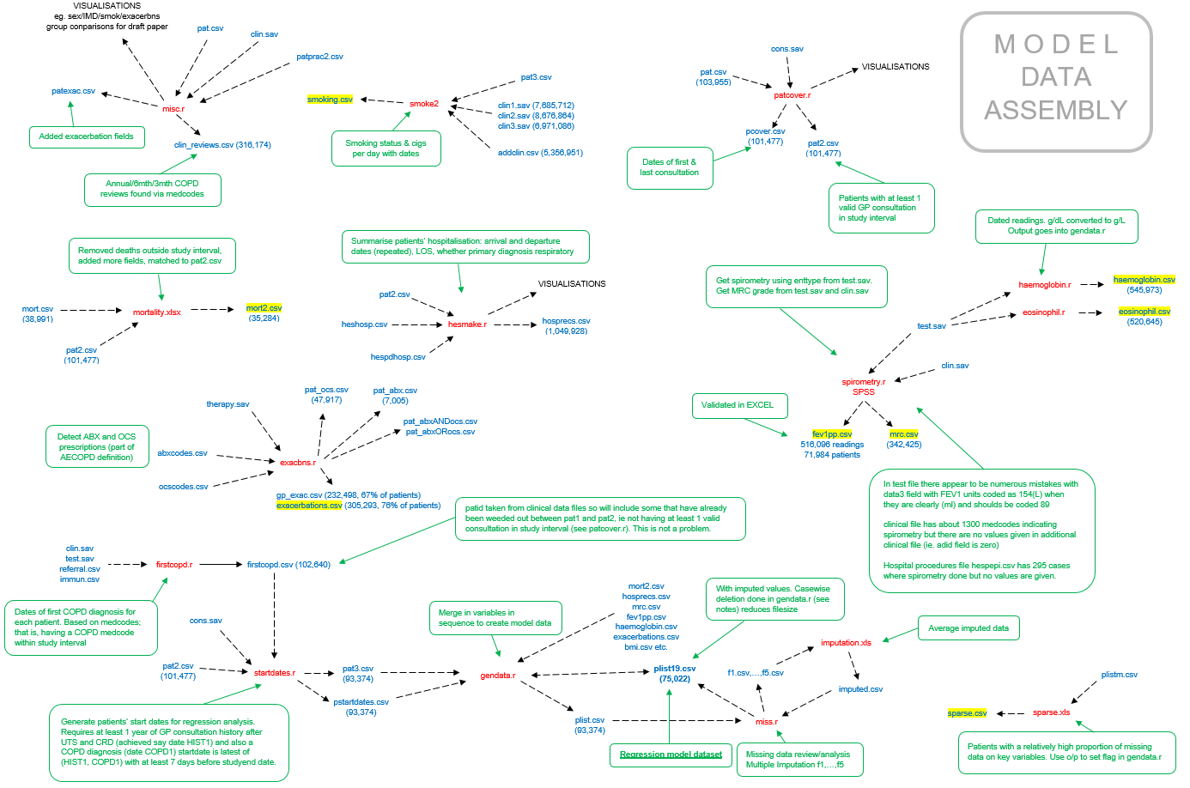

Figure S5c DFD showing constituent processes for exploratory analysis and model data assembly. A key component is the R program gendata.r (centre, bottom) which assembles the patient file for modelling.
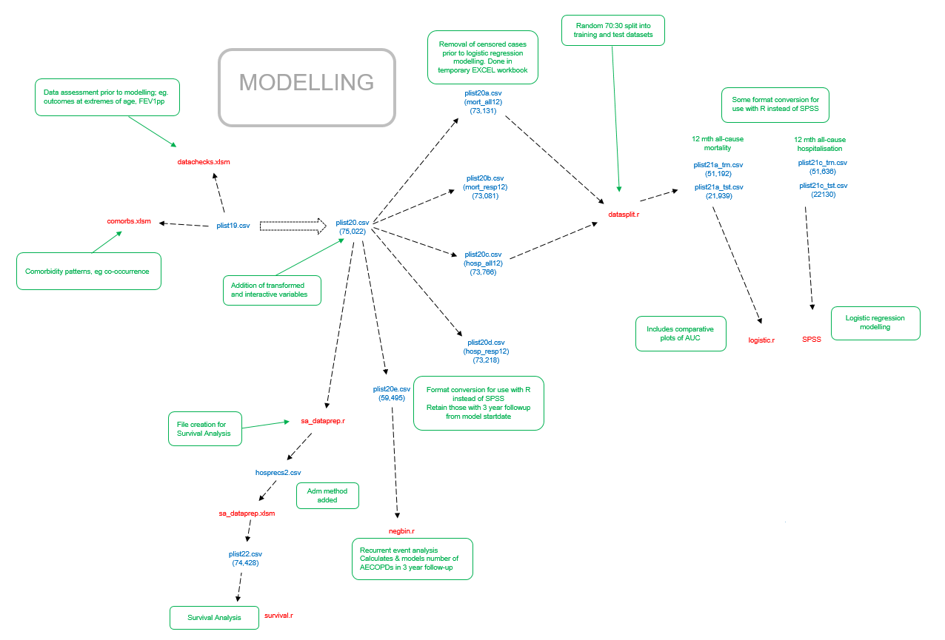

Figure S5d DFD showing data partitioning and modelling processes. Note the division within the diagram corresponding to different outcomes; 12 month mortality (all-cause and with a respiratory primary cause) and 12 month hospitalisation (all-cause and with a respiratory primary cause).

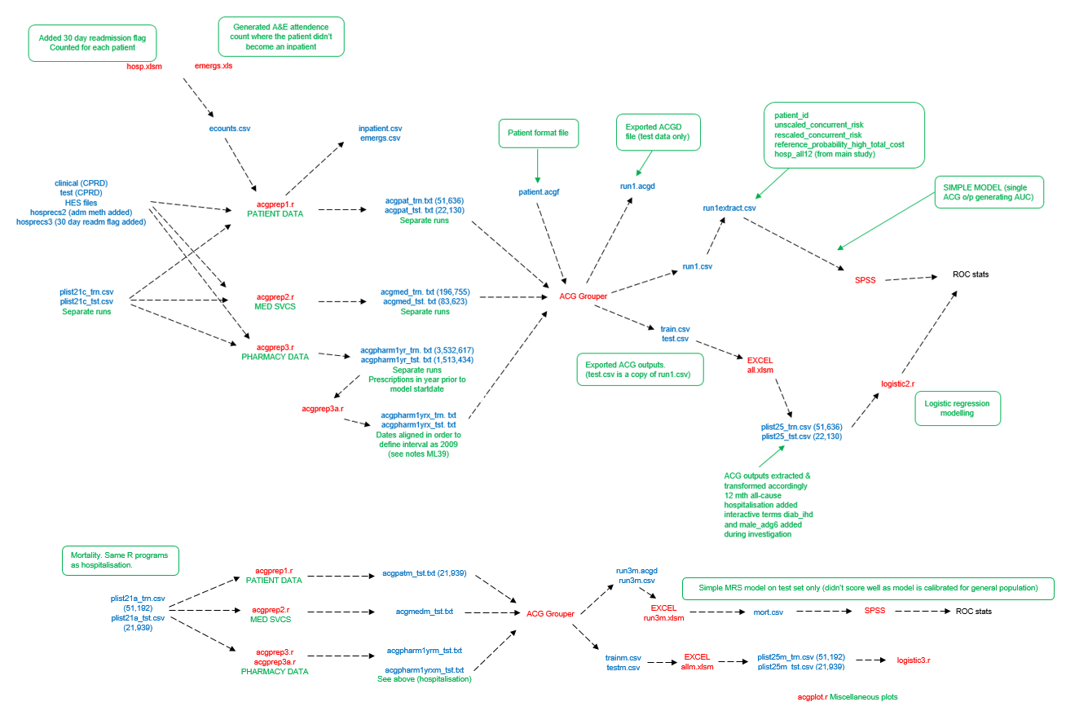

Figure S5e DFD showing ACG-related processing and analysis. The three data types entering the ACG program (left) and processing ACG outputs (right).

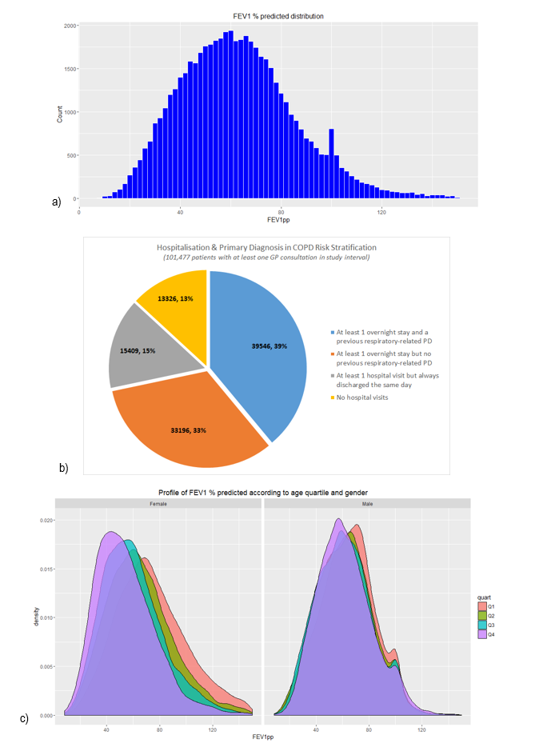
Appendix S6. Graphs

Figure S6a Example graphs; a) shows FEV1pp distribution which is close to normal, b) shows that about two-thirds of our patient sample became a hospital inpatient during the study-interval, just over half with a respiratory-related primary diagnosis, and density plots in c) suggest that decline in FEV1pp is more related to age in females than in males.
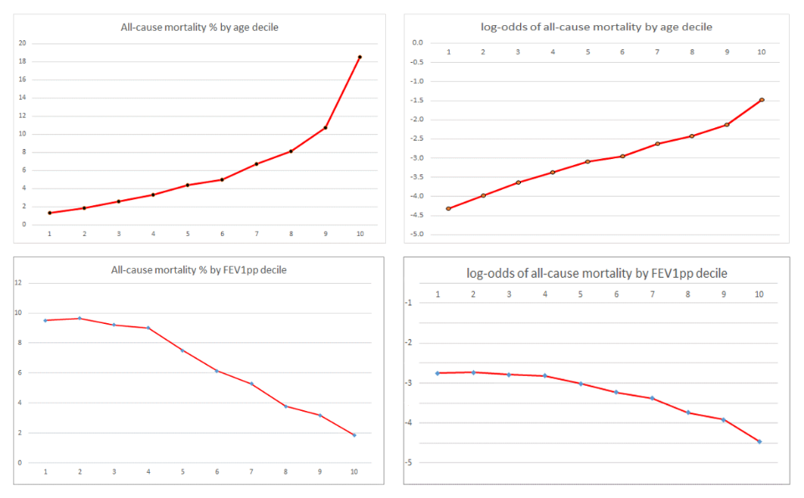

Figure S6b 12 month all-cause mortality (actual and log-odds) for age and FEV1pp. Age satisfies the logistic regression log-odds linearity condition whereas FEV1pp has a ‘critical point’ around the fourth decile.
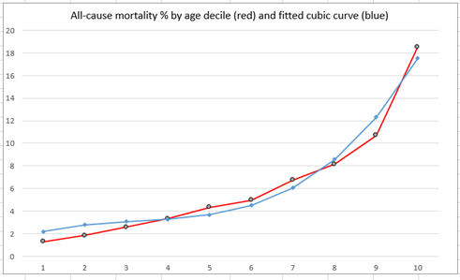

Figure S6c A cubic spline fits well to age decile for all-cause mortality. This suggests that one or more age terms with higher power than 1 might be included within mortality predictors.

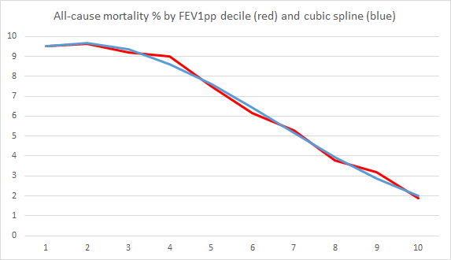

Figure S6d A cubic spline also fits well to FEV1pp decile

Table S7a Logistic regression models for all-cause mortality within 12mths (test data)
M_copd: demographic & COPD-specific predictors |  |  |  |  | M_copdcom: demographic & COPD-specific predictors & addition of comorbidities |  |  |  |  | M_com: comorbidities only
Variable | Estimate | p | OR |  | Variable | Estimate | p | OR |  | Variable | Estimate | p |  | OR
(Intercept) | -1.656 |  |  |  | (Intercept) | -1.992 |  |  |  | (Intercept) | -3.559
age | 0.063 | < 0.0001 | 1.07±.00 |  | age | 0.054 | <0.0001 | 1.06±.00 |  | cvd | 0.897 | <0.0001 |  | 2.45±.17
sexMale | 0.583 | <0.0001 | 1.79±.07 |  | sexMale | 0.482 | <0.0001 | 1.62±.07 |  | hyp | 0.418 | <0.0001 |  | 1.52±.09
fev1pp | -0.005 | <0.0001 | 0.99±.01 |  | fev1pp | -0.007 | <0.0001 | 0.99±.00 |  | kidney | 0.811 | <0.0001 |  | 2.25±.19
mrc | 0.248 | <0.0001 | 1.28±.03 |  | mrc | 0.300 | <0.0001 | 1.26±.03 |  | liver | 0.335 | 0.0002 |  | 1.40±.12
smokYes | 0.274 | <0.0001 | 1.32±.06 |  | smokYes | 0.256 | <0.0001 | 1.29±.06 |  | asthma | -0.222 | <0.0001 |  | 0.80±.04
n_exacs | 0.065 | 0.000202 | 1.07±.02 |  | n_exacs | 0.062 | 0.0004 | 1.06±.02 |  | anaemia | 0.692 | <0.0001 |  | 2.00±.09
hosp_days | 0.020 | <0.0001 | 1.02±.00 |  | hosp_days | 0.018 | <0.0001 | 1.02±.00 |  | psych | 0.418 | <0.0001 |  | 1.52±.07
hosp_admns | 0.274 | <0.0001 | 1.32±.03 |  | hosp_admns | 0.201 | <0.0001 | 1.22±.03 |  | frail | 0.496 | <0.0001 |  | 1.64±.11
hosp_admns2 | -0.014 | <0.0001 | 0.99±.00 |  | hosp_admns2 | -0.010 | <0.0001 | 0.99±.00 |  | cancer | 0.755 | <0.0001 |  | 2.123±.14
bmi | -0.201 | <0.0001 | 0.82±.02 |  | bmi | -0.210 | <0.0001 | 0.81±.02 |  | gerd | -0.295 | <0.0001 |  | 0.74±.05
bmi2 | 0.003 | <0.0001 | 1.00±.00 |  | bmi2 | 0.003 | <0.0001 | 1.00±.00 |  | hyp_kidney | -0.225 | 0.0293 |  | 0.80±.08
haemoglobin | -0.023 | <0.0001 | 0.98±.00 |  | haemoglobin | -0.016 | <0.0001 | 0.99±.00 |  | hyp_cvd | -0.180 | 0.0299 |  | 0.84±.07
eosinophil | -0.583 | <0.0001 | 0.56±.06 |  | eosinophil | -0.559 | <0.0001 | 0.57±.06 |  | hyp_cancer | -0.199 | 0.0190 |  | 0.82±.07
nivoxyYes | 1.117 | <0.0001 | 3.06±.31 |  | nivoxyYes | 1.119 | <0.0001 | 3.06±.31 |  | kidney_asthma | -0.531 | 0.0008 |  | 0.59±.09
immunYes | -0.422 | <0.0001 | 0.66±.03 |  | immunYes | -0.419 | <0.0001 | 0.66±.03 |  | kidney_cancer | -0.297 | 0.0056 |  | 0.74±.08
medYes | 0.118 | 0.004392 | 1.13±.05 |  | medYes | 0.117 | 0.0053 | 1.12±.05 |  | cvd_asthma | 0.307 | 0.0006 |  | 1.36±.12
highmissYes | 0.535 | <0.0001 | 1.71±.18 |  | highmissYes | 0.637 | <0.0001 | 1.89±.20 |  | hyp_kidney_asthma | 0.403 | 0.0146 |  | 1.50±.23
 |  |  |  |  | cvdYes | 0.434 | <0.0001 | 1.54±.07 |  | kidney_asthma_cancer | 0.305 | 0.0655 |  | 1.36±.21
 |  |  |  |  | hypYes | 0.109 | 0.0126 | 1.12±.05 |  | cvd_asthma_cancer | -0.318 | 0.0079 |  | 0.73±.08
 |  |  |  |  | kidneyYes | 0.285 | <0.0001 | 1.33±.06
 |  |  |  |  | diabetesYes | 0.197 | <0.0001 | 1.22±.06
 |  |  |  |  | liverYes | 0.533 | <0.0001 | 1.70±.16
 |  |  |  |  | asthmaYes | -0.159 | 0.0002 | 0.85±.03
 |  |  |  |  | anaemiaYes | 0.213 | <0.0001 | 1.24±.06
 |  |  |  |  | psychYes | 0.378 | <0.0001 | 1.46±.08
 |  |  |  |  | frailYes | 0.303 | <0.0001 | 1.36±.09
 |  |  |  |  | cancerYes | 0.418 | <0.0001 | 1.52±.06
 |  |  |  |  | gerdYes | -0.170 | 0.0145 | 0.84±.06

Appendix S7. Model details

M_copd (demographic & COPD-specific predictors) AIC = 20012; M_copdcom (addition of comorbidities) AIC = 19521; M_com (comorbidities only) AIC = 22034.

Table S7b Pearson product-moment correlations
 | FEV1pp | BMI | haem | eos | n_exacs | hosp_days
age | -0.181 | -0.122 | -0.307 | 0.000* | 0.018* | 0.058*
FEV1pp |  | 0.091* | 0.026* | 0.007* | -0.081 | -0.072
BMI |  |  | 0.057* | 0.023* | -0.004 | -0.018
haem |  |  |  | 0.009* | -0.080 | -0.067
eos |  |  |  |  | 0.016* | -0.008
n_exacs |  |  |  |  |  | 0.253*
Correlations are generally low indicating a minor degree of linear association, positive values have been marked with *.

Table S7c Logistic regression models for all-cause hospitalisation within 12mths (test data)
H_copd: demographic & COPD-specific predictors |  |  |  |  | H_copdcom: demographic & COPD-specific predictors & addition of comorbidities |  |  |  |  | H_com: comorbidities only
Variable | Estimate | p | OR |  | Variable | Estimate | p | OR |  | Variable | Estimate | p | OR
(Intercept) | 4.964 |  |  |  | (Intercept) | 4.455 |  |  |  | (Intercept) | -1.15414
age | -0.219 | <0.0001 | 0.80±.04 |  | age | -0.221 | <0.0001 | 0.80±.04 |  | diabetes | 0.07314 | 0.00387 | 1.08±.03
age2 | 0.003 | <0.0001 | 1.00±.00 |  | age2 | 0.003 | <0.0001 | 1.00±.00 |  | hyp | 0.36436 | <0.0001 | 1.44±.04
age3 | 0.000 | <0.0001 | 1.00±.00 |  | age3 | 0.000 | <0.0001 | 1.00±.00 |  | liver | 0.47406 | <0.0001 | 1.60±.09
sexMale | 0.127 | 0.03619 | 1.14±.07 |  | sexMale | 0.128 | 0.009268 | 1.14±.05 |  | kidney | 0.32109 | <0.0001 | 1.38±.04
fev1pp | 0.001 | 0.03249 | 1.00±.00 |  | fev1pp_sex | 0.002 | 0.02734 | 1.00±.00 |  | anaemia | 0.3826 | <0.0001 | 1.47±.04
fev1pp_sex | 0.002 | 0.03612 | 1.00±.00 |  | smokYes | 0.054 | 0.017153 | 1.06±.02 |  | psych | 0.20468 | <0.0001 | 1.23±.03
smokYes | 0.053 | 0.01727 | 1.05±.02 |  | mrc | 0.139 | <0.0001 | 1.15±.01 |  | frail | 0.37272 | <0.0001 | 1.45±.06
mrc | 0.169 | <0.0001 | 1.18±.01 |  | n_exacs | 0.039 | 0.000158 | 1.04±.01 |  | asthma | 0.12237 | <0.0001 | 1.13±.02
n_exacs | 0.048 | <0.0001 | 1.05±.01 |  | hosp_admns | 0.207 | <0.0001 | 1.23±.02 |  | cancer | 0.50639 | <0.0001 | 1.66±.05
hosp_admns | 0.292 | <0.0001 | 1.34±.02 |  | hosp_admns2 | -0.007 | <0.0001 | 0.99±.00 |  | cvd | 0.53176 | <0.0001 | 1.70±.06
hosp_admns2 | -0.009 | <0.0001 | 0.99±.00 |  | bmi | -0.035 | 0.000673 | 0.97±.01 |  | mskel | 0.37211 | <0.0001 | 1.45±.03
bmi | -0.024 | 0.01998 | 0.98±.01 |  | bmi2 | 0.000 | 0.007909 | 1.00±.00 |  | gerd | 0.26889 | <0.0001 | 1.31±.04
bmi2 | 0.000 | 0.01521 | 1.00±.00 |  | haemoglobin | -0.007 | <0.0001 | 0.99±.00 |  | hyp_cvd | -0.13488 | 0.00465 | 0.87±.04
imd5Yes | 0.046 | 0.04224 | 1.05±.02 |  | eosinophil | -0.108 | 0.039655 | 0.90±.05 |  | hyp_cancer | -0.09242 | 0.04895 | 0.91±.04
haemoglobin | -0.013 | <0.0001 | 0.99±.00 |  | immunYes | 0.082 | 0.000618 | 1.09±.03 |  | kidney_cvd_cancer | -0.24904 | 0.00103 | 0.78±.06
eosinophil | -0.134 | 0.00989 | 0.88±.04 |  | medYes | 0.196 | <0.0001 | 1.22±.02
immunYes | 0.118 | <0.0001 | 1.13±.03 |  | highmissYes | -0.430 | <0.0001 | 0.65±.05
medYes | 0.219 | <0.0001 | 1.24±.02 |  | diabetes | 0.057 | 0.030775 | 1.06±.03
highmissYes | -0.551 | <0.0001 | 0.58±.04 |  | hyp | 0.306 | <0.0001 | 1.36±.04
 |  |  |  |  | liver | 0.451 | <0.0001 | 1.57±.09
 |  |  |  |  | kidney | 0.221 | <0.0001 | 1.25±.03
 |  |  |  |  | anaemia | 0.209 | <0.0001 | 1.23±.04
 |  |  |  |  | psych | 0.166 | <0.0001 | 1.18±.03
 |  |  |  |  | frail | 0.356 | <0.0001 | 1.43±.06
 |  |  |  |  | asthma | 0.083 | <0.0001 | 1.09±.02
 |  |  |  |  | cancer | 0.449 | <0.0001 | 1.57±.05
 |  |  |  |  | cvd | 0.342 | <0.0001 | 1.41±.05
 |  |  |  |  | mskel | 0.320 | <0.0001 | 1.38±.03
 |  |  |  |  | gerd | 0.284 | <0.0001 | 1.33±.04
 |  |  |  |  | hyp_cvd | -0.130 | 0.007192 | 0.88±.04
 |  |  |  |  | hyp_cancer | -0.099 | 0.035475 | 0.91±.04
H_copd (demographic & COPD-specific predictors) AIC = 65509; H_copdcom (addition of comorbidities) AIC = 63788; H_com (comorbidities only) AIC = 65067.

Table S7d ACG Grouper Outputs used for tailored ACG method
ACG Grouper Outputs | Translation
Risk estimates (probabilities) | Of hospital admissions within 12-months, hospital admission within 6 months and of being a persistent high user of healthcare resources.
Aggregated Diagnostic Groups (ADGs) | Each diagnosis is associated with an ADG of which 32 different ones are defined. As a patient can have more than one diagnosis, there can be more than one ADG set. It is a general profile encompassing likely duration, severity, diagnostic certainty, aetiology and the extent of speciality care. 8 ADGs are known as Major ADGs (MADGs) as they represent more serious conditions.
Major ADG count | The number of MADGs which apply (0 to 8);
Adjusted Clinical Group (ACG) | Based on the pattern of ADGs, there are 93 possible ACGs. Individuals in the same ACG are expected to have a similar pattern of morbidity and resource consumption.
Resource Utilisation Band (RUB) | On an increasing scale from 0 to 5, this is the expected healthcare resource usage within the next 12-months. It is directly determined from the ACG.
Expanded Diagnosis Clusters (EDCs) | Used to categorize cases with similar conditions and a patient is placed into one or more of 282 EDCs. Examples are Congestive Heart Failure (CAR05), Tinnitus (EAR02), Respiratory failure (RES10).
Major Expanded Diagnosis Clusters (MEDCs) | Groupings of EDCs of which there are 27. They are represented by three letter abbreviations, for example, CAR – Cardiovascular, MUS – Musculoskeletal, RES – Respiratory.
Rx-MG grouping | Describes the pattern of pharmacy prescriptions that the patient has received. There are 64 groupings, based on the primary physiological system targeted, expected duration and morbidity severity. A patient may be in more than one.
Major Rx-MGs | Similarly to EDCs, 27 groups of more serious Rx-MGs.
Frailty flag | Indicates a patient at least 18 years of age with marked functional limitations. Such conditions include absence of faecal control, pressure sores, dementia, difficulty in walking, a history of falling, loss of weight, major problems of urine retention, malnutrition, severe vision impairment, and requiring social support.
Chronic condition count | The number of EDCs set from a subgroup corresponding to conditions expected to last at least a year with or without medical intervention. Examples are acute hepatitis, acute leukaemia and acute lower respiratory infection.
Diagnosis count | The number of separate diagnoses used in producing the ACG assignment.
Hospital dominant morbidity count | Based on diagnoses that, when present, are associated with a markedly greater probability of hospitalisation in the next year. This is a count of the number of ADGs containing at least one hospital dominant diagnosis. Example ICD-10 codes are C34.1 (Malignant Neoplasm, Upper Lobe, Bronchus or Lung), D73.1 (Hypersplenism), A40 (Streptococcal Septicaemia).

ACG model building process
For the simple hospitalisation model (H_acgstd), test data was fed to ACG and the resulting output was converted to CSV format, combined with the known hospitalisation status and read into SPSS in order to generate an ROC and AUC.
Tailored regression models for mortality and hospitalisation (M_acgtld and H_acgtld) each required the consideration of all ACG outputs as candidate variables. Candidate independent predictive variables are numerous and even after combining EDCs and RxMGs into major groups there are over 100. There is no clearly optimal approach, for example, different stepwise regression algorithms beginning with the full candidate set of covariates yield different, usually sub-optimal models. We chose a strategy where related groups were considered in turn for entry, and this approach is outlined in the original approved Protocol. A benefit of this method is that the Akaike Information Criterion (AIC) and training set Area Under Curve (AUC) at each stage give an indication of each cumulative additional contribution to the final model.

Table S7e ACG regression models (test data)
M_acgtld: 12month all-cause mortality tailored regression using derived ACG outputs |  |  |  |  | H_acgtld: 12month all-cause hospitalisation tailored regression using derived ACG outputs
Variable | Estimate | p | OR |  | Variable | Estimate |  | p | OR
(Intercept) | -9.295 |  |  |  | (Intercept) | -1.913
age | 0.049 | <0.0001 | 1.05±.01 |  | age | 0.003 |  | 0.0079 | 1.00±.00
sexMale | 0.325 | <0.0001 | 1.38±.12 |  | sexMale | 0.171 |  | <0.0001 | 1.19±.06
frailYes | 0.437 | <0.0001 | 1.55±.32 |  | rub | 0.072 |  | <0.0001 | 1.07±.02
UK_Adm12 | -3.791 | <0.0001 |  |  | frailYes | -0.556 |  | <0.0001 | 0.57±.09
UK_Adm12_sqrt | 7.254 | <0.0001 |  |  | UK_Adm12 | 2.354
hosp_dom_count | 0.151 | <0.0001 | 1.16±.08 |  | hosp_dom_count | 0.092 |  | <0.0001 | 1.10±.05
major_adg_count | 0.107 | 0.0038 | 1.11±.08 |  | diagnoses_used | 0.058 |  | <0.0001 | 1.06±.01
chronic_conds | 0.116 | <0.0001 | 1.12±.03 |  | chfYes | -0.151 |  | 0.0004 | 0.86±.07
prob_persist_high_user | -0.904 | 0.0046 | 0.41±.35 |  | diabYes | -0.138 |  | 0.001 | 0.87±.07
ref_prob_high_tot_cost | 0.948 | <0.0001 | 2.58±.52 |  | ihdYes | -0.170 |  | <0.0001 | 0.84±.06
chfYes | 0.139 | 0.0486 | 1.15±.17 |  | ostYes | 0.111 |  | 0.0377 | 1.12±.12
lipidYes | -0.330 | <0.0001 | 0.72±.08 |  | parkYes | 0.258 |  | 0.0776 | 1.29±.43
hypYes | -0.145 | 0.0031 | 0.86±.09 |  | kidneyYes | -0.183 |  | 0.0015 | 0.83±.10
ihdYes | -0.501 | <0.0001 | 0.61±.07 |  | diab_ihdYes | 0.143 |  | 0.024 | 1.15±.15
asthmaYes | -0.392 | <0.0001 | 0.68±.08 |  | acg4430Yes | -0.107 |  | 0.0064 | 0.90±.07
chf_asthmaYes | 0.279 | 0.0081 | 1.32±.30 |  | acg4920Yes | -0.314 |  | 0.0021 | 0.73±.16
acg4420Yes | 0.476 | <0.0001 | 1.61±.26 |  | adg6Yes |  | 0.132 | <0.0001 | 1.14±.08
acg4930Yes | -0.258 | 0.0487 | 0.77±.23 |  | male_adg6Yes |  | -0.103 | 0.0202 | 0.90±.08
MEDC_EYEYes | -0.175 | 0.0013 | 0.84±.09 |  | MEDC_ADMYes |  | 0.174 | 0.015 | 1.19±.18
MEDC_GASYes | -0.386 | <0.0001 | 0.68±.10 |  | MEDC_CARYes |  | 0.099 | 0.0005 | 1.10±.06
MEDC_GTCYes | 0.351 | 0.0138 | 1.42±.46 |  | MEDC_GASYes |  | 0.114 | 0.0024 | 1.12±.09
MEDC_GURYes | -0.350 | <0.0001 | 0.70±.10 |  | MEDC_GURYes |  | 0.106 | 0.0093 | 1.11±.09
MEDC_MUSYes | -0.437 | <0.0001 | 0.65±.07 |  | MEDC_HEMYes |  | 0.322 | 0.0031 | 1.38±.33
MEDC_NUTYes | -0.336 | 0.0003 | 0.71±.14 |  | MEDC_RESYes |  | 0.117 | <0.0001 | 1.12±.06
MEDC_RECYes | 0.325 | 0.002 | 1.38±.32 |  | MEDC_RHUYes |  | 0.119 | 0.0144 | 1.13±.11
MEDC_RESYes | 0.354 | <0.0001 | 1.43±.15 |  | MRXMG_ENDYes |  | 0.060 | 0.0064 | 1.06±.05
MRXMG_EYEYes | -0.237 | <0.0001 | 0.79±.09 |  | MRXMG_EYEYes |  | 0.055 | 0.0459 | 1.06±.06
MRXMG_GURYes | -0.364 | <0.0001 | 0.69±.13 |  | MRXMG_GASYes |  | 0.198 | <0.0001 | 1.22±.05
MRXMG_HEMYes | 1.000 | 0.0036 | 2.72±.61 |  | MRXMG_GSIYes |  | 0.063 | 0.0034 | 1.07±.05
MRXMG_MUSYes | -0.761 | 0.0041 | 0.47±.32 |  | MRXMG_GURYes |  | 0.115 | 0.0048 | 1.12±.09
MRXMG_NURYes | -0.153 | 0.0087 | 0.86±.10 |  | MRXMG_INFYes |  | 0.126 | <0.0001 | 1.13±.05
MRXMG_PSYYes | 0.191 | <0.0001 | 1.21±.11 |  | MRXMG_NURYes |  | 0.116 | <0.0001 | 1.12±.06
MRXMG_RESYes | -0.185 | 0.0011 | 0.83±.10 |  | MRXMG_PSYYes |  | 0.073 | 0.0008 | 1.08±.05
MRXMG_ZZZYes | 0.258 | <0.0001 | 1.29±.12 |  | MRXMG_RESYes |  | -0.095 | 0.0004 | 0.91±.05
 |  |  |  |  | MRXMG_ZZZYes |  | 0.135 | <0.0001 | 1.15±.06
M_acgtld (all-cause mortality within 12 months) AIC = 19734, H_acgtld (all-cause hospitalisation within 12 months) AIC = 62629.

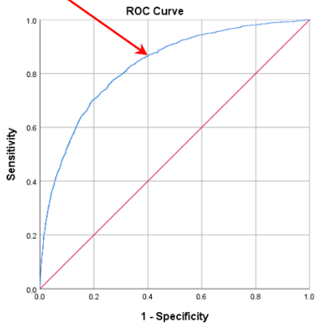

Figure S7e Example Receiver Operating Characteristic on test data for logistic regression 12mth all-cause mortality model M_copdcom using COPD-specific, demographic and comorbidity predictors with AUC (95% CI) = 0.829 (0.818 to 0.839). The arrow indicates the point corresponding to sensitivity = 86.6%, specificity = 60.0%, overall correct = 61.8%, positive predictive value = 14.1%, negative predictive value = 98.3%.
Table S7f Cox regression models
All-cause mortality (M) |  |  |  |  | All-cause hospitalisation (H)
Variable | B | p | HR |  | Variable | B | p | HR
age | 0.063 | <0.0001 | 1.07±.00 |  | age | 0.011 | <0.0001 | 1.01±.00
sexMale | 0.323 | <0.0001 | 1.38±.04 |  | sexMale | 0.136 | <0.0001 | 1.15±.02
mrc | 0.230 | <0.0001 | 1.26±.02 |  | mrc | 0.114 | <0.0001 | 1.12±.01
fev1pp | -0.009 | <0.0001 | 0.99±.00 |  | smokingYes | 0.059 | <0.0001 | 1.06±.02
smokingYes | 0.334 | <0.0001 | 1.40±.04 |  | bmi | -0.007 | <0.0001 | 0.99±.00
bmi | -0.031 | <0.0001 | 0.97±.00 |  | imd | 0.008 | 0.00606 | 1.01±.01
imd | 0.026 | <0.0001 | 1.03±.01 |  | haemoglobin | -0.005 | <0.0001 | 1.00±.00
haemoglobin | -0.008 | <0.0001 | 0.99±.00 |  | eosinophil | -0.122 | <0.0001 | 0.89±.04
eosinophil | -0.230 | <0.0001 | 0.80±.06 |  | n_exacs | 0.067 | <0.0001 | 1.07±.01
n_exacs | 0.046 | <0.0001 | 1.05±.01 |  | hosp_admns | 0.063 | <0.0001 | 1.07±.01
hosp_admns | 0.061 | <0.0001 | 1.06±.01 |  | nivoxyYes | 0.198 | <0.0001 | 1.22±.09
nivoxyYes | 0.681 | <0.0001 | 1.98±.16 |  | immunYes | 0.070 | <0.0001 | 1.07±.02
immunYes | -0.134 | <0.0001 | 0.88±.03 |  | diabetesYes | 0.086 | <0.0001 | 1.09±.02
diabetesYes | 0.193 | <0.0001 | 1.21±.04 |  | hypYes | 0.171 | <0.0001 | 1.19±.02
hypYes | 0.105 | <0.0001 | 1.11±.03 |  | liverYes | 0.228 | <0.0001 | 1.26±.06
liverYes | 0.358 | <0.0001 | 1.43±.10 |  | kidneyYes | 0.111 | <0.0001 | 1.12±.03
kidneyYes | 0.144 | <0.0001 | 1.16±.04 |  | anaemiaYes | 0.144 | <0.0001 | 1.16±.03
anaemiaYes | 0.201 | <0.0001 | 1.22±.04 |  | psychYes | 0.138 | <0.0001 | 1.15±.03
psychYes | 0.291 | <0.0001 | 1.34±.05 |  | frailYes | 0.170 | <0.0001 | 1.19±.04
frailYes | 0.224 | <0.0001 | 1.25±.06 |  | asthmaYes | 0.064 | <0.0001 | 1.07±.02
asthmaYes | -0.094 | <0.0001 | 0.91±.02 |  | cancerYes | 0.270 | <0.0001 | 1.31±.03
cancerYes | 0.139 | <0.0001 | 1.15±.03 |  | cvdYes | 0.208 | <0.0001 | 1.23±.03
cvdYes | 0.324 | <0.0001 | 1.38±.04 |  | mskelYes | 0.220 | <0.0001 | 1.25±.02
gerdYes | -0.112 | <0.0001 | 0.89±.04 |  | gerdYes | 0.189 | <0.0001 | 1.21±.03
All-cause mortality (M): Harrell’s concordance = 0.764 (SE=0.002), R squared = 0.259, Likelihood Ratio = 22290 24df, Wald = 22498 24df; All-cause hospitalisation (H): Harrell’s concordance = 0.640 (SE = 0.001), R squared = 0.149, Likelihood Ratio = 12000 24df, Wald = 13747 24df.

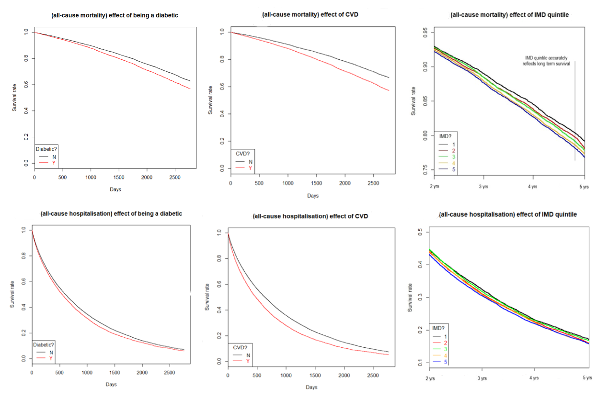

Figure S7f Survival curves from Cox regression models. Convex for the rarer, long-term mortality event and concave for hospitalisation.

ACG predictive modelling
For the simple hospitalisation model (H_acgstd), test data was fed to ACG and the resulting output was converted to CSV format, combined with the known hospitalisation status and read into SPSS in order to generate an ROC and AUC. Tailored regression models for mortality and hospitalisation (M_acgtld and H_acgtld) each required the consideration of all ACG outputs as candidate variables. As this consists of frailty and risk measures, various counts, 32 ADGs, ACG, RUB, 282 EDCs and 64 RxMGs a staged approach was used. Manual experimentation was combined with Akaike Information Criterion (AIC) based backward-elimination and factors considered were p-values, covariate coefficients, AIC and AUC on training data. Variables were considered in the following order.

- ‘Key variables’ (age, sex, hospital admission risk, RUB, frailty marker)
- Counts (hospital dominant count, number of chronic conditions etc.)
- Probability estimates
- Comorbidities
- ACG assignment
- ADGs (only considered if set in at least 5% of cases)
- Major EDCs
- Major RxMGs
- Further terms (non-linear and/or interactive variables)

References
1. Digital N. Attribution Data Set GP-Registered Populations Scaled to ONS Population Estimates. 2011.
2. Herrett E, Gallagher AM, Bhaskaran K, Forbes H, Mathur R, van Staa T, et al. Data Resource Profile: Clinical Practice Research Datalink (CPRD). Int J Epidemiol. 2015;44(3):827-36.
3. Ministry of Housing CLG. The English Indices of Deprivation 2019. 2019.
4. Medicines & Healthcare products Regulatory Agency. ONS death registration data and CPRD primary care data Documentation (Set 19). 2020.
5. NHS Digital. Hospital Episode Statistics (HES) 2020 [Available from: https://digital.nhs.uk/data-and-information/data-tools-and-services/data-services/hospital-episode-statistics.
6. Quanjer PH, Tammeling GJ, Cotes JE, Pedersen OF, Peslin R, Yernault J-C. Lung volumes and forced ventilatory flows. European Respiratory Journal. 1993;6(Suppl 16):5-40.

