Supplementary Figure 1 Combination of Dox with β-Elemene inhibited the proliferation and induced the apoptosis of U-2 OS/Dox cells. U-2 OS/Dox cells were treated with 5 μg/mL Dox or/and 25 μg/mL β-Elemene for 48 h. (A) CCK-8 assay was used to determine cell viability. (B) Apoptotic cells were measured by flow cytometry. **P < 0.01, compared with the control group; ##P < 0.01, compared with the Dox treatment group. Dox, doxorubicin; PI, propidium iodide; U-2 OS/Dox, Dox-resistant U-2 OS cells.
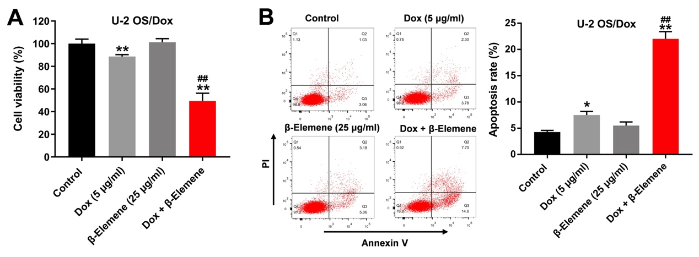
Supplementary Figure 2 Combination of Dox with β-Elemene inhibited the growth of Dox-resistant osteosarcoma cells via inhibiting p38 and ERK pathways. MG63/Dox and Saos-2/Dox cells were treated with β-Elemene (0, 25 or 50 μg/ml) for 48 h. (A) Expression levels of p-p38 and p-ERK in cells were detected with western blotting. β-actin was used as an internal control. (B, C) The relative expressions of p-p38 and p-ERK in cells were quantified via normalization to p38 and ERK. *P < 0.05, **P < 0.01, compared with the β-Elemene (0 μg/ml) group.
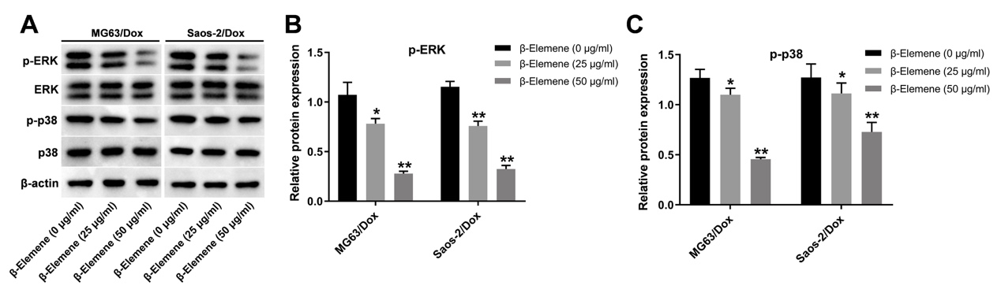
Supplementary Figure 3 Combination of Dox with β-Elemene could inhibit the angiogenesis in Saos-2/Dox xenograft in vivo. (A, B) CD31-MVD IHC staining was performed in tumor tissues. *P < 0.05, **P < 0.01, compared with the control group; ##P < 0.01, compared with the Dox treatment group. Dox, doxorubicin; IV, intravenous injection.
