Supporting information

SERS spectra of commonly used Raman reporter molecules 4-Aminothiophenol (4-ATP) and 2-Naphthalenethiol (2-NT) were tested onto the silver coated flexible Cellulose fibre (CF), as shown in Figure S1.
Fig. S1. Representative SERS spectra of (A) 4-Aminothiophenol (4-ATP) and (B) 2-Naphthalenethiol (2-NT).
For the fabrication of the plasmon active CF membrane substrate, we have explored different deposition conditions, such as varying the current and duration of silver deposition.
Figure S2, shows the silver deposition onto CF membrane at 10mA current and with different time duration.
Fig. S2. FE-SEM image of the CF SERS substrate fabricated by Ag deposition at 10 mA with varying deposition times, scale bar (in black) is 100 nm; A: 30 s; B: 40 s; C: 50 s; D: 60 s; E: 70 s; F: 80 s.

The evaluation of the resultant SERS substrates was characterized using Raman reporter molecule 2-NT to identify the best fabrication condition among the substrates tested. Based on the 2-NT performance, the 60 s silver deposition gave better SERS enhancement, as shown in Figure S3.
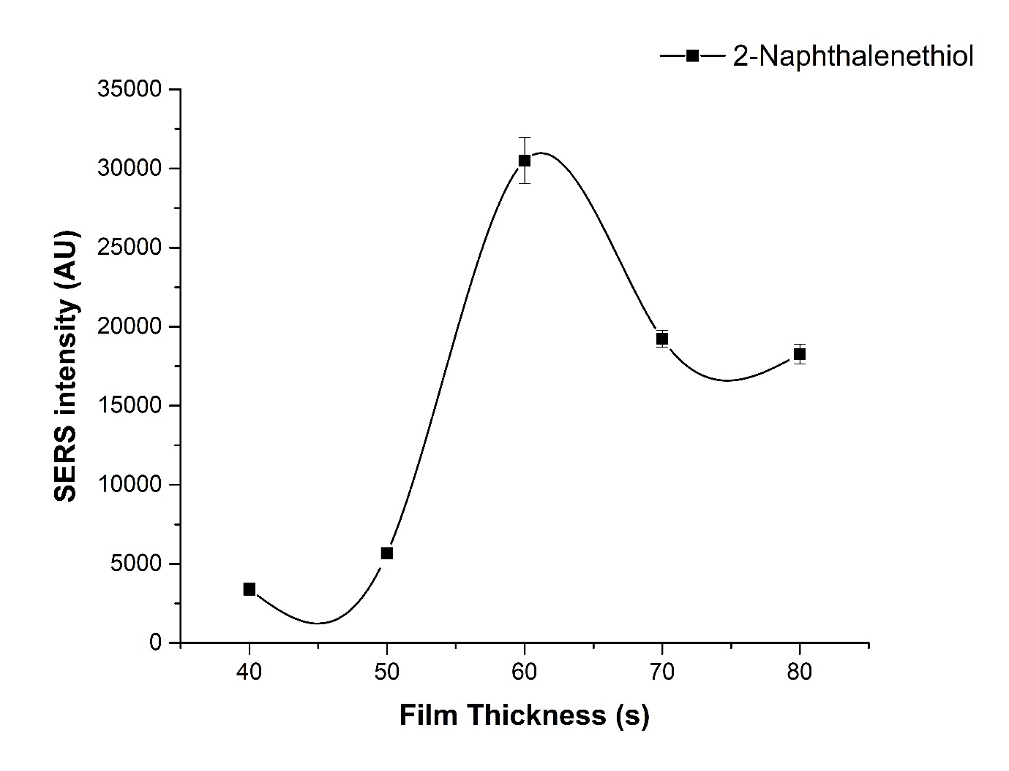
Fig. S3. Evaluation of ideal Ag deposition condition at 10 mA for the CF SERS substrate. This plot shows the maximum SERS signal enhancement that was obtained for the cellulose fibres SERS substrate.

In order to affirm the uniformity along the length of the as fabricated plasmon active flexible CF membrane, we have performed mapping large path of the substrate to see the variation in SERS enhancement across the large area. Figure S4, shows A) The optical view of the CF membrane (B) shows the mapping view overlaid on to the optical view. The bright red color represents the SERS intensity of representative Raman peak at 1066 cm⁻¹. SERS mapping shows minimum variation in SERS enhancement for 2NT on the flexible CF SERS substrate.

Figure S4: SERS mapping of 2NT on immobilised flexible CF membrane. (A) The optical view of the CF membrane and the (B) mapping view overlaid on the optical view. The bright red colour represents the SERS intensity of representative Raman peak at 1066 cm⁻¹. Scale bar; 200 µm.

We have used biofunctionalized CF membrane coated with 20 mA current and approximately 60 nm silver. Figure S5, shows the calibration plot for IL-1α and IL-1β surrogate indicators. Both calibration plots showed a good R² value of above 0.9.
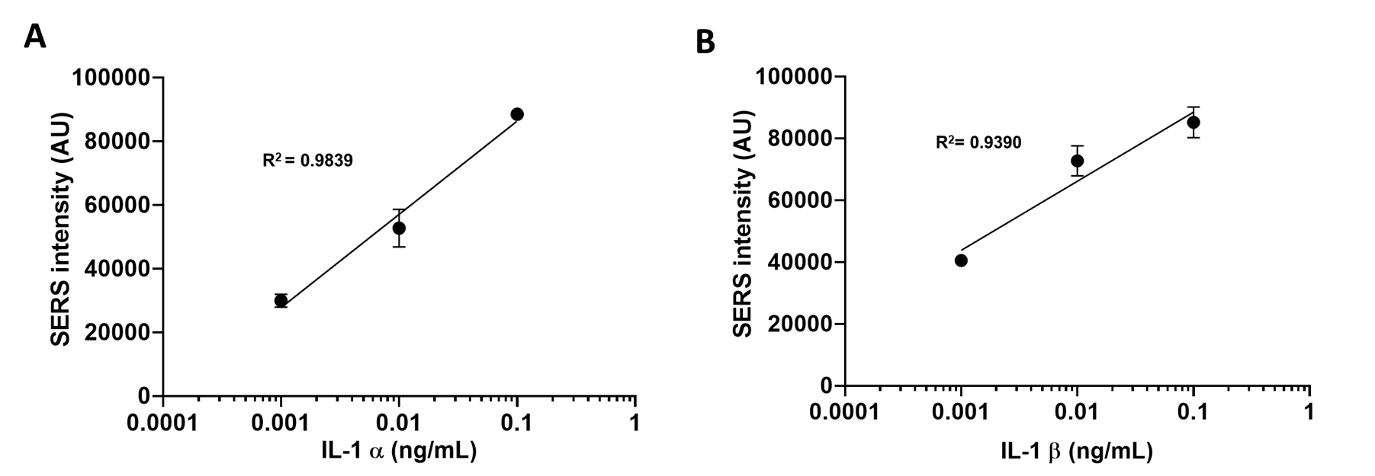
Fig. S5. Calibration plots of (A) IL-1α and (B) IL-1β surrogate indicators respectively.

