Supplementary Information

Figure S1. Estimation of sample size by G power software

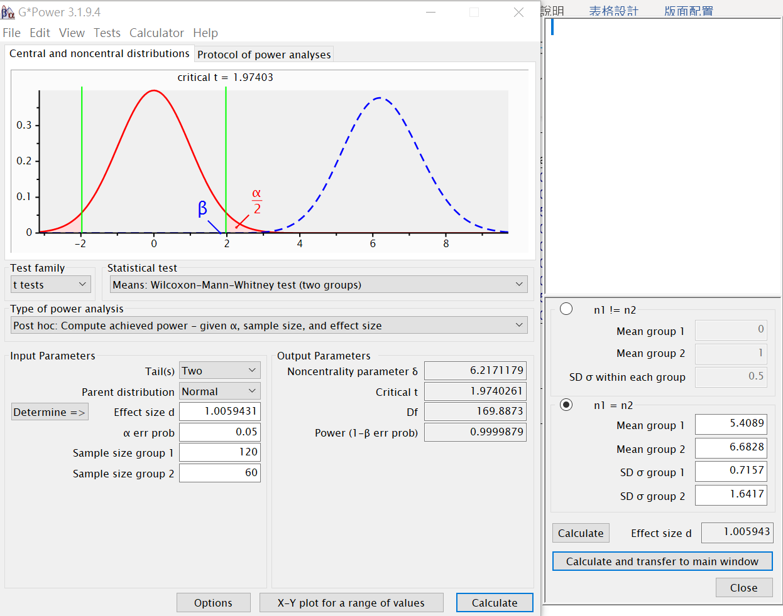

Table S1 The Expression of Circadian Clock Genes in Asthmatic Patients With and Without Night Symptoms

 | With Night Symptoms  (n = 53) |  | Without Night Symptoms  (n = 67)
Gene | Median (-ΔCt) | Average Rank | Median (-ΔCt) | Average Rank | P value
BMAL1 | -5.39 | 60.86 | -5.56 | 60.22 | 0.9200
CKIε | -9.24 | 60.47 | -9.15 | 60.52 | 0.9937
CLOCK | -7.99 | 62.59 | -7.97 | 58.84 | 0.5574
CRY1 | -10.88 | 65.71 | -10.74 | 56.38 | 0.1447
CRY2 | -7.08 | 60.87 | -7.02 | 60.21 | 0.9179
PER1 | -8.38 | 58.58 | -8.65 | 62.02 | 0.5898
PER2 | -7.74 | 59.97 | -7.8 | 60.92 | 0.8824
PER3 | -11.29 | 67.80 | -10.83 | 54.72 | 0.0408*
TIM | -9.41 | 63.61 | -9.16 | 58.04 | 0.3832

Note: The Median were calculated using the values of -ΔCt [–(Ct of Circadian clock gene – Ct of ACTB gene)]. Higher –ΔCt represents higher expression level, and vice versa. The P values indicated were evaluated with Mann-Whitney test. *P < 0.05

Table S2 Expression of Circadian Clock Genes in Well- and Not Well-controlled Asthmatic Patients With and Without Night Symptoms

 | Well controlled Asthma |  |  | Not-well controlled Asthma
Gene | With  Night Symptoms  (n = 16) | Without  Night Symptoms  (n = 44) | P value | With  Night Symptoms  (n = 16) | Without  Night Symptoms  (n = 44) | P value
BMAL1 | -5.93 (38.72) | -5.49 (26.76) | 0.0174* | -5.25 (26.93) | -5.65 (36.24) | 0.0447*
CKIε | -9.67 (39.22) | -9.04 (26.57) | 0.0119* | -8.98 (26.19) | -9.64 (37.43) | 0.0153*
CLOCK | -8.42 (37.75) | -7.89 (27.12) | 0.0345* | -7.65 (28.22) | -8.06 (34.17) | 0.1988
CRY1 | -11.14 (39.03) | -10.53 (26.64) | 0.0137* | -10.85 (28.45) | -10.97 (33.80) | 0.2478
CRY2 | -7.46 (37.69) | -6.75 (27.14) | 0.0360* | -6.88 (27.14) | -7.33 (35.91) | 0.0584
PER1 | -9.12 (40.00) | -8.10 (26.28) | 0.0064** | -7.95 (24.11) | -9.16 (40.78) | 0.0003**
PER2 | -8.03 (36.50) | -7.64 (27.58) | 0.0762 | -7.65 (26.77) | -7.96 (36.50) | 0.0359*
PER3 | -11.12 (36.63) | -10.77 (27.53) | 0.0707 | -11.34 (31.07) | -11.14 (29.59) | 0.7495
TIM | -9.48 (36.38) | -9.00 (27.62) | 0.0820 | -9.24 (29.16) | -9.33 (32.65) | 0.4517

Note: Data are expressed as median (average rank). Median was calculated using the values of -ΔCt [–(Ct of Circadian clock gene – Ct of ACTB gene)]. Higher –ΔCt represents higher expression level, and vice versa. The P values indicated were evaluated with Mann-Whitney test between patients without and with night symptoms. *P < 0.05 **P < 0.01

