Supplementary Materials
Supplementary Table 1. Performance of CAPTURE and COPD-Q for case finding or screening of spirometry-based impaired lung function

Questionnaire | Cutoff point | Performance index |  | Screening target
Questionnaire | Cutoff point | Performance index | Airflow limitation* (n=52) | PRISm** (n=419***) | PRISm with CAT≥10# |  | CAAT≥10 without PRISm/airflow limitation  (n=240) | PRISm with CAT≥7## (n=140)
 |  |  |  |  | Total (n=75) | Current smokers only  (n=38) | CAAT≥10 without PRISm/airflow limitation  (n=240) | PRISm with CAT≥7## (n=140)
CAPTURE | Positive≥2 | Sensitivity | 0.25 | 0.25 | 0.49 | 0.50 | 0.45 | 0.40
CAPTURE | Positive≥2 | Specificity | 0.81 | 0.83 | 0.82 | 0.84 | 0.84 | 0.83
CAPTURE | Positive≥2 | PPV | 0.03 | 0.23 | 0.08 | 0.13 | 0.24 | 0.12
CAPTURE | Positive≥2 | NPV | 0.98 | 0.84 | 0.98 | 0.97 | 0.93 | 0.96
CAPTURE | Positive≥2 | Accuracy | 0.80 | 0.73 | 0.81 | 0.82 | 0.80 | 0.80
CAPTURE | Positive≥1 | Sensitivity | 0.65 | 0.53 | 0.72 | 0.69 | 0.75 | 0.66
CAPTURE | Positive≥1 | Specificity | 0.54 | 0.55 | 0.55 | 0.52 | 0.57 | 0.55
CAPTURE | Positive≥1 | PPV | 0.03 | 0.19 | 0.05 | 0.07 | 0.16 | 0.08
CAPTURE | Positive≥1 | NPV | 0.99 | 0.85 | 0.98 | 0.97 | 0.95 | 0.96
CAPTURE | Positive≥1 | Accuracy | 0.54 | 0.54 | 0.55 | 0.52 | 0.58 | 0.55
CAPTURE | ROC-AUC | AUC | 0.59 | 0.55 | 0.69 | 0.68 | 0.66 | 0.64
CAPTURE | ROC-AUC | 95% CI | 0.52, 0.67 | 0.52, 0.58 | 0.62, 0.75 | 0.61, 0.76 | 0.63, 0.69 | 0.59, 0.69
COPD-Q | Positive≥4 | Sensitivity | 0.35 | 0.22 | 0.28 | 0.48 | 0.23 | 0.24
COPD-Q | Positive≥4 | Specificity | 0.87 | 0.89 | 0.87 | 0.72 | 0.88 | 0.87
COPD-Q | Positive≥4 | PPV | 0.05 | 0.29 | 0.06 | 0.08 | 0.17 | 0.10
COPD-Q | Positive≥4 | NPV | 0.98 | 0.85 | 0.97 | 0.97 | 0.91 | 0.95
COPD-Q | Positive≥4 | Accuracy | 0.86 | 0.77 | 0.85 | 0.70 | 0.81 | 0.83
COPD-Q | Positive≥3 | Sensitivity | 0.56 | 0.44 | 0.59 | 0.76 | 0.48 | 0.47
COPD-Q | Positive≥3 | Specificity | 0.68 | 0.71 | 0.69 | 0.43 | 0.70 | 0.69
COPD-Q | Positive≥3 | PPV | 0.04 | 0.24 | 0.06 | 0.06 | 0.15 | 0.08
COPD-Q | Positive≥3 | NPV | 0.99 | 0.86 | 0.98 | 0.97 | 0.93 | 0.96
COPD-Q | Positive≥3 | Accuracy | 0.68 | 0.66 | 0.68 | 0.43 | 0.67 | 0.67
COPD-Q | Positive≥2 | Sensitivity | 0.83 | 0.66 | 0.83 | 0.93 | 0.74 | 0.78
COPD-Q | Positive≥2 | Specificity | 0.40 | 0.41 | 0.41 | 0.14 | 0.42 | 0.41
COPD-Q | Positive≥2 | PPV | 0.03 | 0.19 | 0.04 | 0.05 | 0.12 | 0.07
COPD-Q | Positive≥2 | NPV | 0.99 | 0.86 | 0.99 | 0.98 | 0.94 | 0.97
COPD-Q | Positive≥2 | Accuracy | 0.41 | 0.45 | 0.42 | 0.17 | 0.44 | 0.43
COPD-Q | ROC-AUC | AUC | 0.67 | 0.58 | 0.68 | 0.67 | 0.58 | 0.63
COPD-Q | ROC-AUC | 95% CI | 0.59, 0.75 | 0.55, 0.61 | 0.62, 0.74 | 0.60, 0.73 | 0.55, 0.61 | 0.59, 0.68

Airflow limitation, FEV₁/FVC <0.7; **PRISm, FEV₁/FVC≥0.7 and %FEV₁<80%; ***Data from 1 patient in the PRISm group (n=420) was missing CAAT scores, therefore this patient data was excluded from the ROC analysis; #PRISm with CAT≥10; PRISm with CAT total score≥10; ##PRISm with CAT≥7; PRISm with CAT total score≥7.
Accuracy, true positives and true negatives divided by the total number of responses; CAAT, chronic airways assessment test; CAPTURE, COPD Assessment in Primary Care to Identify Undiagnosed Respiratory Disease and Exacerbation Risk; CAT, COPD Assessment Test; CI, confidence interval; COPD, chronic obstructive pulmonary disease; COPD-Q, COPD screening questionnaire; FEV₁, forced expiratory volume in 1 second; FVC, forced vital capacity; NPV, negative predictive value; PPV, positive predictive value; PRISm, Preserved Ratio Impaired Spirometry; ROC-AUC, area under the Receiver Operating Characteristic curve
Supplementary Table 2. Performance of CAPTURE and COPD-Q by gender for case finding or screening of spirometry-based impaired lung function
Questionnaire | Cutoff point | Performance index | Screening target
Questionnaire | Cutoff point | Performance index | Airflow limitation* (n=52) |  | PRISm** (n=419***) |  | PRISm with CAT≥10# (n=75) |  | CAAT≥10 without PRISm/airflow limitation (n=240)
Questionnaire | Cutoff point | Performance index | Males only (n=30) | Females only (n=22) | Males only (n=296) | Females only (n=123) | Males only (n=55) | Females only (n=20) | Males only (n=115) | Females only (n=125)
CAPTURE | Positive≥2 | Sensitivity | 0.33 | 0.14 | 0.24 | 0.28 | 0.49 | 0.50 | 0.44 | 0.46
CAPTURE | Positive≥2 | Specificity | 0.82 | 0.81 | 0.83 | 0.82 | 0.83 | 0.82 | 0.84 | 0.85
CAPTURE | Positive≥2 | PPV | 0.04 | 0.01 | 0.29 | 0.17 | 0.11 | 0.05 | 0.20 | 0.28
CAPTURE | Positive≥2 | NPV | 0.98 | 0.98 | 0.80 | 0.90 | 0.97 | 0.99 | 0.94 | 0.93
CAPTURE | Positive≥2 | Accuracy | 0.80 | 0.80 | 0.70 | 0.77 | 0.81 | 0.81 | 0.80 | 0.81
CAPTURE | Positive≥1 | Sensitivity | 0.70 | 0.59 | 0.53 | 0.52 | 0.71 | 0.75 | 0.74 | 0.75
CAPTURE | Positive≥1 | Specificity | 0.54 | 0.54 | 0.56 | 0.55 | 0.55 | 0.55 | 0.56 | 0.58
CAPTURE | Positive≥1 | PPV | 0.03 | 0.02 | 0.25 | 0.13 | 0.06 | 0.03 | 0.14 | 0.19
CAPTURE | Positive≥1 | NPV | 0.99 | 0.99 | 0.81 | 0.90 | 0.98 | 0.99 | 0.96 | 0.95
CAPTURE | Positive≥1 | Accuracy | 0.54 | 0.54 | 0.55 | 0.54 | 0.55 | 0.55 | 0.57 | 0.60
CAPTURE | ROC-AUC | AUC | 0.62 | 0.57 | 0.54 | 0.54 | 0.68 | 0.70 | 0.65 | 0.67
CAPTURE | ROC-AUC | 95% CI | 0.53, 0.71 | 0.46, 0.67 | 0.51, 0.57 | 0.49, 0.58 | 0.61, 0.76 | 0.58, 0.83 | 0.61, 0.69 | 0.62, 0.71
COPD-Q | Positive≥4 | Sensitivity | 0.43 | 0.23 | 0.27 | 0.10 | 0.33 | 0.15 | 0.32 | 0.15
COPD-Q | Positive≥4 | Specificity | 0.81 | 0.94 | 0.83 | 0.95 | 0.81 | 0.94 | 0.82 | 0.95
COPD-Q | Positive≥4 | PPV | 0.05 | 0.07 | 0.31 | 0.20 | 0.07 | 0.05 | 0.14 | 0.30
COPD-Q | Positive≥4 | NPV | 0.98 | 0.98 | 0.80 | 0.89 | 0.97 | 0.98 | 0.93 | 0.90
COPD-Q | Positive≥4 | Accuracy | 0.8 | 0.93 | 0.71 | 0.85 | 0.79 | 0.93 | 0.77 | 0.86
COPD-Q | Positive≥3 | Sensitivity | 0.63 | 0.45 | 0.51 | 0.28 | 0.62 | 0.5 | 0.60 | 0.38
COPD-Q | Positive≥3 | Specificity | 0.6 | 0.78 | 0.63 | 0.79 | 0.61 | 0.78 | 0.62 | 0.80
COPD-Q | Positive≥3 | PPV | 0.03 | 0.04 | 0.28 | 0.14 | 0.06 | 0.04 | 0.13 | 0.19
COPD-Q | Positive≥3 | NPV | 0.99 | 0.99 | 0.82 | 0.90 | 0.97 | 0.99 | 0.94 | 0.91
COPD-Q | Positive≥3 | Accuracy | 0.6 | 0.77 | 0.6 | 0.73 | 0.61 | 0.77 | 0.61 | 0.75
COPD-Q | Positive≥2 | Sensitivity | 0.9 | 0.73 | 0.71 | 0.53 | 0.89 | 0.65 | 0.83 | 0.66
COPD-Q | Positive≥2 | Specificity | 0.34 | 0.47 | 0.36 | 0.47 | 0.35 | 0.47 | 0.36 | 0.49
COPD-Q | Positive≥2 | PPV | 0.03 | 0.03 | 0.24 | 0.11 | 0.06 | 0.02 | 0.11 | 0.14
COPD-Q | Positive≥2 | NPV | 0.99 | 0.99 | 0.82 | 0.89 | 0.99 | 0.99 | 0.96 | 0.92
COPD-Q | Positive≥2 | Accuracy | 0.36 | 0.48 | 0.43 | 0.48 | 0.37 | 0.47 | 0.40 | 0.50
COPD-Q | ROC-AUC | AUC | 0.62 | 0.60 | 0.54 | 0.50 | 0.67 | 0.63 | 0.60 | 0.57
COPD-Q | ROC-AUC | 95% CI | 0.57, 0.68 | 0.50, 0.69 | 0.51, 0.57 | 0.46, 0.55 | 0.60, 0.73 | 0.50, 0.77 | 0.56, 0.63 | 0.53, 0.62

*Airflow limitation, FEV₁/FVC <0.7; **PRISm, FEV₁/FVC≥0.7 and %FEV₁<80%; ***Data from 1 patient in the PRISm group (n=420) was missing CAAT scores, therefore this patient data was excluded from the ROC analysis; #PRISm with CAT≥10; PRISm with CAT total score≥10; ##PRISm with CAT≥7; PRISm with CAT total score≥7.
Accuracy, true positives and true negatives divided by the total number of responses; CAAT, chronic airways assessment test; CAPTURE, COPD Assessment in Primary Care to Identify Undiagnosed Respiratory Disease and Exacerbation Risk; CAT, COPD Assessment Test; CI, confidence interval; COPD, chronic obstructive pulmonary disease; COPD-Q, COPD screening questionnaire; FEV₁, forced expiratory volume in 1 second; FVC, forced vital capacity; NPV, negative predictive value; PPV, positive predictive value; PRISm, Preserved Ratio Impaired Spirometry; ROC-AUC, area under the Receiver Operating Characteristic curve Undiagnosed Respiratory Disease and Exacerbation Risk; CAT, COPD Assessment Test; CI, confidence interval; COPD, chronic obstructive pulmonary disease; COPD-Q, COPD screening questionnaire; FEV₁, forced expiratory volume in 1 second; FVC, forced vital capacity; NPV, negative predictive value; PPV, positive predictive value; PRISm, Preserved Ratio Impaired Spirometry; ROC-AUC, area under the Receiver Operating Characteristic curve
Questionnaires used in the OCEAN study
The CAPTURE Questionnaire
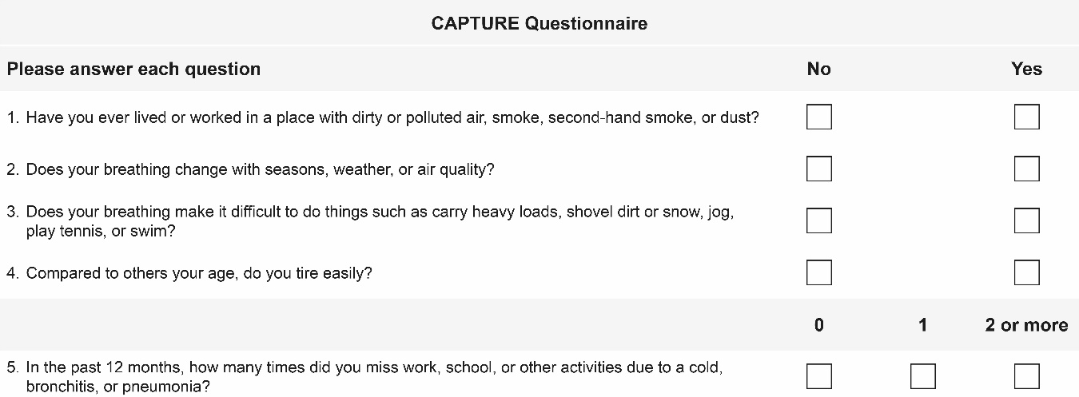
Note: Copyright ©2018. Dove Medical Press. Reproduced from Leidy NK, Martinez FJ, Malley KG, et al. Can CAPTURE be used to identify undiagnosed patients with mild-to-moderate COPD likely to benefit from treatment? Int J Chron Obstruct Pulmon Dis. 2018;13:1901-1912.¹
The COPD-Q Questionnaire
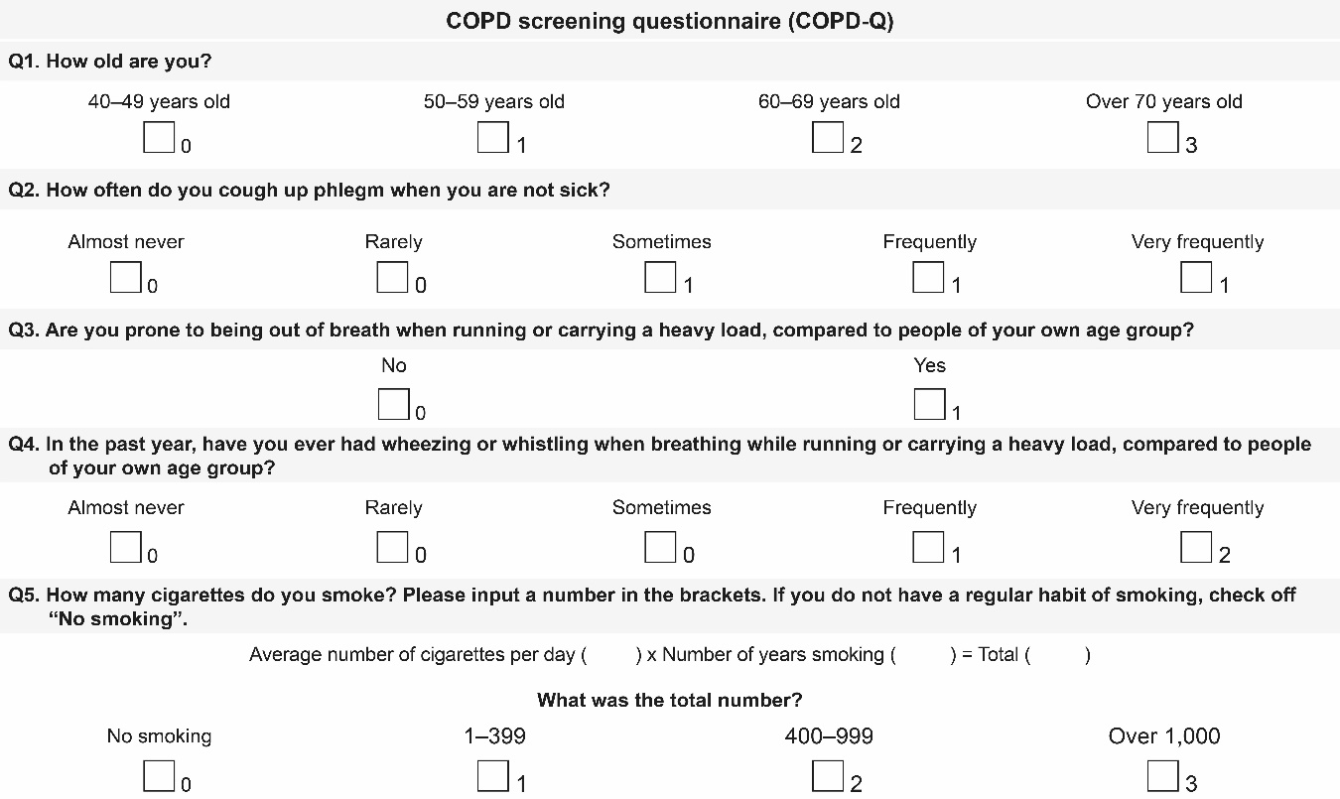
Note: Copyright ©2017. Dove Medical Press. Reproduced from Samukawa T, Matsumoto K, Tsukuya G, et al. Development of a self-scored persistent airflow obstruction screening questionnaire in a general Japanese population: the Hisayama study. Int J Chron Obstruct Pulmon Dis. 2017;12:1469-1481.²
CAAT³

Example:
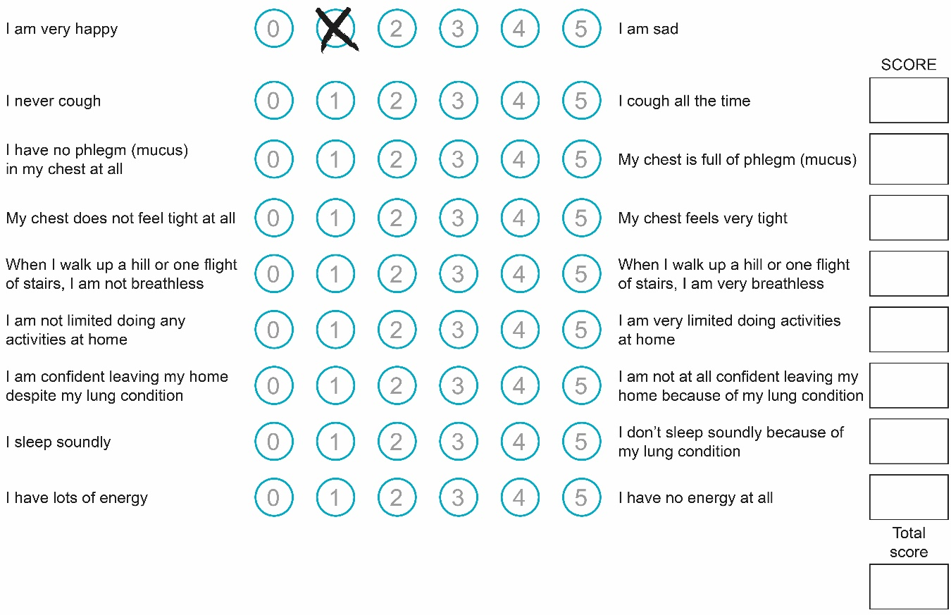
Used with permission of European Respiratory Society, from Jones PW, Harding G, Berry P, Wiklund I, Chen WH, Kline Leidy N. Development and first validation of the COPD Assessment Test. Eur Respir J. 2009;34(3):648-654; © ERS Journals Ltd; permission conveyed through Copyright Clearance Center, Inc.³

PROMIS Item Bank v 2.0 – Physical Function - Short Form 4a⁴

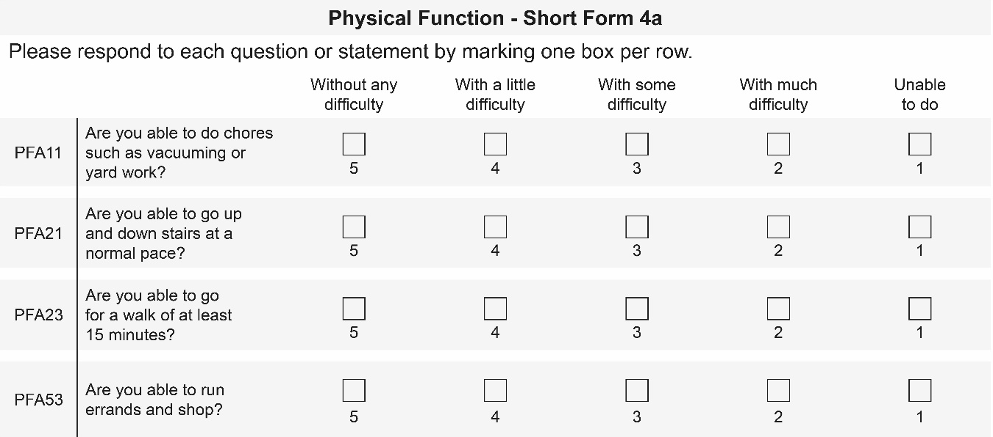

Figure showing questions from PROMIS Short Form v2.0 - Physical Function 4a. Reproduced with permission from PROMIS Health Organization and PROMIS Cooperative Group. First reported in Cella D, Choi SW, Condon DM, et al. PROMIS(®) Adult Health Profiles: Efficient Short-Form Measures of Seven Health Domains. Value Health. 2019;22(5):537-544. © 2019 ISPOR-The Professional Society for Health Economics and Outcomes Research. Published by Elsevier Inc.⁴
Study-specific questionnaire

History of Respiratory Diseases
Please select “Yes” or “No” to each question.
1. Have you ever been diagnosed with chronic bronchitis (excluding pneumonia and acute bronchitis)? – “Yes”, “No”
a) If Yes, are you currently receiving treatment for chronic bronchitis? “Yes”, “No”
2. Have you ever been diagnosed with pulmonary emphysema? - “Yes”, “No”
a) If Yes, are you currently receiving treatment for pulmonary emphysema? “Yes”, “No”
3. Have you ever been diagnosed with Chronic Obstructive Pulmonary Disease (COPD)? – “Yes”, “No”
a) If Yes, are you currently receiving treatment for COPD? “Yes”, “No”
4. Have you ever been diagnosed with other respiratory diseases? – “Yes”, “No”
a) If Yes, are you currently receiving treatment for the respiratory disease? – “Yes”, “No”
b) If Yes, what respiratory disease was it? ________________________________

History of Respiratory Symptoms
Please select “Yes” or “No” to each question.
5. Do you have a sputum continuing more than 3 months? - “Yes”, “No”
b) If Yes, did the sputum (which continued more than 3 months) last 2 years? - “Yes”, “No”
6. Do you have a cough continuing more than 3 months? - “Yes”, “No”
b) If Yes, did the cough (which continued more than 3 months) last 2 years? - “Yes”, “No”

History of Asthma
Please select “Yes” or “No” to each question.
7. During the past 12 months, have you had more than 1 episode of waking up at night or early morning as a result of spasmodic breathlessness even when you didn’t have a cold? - “Yes”, “No”
8. During the past 12 months, have you had more than 1 episode of waking up at night or early morning as a result of wheezing or whistling in the chest even when you did not have a cold? – “Yes”, “No”
9. Have you ever been diagnosed with asthma? – “Yes”, “No”
c) If “Yes”, are you currently receiving treatment for asthma? - “Yes”, “No”
d) How old were you when you had your first attack of asthma? - XX Years

History of use of bronchodilators
Please select “Yes” or “No” to the question.
10. Are you currently taking any bronchodilators (in inhalers or aerosols) for the treatment of respiratory diseases (such as asthma, COPD, chronic bronchitis, pulmonary emphysema)? – “Yes”, “No”

Smoking History
Please select “Never”, “Past” or “Current”.
11. Have you ever smoked a cigarette? – “Never”, “In the Past”, “Current Smoker” If “In the Past” or “Current Smoker”, please answer the following 2 questions.
- a) How many years did you smoke, or have you been smoking? – xx years
- b) How many cigarettes per day did you smoke or are you smoking? – xx cigarettes

History of Pulmonary Rehabilitation
12. Have you been prescribed a course of pulmonary rehabilitation within the last 2 years? Y/N
b) If Yes, did you complete the course? Y/N
13. Compared to the last 1 year, do you think that you have lost weight? Y/N
b) If yes, was this unintended? Y/N
Health exam questionnaire
Age:
Gender:

Item | Medicines you are currently taking |  | 1 | Hypertension drug | Yes No
Item |  |  | 2 | Insulin injection or hypoglycemic drug | Yes No
Item |  |  | 3 | Cholesterol-lowering drug | Yes No
Item | 4 | Have you ever been told that you are suffering from a stroke (cerebral hemorrhage, cerebral infarction, etc) from a doctor or received treatment? |  |  | Yes No
Item | 5 | Have you been told that your doctor is suffering from heart disease (angina, myocardial infarction, etc), have you been treated? |  |  | Yes No
Item | 6 | Have you ever been told by a doctor that you are suffering from chronic kidney failure or has undergone treatment (artificial dialysis)? |  |  | Yes No
Item | 7 | Have you ever been told by your doctor that you are anemic? |  |  | Yes No
Item | 8 | I am currently smoking cigarettes habitually. |  |  | Yes No
Item | 9 | It has increased by 10 kg or more from the weight at the age of 20. |  |  | Yes No
Item | 10 | I have exercised a light sweat of over 30 minutes over two days a week for more than 1 year. |  |  | Yes No
Item | 11 | In daily life, I am carrying out walking or equivalent physical activity more than an hour a day. |  |  | Yes No
Item | 12 | I walk at a faster rate compared to person who is same sex and almost same age. |  |  | Yes No
Item | 13 | I have had more than 3 kg of weight gain or lose in the past one year. |  |  | Yes No
Item | 14 | I eat faster than other people. |  |  | Fast Normal Slow
Item | 15 | I have dinner within 2 hours before going to bed three or more times a week. |  |  | Yes No
Item | 16 | I have snacking after dinner (snacks other than 3 meals) three or more times a week. |  |  | Yes No
Item | 17 | I have not had breakfast more than three times a week. |  |  | Yes No
Item | 18 | Frequency of drinking alcohol |  |  | Every day Sometimes Not drink
Item | 19 | Drinking amount  (1 GOU = beer 500mL or wine 240mL) |  |  | Less than 1 GOU 1 -2 GOU  2-3 GOU more than 3 GOU
Item | 20 | I have enough rest for sleep. |  |  | Yes No
Item | 21 | Do you think to improve lifestyle such as exercise and eating habits? |  |  | No interest Planning within 6 months  Planning within 1 month or starting Already started (less than 6 months) Already started (more than 6  months)
Item | 22 | Do you use if you have opportunity to receive health guidance on improving lifestyle habits? |  |  | Yes No
Item | 23 | (Question to women) Are you in the menstruation period? |  |  | Yes No

Mandatory exam. | Blood  pressure | / mmHg |  | Condition of  blood sampling | Fasting After meal (hr)
Mandatory exam. | Physical measurement | Height | cm | Urinalysis | Urine sugar | -  +- 1+  2+  3+  4+ | Occult blood | -  +- 1+  2+  3+  4+
Mandatory exam. | Physical measurement | Weight | kg
Mandatory exam. | Physical measurement | West size | cm
Mandatory exam. | General consultation | Heart murmur Abnormal breathing sound Cyanosis  Anemic symptom Abdominal palpation abnormality Movement disorder Arrhythmia edema jaundice  Disorder abnormality Reflection abnormality Sensory disorder  Thyroid hypertrophy Other findings ( )

References
- Leidy NK, Martinez FJ, Malley KG, et al. Can CAPTURE be used to identify undiagnosed patients with mild-to-moderate COPD likely to benefit from treatment? Int J Chron Obstruct Pulmon Dis. 2018;13:1901-1912.
- Samukawa T, Matsumoto K, Tsukuya G, et al. Development of a self-scored persistent airflow obstruction screening questionnaire in a general Japanese population: the Hisayama study. Int J Chron Obstruct Pulmon Dis. 2017;12:1469-1481.
- Jones PW, Harding G, Berry P, Wiklund I, Chen WH, Kline Leidy N. Development and first validation of the COPD Assessment Test. Eur Respir J. 2009;34(3):648-654.
- Cella D, Choi SW, Condon DM, et al. PROMIS(®) Adult Health Profiles: Efficient Short-Form Measures of Seven Health Domains. Value Health. 2019;22(5):537-544.

