Supplementary materials:
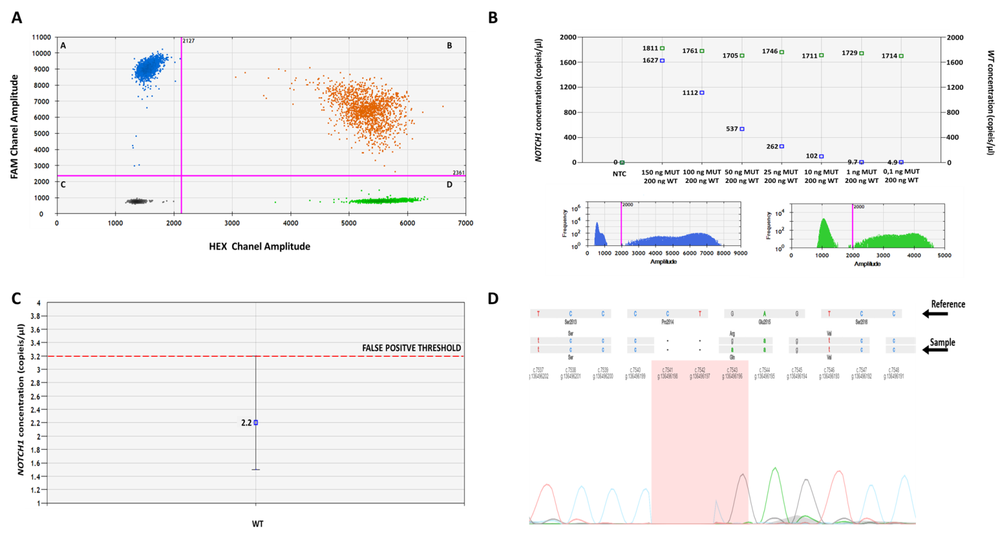
Figure S1. Determination of the limit of detection of droplet digital (ddPCR) method in the NOTCH1^{mut} assessment. (A) A two-dimensional (2D) example of NOTCH1 gene mutation analysis by ddPCR. The analysis is displayed as a plot in which FAM fluorescence (NOTCH1^{mut}) is plotted versus HEX fluorescence (NOTCH1^{wt}) for each droplet. DNA is distributed into the droplets follows a random pattern; the droplets are clustered into four groups. A - FAM positive droplets are a representation of NOTCH1^{mut} droplets according to the fluorophore threshold indicated in magenta lines. B - FAM/HEX positive droplets are a representation of NOTCH1^{mut} and NOTCH1^{wt} droplets. C - Negative droplets are a representative of droplets with no fluorescence in any channel. D - HEX positive droplets are a representation of NOTCH1^{wt} droplets only. The results were calculated as a percentage ratio of copies containing the mutation in comparison to all detected copies (fractional abundance - FA). The analysis was performed using the QuantaSoft v1.7.4.Software. (B) Determination of the detection limit. To determine the limit of detection of the ddPCR method in the NOTCH1^{mut} assessment, we used a plurality of plasmid dilutions containing NOTCH1^{mut} insert in a constant amount of NOTCH1^{wt}. Blue squares - NOTCH1^{wt} template concentration in copies per μL, Green squares - NOTCH1^{mut} concentration in copies per μL. NTC- no template control. The limit of detection was defined as 2.2 copies per µl. The analysis was performed using the QuantaSoft v1.7.4.Software. (C) Assessment of the false positive threshold. The arithmetic mean of mutant concentration was assessed from all control wells and the false-positive threshold was determined as the upper limit of the mutant concentration error bars of the NOTCH1^{wt} control. The false-positive threshold was determined as upper that 3,2 copies of NOTCH1^{mut} per μL. Blue square - NOTCH1^{mut} concentration in copies per μL. Dashed line – the false positive threshold of NOTCH1^{mut}. The reproducibility of the method has been confirmed as three independent repetitions of the ddPCR. (D) Sanger sequencing analysis of NOTCH1^{mut} carrying fragment. To confirm mutation NOTCH1 c.7541_ 7542delCT occurred in the PEST domain (exon 34) in carrying fragment, Sanger sequencing analysis was performed. The insert sequence was compared with the reference sequence. Sequencing peaks analysis indicates the presence of c.7541_ 7542delCT mutation in the NOTCH1 gene The analysis was performed based on the NCBI Reference Sequence: NM_017617.4 using the web-based GLASS tool (http://bat.infspire.org/genomepd/glass/).

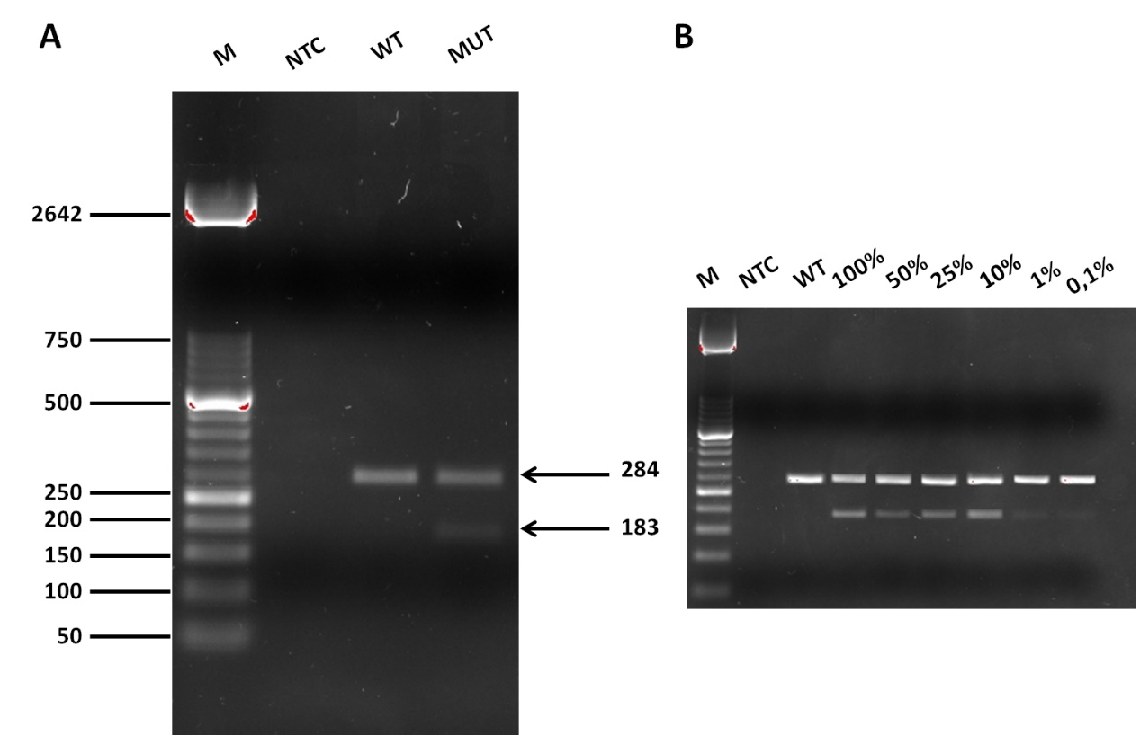

Figure S2. (A)Amplification refractory mutation system (ARMS-PCR) analysis of NOTCH1^{mut}. Sample of NOTCH1^{wt} shows a band of 284bp. The presence of the two bands, including 284 bp as well as 183 bp indicates the presence of NOTCH1^{mut}. For no template control (NTC) was water instead of DNA sample was used. Molecular weight (M) is DNA Molecular Weight Marker XIII 50 bp ladder (Roche, Basel, Switzerland). (B) NOTCH1^{mut} limit of detection in ARMS-PCR. Series dilutions of mutated DNA in wild type DNA as a background was performed. Dilutions contained 100%, 50%, 25%,10%, 1% and 0,1% of DNA with Notch1 mutation, respectively were separated on an agarose gel. he bands obtained from dilutions containing 1% and 0.1% of DNA were weak, which did not allow for a correct mutation determination.

