ORIGINAL RESEARCH
Moritz E et al.
Online Supplement
Increased sphingosine-1-phosphate serum concentrations in subjects with periodontitis: a matter of inflammation

Eileen Moritz*^{1,2}, Gabriele Jedlitschky*¹, Josefine Negnal¹, Mladen V. Tzvetkov¹, Günter Daum^{3,4}, Marcus Dörr^{2,5}, Stephan B. Felix^{2,5}, Henry Völzke^{2,6}, Matthias Nauck^{2,7}, Edzard Schwedhelm^{4,8}, Peter Meisel⁹, Thomas Kocher⁹, Bernhard H. Rauch*^{1,2}, Birte Holtfreter*⁹
*equal contribution
¹Institute of Pharmacology, Department of General Pharmacology, University Medicine Greifswald, Germany; ²German Center for Cardiovascular Research (DZHK), Partner Site Greifswald, Germany; ³Clinic and Polyclinic for Vascular Medicine, University Heart Center, University Medical Center Hamburg-Eppendorf, Germany; ⁴German Center for Cardiovascular Research (DZHK), Partner Site Hamburg/Kiel/Lübeck, Germany; ⁵Department of Internal Medicine B, University Medicine Greifswald, Germany; ⁶Institute for Community Medicine, University Medicine Greifswald, Germany; ⁷Institute of Clinical Chemistry and Laboratory Medicine, University Medicine Greifswald, Germany; ⁸Institute of Clinical Pharmacology and Toxicology, University Medical Center Hamburg-Eppendorf, Germany; ⁹Dental Clinics, Department of Periodontology, University Medicine Greifswald, Greifswald, Germany.

Correspondence: Prof. Dr. med. Bernhard H. Rauch
University Medicine Greifswald,
Institute of Pharmacology, Department of General Pharmacology,
Felix-Hausdorff-Straße 3, 17487 Greifswald, Germany.
Tel: +49 (0)3834 - 86 56 50
Fax: +49 (0)3834 - 86 56 31
Email: Bernhard.Rauch@med.uni-greifswald.de

Supplemental Table 1. Unadjusted concentrations of sphingosine-1-phosphate and high-sensitive C-reactive protein in subgroups of CDC/AAP case definition and number of teeth.
Periodontitis variables | N | Sphingosine-1-phosphate, nmol/L | P value | N | High-sensitivity C-reactive protein [mg/L] | P value
CDC/AAP definition
no or mild (Ref.) | 1511 | 802.6 (687.6; 917.7) | 0.97* | 1406 | 1.12 (0.57; 2.53) | 0.0001*
moderate | 1087 | 801.2 (689.1; 926.7) | 1.00** | 1047 | 1.31 (0.72; 2.92) | 0.0008**
severe | 521 | 800.8 (676.1; 923.9) | 1.00** | 503 | 1.33 (0.77; 3.07) | 0.0004**
Number of teeth
28 (Ref.) | 677 | 790.8 (685.9; 897.7) | 0.0001* | 629 | 1.06 (0.58; 2.53) | 0.0001*
20-27 | 2032 | 801.3 (690.4; 919.9) | 1.00** | 1929 | 1.20 (0.64; 2.56) | 0.34**
10-19 | 664 | 778.1 (656.1; 914.5) | 0.26** | 633 | 1.58 (0.83; 3.38) | 0.0004**
1-9 | 405 | 737.7 (625.5; 885.9) | 0.0004** | 385 | 1.94 (1.06; 4.22) | 0.0004**
0 | 264 | 752.7 (645.5; 851.1) | 0.0004** | 253 | 1.97 (0.93; 4.39) | 0.0004**

Data are presented as median (25%; 75% quantile). * p value for comparison across all groups using the Kruskal-Wallis-test; ** p values for pairwise comparisons versus reference group (Ref.) using Mann-Whitney U tests corrected for multiple testing (Bonferroni). CDC/AAP, Centers for Disease Control and Prevention/American Academy of Periodontology; N, number.

Supplemental Table 2. Results from linear regression models analyzing the association between periodontitis variables and sphingosine-1-phosphate serum levels (continuously modelled) in subjects aged 20-59 years.
 |  | Model 1,  adjusted for age and gender |  | Model 2,  fully adjusted
Periodontitis variables | N | B (95% CI) | P value | B (95% CI) | P value
Mean PD, mm | 2383 | 14.67 (2.54; 26.80) | 0.02 | 11.50 (-1.41; 24.41) | 0.08
Percentage of sites with PD 3+mm, % | 2383 | 5.11 (1.71; 8.50) | 0.003 | 4.18 (0.56; 7.82) | 0.02
Percentage of sites with PD 4+mm, % | 2383 | 4.95 (0.76; 9.15) | 0.02 | 3.78 (-0.71; 8.27) | 0.10
Mean CAL, mm | 2331 | 8.04 (2.04; 14.04) | 0.009 | 5.74 (-0.57; 12.06) | 0.08
Percentage of sites with CAL 3+mm, % | 2331 | 4.52 (1.74; 7.31) | 0.001 | 3.46 (0.52; 6.39) | 0.02
Percentage of sites with CAL 4+mm, % | 2331 | 4.54 (1.20; 7.88) | 0.008 | 3.35 (-0.18; 6.88) | 0.06
CDC/AAP case definition | 2305
no or mild | 1357 | 0.00 (Ref.) |  | 0.00 (Ref.)
moderate | 663 | 18.57 (1.31; 35.83) | 0.04 | 13.45 (-4.09; 31.00) | 0.13
severe | 285 | 21.67 (-2.62; 45.96) | 0.08 | 13.20 (-11.94; 38.34) | 0.30
 |  | P_{trend}=0.03 |  | P_{trend}=0.16

Model 2 was adjusted for age (cubic splines with 3 knots), gender, school education, smoking status combined with pack-years, waist-to-hip-ratio, known diabetes mellitus and HbA1c. PD, probing depth; CAL, clinical attachment loss; CDC/AAP, Centers for Disease Control and Prevention/American Academy of Periodontology; N, number; B, linear regression coefficient; CI, confidence interval.

Supplemental Table 3. Results from linear regression models analyzing effects of caries measures on sphingosine-1-phosphate serum levels in all subjects (aged 20-83 years).
 |  | Model 1,  adjusted for age and gender |  | Model 2,  fully adjusted
Caries definitions | N | B (95% CI) | P value | B (95% CI) | P value
Number of decayed and filled surfaces | 3421 | 0.31 (-0.29; 0.92) | 0.31 | 0.26 (-0.35; 0.87) | 0.40
Percentage of decayed and filled surfaces, % | 3421 | 24.27 (-1.97; 50.51) | 0.07 | 19.38 (-6.67; 45.43) | 0.15

Model 2 was adjusted for age (cubic splines with 3 knots), gender, school education, smoking status combined with pack-years, waist-to-hip-ratio, known diabetes mellitus and HbA1c. N, number; B, linear regression coefficient; CI, confidence interval.

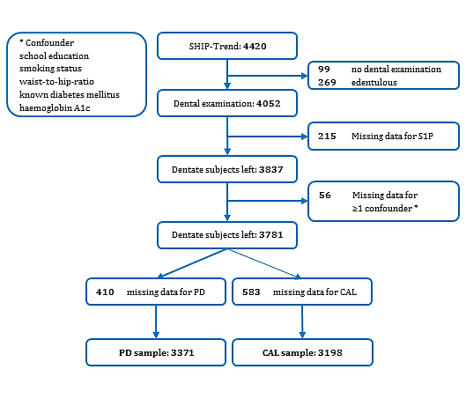

Supplemental Figure 1. Flowchart showing exclusion criteria and number and type of missing data. S1P, sphingosine-1-phosphate; PD, probing depth; CAL, clinical attachment loss. *Confounder: school education, smoking status, waist-to-hip-ratio, known diabetes mellitus, haemoglobin A1c.

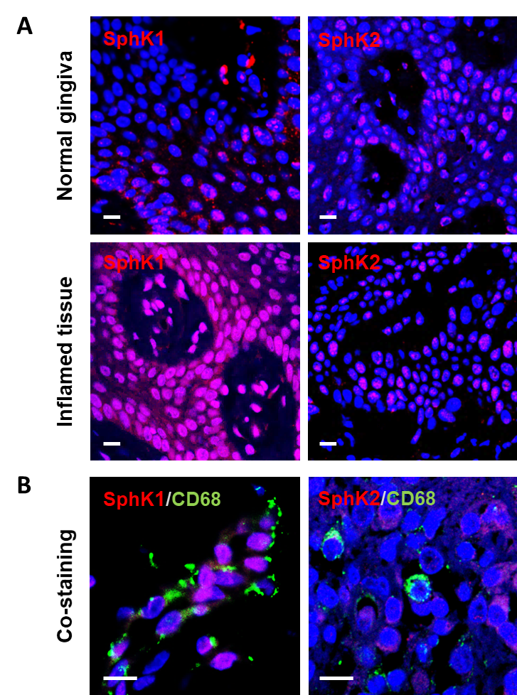

Supplemental Figure 2. Immunofluorescence staining of the sphingosine kinases SphK1 and SphK2 in the gingival epithelium (A) and co-staining with an immune cell marker (CD68; B). A: In the epithelial layer (horizontal sections through the rete pegs) both SphK1 and SphK2 could be detected. Staining of SphK1 (left panels) was markedly increased in the inflamed tissue (lower panels) compared to normal tissue (upper panels), whereas no significant difference was observed for SphK2 detection (right panels). B: To identify further cell types with potentially high sphingosine kinase expression, co-staining with CD68, a marker of macrophages and related immune cells, was performed. CD68-positive cells showed high SphK1 expression (left panel), while staining of SphK2 was only marginal. Micrographs were taken using a laser scanning microscope (Zeiss LSM780) and a 63x/1.4 objective (bar = 10 µm).

