Supplementary Materials
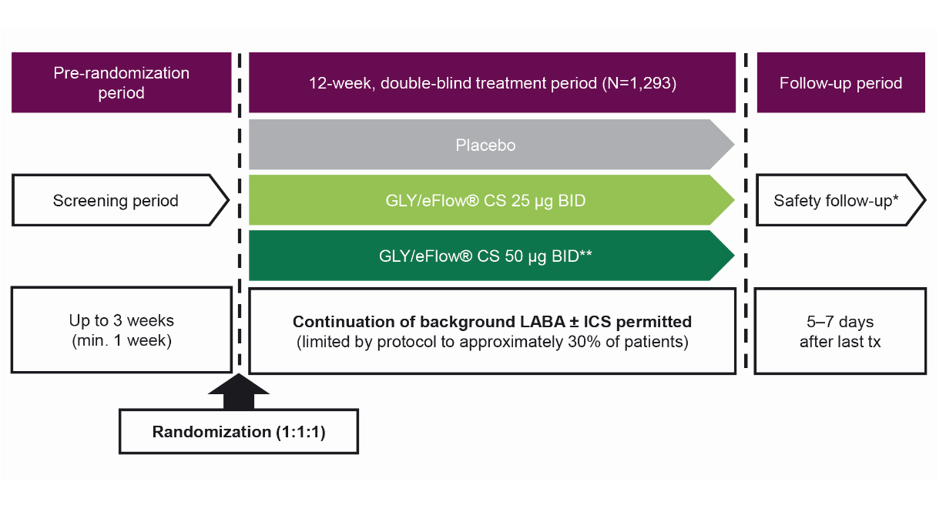
Figure S1. GOLDEN 3 and 4 study designs: 12-week, randomized, double-blind, placebo-controlled, parallel-group, multicenter studies. Data from Kerwin et al.¹
*SAEs were monitored for 30 days after the last dose of study treatment. **Data for the GLY 50 μg BID treatment arm are not presented in this post hoc analysis in order to focus on the FDA-approved and clinically relevant GLY 25 μg dose. The data from the 50 μg BID dose was used for identifying the overall prevalence of comorbidities in the study population, but analysis of outcomes was performed using the placebo and GLY 25 μg BID arms.
Abbreviations: BID, twice daily; CS, closed system; GLY, nebulized glycopyrrolate; ICS, inhaled corticosteroids; LABA, long-acting β₂-agonist; min, minimum; SAE, serious adverse event; tx, treatment.
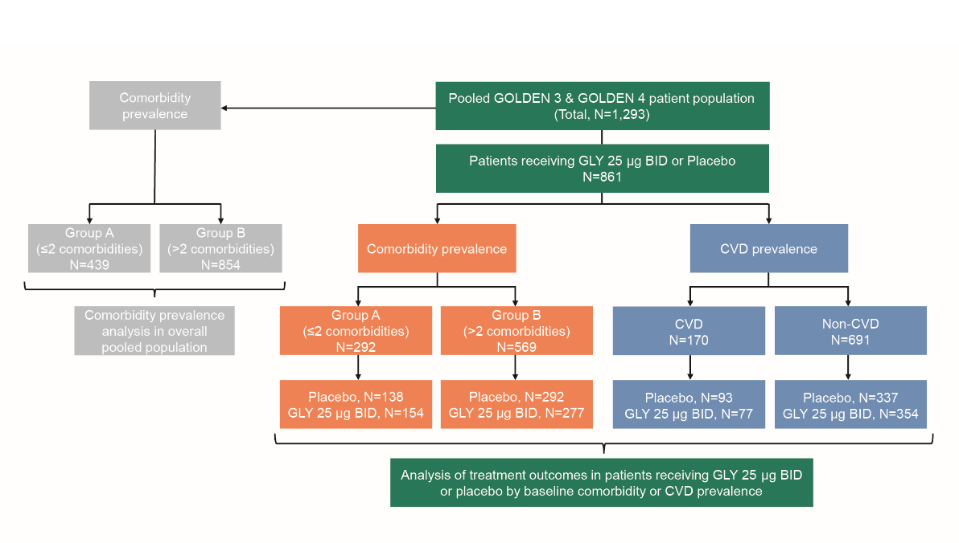
Figure S2. Patient distribution by comorbidity prevalence for overall analysis and outcomes analysis, as well as distribution by CVD status.
Abbreviations: BID, twice daily; CVD, cardiovascular disease; GLY, nebulized glycopyrrolate

Table S1. Classification of comorbidities identified via patient self-reporting or medical records, by preferred terms.
Comorbidity | Preferred term
CHD | “coronary artery disease” or “angina pectoris” or " myocardial infarction” or “acute coronary syndrome” or (“coronary artery bypass” from “surgical and medical procedures”) or (coronary angioplasty from “surgical and medical procedures”)
Diabetes | “Type 2 diabetes mellitus” or “diabetes mellitus”
CHF | Cardiac failure congestive
Hypertension | Hypertension
High cholesterol | “Blood cholesterol increased” or “hypercholesterolaemia” or “hyperlipidaemia” or “dyslipidaemia”
GERD | Gastrooesophageal reflux disease
PVD | Peripheral vascular disorder
Obesity | BMI ≥30 kg/m²
Osteoarthritis | Osteoarthritis
Osteoporosis | Osteoporosis
Depressionª | Depression
Anxietyª | “Anxiety” or “anxiety disorder”
Insomnia | “Middle insomnia” or “insomnia”
Sleep Apnea | Sleep apnoea syndrome
ªSelf-reported medical history for anxiety and depression. For other comorbidities, medical records were used when available.
Abbreviations: BMI, body mass index; CHD, coronary heart disease; CHF, congestive heart failure; GERD, gastroesophageal reflux disease; PVD, peripheral vascular disease.
Table S2. Prevalence of comorbidities in participants with COPD in COPDGene®, SPIROMICS and GOLDEN 3 and 4 cohorts. COPDGene® and SPIROMICS data were obtained with permission from Putcha N et al., 2014.²
Comorbidity, n (%) | COPDGene®  N=3,690 | SPIROMICS  N=853 | GOLDEN 3 and 4  (N=1,293)ª
Anxiety | N/A | N/A | 342 (26)
Depression | N/A | N/A | 438 (34)
Insomnia | N/A | N/A | 318 (25)
Coronary Heart disease (CHD)^{b} | 608 (16) | 177 (21) | 181 (14)
Diabetes | 482 (13) | 114 (13) | 221 (17)
Congestive heart failure (CHF)^{b} | 198 (5) | 21 (2) | 48 (4)
Stroke | 220 (6) | 35 (4) | N/A
Osteoarthritis | 764 (21) | 246 (29) | 476 (37)
Osteoporosis | 640 (17) | 107 (13) | 106 (8)
Hypertension | 1868 (51) | 428 (50) | 774 (60)
High cholesterol | 1529 (41) | N/A | 687 (53)
Gastroesophageal reflux disease (GERD) | 1116 (30) | 254 (30) | 459 (35)
Stomach ulcers | 372 (11) | N/A | N/A
Obesity | 1227 (33) | 270 (32) | 446 (34)
Sleep apnea | 631 (17) | 139 (16) | 190 (15)
Hay fever | 900 (24) | 236 (28) | N/A
Peripheral Vascular Disease (PVD)^{b} | 126 (3) | N/A | 55 (4)
ªIncludes patients who received placebo, GLY 25 µg BID or GLY 50 µg BID.
^{b}These are combined as cardiovascular disease (CVD). N/A, data not available.

Table S3. Participant demographics and baseline characteristics in the GOLDEN 3 and 4 trialsª, by individual comorbidities.
 | Anxiety | Depression | Insomnia | OSA | CHF | CHD | PVD | Obesity | Hypertension | High Cholesterol | Diabetes | GERD | OA | OP
N | 342 | 438 | 318 | 190 | 48 | 181 | 55 | 446 | 774 | 687 | 221 | 459 | 476 | 106
Age, years, median (range) | 60.5 (40–82) | 61.0 (40–83) | 62.0 (40–81) | 64.0 (46–81) | 65 (44–82) | 66 (42–83) | 66.0 (42–78) | 62.5 (41–85) | 65.0 (42–87) | 66 (42–85) | 64.0 (44–85) | 63.0 (41–84) | 65.0 (44–87) | 68.0 (47–82)
Male, n (%) | 135 (39.5) | 171 ( 39.0) | 137 (43.1) | 124 (65.3) | 26 (54.2) | 121 (66.9) | 32 (58.2) | 243 (54.5) | 459 (59.3) | 396 (57.6) | 139 (62.9) | 232 (50.5) | 252 (52.9) | 17 (16.0)
Current Smoker, n (%) | 221 (64.6) | 263 (60.0) | 194 (61.0) | 85 (44.7) | 23 (47.9) | 86 (47.5) | 29 (52.7) | 198 (44.4) | 376 (48.6) | 312 (45.4) | 94 (42.5) | 230 (50.1) | 244 (51.3) | 44 (41.5)
BMI, kg/m² Mean (SD) | 28.7 (6.9) | 29.2 (6.8) | 28.6 (6.6) | 33.3 (7.4) | 32.2 (7.3) | 29.8 (6.4) | 28.9 (6.4) | 35.9 (5.5) | 29.7 (7.0) | 29.5 (6.4) | 32.7 (7.4) | 29.2 (6.4) | 29.6 (7.0) | 27.5 (6.1)
Pack-years, median (range) | 51.0 (26.1) | 51.6 (26.0) | 50.8 (26.2) | 55.7 (28.3) | 51.1 (35.8) | 59.6 (33.2) | 57.5 (26.2) | 54.2 (29.1) | 54.2 (28.4) | 55.9 (28.7) | 57.6 (28.2) | 55.4 (29.8) | 56.8 (30.3) | 54 (34.0)
Post-bronchodilator FEV₁ % predicted, median (range) | 53.1 (13.76) | 53.4 (13.58) | 53.1 (13.75) | 53.4 (13.85) | 55.8 (14.80) | 52.3 (13.55) | 54.2 (12.28) | 52.8 (13.01) | 51.7 (13.48) | 51.7 (13.30) | 51.2 (13.02) | 53.9 (13.41) | 52.8 (13.22) | 52.8 (11.32)
Post-bronchodilator FEV₁/FVC, % (range) | 55.7 (9.7) | 55.7 (9.6) | 55.1 (9.9) | 57.2 (9.5) | 57.3 (10.8) | 56.4 (9.9) | 56.8 (8.6) | 57.5 (9.1) | 55.3 (9.5) | 55.0 (9.6) | 56.3 (9.4) | 56.3 (9.1) | 55.2 (9.6) | 55.2 (9.1)
Background LABA use, n (%) | 93 (27.2) | 133 (30.4) | 102 (32.1) | 83 (43.7) | 13 (27.1) | 64 (35.4) | 16 (29.1) | 151 (33.9) | 249 (32.2) | 241 (35.1) | 82 (37.1) | 171 (37.3) | 164 (34.5) | 34 (32.1)
Background ICS use, n (%) | 85 (24.9) | 129 (29.5) | 92 (28.9) | 79 (41.6) | 12 (25.0) | 58 (32.0) | 14 (25.5) | 143 (32.1) | 231 (29.8) | 224 (32.6) | 76 (34.4) | 158 (34.4) | 154 (32.4) | 35 (33.0)
ªIncludes patients who received placebo, GLY 25 µg BID or GLY 50 µg BID.
Abbreviations: BID, twice daily; BMI, body mass index; CHD, chronic heart disease; CHF, chronic heart failure; FEV₁, forced expiratory volume in 1 second; FVC, forced vital capacity; GERD, gastroesophageal reflux disease; GLY, nebulized glycopyrrolate; ICS, inhaled corticosteroid; LABA, long-acting β₂-agonist; OA, osteoarthritis; OP, osteoporosis; OSA, obstructive sleep apnea; PVD, peripheral vascular disease; SD, standard deviation.

Table S4. Concomitant medication by CVD categories.
n (%) | CVD |  | Non-CVD |  | CVD category- CHF |  | CVD category- CHD |  | CVD category- PVD
n (%) | Placebo  n=93 | GLY 25 μg BID  n=77 | Placebo  n=337 | GLY 25 μg BID  n=354 | Placebo  n=19 | GLY 25 μg BID  n=10 | Placebo  n=64 | GLY 25 μg BID  n=62 | Placebo  n=30 | GLY 25 μg BID  n=13
Overall | 93 (100) | 77 (100) | 307 (91.1) | 317 (89.5) | 19 (100) | 10 (100) | 64 (100) | 62 (100) | 30 (100) | 13 (100)
Alimentary tract and metabolism | 22 (23.7) | 12 (15.6) | 43 (12.8) | 44 (12.4) | 7 (36.8) | 1 (10.0) | 11 (17.2) | 11 (17.7) | 8 (26.7) | 3 (23.1)
Acetylsalicylic Acid | 62 (66.7) | 48 (62.3) | 73 (21.7) | 80 (22.6) | 11 (57.9) | 4 (40.0) | 47 (73.4) | 42 (67.7) | 19 (63.3) | 7 (53.8)
ACE Inhibitors, plain | 41 (44.1) | 23 (29.9) | 68 (20.2) | 79 (22.3) | 11 (57.9) | 4 (40.0) | 26 (40.6) | 15 (24.2) | 15 (50.0) | 6 (46.2)
Alpha and Beta blocking agents | 11 (11.8) | 10 (13.0) | 2 (0.6) | 7 (2.0) | 3 (15.8) | 3 (30.0) | 9 (14.1) | 7 (11.3) | 0 | 1 (7.7)
Angiotensin II Antagonists, Plain | 12 (12.9) | 10 (13.0) | 25 (7.4) | 26 (7.3) | 0 | 0 | 10 (15.6) | 9 (14.5) | 3 (10.0) | 2 (15.4)
Beta Blocking Agents, Selective | 45 (48.4) | 33 (42.9) | 43 (12.8) | 42 (11.9) | 9 (47.4) | 3 (30.0) | 34 (53.1) | 29 (46.8) | 14 (46.7) | 5 (38.5)
HMG-CoA Reductase Inhibitors | 56 (60.2) | 52 (67.5) | 110 (32.6) | 112 (31.6) | 9 (47.4) | 6 (60.0) | 42 (65.6) | 46 (74.2) | 17 (56.7) | 7 (53.8)
Organic Nitrates | 19 (20.4) | 18 (23.4) | 0 | 2 (0.6) | 4 (21.1) | 1 (10.0) | 18 (28.1) | 17 (27.4) | 3 (10.0) | 1 (7.7)
Sulfonamides, Plain | 16 (17.2) | 10 (13.0) | 17 (5.0) | 7 (2.0) | 11 (57.9) | 5 (50.0) | 7 (10.9) | 8 (12.9) | 2 (6.7) | 1 (7.7)
Abbreviations: ACE, angiotensin-converting enzyme; BID, twice daily; CHD, congestive heart disease; CHF, congestive heart failure; CVD, cardiovascular disease; GLY, glycopyrrolate; HMG-CoA, 3-hydroxy-3-methylglutaryl coenzyme A; PVD, peripheral vascular disease.

Table S5. Placebo-adjusted change from baseline with GLY 25 µg BID in trough FEV₁ and SGRQ total and domain score at Week 12, based on CVD subgroup.
LS Mean difference (SE) from baseline | GLY 25 μg BID | p-value
Congestive heart failure
n (Placebo: GLY 25 µg BID) | 19:10
Change from baseline in trough FEV₁, | 0.16 (0.08) | 0.07
SGRQ total score | –11.06 (5.41) | 0.048
Activity domain | –17.34 (6.35) | 0.0097
Impacts domain | –7.46 (5.66) | 0.196
Symptoms domain | –9.84 (6.61) | 0.15
SGRQ Responder rate, OR (95% CI) | 12.57 (1.64, 96.5) | 0.0149
Coronary heart disease
n (Placebo: GLY 25 µg BID) | 64:62
Change from baseline in trough FEV₁, | 0.17 (0.04) | <0.0001
SGRQ total score | –4.27 (1.85) | 0.02
Activity domain | –5.24 (2.55) | 0.04
Impacts domain | –2.82 (2.1) | 0.18
Symptoms domain | –4.79 (3.08) | 0.12
SGRQ Responder rate, OR (95% CI) | 2.95 (1.27, 6.89) | 0.0123
Peripheral vascular disease
n (Placebo: GLY 25 µg BID) | 30:13
Change from baseline in trough FEV₁, | 0.24 (0.08) | 0.0042
SGRQ total score | –0.31 (3.77) | 0.94
Activity domain | 6.92 (5.55) | 0.22
Impacts domain | –2.25 (3.83) | 0.56
Symptoms domain | –9.55 (6.5) | 0.15
SGRQ Responder rate, OR (95% CI) | 1.19 (0.25, 5.60) | 0.829
Abbreviations: BID, twice daily; CI, confidence interval; CVD, cardiovascular disease; GLY, glycopyrrolate; LS, least square; FEV₁, forced expiratory volume in 1 second; OR, odds ratio; SE, standard error; SGRQ, St George’s Respiratory Questionnaire.

Table S6. Characteristics of participants with COPD in COPDGene®, SPIROMICS, GOLDEN 3 and 4 studies by comorbidity count. COPDGene® and SPIROMICS data were obtained with permission from Putcha N et al., 2014.²
 | COPDGene® |  | SPIROMICS |  | GOLDEN 3 and 4ª
 | < 2 | > 2 | < 2 | > 2 | < 2 | > 2
N | 1,733 (47) | 1,954 (53) | 426 (50) | 427 (50) | 439 (34) | 854 (66)
Age, years | 62 (8.7) | 65 (8.1) | 66 (7.9) | 67 (7.6) | 62.0 (9.1) | 63.8 (8.5)
Current smokers, n (%) | 851 (49) | 649 (33) | 172 (40) | 107 (25) | 253 (57.6) | 431 (50.5)
Pack-years | 50.0 (25.7) | 55.6 (28.8) | 53.1 (25.5) | 56.0 (27.6) | 48.2 (24.5) | 54.2 (28.1)
Post-BD FEV₁ predicted | 49.9 (19.2) | 50.5 (16.8) | 59.4 (23.7) | 62.7 (22.1) | 49.6 (14.8) | 52.8 (13.4)
BMI, kg/m² | 25.7 (5.0) | 30.1 (6.5) | 24.8 (3.8) | 30.1 (5.0) | 25.97 (5.4) | 29.90 (7.0)
SGRQ scores | 37.9 (22.4) | 43.6 (21.1) | 34.4 (19.7) | 36.4 (18.3) | 46.8 (19.5) | 49.9 (17.5)
Exacerbation in past year, n (%) | 588 (34) | 938 (48) | 106 (25) | 124 (29) | 82 (18.7) | 168 (19.7)
Use of ICS, n (%) | 788 (46.5) | 1,100 (57.1) | 140 (40.6) | 196 (43.9) | 109 (24.8) | 266 (31.1)
ªAll doses (placebo, GLY 25 µg BID and 50 µg BID) are used for characteristics; the placebo and GLY 25 µg BID were used for safety and efficacy, because GLY 25 µg BID is the approved dose.
Values shown are mean (SD) unless otherwise noted.
Abbreviations: BD, bronchodilator; BID, twice daily; BMI, body mass index; FEV₁, forced expiratory volume in 1 second; ICS, inhaled corticosteroid; SD, standard deviation; SGRQ, St George’s Respiratory Questionnaire.

References
1. Kerwin E, Donohue JF, Goodin T, Tosiello R, Wheeler A, Ferguson GT. Efficacy and safety of glycopyrrolate/eFlow® CS (nebulized glycopyrrolate) in moderate-to-very-severe COPD: Results from the glycopyrrolate for obstructive lung disease via electronic nebulizer (GOLDEN) 3 and 4 randomized controlled trials. Respir Med. Nov 2017;132:238-250. doi:10.1016/j.rmed.2017.07.011
2. Putcha N, Puhan MA, Drummond MB, et al. A Simplified Score to Quantify Comorbidity in COPD. PLoS ONE. 2014;9(12): e114438.

