SUPPORTING INFORMATION
[Guoxin Jing] et al
Layer-Number-Dependent Effects of Graphene Oxide on the Pluripotency of Mouse Embryonic Stem Cells Through the Regulation of the Interaction Between the Extracellular Matrix and Integrins
Guoxin Jing,¹ Kun Li,¹ Feiyue Sun, ¹ Jintong Niu, ¹ Rongrong Zhu,¹ Yechang Qian*,² and Shilong Wang*.¹
¹ Research Center for Translational Medicine at East Hospital, School of Life Science and Technology, Tongji University, Shanghai, P. R. China;
² Department of Respiratory Disease, Baoshan District Hospital of Integrated Traditional Chinese and Western Medicine, Shanghai, P. R. China.

Correspondence: Yechang Qian* and Shilong Wang*
Tel +86 2165918108 Fax +86 2136070892, Email: qianyechang@163.com
Tel +86 2165982595 Fax +86 2165982595, Email: wsl@tongji.edu.cn

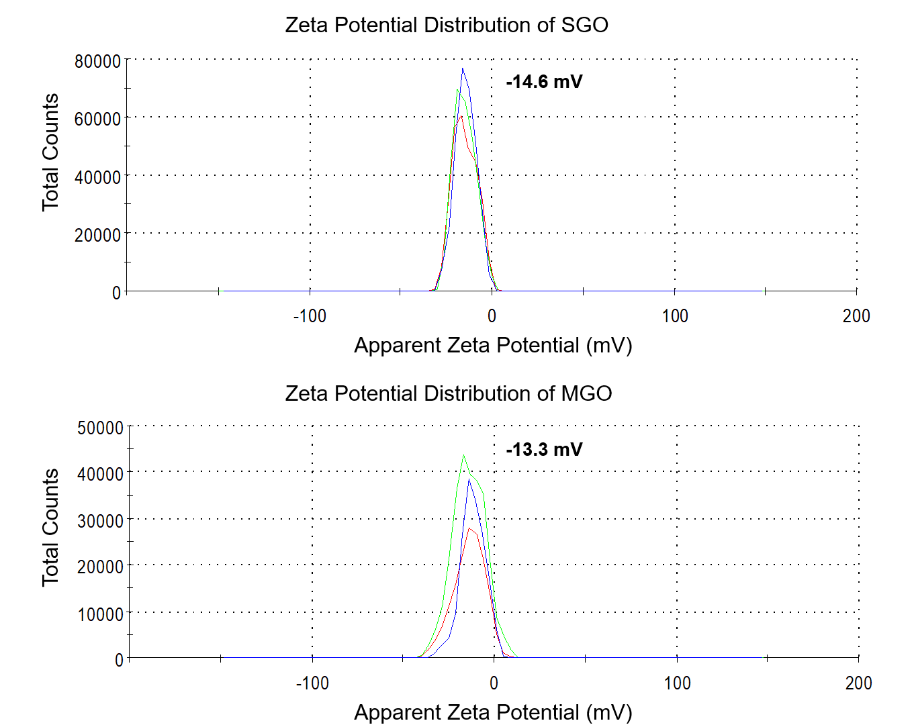
Figure S1. Zeta potential distribution of SGO and MGO. Each sample was repeated three times and take the average.

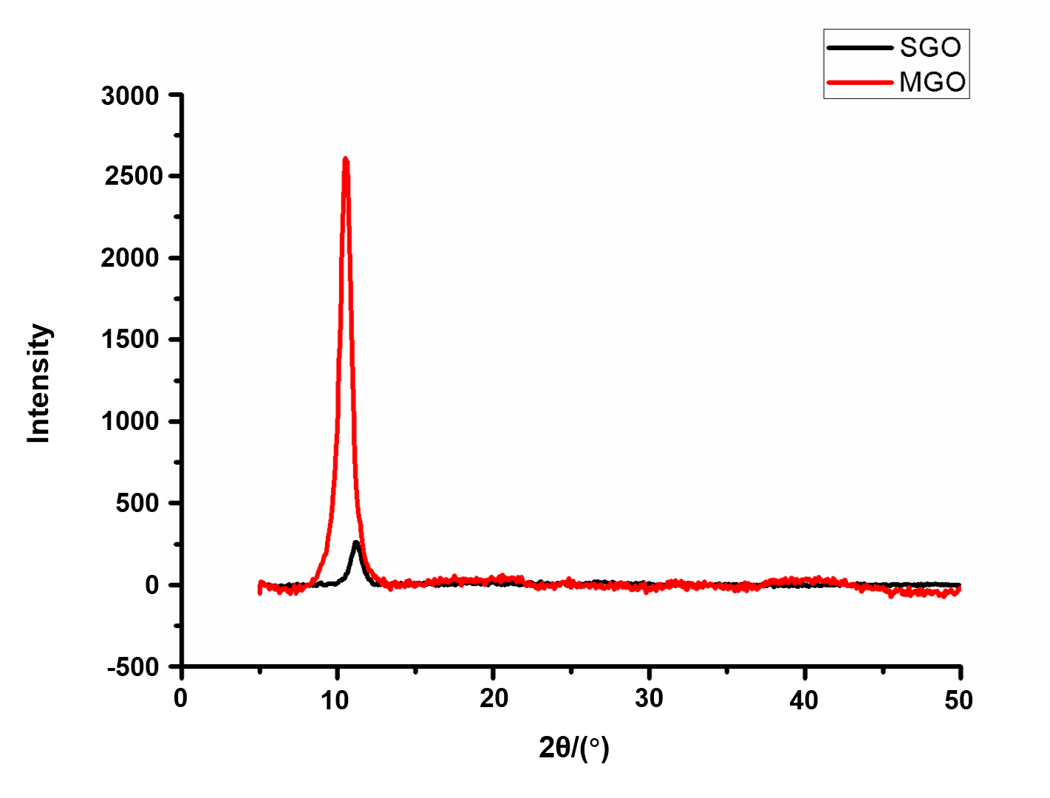
Figure S2. XRD pattern of SGO (black line) and MGO (red line).

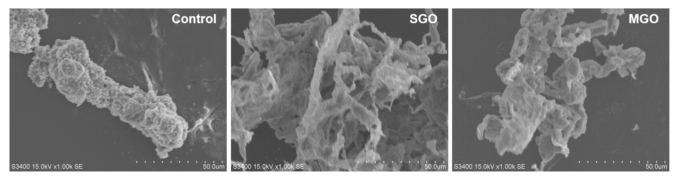
Figure S3. Scanning electron microscopy (SEM) detect the interaction between SGO/MGO and mESCs after co-incubated for 16 h.

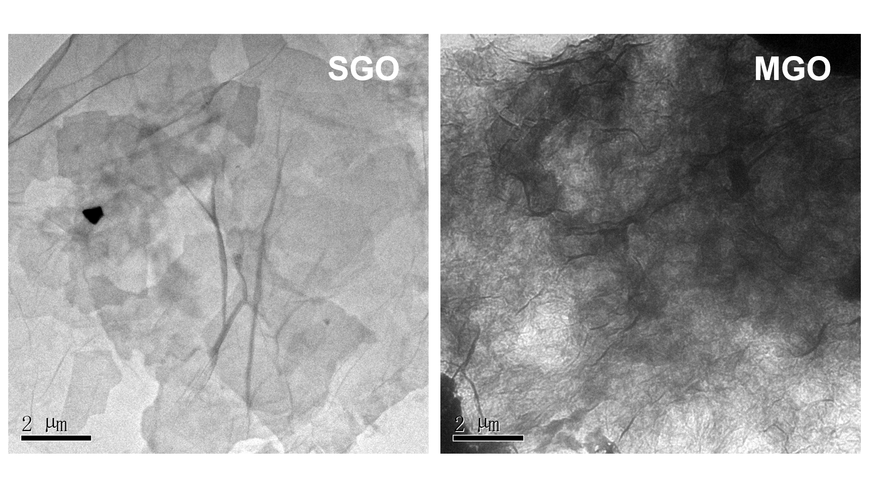
Figure S4. The TEM detection of the binding ability between SGO/MGO and Fibronectin.

