Erythrocyte-camouflaged Mesoporous Titanium Dioxide Nanoplatform for an Ultrasound-mediated Sequential Therapies of Breast Cancer

Qunying Li¹, Bin Lin², Yongzhou Li³, Nan Lu^{4,} *

¹ Department of Ultrasound, Second Affiliated Hospital of Zhejiang University, School of Medicine, Hangzhou, Zhejiang 310009, China; ² Department of Radiology, The Second Affiliated Hospital, Zhejiang University School of Medicine, Hangzhou, Zhejiang, 310009, China; ³ Department of Surgery, The Second Affiliated Hospital, Zhejiang University School of Medicine, Hangzhou, Zhejiang, China; ⁴ Department of Radiology, The Second Affiliated Hospital, Zhejiang University School of Medicine, Hangzhou, Zhejiang, 310009, China.

*Corresponding authors: Nan Lu
Department of Radiology, The Second Affiliated Hospital, Zhejiang University School of Medicine, Hangzhou, Zhejiang 310009, China
Tel: 86+13674665528
Fax: 86+13674665528
E-mail address: 2317075@zju.edu.cn

Materials
Titanium butoxide (GC, 99.0%), ethanol, N-(3-dimethylaminopropyl)-N-ethylcarbodiimide and heptanoic acid (AR, 98.0%) were from the Sigma-Aldrich Co. Other chemical materials were purchased from China National Pharmaceutical Group Corporation RPMI-1640 medium and fetal bovine serum (FBS) were purchased from GIBCO. Diagnostic kits for phosphocreatine kinase (CK)alanine aminotransferase (ALT), aspartate aminotransferase (AST) and blood urea nitrogen (BUN) were obtained from Shanghai Renjie Bioengineering Company.

Statistical analysis
Differences between groups were analyzed by Student’s t-test. Differences among more than two groups were analyzed by one-way analysis of variance. Bonferroni post hoc test was used to analyze differences between any two groups. P < 0.05 indicates a significant difference.

Figure Caption

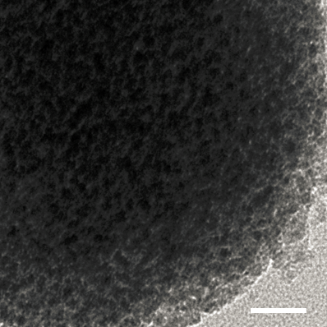

Figure S1. High-resolution transmission electron microscopy image of TNPs. Scale bar, 5nm.

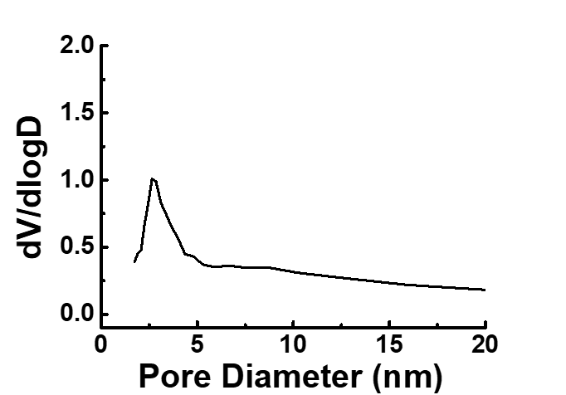

Figure S2. Pore size distribution of TNPs

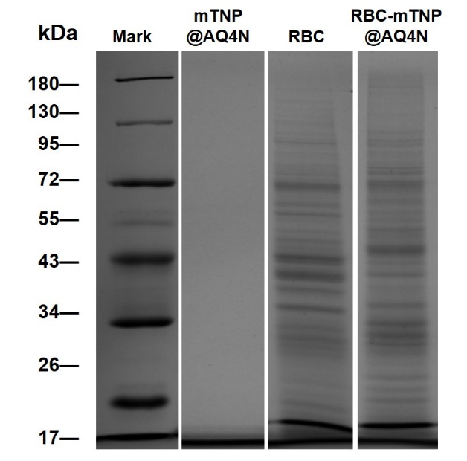
Figure S3. SDS-PAGE protein analysis of the mTNP@AQ4N, RBC and RBC- mTNP@AQ4N.

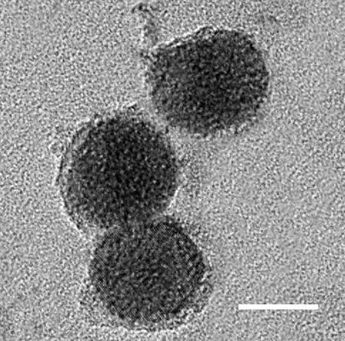

Figure S4. TEM image of RBC-TNP@AQ4N after irradiation by US. Scale bar, 30 nm.

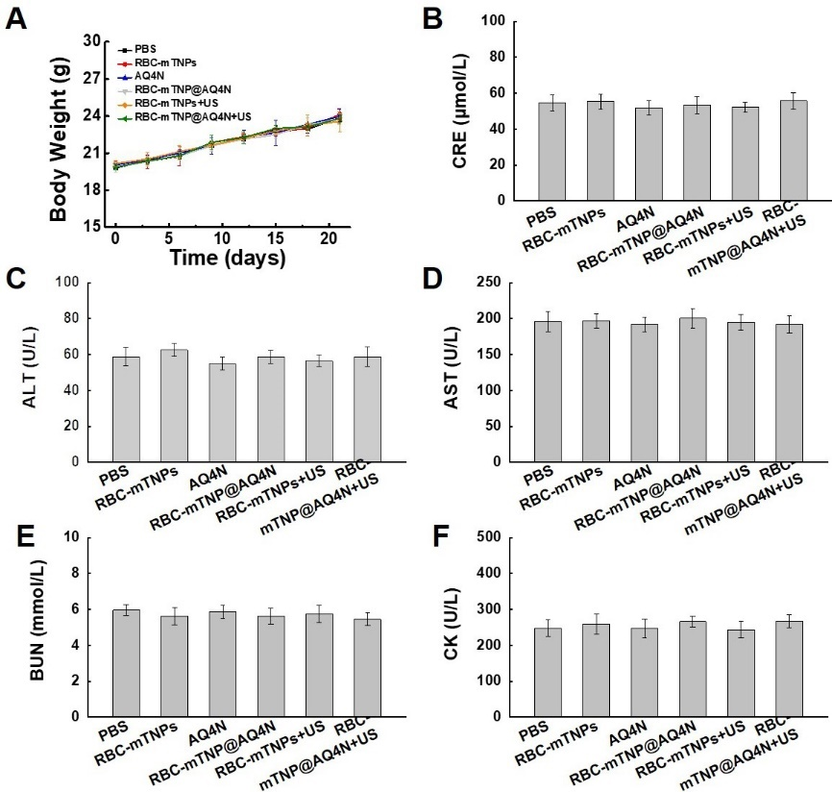
Figure S5. Body weight (A) and blood biochemical indicators including CRE (B), ALT (C), AST (D) BUN (E) and CK (F). All the data represent mean ± S.D. (n=4).

