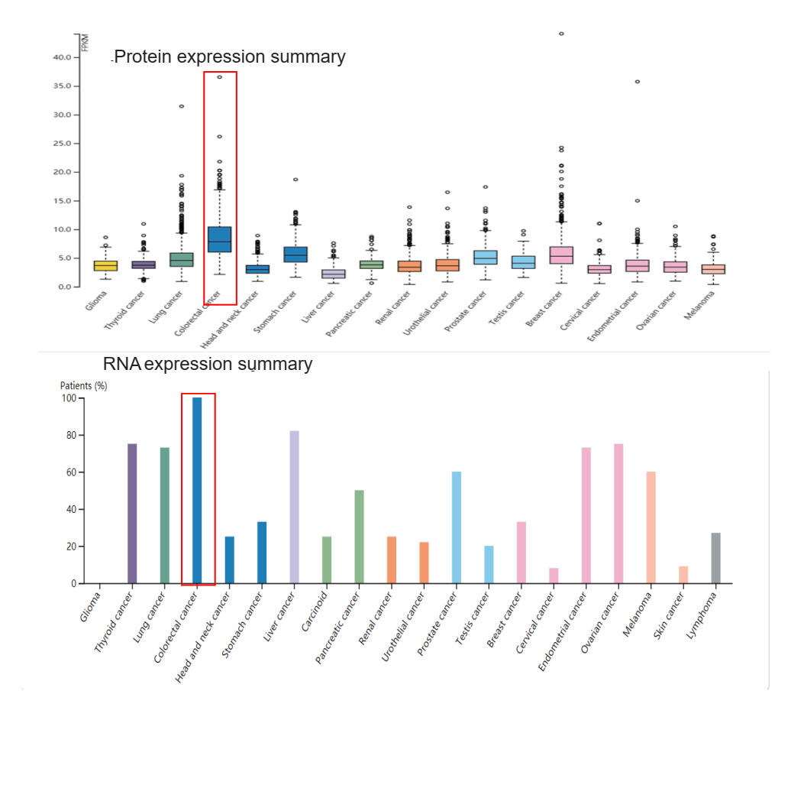
Figure S1 mRNA and protein expression of AVL9 in different tumors. Note: Both AVL9 mRNA and protein were significantly highly expressed in colorectal cancer tissues.

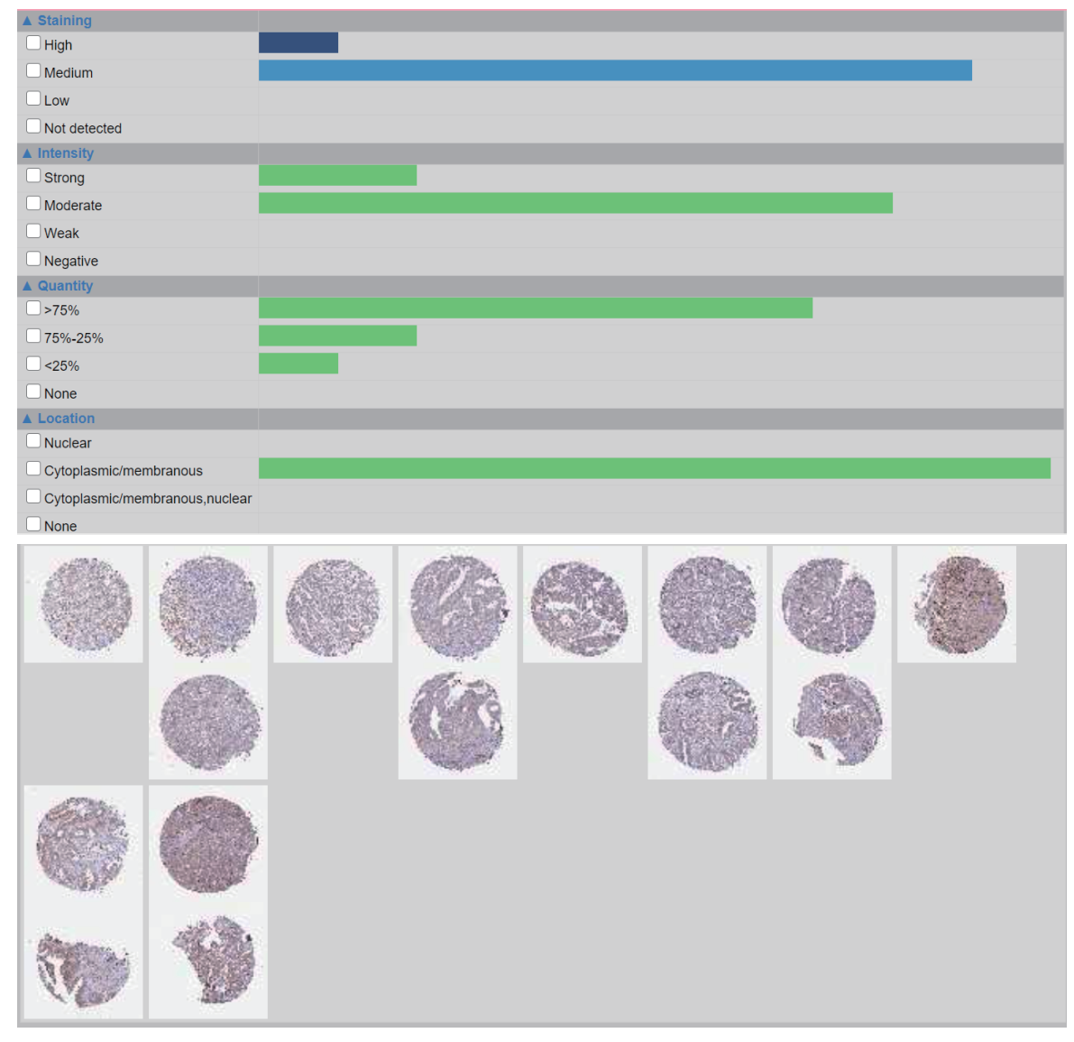 Figure S2 IHC analysis of AVL9 in CRC tissues. Note: AVL9 was highly expressed in the staining, intensity, and quantity analyses. CRC, colorectal cancer; IHC, IHC Immunohistochemical

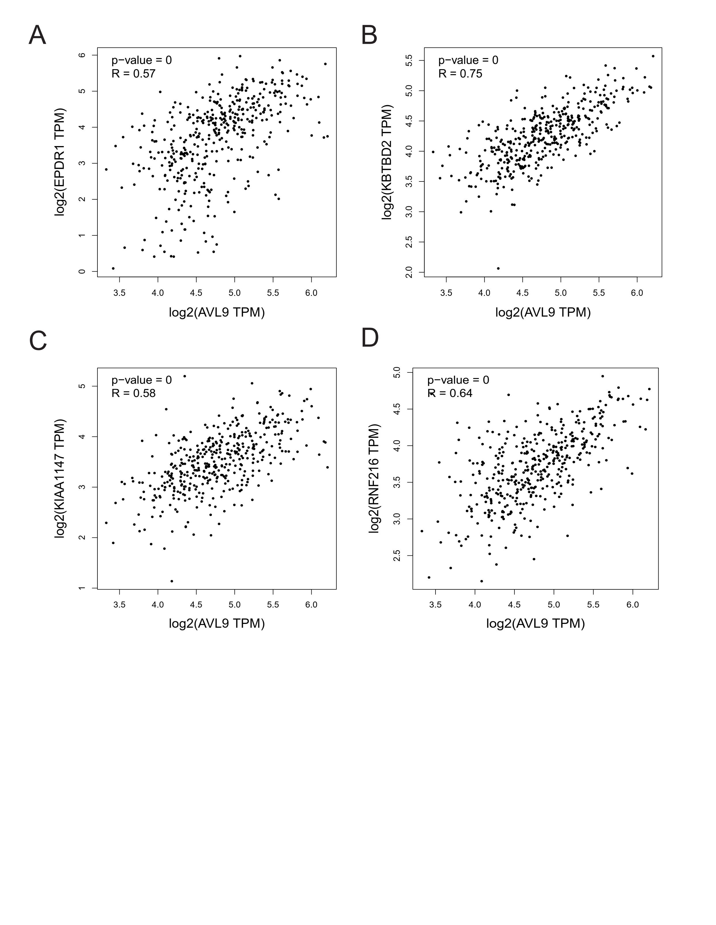 Figure S3 The correlation between AVL9 and KBTBD2, KIAA1147, RNF216 were all positively correlated according to GEPIA data.

