Supplementary materials

Loading Tetrandrine and 1-Bromoheptadecaflurooctane Liposomes Effectively Treat Dry Eye Disease via Anti-inflammation in Rabbit

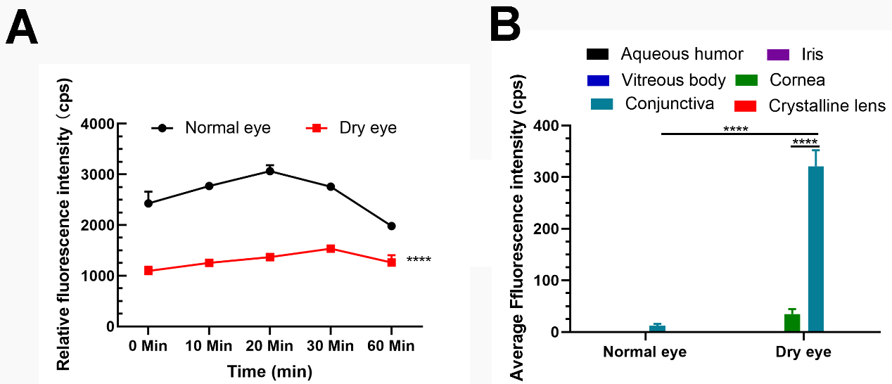
Figure S1. (A) Analysis of fluorescence signal intensities of DiR-tagged liposomes wash out of eyes at corresponding time points. (B) Analysis of fluorescence signal intensities of different segments of eyes. T-test and Two-way ANOVA were performed for analysis (****p<0.0001).
Figure S2 (A) Detection and analysis of survival rates of normal and inflamed SIRC cells incubated with PBS and PFOB@LIP-Tet formulations (Tet: 5 µg/mL) for 24 h. (B) Detection and analysis of survival rates of normal and inflamed SIRC cells incubated with PBS and PFOB@LIP-Tet (Tet: 5 µg/mL) formulations for 48 h. Ordinary one-way ANOVA was performed for analysis (***p < 0.001, ****p<0.0001).
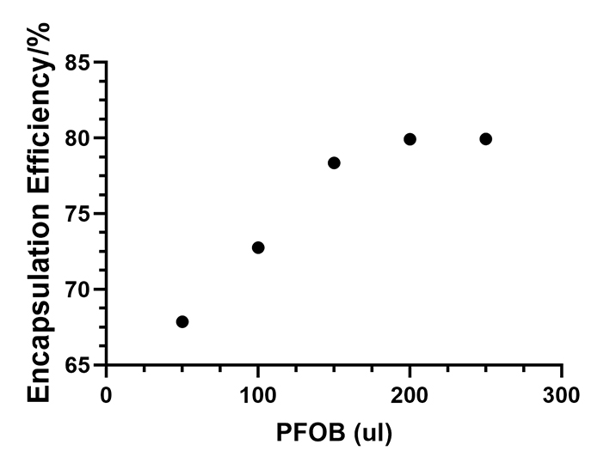
Figure S3. Encapsulation efficiency of Tet when adding 50, 100, 150, 200 and 250 μl PFOB to prepare of PFOB@LIP-Tet.

