Supplementary Material

Figure S1 Example DCE question.
Medicine Feature | Medicine A | Medicine B
How you take the “OFF” episode medicine | Inhaled   | Dissolvable sublingual film  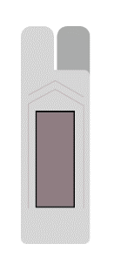
Possible side effect from medicine | Cough or mild respiratory infection | Mouth or lip sores
How long until you are fully back “ON” | 30 min | 30 min
How long the “OFF” episode medicine treats your symptoms | 1.5 h | 2 h
Out-of-pocket cost for a 30-day supply of the medicine | $10 | $10
Which would you choose?

The mode of administration and mode-specific adverse events were modeled in the experimental design as 1 attribute with 6 levels. In the DCE questions presented to the respondent, the mode of administration and adverse event were put on 2 rows to make the question easier to read.
Note: The levels of the attributes varied across the choice questions. Table 1 presents the full range of levels for each attribute. The individual combination of attribute levels shown for Medicine A and Medicine B in each question is theoretical and does not reflect the profile of any actual treatment.
Abbreviation: DCE, discrete choice experiment.

Figure S2 Conditional relative attribute importance of changing each attribute of a theoretical treatment from the least preferred level to the most preferred level. The sum of the relative attribute importance calculations is scaled to 100, and the conditional importance of each attribute is a percentage of the total. The vertical bars surrounding each relative importance weight estimate denote the 95% CI. Abbreviations: AE, adverse event; CI, confidence interval.
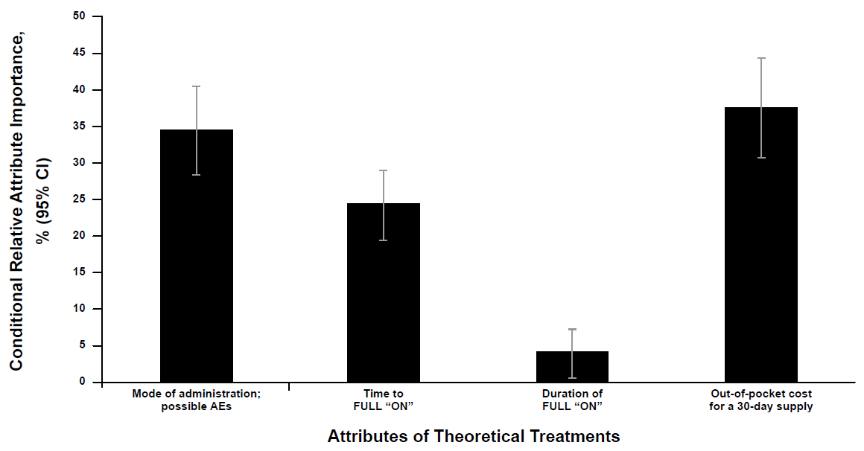

Table S1 Theoretical profiles for preference share predictions
Attribute | Theoretical Treatment A | Theoretical Treatment B | Theoretical Treatment C
Scenario 1
How you take the on-demand treatment and possible adverse events from the medicine | Dissolvable sublingual film; mouth or lip sores | Injected; injection-site reactions | Inhaled; cough or mild respiratory infection
Time to FULL “ON” | 30 min | 15 min | 30 min
Duration of FULL “ON” | 1 h | 1 h | 1 h
Out-of-pocket cost for a 30-day supply of the medicine | $30 | $30 | $30
Scenario 2
How you take the on-demand treatment and possible adverse events from the medicine | Dissolvable sublingual film; mouth or lip sores | Injected; injection-site reactions | Inhaled; cough or mild respiratory infection
Time to FULL “ON” | 30 min | 30 min | 30 min
Duration of FULL “ON” | 1.5 h | 1 h | 1 h
Out-of-pocket cost for a 30-day supply of the medicine | $30 | $30 | $30

Table S2 Preference weights for attribute levels of theoretical treatments
Attribute | Level | Preference weight (95% CI)
Mode of administration; adverse event | Inhaled; none | 0.446 (0.244, 0.648)
 | Inhaled; cough or mild respiratory infection | –0.336 (–0.542, –0.130)
 | Injected; none | –0.418 (–0.632, –0.203)
 | Injected; injection-site reactions | –1.056 (–1.294, –0.819)
 | Dissolvable sublingual film; none | 1.072 (0.851, 1.294)
 | Dissolvable sublingual film; mouth or lip sores | 0.291 (0.035, 0.547)
Time to FULL “ON” | 15 min | 0.718 (0.560, 0.877)
 | 30 min | 0.057 (–0.047, 0.161)
 | 60 min | –0.775 (–0.933, –0.617)
Duration of FULL “ON” | 1 h | –0.115 (–0.230, 0.001)
 | 1.5 h | –0.010 (–0.128, 0.108)
 | 2 h | 0.125 (0.005, 0.245)
Out-of-pocket cost for a 30-day supply of the medicine | $0 (no cost) | 0.838 (0.684, 0.992)
 | $10 | 0.580 (0.473, 0.687)
 | $30 | 0.064 (0.053, 0.076)
 | $90 | –1.483 (–1.756, –1.210)
Abbreviation: CI, confidence interval.

Table S3 WTP for changes in attribute levels of theoretical treatments
Attribute | From level | To level | Mean WTP (95% CI),ª $
Mode of administration; adverse event | Injected; injection-site reactions | Dissolvable sublingual film; none | 83 (66, 99)
Mode of administration; adverse event | Injected; injection-site reactions | Inhaled; none | 58 (43, 73)
Mode of administration; adverse event | Injected; none | Dissolvable sublingual film; none | 58 (43, 72)
Mode of administration; adverse event | Inhaled; cough or mild respiratory infection | Dissolvable sublingual film; none | 55 (40, 69)
Mode of administration; adverse event | Injected; injection-site reactions | Dissolvable sublingual film; mouth or lip sores | 52 (36, 69)
Mode of administration; adverse event | Injected; none | Inhaled; none | 33 (20, 47)
Mode of administration; adverse event | Dissolvable sublingual film; mouth or lip sores | Dissolvable sublingual film; none | 30 (17, 44)
Mode of administration; adverse event | Inhaled; cough or mild respiratory infection | Inhaled; none | 30 (18, 43)
Mode of administration; adverse event | Injected; injection-site reactions | Inhaled; cough or mild respiratory infection | 28 (15, 40)
Mode of administration; adverse event | Injected; none | Dissolvable sublingual film; mouth or lip sores | 27 (12, 43)
Mode of administration; adverse event | Injected; injection-site reactions | Injected; none | 25 (12, 38)
Mode of administration; adverse event | Inhaled; cough or mild respiratory infection | Dissolvable sublingual film; mouth or lip sores | 24 (10, 39)
Mode of administration; adverse event | Inhaled; none | Dissolvable sublingual film; none | 24 (12, 36)
Mode of administration; adverse event | Dissolvable sublingual film; mouth or lip sores | Inhaled; none | 6 (−8, 20)
Mode of administration; adverse event | Injected; none | Inhaled; cough or mild respiratory infection | 3 (−9, 15)
Time to FULL “ON” | 60 min | 15 min | 58 (46, 70)
Time to FULL “ON” | 60 min | 30 min | 32 (24, 41)
Time to FULL “ON” | 30 min | 15 min | 26 (17, 34)
Duration of FULL “ON” | 1 h | 2 h | 9 (1, 17)
Duration of FULL “ON” | 1.5 h | 2 h | 5 (−3, 13)
Duration of FULL “ON” | 1 h | 1.5 h | 4 (−4, 12)
Abbreviations: CI, confidence interval; WTP, willingness to pay.
ª The 95% CIs were calculated using the delta method.

