Antimicrobial peptides SLPI and beta defensin-1 in sputum are negatively correlated with FEV₁
Supplementary tables and figures

Jennifer L Cane^{1,2}, Laura J Tregidgo¹, Samantha J Thulborn^{1,2}, Donna Finch³, Mona Bafadhel^{1,2}
¹Respiratory Medicine Unit, Nuffield Department of Medicine, University of Oxford, UK
²Oxford NIHR Biomedical Research Centre, University of Oxford, UK
³Alchemab Therapeutics, Cambridge, UK
 | Age (median, IQR) | Sex (M/F) | Race (Caucasian/Black) | Ever smoker
COPD (n=3) | 66 (59-73) | 100/0 | 100/0 | 100%
Health (n=3) | 57 (56-69) | 33/67 | 67/33 | 0
Table E1: Characteristics of HBEC donors

Table E2: Peptide levels in sputum supernatants of patients with COPD (n=14) and asthma (n=21) grouped into those with high sputum neutrophils (≥70%), and those with <70% sputum neutrophils.
 | SLPI (ng/ml) | Osteopontin (pg/ml) | Elafin (ng/ml) | Beta defensin-1 (ng/ml)
<70% neutrophils | 324.6 (203.6-517.4) | 181.2 (89.93-365) | 19.64 (13.4-28.79) | 6.001 (3.5-10.29)
≥70% neutrophils | 614.7 (320.2-1180) | 227 (108.8-473.6) | 19.82 (13.7-28.66) | 11.5 (5.703-23.39)
p value | 0.178 | 0.495 | 0.798 | 0.095

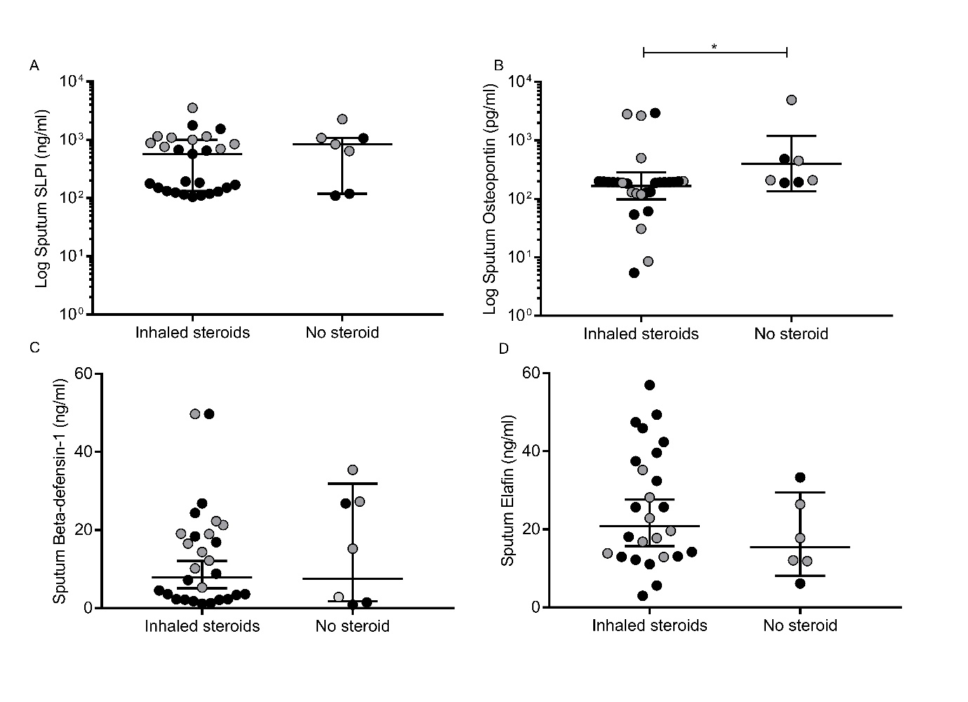
Figure E1
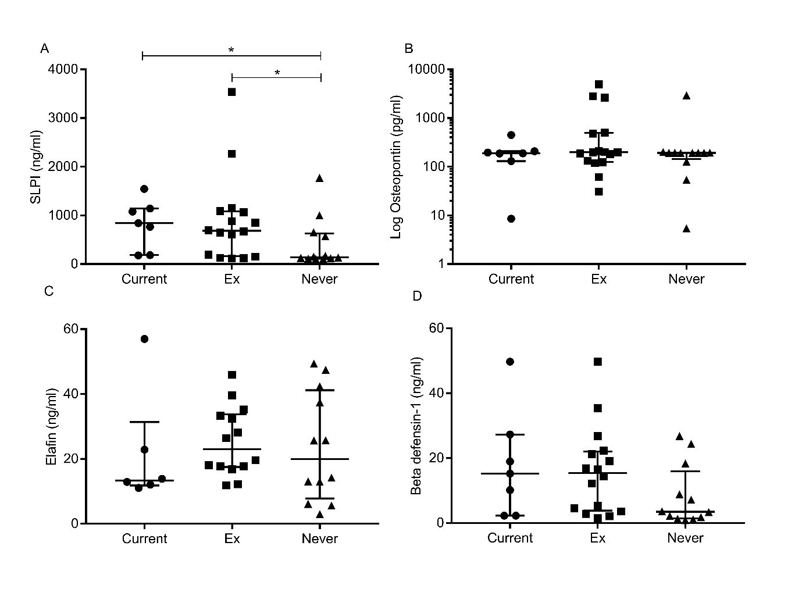Figure E2

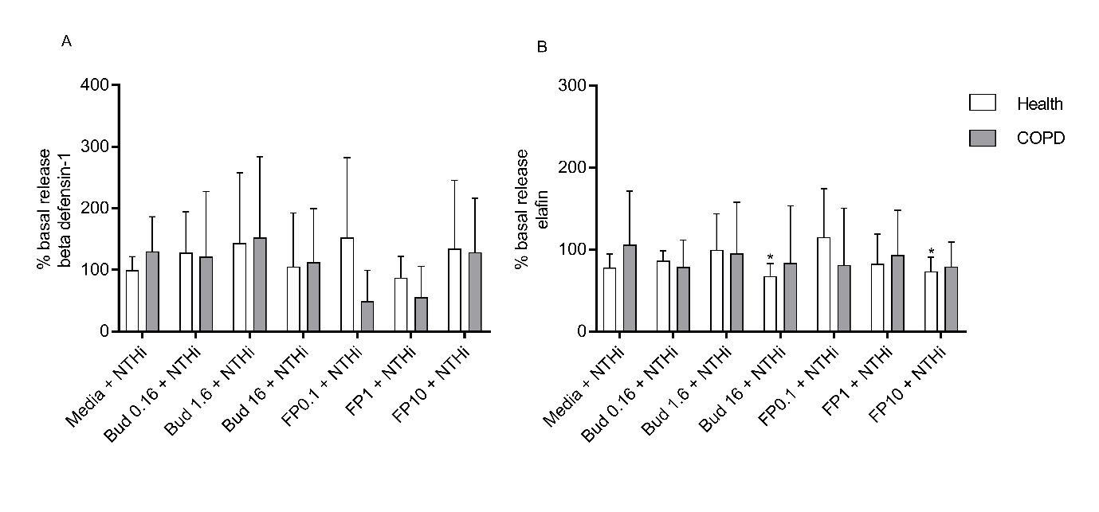Figure E3

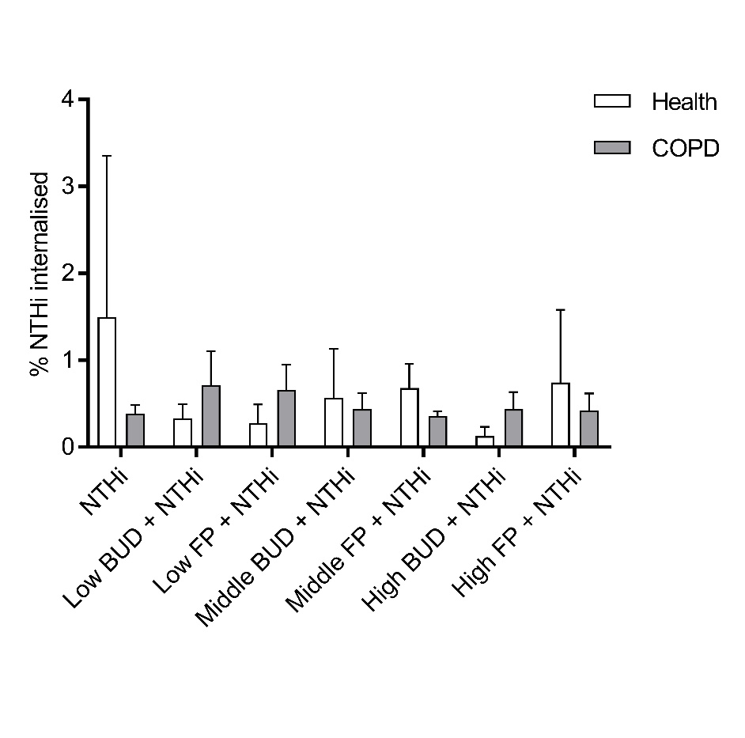
Figure E4

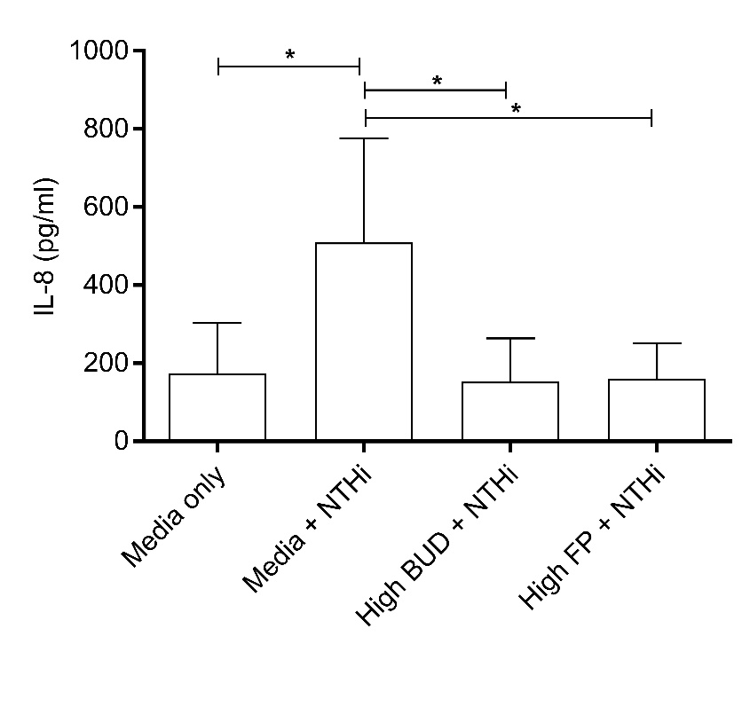
Figure E5
Figure E1: Sputum peptide levels in patients with COPD (n=14, grey dots) and asthma (n=21, black dots), tested in duplicate. A: SLPI, B: osteopontin, C: elafin and D: beta defensin-1. * denotes p<0.05.
Figure E2: Sputum peptide levels grouped according to smoking status of participants with COPD (n=14) or asthma (n=21), tested in duplicate. A: SLPI, B: osteopontin, C: elafin and D: beta defensin-1. * denotes p<0.05.
Figure E3: A: Beta defensin-1 and B: Elafin release with a combination of NTHi and steroid treatments. Results are shown as a mean percentage change from untreated cell release. Donors: health (n=3, white bars) and COPD (n=3, grey bars). Budesonide (Bud) levels tested: 0.16nM, 1.6nM and 16nM, and fluticasone propionate (FP) levels tested: 0.1nM, 1nM and 10nM in cell media. Significant changes form basal release shown as * p<0.05.
Figure E4: Amount of NTHi internalised into HBECs, shown as a mean percentage and SD of all NTHi added. Donors: health (n=3, white bars), COPD (n=3, grey bars), tested in duplicate.
Figure E5: IL-8 release from HBECs from healthy donors (n=3) was increased after two hours of treatment with NTHi, and that increase was prevented with treatment with budesonide or fluticasone prior to infection. Tests were run in duplicate. * denotes p<0.05.

