Supplementary Materials
Cluster Analysis
Principal component analysis (PCA) was adopted for dimensionality reduction. Horn’s parallel analysis was applied to determine the optimal number of principal components (PCs) to retain in the cluster analysis.¹ After excluding the proportion of variance resulting from sampling error (Figure S1), 16 PCs were retained in the cluster analysis to account for data variance. Subsequently, different clustering methods and numbers of clusters were assessed by connectivity, average Silhouette width and Dunn indices.² Connectivity indicated the degree of compactness within each cluster and should be minimized. The Dunn index and the Silhouette width measured the separation among different clusters and should be maximized. Clustering methods, such as hierarchical, K-means and Gaussian finite mixture model-based methods, were evaluated (Figure S2). K-means and Gaussian finite mixture model-based methods are the better choices in terms of connectivity and average Silhouette width. The stability for different numbers of clusters based on different clustering methods was tested using a nonparametric bootstrap analysis with 200 bootstrapped datasets. The mean of Jaccard similarity coefficients, defined by the intersection size divided by the size of the union between clusters, was computed to find the good stability cluster number.³ Considering all above-mentioned indices, the K-means method with a cluster number of 4 yielded the best results.

Effect of Visit Interval Variation
The visit interval was not strictly one year for all subjects although it was designed to be one year apart.⁴ The average time interval between two visits for the studied cohort was 397.49 (±71.89) days. In order to evaluate the effect of visit interval variation, we adjusted the ${\overset{⃑}{V}}_{progression}$ by a factor of ${397.49}/{T_{i}, }$ where $T_{i}$ is the visit interval (in days) for subject i, and compared the adjusted cluster membership with that without adjustment (Table S9). The similarity between the two cluster memberships was measured by the Jaccard similarity coefficient, which ranges from 0.0 (no similarity) to 1.0 (exactly the same).³ The result showed that only 1.8% of the subjects changed cluster memberships after adjustment with the Jaccard similarity coefficient of 0.93. Thus, the effect of visit interval variation was negligible and omitted in the clustering analysis.
We also assessed the effect of visit interval variation on the post analysis of variables. Apart from the effect of visit interval variation on cluster memberships, the progression rates of variables with longitudinal changes are also expected to be affected. Even though the visit interval was shown to be not significantly different among clusters (Table S10), the difference in progression rates between two subjects could be significantly large if a large difference in visit interval exists between the two subjects. However, in our post analysis of relevant variables, the cluster averages play the main role to characterize different clusters. We hypothesize that the visit interval variation has limited effect on the cluster averages, and it does not change related conclusions in our study. We studied the effect of the visit interval variation on the representative variables, the major functional features in four imaging-based clusters and never smokers as in Table 3. We take the average visit interval 397.49 days as the time interval for roughly one year since strict definition of one calendar year means manually temporal translation of all progression rates which entails major artifacts in our data analysis. The effect was measured by the relative difference which is defined as the percentage of difference between original progression rates and adjusted progression rates relative to the original progression rates. The average relative differences are small with largest value lower than 4% (Table S11), though the visit interval variation did affect the average values. We hence conclude that the hypothesis is valid, and the post analyses based on the cluster membership are also valid.
Comparison between Longitudinal Clustering and Cross-Sectional Clustering
We compared the cross-sectional clustering with our longitudinal clustering by studying the 269 participants who were in both studies.⁵ The confusion matrix between cross-sectional clustering and longitudinal clustering (Table S12) showed that the cluster members in cross-sectional clusters were divided between neighboring longitudinal clusters since the subjects in the same cross-sectional cluster might have different progression patterns. The original cross-sectional cluster 1⁵ shared most common subjects with the longitudinal cluster 2 and the original cross-sectional cluster 2 shared most subjects with the longitudinal cluster 1. We hence interchanged the cross-sectional cluster numbers 1 and 2. Part of major clinical variables and biomarkers were laid out for comparison between cross-sectional clustering and longitudinal clustering (Table S13). All the average baseline variables showed bigger inter-cluster difference in cross-sectional clustering than longitudinal clustering. For example, baseline CAT scores in cross-sectional clustering were 10.73, 9.36, 10.96, and 17.07, while baseline CAT scores in longitudinal clustering were 10.00, 10.12, 13.42, and 13.79. The CAT score difference between the most severe cluster and the least severe cluster was 7.71 in cross-sectional clustering, while the difference in longitudinal-sectional clustering was 3.79. Unlike cross-sectional clusters, longitudinal clusters exhibited no sex nor race dominance.
The cross-sectional cluster members were divided between neighboring longitudinal clusters due to different progression patterns. Cross-sectional clustering, though being able to derive meaningful clusters for disease phenotyping,^{5–7} was based on the static state of COPD only. The bigger inter-cluster difference in cross-sectional clustering than longitudinal clustering indicated that cross-sectional clustering may tend to derive clusters that maximize the inter-difference between clusters and at the same time minimize the intra-difference⁸ within each cluster. Accordingly, maximizing the inter-differences between clusters without considering progression information may over-estimate the differences of COPD baseline characteristics between clusters. Since progression variables contributed significantly to the selected 16 principal components (Figure S3),⁹ the over-estimated inter-cluster difference in cross-sectional clustering was attenuated in longitudinal cluster. Hence, longitudinal clustering captures characteristics of disease progression, which may be less dependent upon disease severity than cross-sectional clustering. Furthermore, the significant difference in sex and race among cross-sectional clusters was not observed in longitudinal clusters, suggesting that progression patterns are independent of sex and race.
In summary, we conclude that use of baseline variables and their progression rates in clustering can identify the progression-aware clusters with more relevant baseline characteristics for COPD phenotyping. Our longitudinal clustering holds promise in identifying emphysema susceptible and non-susceptible subjects at early COPD stages. While spirometry is an important tool for assessing COPD stage, it may not sensitively detect the heterogeneity in patients. The imaging-based method has great potential in differentiating homogeneous patient subgroups within the heterogeneous large cohort.

REFERENCES
1. Courtney MGR. Determining the Number of Factors to Retain in EFA: Using the SPSS R-Menu v2.0 to Make More Judicious Estimations. Pract Assess Res Eval. 18(1):8.
2. Brock G, Pihur V, Datta S, Datta S. clValid: An R Package for Cluster Validation. J Stat Softw. 2008;25(4).
3. Hennig C. Cluster-wise assessment of cluster stability. Comput Stat Data Anal. 2007 Sep;52(1):258–71.
4. Couper D, LaVange LM, Han M, et al. Design of the Subpopulations and Intermediate Outcomes in COPD Study (SPIROMICS). Thorax. 2014 May;69(5):492–5.
5. Haghighi B, Choi S, Choi J, et al. Imaging-based clusters in former smokers of the COPD cohort associate with clinical characteristics: the SubPopulations and intermediate outcome measures in COPD study (SPIROMICS). Respir Res. 2019 Dec;20(1).
6. Choi S, Hoffman EA, Wenzel SE, et al. Quantitative computed tomographic imaging–based clustering differentiates asthmatic subgroups with distinctive clinical phenotypes. J Allergy Clin Immunol. 2017 Sep;140(3):690–700.
7. Haghighi B, Choi S, Hoffman EA, et al. Imaging-based clusters in Current Smokers of the COPD Cohort Associate with Clinical Characteristics: the SubPopulations and Intermediate Outcome Measures in COPD Study. Respir Res. 2018 Dec;19(1):178.
8. Halkidi M, Batistakis Y, Vazirgiannis M. On clustering validation techniques. J Intell Inf Syst. 2001;17(2–3):107–45.
9. Abdi H, Williams LJ. Principal component analysis: Principal component analysis. Wiley Interdiscip Rev Comput Stat. 2010 Jul;2(4):433–59.

Table S1. Normalized airway diameters at specific regions and their percentage change.
DD_{h}* | Region | Type | Cluster 1 | Cluster 2 | Cluster 3 | Cluster 4 | P value
DD_{h}* | Trachea | Baseline | 1.01  (0.11) | 1.04  (0.12) | 1.00  (0.10) | 0.97  (0.11) | < 0.0001
DD_{h}* | Trachea | Change (%) | 0.34  (4.28) | -0.83**  (3.99) | 0.78  (4.76) | 0.75**  (3.88) | 0.0072
DD_{h}* | LMB | Baseline | 0.70  (0.07) | 0.73  (0.07) | 0.69  (0.08) | 0.68 (0.06) | < 0.0001
DD_{h}* | LMB | Change (%) | 0.47  (3.91) | -1.37**  (4.09) | 0.46  (4.27) | 0.39  (4.29) | 0.0004
DD_{h}* | RMB | Baseline | 0.82  (0.08) | 0.84  (0.08) | 0.79  (0.08) | 0.77  (0.08) | < 0.0001
DD_{h}* | RMB | Change (%) | -0.09  (3.60) | -1.79**  (3.67) | -0.13  (3.88) | 0.22  (3.69) | < 0.0001
DD_{h}* | TriLLB | Baseline | 0.46  (0.06) | 0.47  (0.05) | 0.44  (0.07) | 0.43  (0.05) | < 0.0001
DD_{h}* | TriLLB | Change (%) | -0.59  (4.88) | -1.91**  (4.38) | 0.56  (5.42) | -0.54  (5.22) | 0.0043
DD_{h}* | BronInt | Baseline | 0.62  (0.06) | 0.63  (0.06) | 0.60  (0.07) | 0.57  (0.06) | < 0.0001
DD_{h}* | BronInt | Change (%) | -0.16  (3.12) | -0.71**  (2.84) | 0.35  (3.33) | -0.16  (3.25) | 0.1084
DD_{h}* | sLUL | Baseline | 0.26  (0.03) | 0.26  (0.03) | 0.25  (0.03) | 0.24  (0.03) | < 0.0001
DD_{h}* | sLUL | Change (%) | -0.49  (8.41) | -0.93**  (7.43) | 0.33  (6.36) | -0.09  (9.87) | 0.7193
DD_{h}* | sLLL | Baseline | 0.33  (0.04) | 0.34  (0.04) | 0.31  (0.04) | 0.30  (0.04) | < 0.0001
DD_{h}* | sLLL | Change (%) | 2.02**  (9.04) | -1.59**  (8.74) | 2.24*  (7.77) | -0.41  (9.11) | 0.0015
DD_{h}* | sRUL | Baseline | 0.32  (0.04) | 0.32  (0.04) | 0.31  (0.05) | 0.30  (0.04) | 0.0003
DD_{h}* | sRUL | Change (%) | 0.19  (10.56) | -1.52**  (9.58) | 0.12  (9.81) | -2.05**  (11.12) | 0.2344
DD_{h}* | sRML | Baseline | 0.27  (0.04) | 0.27  (0.04) | 0.25  (0.04) | 0.24  (0.04) | < 0.0001
DD_{h}* | sRML | Change (%) | 0.39  (8.24) | -1.95**  (7.98) | 1.16  (5.91) | -0.05  (8.90) | 0.0262
DD_{h}* | sRLL | Baseline | 0.28  (0.04) | 0.28  (0.03) | 0.27  (0.04) | 0.25  (0.04) | < 0.0001
DD_{h}* | sRLL | Change (%) | 1.65  (9.76) | -1.66  (8.06) | 2.36**  (8.90) | 2.17  (11.05) | 0.0024

Notes: Values expressed as mean (SD). Kruskal-Wallis tests were performed for continuous variables. Baseline refers to variables measured at baseline. Change (%) refers to the percentage of change over one year with respect to its baseline value. The P values evaluate the differences between clusters. **The change between baseline and year 1 is significant (P<0.05). *The change between baseline and year 1 is close to being significant (P<0.1).
Table S2. TLC and RV at two visits.
 | Visit | Cluster 1 | Cluster 2 | Cluster 3 | Cluster 4 | Never Smokers
RV | Baseline | 1.94  (0.54) | 2.31  (0.57) | 3.30  (1.06) | 3.70  (1.10) | 1.85  (0.55)
RV | Year 1 | 2.18**  (0.69) | 2.29  (0.63) | 2.73**  (0.80) | 3.85**  (1.07) | 1.87  (0.65)
TLC | Baseline | 4.51  (1.17) | 5.16  (1.08) | 5.19  (1.27) | 5.82  (1.21) | 4.46  (1.13)
TLC | Year 1 | 4.64**  (1.25) | 4.90**  (1.13) | 5.31**  (1.29) | 5.84  (1.24) | 4.34  (1.35)

Notes: Values expressed as mean (SD). Kruskal-Wallis tests were performed for continuous variables. Baseline refers to variables measured at baseline. **The change between baseline and year 1 is significant (P<0.05).

Table S3. Baseline FEV₁ (mL) and FEV₁ change over one year (mL/year).
 | Cluster 1 | Cluster 2 | Cluster 3 | Cluster 4 | P value | Never Smokers
FEV_{1baseline} | 2445.74^{h}  (719.74) | 2492.57^{h}  (722.34) | 1874.63^{h}  (819.51) | 1372.34^{h}  (622.28) | < 0.0001 | 2891.95  (616.99)
FEV_{1year1} - FEV_{1baseline} | -38.74**  (194.16) | -86.41^{**h}  (189.19) | 3.93  234.01 | -31.12**  (126.75) | < 0.0087 | -11.00  (129.15)
FEV_{1year2} - FEV_{1year1} | -47.38**  (200.87) | -39.12*  (209.03) | -51.72**  (152.69) | -32.49**  (153.07) | 0.7490 | -76.27**  (183.78)

Notes: Values expressed as mean (SD). _{baseline}The value is at baseline. _{year1}The value is at the visit one year after the baseline visit. _{year2}The value is at the visit two years after the baseline visit. Due to significantly increased number of studied subjects being absent at year 3, the FEV₁ change was only shown till year 2. ^{h}The value is significantly (P < 0.05) different from that of never smokers. The P values evaluate the differences between clusters. **The change between baseline and year 1 is significant (P<0.05). *The change between baseline and year 1 is close to being significant (P<0.1).

Table S4. BMI distribution in cluster 1 and the comparison with cluster 2 and healthy group.
 | GOLD 0 | GOLD 1 | GOLD 2 | GOLD 3
Cluster 1 BMI | 29.94 | 30.44 | 30.64 | 34.93
Comparison between cluster 1 and cluster 2
Cluster 2 BMI | 28.84 | 27.30 | 28.20 | 34.66
P value | 0.20 (>0.05) | 0.02 | 0.047 | NA
Comparison between cluster 1 and healthy group
Healthy BMI | 28.44
P value | 0.1 | 0.15 | 0.034 | NA

Notes: P value < 0.05 means cluster 1 BMI and cluster 2 BMI are different for that column. NA: there are not enough data for comparison.
Table S5. Associations of visual diagnostics (VD) and of emphysematous subtypes with cluster membership.
 | Cluster 1 | Cluster 2 | Cluster 3 | Cluster 4 | P value
Visual Diagnosis by Radiologist (VD)
 | N = 78 | N = 70 | N = 38 | N = 70
Bronchiectasis (%) | 41.03 | 37.14 | 55.26 | 62.86 | 0.0080
CT patterns of ILD (%) | 48.72 | 25.71 | 21.05 | 18.57 | 0.0002
 | N =122 | N = 134 | N = 77 | N = 132
Lung nodule (%) | 4.92 | 5.22 | 7.79 | 13.63 | 0.0258
Emphysema subtypes
 | N = 67 | N = 65 | N = 37 | N = 68
PLE (%) | 0.42 | 0 | 0.85 | 4.24 | 0.0008
 | N = 67 | N = 64 | N = 37 | N = 68
CLE + PLE (%) | 1.49 | 0 | 5.41 | 14.71 | 0.0008
PSE + PLE (%) | 0 | 0 | 2.70 | 8.82 | 0.0070
CLE + PSE + PLE (%) | 0 | 0 | 2.70 | 8.82 | 0.0070

Notes: Kruskal-Wallis and chi-square tests were performed for continuous and categorical variables, respectively, and their P values were reported. Kruskal-Wallis and chi-square tests were performed for continuous and categorical variables, respectively.
Abbreviations: CLE: Centrilobular; PSE: Paraseptal; PLE: Panlobular emphysema.

Table S6. Biomarkers for longitudinal clusters.
Variable | Type | Cluster 1  (N = 124) | Cluster 2  (N = 136) | Cluster 3  (N = 77) | Cluster 4  (N = 135) | P value
RAGE  (ng/ml) | Baseline | 3.06  (2.22) | 2.94  (2.09) | 2.93  (1.95) | 2.27  (1.80) | 0.0014
RAGE  (ng/ml) | Change | -0.09  (1.18) | 0.07  (1.01) | -0.30  (1.51) | 0.09  (0.95) | 0.7854
CCL11  (pg/ml) | Baseline | 102.20  (56.46) | 115.20  (58.07) | 120.04  (67.61) | 124.98  (83.17) | 0.1073
CCL11  (pg/ml) | Change | 17.36**  (45.35) | -0.42  (68.15) | 4.53  (72.06) | 22.68**  (76.29) | 0.2660
MDK  (ng/ml) | Baseline | 1.43  (0.98) | 1.59  (1.02) | 2.17  (3.56) | 1.60  (1.05) | 0.1339
MDK  (ng/ml) | Change | 0.42**  (1.24) | 0.26*  (1.01) | 0.55  (2.85) | 0.12  (0.97) | 0.7564
BNP  (pg/ml) | Baseline | 644.09  (988.20) | 607.10  (741.61) | 720.60  (1120.37) | 634.33  (733.48) | 0.5758
BNP  (pg/ml) | Change | 114.60  (463.60) | 161.27*  (649.75) | -207.12**  (540.39) | -35.10  (493.56) | 0.0088
LOX-1  (ng/ml) | Baseline | 1.21  (0.88) | 1.16  (0.70) | 1.24  (0.81) | 1.40  (1.05) | 0.3022
LOX-1  (ng/ml) | Change | 0.10  (1.07) | 0.45**  (0.83) | 0.14  (0.92) | -0.04  (0.98) | 0.0189
SERPINA1  (mg/ml) | Baseline | 1.83  (0.43) | 1.87  (0.47) | 1.98  (0.44) | 1.90  (0.51) | 0.0671
SERPINA1  (mg/ml) | Change | 0.27**  (0.53) | 0.11  (0.59) | -0.05  (0.51) | 0.02  (0.46) | 0.0465
TIMP1  (ng/ml) | Baseline | 86.54  (24.11) | 83.84  (17.58) | 89.83  (21.83) | 89.48  (25.00) | 0.1979
TIMP1  (ng/ml) | Change | 4.14  (21.16) | 0.35  (20.59) | -8.32**  (16.42) | -0.75  (21.85) | 0.0972
VCAM1  (ng/ml) | Baseline | 611.58  (224.56) | 571.18  (146.20) | 592.80  (160.04) | 602.80  (163.40) | 0.6867
VCAM1  (ng/ml) | Change | 28.93  (161.16) | 0.46  (113.42) | -52.74**  (84.01) | -10.94  (113.49) | 0.1044
TNFRSF11B  (pmol/L) | Baseline | 5.39  (1.47) | 5.61  (1.73) | 5.86  (1.58) | 6.29  (2.20) | 0.0058
TNFRSF11B  (pmol/L) | Change | 0.26  (1.21) | -0.10  (1.34) | -0.59**  (1.55) | -0.07  (1.25) | 0.1165

Notes: Change refers the difference between the mean values at follow-up visit and baseline visit. Kruskal-Wallis tests were performed for continuous variables. The P values evaluate the differences between clusters. **The pairwise difference between the value at baseline and the value at follow-up is significant (p<0.05). *The P value for the pairwise test between the value at baseline and the value at follow-up is smaller than 0.
Abbreviations: RAGE, advanced glycosylation end-product specific receptor; CCL11, C-C motif chemokine 11; MDK, midkine; BNP, brain natriuretic peptide; LOX-1, oxidized low-density lipoprotein receptor 1; SERPINA1, alpha-1 antitrypsin; TIMP1, TIMP metallopeptidase inhibitor 1; VCAM1, vascular cell adhesion protein 1; TNFRSF11B, tumor necrosis factor receptor superfamily member 11B.

Table S7. Comparison of eosinophils (%) between longitudinal clusters (this study) and cross-sectional clusters.⁵
Eosinophils (%) | Cluster 1 | Cluster 2 | Cluster 3 | Cluster 4 | P value
Longitudinal clusters | 3.15 | 3.09 | 3.42 | 2.97 | 0.5239
Cross-sectional clusters¹ | 3.29 | 3.18 | 2.85 | 2.64 | 0.071

Notes: Values are presented by number (%). The P values evaluate the differences between clusters. ¹Haghighi et al. Respiratory Research (2019) 20:153

Table S8. The most important 23 CT variables employed as inputs for the random forest classification.
Random Forest
Variable | Region
$$β_{tissue}^{RV}$$ | Total
∆$β_{tissue}^{RV}$ (%) | Total
∆Jacobian (%) | Total
∆$β_{tissue}^{RV}$(%) | LUL
∆(fSAD%) (%) | RUL
∆(fSAD%) (%) | Total
$$β_{tissue}^{RV}$$ | LUL
∆(fSAD%) (%) | LUL
fSAD% | LUL
∆Jacobian (%) | LUL
∆ADI (%) | Total
∆$β_{tissue}^{RV}$(%) | RUL
∆ADI (%) | RUL
∆(fSAD%) (%) | Total
∆$β_{tissue}^{TLC}$(%) | Total
∆ADI (%) | LUL
$$β_{tissue}^{RV}$$ | LLL
fSAD% | LLL
$$β_{tissue}^{RV}$$ | RLL
Emph% | Total
∆$β_{tissue}^{TLC}$(%) | RLL
$$β_{tissue}^{RV}$$ | RML
Emph% | RML

Table S9. Comparison of cluster memberships without and with interval-adjusted ${\overset{⃑}{V}}_{progression}$.
 |  | Cluster Membership with Adjustment
Total number N = 472 |  | Cluster 1  N = 121 | Cluster 2  N = 136 | Cluster 3  N=77 | Cluster 4  N = 138
Membership without Adjustment | Cluster 1  N = 124 | 120 | 2 | 1 | 1
Membership without Adjustment | Cluster 2  N = 136 | 1 | 134 | 0 | 1
Membership without Adjustment | Cluster 3  N = 77 | 0 | 0 | 75 | 2
Membership without Adjustment | Cluster 4  N = 135 | 0 | 0 | 1 | 134

Notes: ${\overset{⃑}{V}}_{progression,adjusted}=({\overset{⃑}{V}}_{followup}-{\overset{⃑}{V}}_{baseline})⊘{\overset{⃑}{V}}_{baseline}⨀\frac{T_{avg}}{T}$ was used to adjust the progression rates of each subject according to their time interval between visits. ${\overset{⃑}{V}}_{progression,adjusted}$ refers to adjusted progression rate. $T_{avg}$ refers to the average time interval between visits for all former smokers and $T$ represents the time interval for the subject.$\frac{T_{avg}}{T}$ scaled the progression rates by decreasing the progression rates linearly if $T$ > $T_{avg}$ and increased the progression rates linearly if $T$ < $T_{avg}$. $T_{avg}$ for the cohort is 397.49 days. $⨀$ refers to each element of the vector is multiplied by the factor $\frac{T_{avg}}{T}$.

Table S10. Visit intervals in each cluster.
 | Cluster 1  (N = 124) | Cluster 2  (N = 136) | Cluster 3  (N = 77) | Cluster 4  (N = 135) | P value
Visit Interval  (Days) | 399.29  (79.55) | 402.69  (90.04) | 402.45  (69.08) | 387.78  (38.39) | 0.9364

Notes: Values are presented by mean (SD). The P values evaluate the differences between clusters.

Table S11. Effect of visit interval variation on main functional variable.
Variable | Region | Type | Cluster 1  (N = 124) | Cluster 2  (N = 136) | Cluster 3  (N = 77) | Cluster 4  (N = 135) | P value
$$β_{tissue}^{RV}$$  (%) | Total | Change | -2.29  (2.25) | 0.36  (1.56) | 1.79  (2.16) | -0.70  (1.31) | < 0.0001
$$β_{tissue}^{RV}$$  (%) | Total | Adjusted  Change | -2.34  (2.36) | 0.36  (1.64) | 1.80  (2.22) | -0.72  (1.37) | < 0.0001
$$β_{tissue}^{RV}$$  (%) | Total | Relative Difference  (%) | -1.83  (12.30) | -1.59  (13.19) | -0.82  (12.79) | -3.15  (8.52) | NA
Jacobian | Total | Change | -0.10  (0.26) | -0.10  (0.20) | 0.27  (0.20) | -0.06  (0.15) | < 0.0001
Jacobian | Total | Adjusted  Change | -0.10  (0.26) | -0.09  (0.21) | 0.28  (0.22) | -0.06  (0.15) | < 0.0001
Jacobian | Total | Relative Difference (%) | -1.70  (12.21) | -1.41  (13.42) | -0.87  (12.67) | -3.33  (8.45) | NA
Emph% | Total | Change | 0.72  (1.72) | -0.80  (1.89) | 1.15  (2.57) | 0.44  (3.27) | < 0.0001
Emph% | Total | Adjusted  Change | 0.72  (1.77) | -0.86  (1.97) | 1.09  (2.75) | 0.55  (3.58) | < 0.0001
Emph% | Total | Relative Difference (%) | -1.80  (12.21) | -1.57  (13.36) | -1.34  (11.84) | -3.51  (8.35) | NA
fSAD% | Total | Change | 4.29  (5.91) | -1.01  (5.19) | -4.54  (7.92) | 1.03  (6.31) | < 0.0001
fSAD% | Total | Adjusted  Change | 4.85  (7.43) | -1.02  (5.19) | -4.54  (8.28) | 1.21  (6.83) | < 0.0001
fSAD% | Total | Relative Difference (%) | -2.18  (11.42) | -1.50  (13.34) | -0.87  (12.67) | -3.42  (8.48) | NA
$$β_{tissue}^{TLC}$$  (%) | Total | Change | -0.57  (1.06) | 0.75  (1.13) | -0.48  (0.96) | -0.11  (0.57) | < 0.0001
$$β_{tissue}^{TLC}$$  (%) | Total | Adjusted  Change | -0.51  (1.25) | 0.74  (1.43) | -0.62  (1.40) | -0.11  (0.59) | < 0.0001
$$β_{tissue}^{TLC}$$  (%) | Total | Relative Difference (%) | -1.87  (12.20) | -1.67  (13.55) | -0.56  (12.82) | -3.19  (8.49) | NA
ADI | Total | Change | -0.04  (0.10) | -0.02  (0.06) | 0.09  (0.07) | -0.03  (0.06) | < 0.0001
ADI | Total | Adjusted  Change | -0.04  (0.09) | -0.03  (0.09) | 0.10  (0.07) | -0.03  (0.06) | < 0.0001
ADI | Total | Relative Difference (%) | -1.80  (12.21) | -1.50  (13.43) | -0.77  (12.80) | -3.33  (8.45) | NA

Notes: Values are presented by mean (SD). The P values evaluate the differences between clusters.
Change refers to the change over one year. Adjusted change is the change adjusted by visit interval. Relative difference refers to the difference between the change and the adjusted change relative to the change.

Table S12. Confusion matrix of the memberships between cross-sectional clustering and longitudinal clustering. The original cross-sectional cluster 1 was renumbered as cluster 2 and the original cross-sectional cluster 2 was renumbered as cluster 1 in the table.⁵
 |  | Longitudinal clustering of former smokers
Total number N = 269 |  | Cluster 1  N = 58 | Cluster 2  N = 82 | Cluster 3  N=50 | Cluster 4  N = 79
Cross-sectional clustering of former smokers | Cluster 1  N = 53 | 30 | 11 | 12 | 0
Cross-sectional clustering of former smokers | Cluster 2  N = 67 | 23 | 41 | 1 | 2
Cross-sectional clustering of former smokers | Cluster 3  N = 99 | 5 | 30 | 28 | 36
Cross-sectional clustering of former smokers | Cluster 4  N = 50 | 0 | 0 | 9 | 41

Table S13. Comparison of major clinical and biomarkers between cross-sectional and longitudinal clustering.
Longitudinal clustering of former smokers
 | Cluster 1 | Cluster 2 | Cluster 3 | Cluster 4 | P value
Total WBC count (N/μl) | 6510.14  (1580.94) | 6496.47  (2021.29) | 6947.73  (1844.59) | 7013.19  (1976.10) | 0.0483
Baseline CAT score | 10.00  (6.21) | 10.12  (6.93) | 13.42  (7.16) | 13.79  (6.36) | < 0.0001
BMI_{baseline} (kg/m²) | 30.30  (52.4) | 28.32  (4.53) | 28.23  (4.54) | 26.94  (4.58) | < 0.0001
Sex (Male%) | 50.4 | 58.09 | 58.44 | 63.70 | 0.1697
Race, Caucasian/ African American/ Other (%) | 78/14/7 | 90/6/4 | 87/10/3 | 88/9/3 | 0.3044
Oxygen desaturation with 6-minute walk (%) | 19.51 | 20.30 | 39.73 | 55.47 | < 0.0001
Post-bronchodilator  FEV₁%predicted | 87.95  (17.22) | 87.04  (16.62) | 66.56  (23.95) | 48.66  (19.48) | < 0.0001
Post-bronchodilator FEV₁/FVC×100 | 70.88  (9.99) | 66.04  (10.56) | 53.50  (14.92) | 42.16  (11.93) | < 0.0001
Cross-sectional clustering of former smokers
Total WBC count (N/μl) | 6773.08  (1954.30) | 6203.80  (1595.18) | 6907.27 (1721.50) | 7330.24 (2155.12) | 0.0005
Baseline CAT score | 10.73 (6.61) | 9.36  (6.19) | 10.96 (6.38) | 17.06 (7.33) | < 0.0001
BMI (kg/m²) | 30.76 (4.55) | 28.67 (4.43) | 28.49 (4.60) | 25.68 (4.44) | < 0.0001
Sex (Male%) | 68 | 36 | 66 | 59 | 0.0002
Race, Caucasian/ African American/ Other (%) | 75/20/5 | 88/6/6 | 91/4/5 | 84/12/5 | 0.0088
Oxygen desaturation with 6-minute walk (%) | 17 | 18 | 37 | 76 | < 0.0001
Post-bronchodilator  FEV₁%predicted | 86 | 95 | 68 | 37 | < 0.0001
Post-bronchodilator FEV₁/FVC×100 | 71  (9) | 72  (10) | 53  (11) | 34  (12) | < 0.0001

Notes: Values are presented by mean (SD) or number (%). The P values evaluate the differences between clusters.

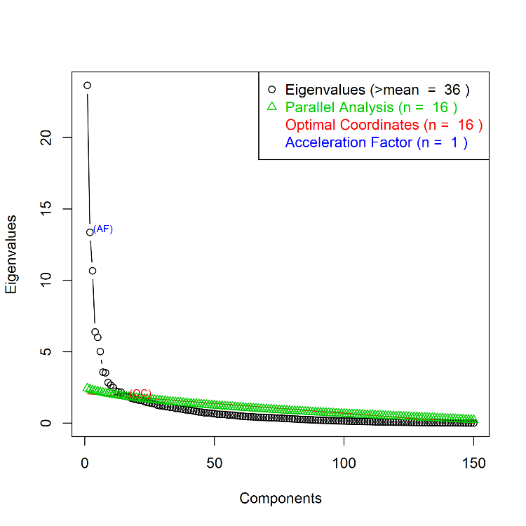
Figure S1: A scree plot: eigenvalues (magnitude of variances) according to the number of principal components for determining the optimal number of components.

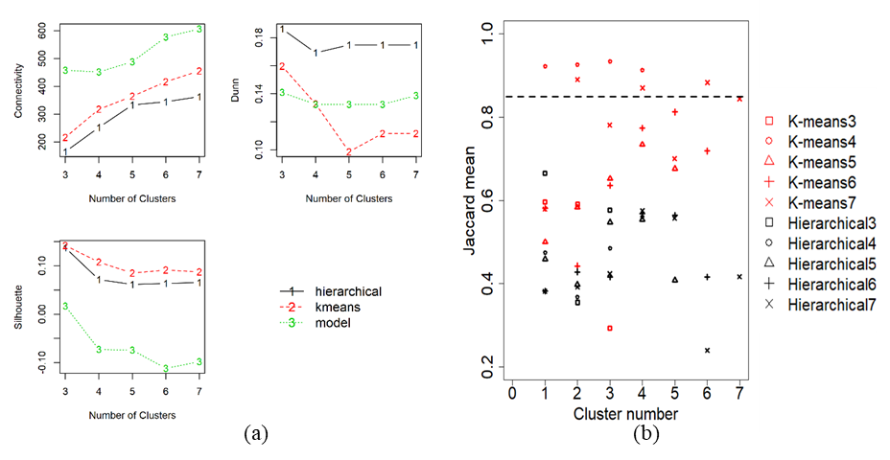
Figure S2: Clustering approaches, number of clusters and stability analysis. a: Internal properties in different clustering methods to find the best clustering approaches as well as the optimal number of clusters. b: Bootstrapping stability analysis between K-means and hierarchical clustering with 3 to 7 numbers of clusters.
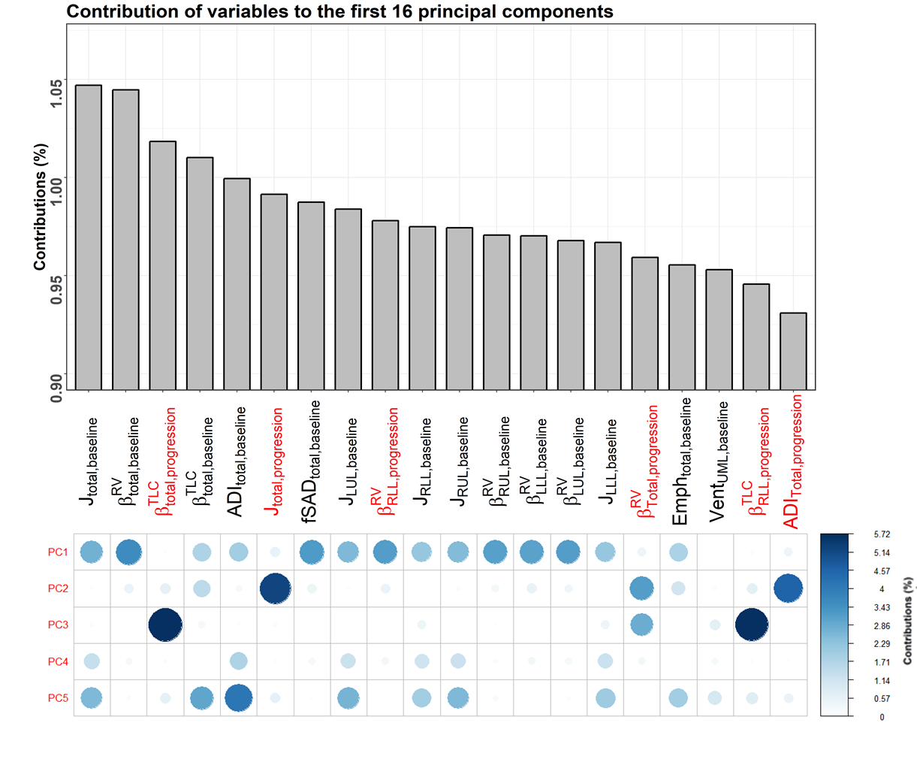
Figure S3: Variables that contribute most to principal components. Top: the top 20 qCT variables that contribute most to the first 16 selected principal components; Bottom: the contribution of the 20 qCT variables to the first 5 principal components respectively. The variables in red are the progression variables.

