Supplementary figures and table

Supplementary material

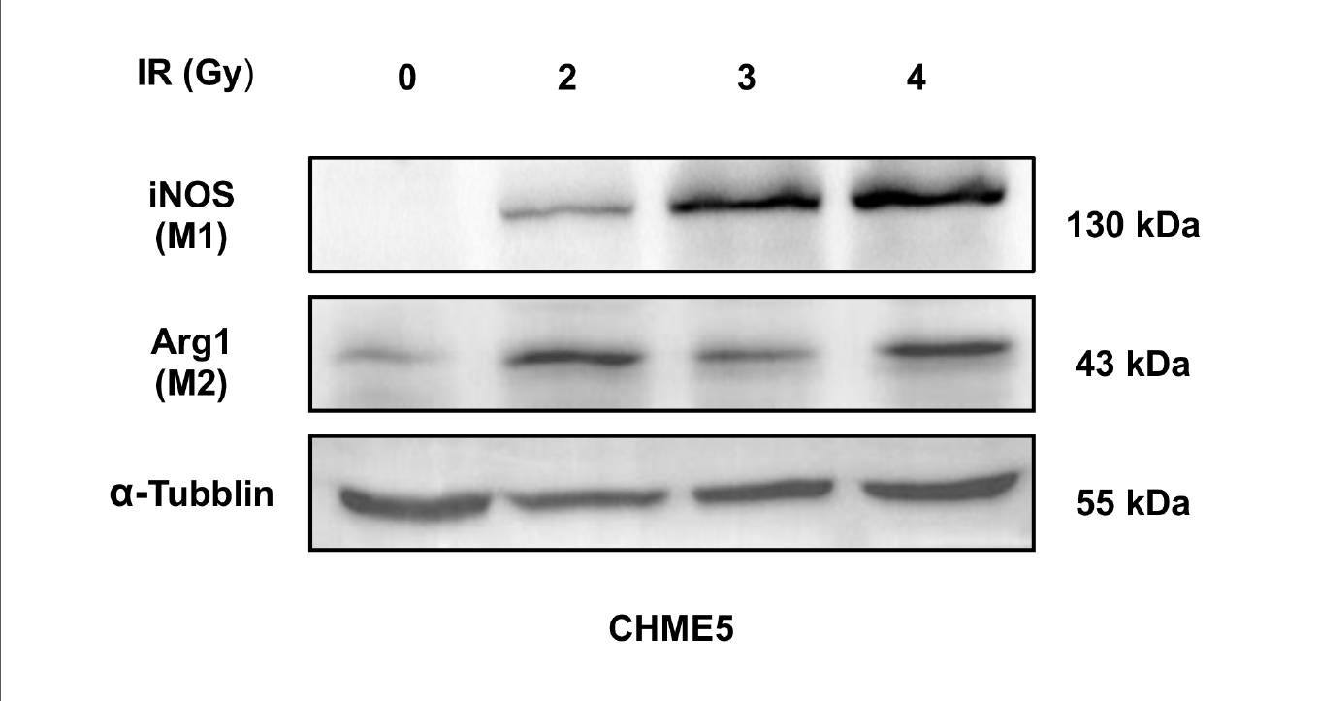
Supplementary Figure 1 The original result of agarose gel electrophoresis for ARG1 in CHME5 cells was shown.
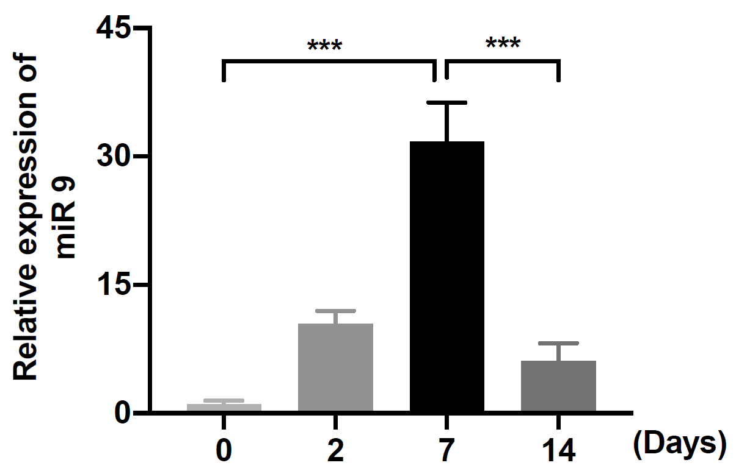
Supplementary Figure 2 qRT-PCR results of miR-9 from mice brain tissue treated with irradiation at different time points.
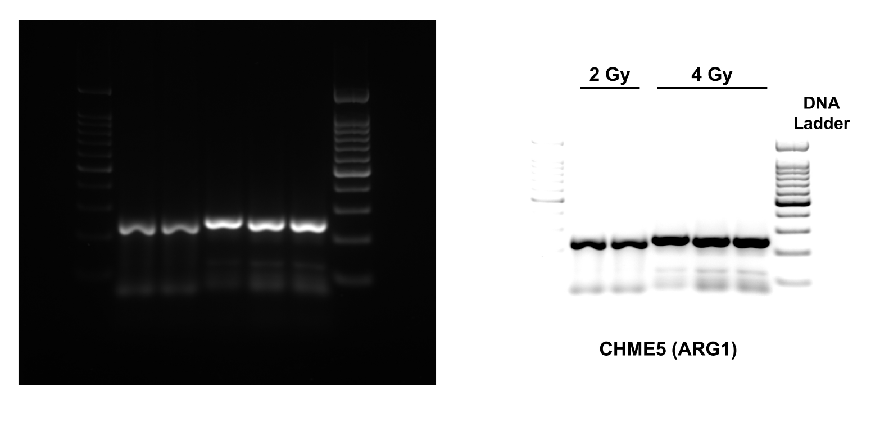
Supplementary Figure 3 Western blots showed different levels of iNOS and Arg1 with different dose gradients.

TABLE S1 Primer sequences used for quantitative reverse transcription-polymerase chain reaction

Gene | Forward or Reverse | Sequences (5’-3’)
GAPDH Forward GGAGCGAGATCCCTCCAAAAT
Reverse GGCTGTTGTCATACTTCTCATGG
Arg1 Forward GTGGAAACTTGCATGGACAAC
Reverse AATCCTGGCACATCGGGAATC
iNOS Forward TTCAGTATCACAACCTCAGCAAG
Reverse TGGACCTGCAAGTTAAAATCCC
IL1B Forward ATGATGGCTTATTACAGTGGCAA
Reverse GTCGGAGATTCGTAGCTGGA

