Appendix I

Competition Instructions:

- Make sure your group is a pre-assigned mixed discipline of four professions.
- In each group the total number is seven.
- Nominate a leader for your team to present your learning findings.
- This competition contains two parts:
  - First part: IPE related questions.
  - Second part: case-based integrated care.
- Total duration of competition is 90 minutes:
  - 20 minutes for the first part.
  - 50 minutes for the second part.
  - 20 minutes to finalize your answers.
- Students should work together to answer all these questions.
- IPE-related questions should be answered by highlighting the wanted answer.
- Profession-related questions should be answered by the students representing this profession, then present the answers to the team, and explain any difficult terminology/procedures to them.
- Answer the questions in an organized manner; starting from the top to the bottom.
- If you need any additional diagnostic results, ask the facilitator to help you.
- This exam is open book, you can use any reference you wish.

Part One: Interprofessional Education Related Questions:

- A 60 years old patient known to have type 2 diabetes for the last 10 years came to the emergency department with infected foot ulcer. On arrival he has high fever and he was confused, the emergency physician was so busy with other critical patients and he gave an order to the attending nurse to clean the infected ulcer and apply dressing, give paracetamol and send the patient home. What is the appropriate action should be taken by the nurse to provide high quality care?
- Respond to the orders and discharge the patient.
- Raise concerns about patient’s situation to the physician.
- Contact the patient’s family and ask them to complain.
- Write an incident report to the hospital manger.
- A pharmacist received an order written by a young resident for a child and he noticed that the dose of the antibiotic was an adult dose. He contacted the resident who replied that it was the advice of the consultant to give this dose. The pharmacist then contacted the consultant to clarify the issue and found that the consultant gave the order by phone to the nurse and explained that the dose should be divided to be given three times/day. What do you think is the reason for this mistake?
- The nurse was ignorant.
- The consultant did not give clear order.
- The resident did not pay attention.
- Lack of communication.
- A healthcare team was having a meeting to dicuss the progress of their patients. One of the members shouted loudly after a conflict about the management of one patient. What do you think is the appropriate action of the leader?
  - Ask him/ her to leave the meeting immediatly.
  - Ignor him and threaten that he will give him/her a bad evaluation.
  - Try to calm him/ her down and give a constructive feedback privetly.
  - Report him/her to the higher authorities to take the appropriate action.
- Which one of the following is a benefit of an interprofessional collaboration?
  - Improves conflict resolution.
  - Increased competition.
  - Hinders creativity.
  - Increases readmission rates.
- What is the most common cause of medical errors?
  - Non ethical practices among phycicians, nurses and pharmacists.
  - Miscommunication between the members of healthcare team.
  - Competition between healthcare workers.
  - Lack of resources and supplies for hospitals.

Part Two: Case Related Questions:

Case Scenario
Title | Interprofessional Education Collaboration and Competition – Case. | Version | 1.1.
Target Audience | King Saud University Health Colleges Students. | Run Time | 50 min.

Case Summary
Amina Abdulrahman is a 65-year-old woman with a two-day history of shortness of breath, fatigue, high-grade fever and feeling hot and cold at the same time. She has positive contact with COVID-19 family member last week. The candidate calls the red crescent to bring her to the hospital.

As you read the case summery, answer the following questions, the suitable profession should answer questions appropriately:

Number | Question | Hint | Grade
1 | What profession is expected to perform the initial assessment and management before transferring patient to the hospital? |  | 1
Answer | Paramedics.
2 | What precaution measures should you consider when dealing with COVID-19 case? | Write a full answer. | 2
Answer | - Consider every patient as a COVID-19 patient.  - Proper hand hygiene.  - Use personal protective equipment (PPE):  - Respiratory protection: N95 mask, FFP2 or FFP3.  - Eye protection: face shield.  - Body protection: Long-sleeved water-resistant gown.  - Hand protection: gloves.  - Initially, only one paramedic should make patient contact unless another personnel is required.
3 | What is your initial assessment and management for this patient ؟ | Answer scientifically. | 3
Answer | - General assessment with emphasizing chief compliant impression which may include:  - ABCDE assessment.  - Vital signs screening.  - Patient’s history.  - And based on patient’s condition: getting IV access, providing high flow oxygen therapy, and cooling the patient with cold compress or bags.  - Then transport with comforting position and reassess every 5 minutes.  - Be ready when arriving to provide the verbal report.
4 | What hospitals did you chose to pick the patient for? | Explain prehospital system for other profession. | 2
Answer | Contacting dispatch center, then transferring the patient to the hospital chosen by dispatch centre, taking in consideration the near hospital capacity.
5 | If patient deteriorating and oxygen level reach 60%, what would you do? | Answer scientifically. | 3
Answer | First try to raise the Spo2 by using NRB 100%, if O2 doesn't work asses the lungs (& may be GCS), then intubate the patient using RSI sequence.

Patient has arrived at the hospital, answer the following questions:

Number | Question | Hint |  | Grade
1 | What profession is expected to receive the case? |  |  | 1
Answer | - Nurses.  - Nurses with ER physician.  Both are correct.
2 | What questions should be asked to the HCW who bring the patient to the hospital? |  |  | 2
Answer | Verbal report which includes:  - Incident and time of incident.  - Vitals.  - History.  - Prehospital intervention.
3 | What are the procedures and assessment tools should be performed immediately for the patient? | Write a full answer. |  | 3
Answer | - Registration  - Triage (ABCDE).  - Monitor the saturation of spo2.  - Isolation of the patient.  - COVID-19 swap.
4 | What is the next step?
Answer | - Chest x-ray.  - Blood sample; ABG, CBC, CMP  - Getting IV access (2 IV Lines) if not already done.
5 | After a few minutes of arriving, patient BP drop significantly. What should you do? | Answer scientifically. |  | 3
Answer | - IV has been established already by 2 large bore needles.  - Resuscitate patient with ≥30 mL/kg (~2L in a 70-kg adult) of lactated Ringer’s solution or normal saline.  - If the suspected infection PLUS 2 of these 3 (SBP ≤ 100, RR ≥ 22, or altered mental status), sepsis will be suspected and antibiotics targeting chest infection such as third generation cephalosporin or piperacillin/tazobactam PLUS azithromycin may be used.
6 | Patient BP has retained to semi-normal level, what is the next step? What profession should be involved now? And for what reason? |  |  |  | 1
- Consult ICU team and Keep monitoring the patient.
- Consult Infectious Diseases department, to further investigation the patient's condition and possibility of COVID-19.
Patient Profile
Setting | Emergency Department – Resus area
Name | AA
Age | 65
Gender | Female
History of Present Illness
PRESENTING COMPLAINT – Shortness of breath
- Patient presented by an ambulance, complaining of shortness of breath and feeling hot and cold at the same time, with two-days history of feeling unwell. She had started a course of antibiotics prescribed by the GP, but she didn’t know what they are called.

OTHER SYMPTOMS
- Generally, feel unwell
- Anxious
PAST MEDICAL HISTORY
- Diabetes Miletus.
- Hypertension.
- Constipation
- No known drug allergies
SOCIAL HISTORY
- Married, lives with husband Mohamad Khalid (68 years old)
- Independent
- Non-smoker

Initial monitor parameters
RR | O2 sats | Pulse (HR) | BP | ECG rhythm
40 / min | 90% | 110 /min | 90/68 mmHg | Sinus rhythm
Cap Refill Time |  | Blood glucose |  | Temp.
3 sec |  | 10.6 mmol |  | 38.9 Cº
The patient now in triage in Resus. Answer appropriately.

Number | Question | Hint | Grade
1 | According to the case scenario until now, what is your differential diagnosis? | Answer scientifically. | 2
Answer | Respiratory infection (suspected COVID-19 pneumonia).
2 | What are the lab tests/procedures would you recommend for this patient? | Answer scientifically. | 2
Answer | - Lactic acid  - MAP  - ABG  - Urinalysis  - Blood and urine culture  - Liver and kidney profile  - Urine cath  - CBC  - CRP  - Coagulation profile
3 | Who is the profession that he/she should identify and delegate work to the team? |  | 3
Answer | Physicians.
4 | What is the next step? |  | 1.5
Answer | - Start antipyretics (paracetamol 650 mg PO/PRN q4hr for pain and fever).  - Start regular insulin IV, follow inpatient hospital policy.  - Start prophylaxis LMWH: enoxaparin 40 mg SC once daily.  - Monitor BP, BG, oxygen saturation, and modify accordingly.
5 | Assume patient experience a second drop in the BP, with no response to the management plan. What we call this case? And how you going to manage this case? | Answer scientifically. | 3
Answer | - Septic shock.  - Start vasopressor through central venous access (Norepinephrine 0.4 mcg/hour) titrated to reach mean arterial pressure of 65 mm Hg.  - Start or continue antibiotics therapy.

Available diagnostic tools until now:

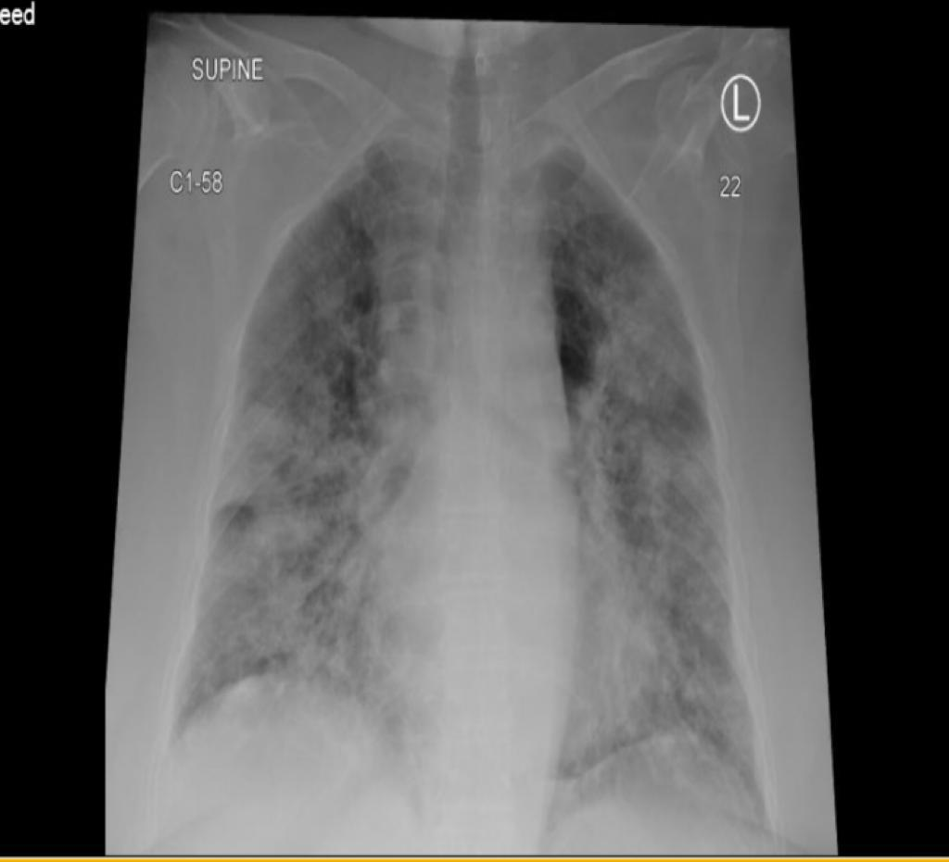
Lab results

 | Results | Normal Values
Blood Gas Values
pH | 7.285
pCO₂ | 5.63 kPa
pO₂ | 3.21 kPa
Oximetry values
HCO₃⁻ | 16 mmol/L
Electrolytes values
Na⁺ | 13.6 mmol/L | [136-146]
K⁺ | 5 mmol/L | [3.4-4.5]
CL⁺ | 93 mmol/L | [98-106]
Ca²⁺ | 1.08 mmol/L | [1.15-1.29]
Anion gap | 28 mmol/L
Metabolite values
Glu | 6.8 mmol/L | [3.9-5.8]
Lac | 8.2 mmol/L | [0.5-1.6]
Albumin | 35 g/L | [35-55]

Number | Question | Hint | Grade
1 | After reviewing the diagnostic tools listed above, what is your diagnosis? | Answer scientifically. | 2
Answer | - Confirm septic shock due to COVID-19 pneumonia.  - Metabolic acidosis (with increased anion gap).  - Diffuse pneumonia.
Did you need a further diagnostic criterion? If Yes, ask the facilitator to provide you what you need. If no, please skip this point.
2 | Explain in detail; role of every profession, with their assigned tasks. | Write a full answer. | 3
Answer | - Paramedics: primary care, transferring patients to other departments or facilities if needed.  - Nurses: they are a vital link between the patient and the rest of the health care team. They administer medication fluids, take samples, and follow up the patient's case.  - Pharmacists: pharmacists review patient medication history, and current medications and optimize therapeutic management and minimize medication adverse events. They look for possible interactions and side effects of prescribed medications.  - Physicians: diagnose patient, prescribing medications, following up.
3 | What is the next step?
Answer | Isolating patient, reassessment, administering medication, Evaluate patient response.

Q: In order to know more about other professions role, answer all the following question TOGETHER. If your colleagues did not understand the procedure/terminology, you have to explain to them:

For the paramedics
Q: What are the criteria to classify a patient as a possible or confirmed case? | A: 1. Confirmed laboratory test of being a COVID-19 patient  2. A close contact to a patient with confirmed or probable COVID-19.  3. There are signs and symptoms of COVID-19. | G: 2 points
Q: What is the recommended position to promote air exchange? | A: up right or tripod position or position of comfort | G: 2 point
For the nurses
Q: What signs and symptoms indicate deterioration of patient case? | A: shortness of breath, fatigue, high fever, feeling hot and cold at same time. | G: 2 points
Q: Priorities two nursing diagnose (1 actual, 1 potential) based on patient assessment findings. | A: 1. Actual: Ineffective Breathing Pattern related to hypoxia as evidence by shortness of breath and the patient O2 saturation is 90%  2. Potential: Risk for activity intolerance related to fatigue. | G: 2 points
For the medical doctors
What is the best method(s) to reduce the nosocomial spread of COVID19? | A: 1. Maintain contact and droplet precautions at all times plus airborne precaution during aerosol-producing procedures like: N95, HEPA filter, goggles.  2. Wearing PPE, place patients in adequately ventilated single rooms, isolating patients in the negative pressure room, administering medication together if possible, rather than many times per day to decrease patient contact, strict hand hygiene, pharmacy home delivery, virtual clinics, postpone unnecessary procedures, keeping record of the HCW who contacted or dealt with COVID-19 patients for contact tracing, refrain from touching eyes, nose or mouth with potentially contaminated hands.  3. If transport is required, use predetermined transport routes to minimize exposures to other staff, other patients and visitors, and apply medical masks to patients.  4. Routinely clean and disinfect patient-contact surfaces. | G: 2 points
What is different in HCWs Safety measures during an infectious disease outbreak from routine occupational safety? | A:  - PPE upon entering any patient’s area.  - Establishment of sustainable IPC infrastructures and activities, with clear roles and responsibilities as per the infection control guidelines.  - Ensure all necessary preventive and protective measures are available and implemented to minimize occupational safety and health risks.  - Provide daily technical COVID-19 updates from trusted resources and share up-to-date infection prevention and control information with providers, patients and the public via electronic platforms.  - Provide HCWs with the appropriate tools to assess, triage, and treat patients.  - HCWs who are ill should follow the established guidelines with regards to self-isolation and testing for COVID-19.  - Avoid transport of patients throughout the facility except for medically essential purposes and develop a dedicated transport route and routes of entry involving source control for the patient, PPE for workers, and environmental cleaning. | G: 2 points
For the pharmacist
Q: Assess for the need of thromboprophylaxis and stress-ulcer prophylaxis, then write your recommendations. | A: Thromboprophylaxis with low molecular weight heparin (LMWH) should be considered in ALL patients (including non-critically ill) who require hospital admission for COVID-19 infection, in the absence of any contraindications (active bleeding and platelet count less than 25 x 109/L; monitoring is advised in severe renal impairment; abnormal PT or APTT is not a contraindication)  - Recommended Drug Enoxaparin 40 mg daily  Stress-ulcer prophylaxis : No specific consideration. | G: 2 points
Q: Did you optimize the prescribed therapy in terms of the choice, regimen, efficacy/safety parameters, lack of interaction, and pharmacokinetic monitoring? If yes list a detail answer. | A: yes.  - Antipyretics (paracetamol 500 mg PO/PRN q4hr for pain and fever).  - Continue fluid resuscitation (crystalloid 30 ml/h/kg)  - Continue the patient on pre existing meds (hypertension meds and diabetes meds (1 point)  --------  - Suspicious Cases ( Mild to Moderate: Symptoms with shortness of breath in high risk patients )  - Treat Symptoms : Paracetamol (acetaminophen) is the preferred agent for pain/fever  - Labs and work-up: CBC,Urea/Electrolytes, Creatinine, CRP, LFTs, Chest X-ray, COVID-19 PCR tests  - Case shall be discussed with infectious disease specialists, to initiate empirical antiviral therapy, while awaiting PCR results.  - Do not stop ACEI/ARBs in patients with hypertension, post-MI, heart failure ( if she taken one )  - Patient case consider Severe : Symptoms ≥ 1 of the following: ( Respiratory rate≥30/min(adults)  - Recommend a Favipiravir  - Adult Dosing: 1800 mg/dose twice a day on the first day; followed by 800 mg/dose twice a day for 7-10 days. | G: 2 points

Q: Question, A: Answer, G: Grade.

Abbreviations:

COVID-19 | Corona virus-2019 | CMP | Comprehensive metabolic panel
HCWs | Health care workers | SBP | systolic blood pressure
PPE | Personal protective equipment | RR | Respiratory rate
N95 | Respirator blocks at least 95% of very small (0.3 micron) particles. | ICU | Intensive care unit
FFP2 | Filtering facepiece-2 | GP | General practitioner
FFP3 | Filtering facepiece-3 | MAP | Mean arterial pressure
ABCDE | Airway, breathing, circulation, disability, exposure | CRP | C-reactive protein
IV | Intravenous | PO | By mouth
Spo2 | Oxygen saturation | PRN | As needed.
NRB | Non-rebreather mask | LMWH | Low molecular weight heparin
O2 | Oxygen | SC | Subcutaneous
GCS | Glasgow coma scale | BP | Blood pressure
RSI | Rapid sequence intubation | BG | Blood glucose
ER | Emergency room | IPC | Infection prevention and control
ABG | Arterial blood gas
CBC | Complete blood count

