Supplementary Material

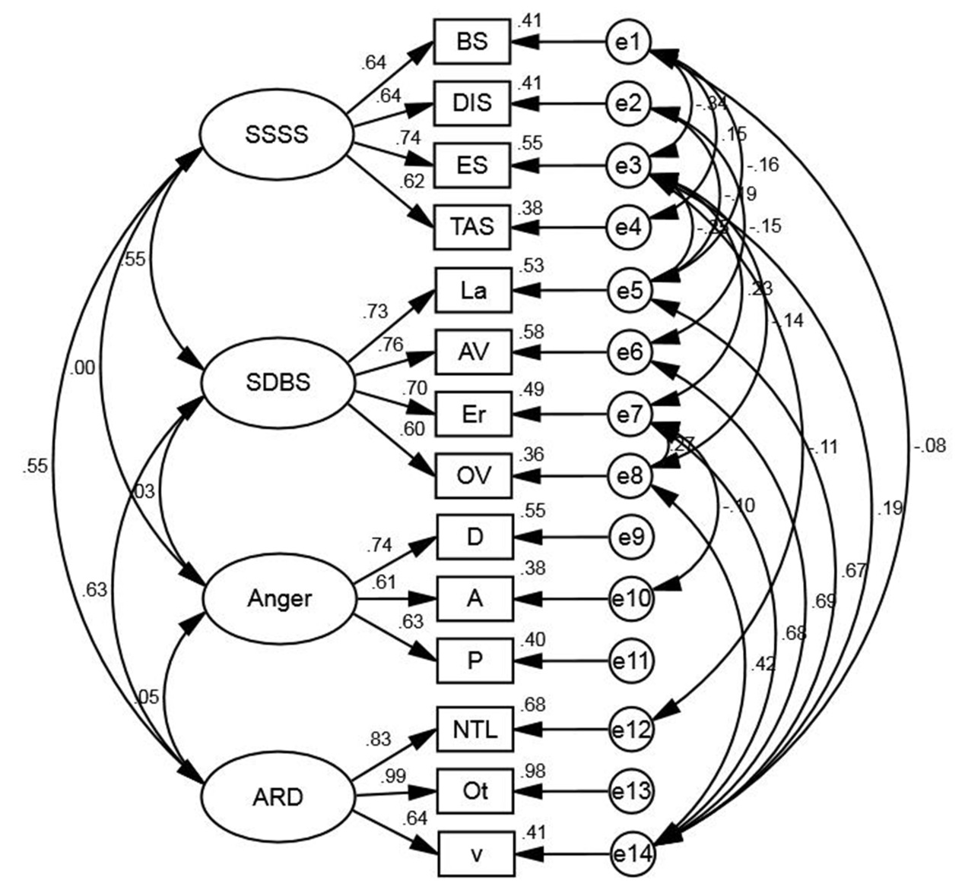
Figure S1 The CFA model for anger.
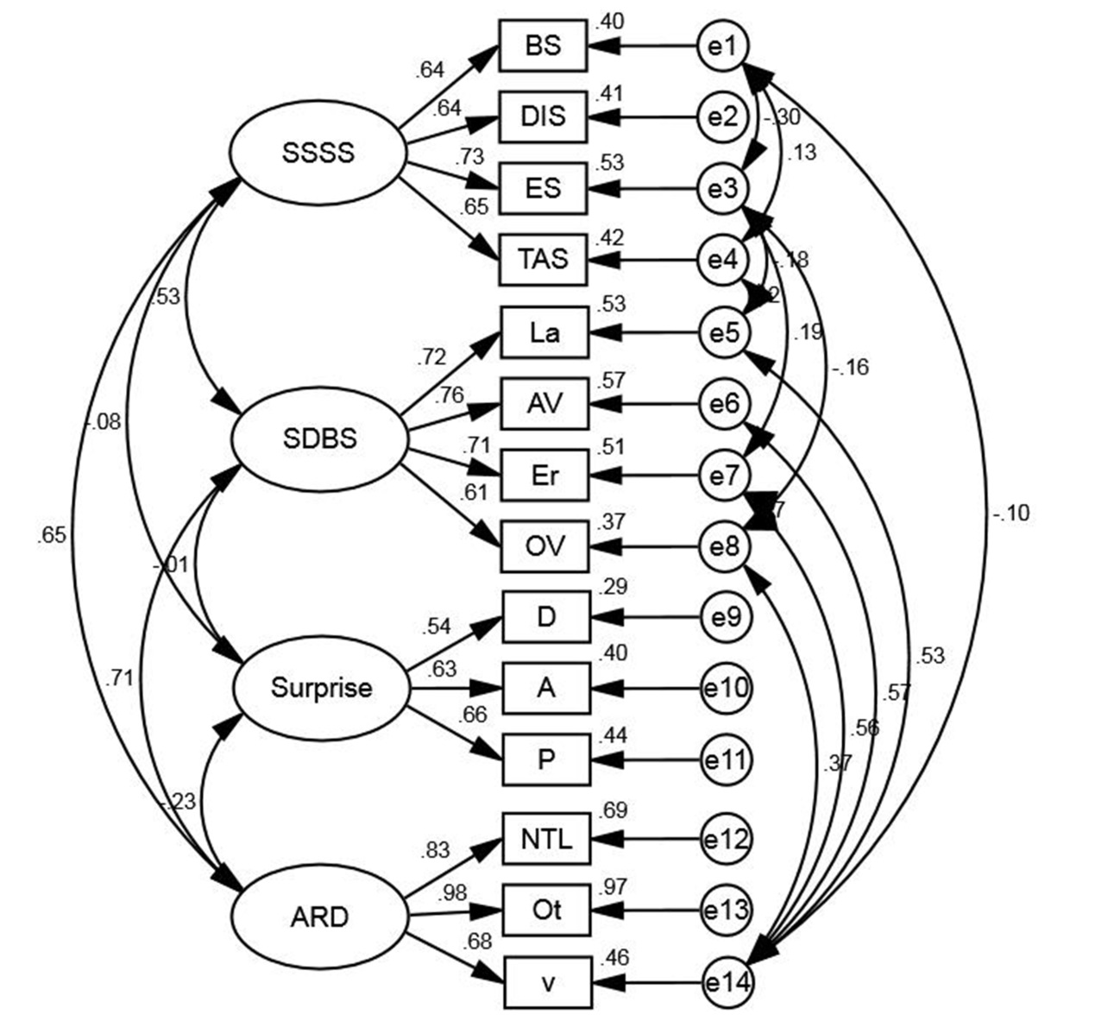
Figure S2 The CFA model for surprise.
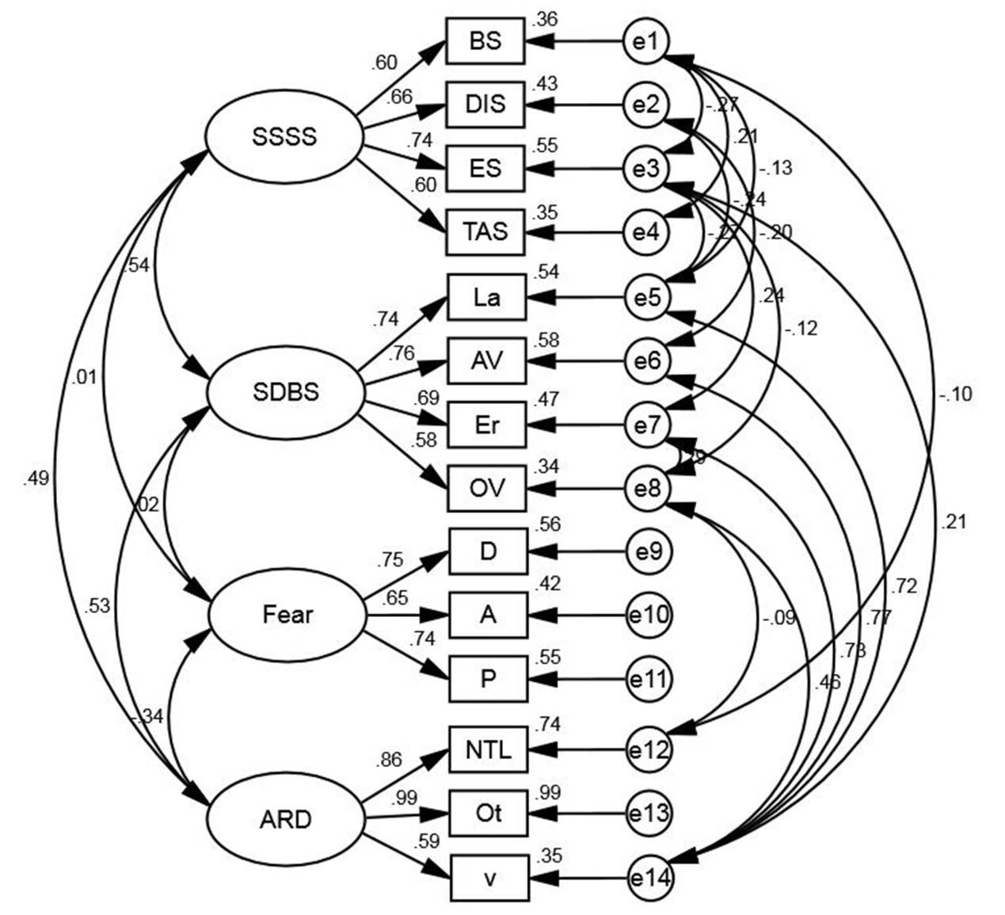
Figure S3 The CFA model for fear.
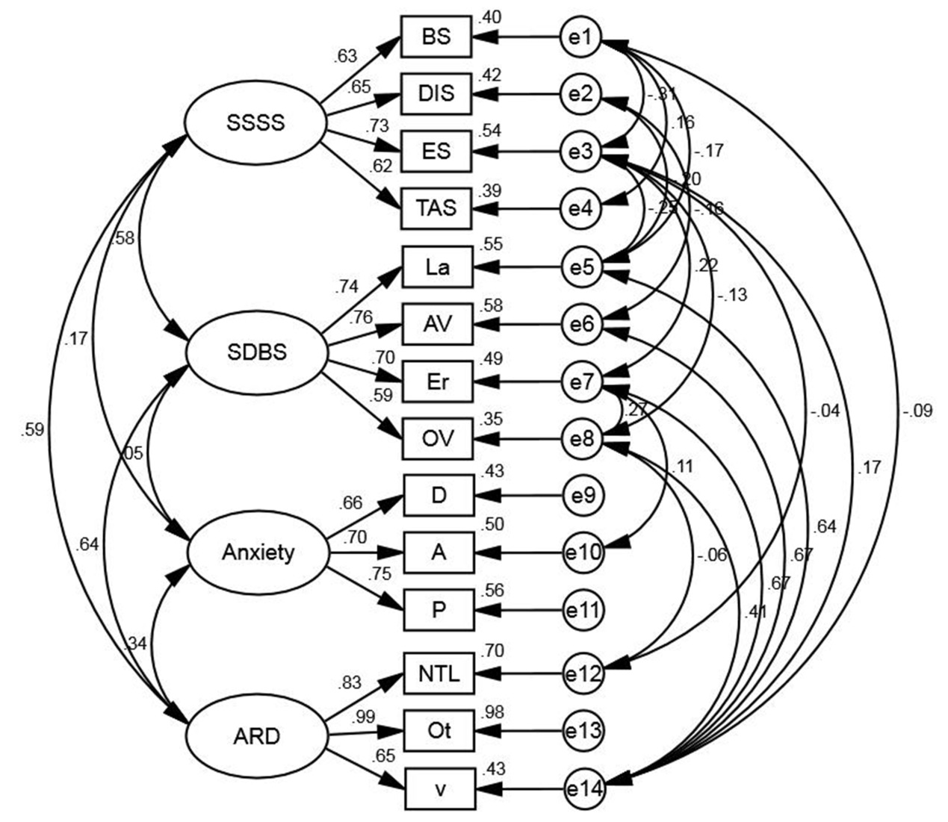
Figure S4 The CFA model for anxiety.
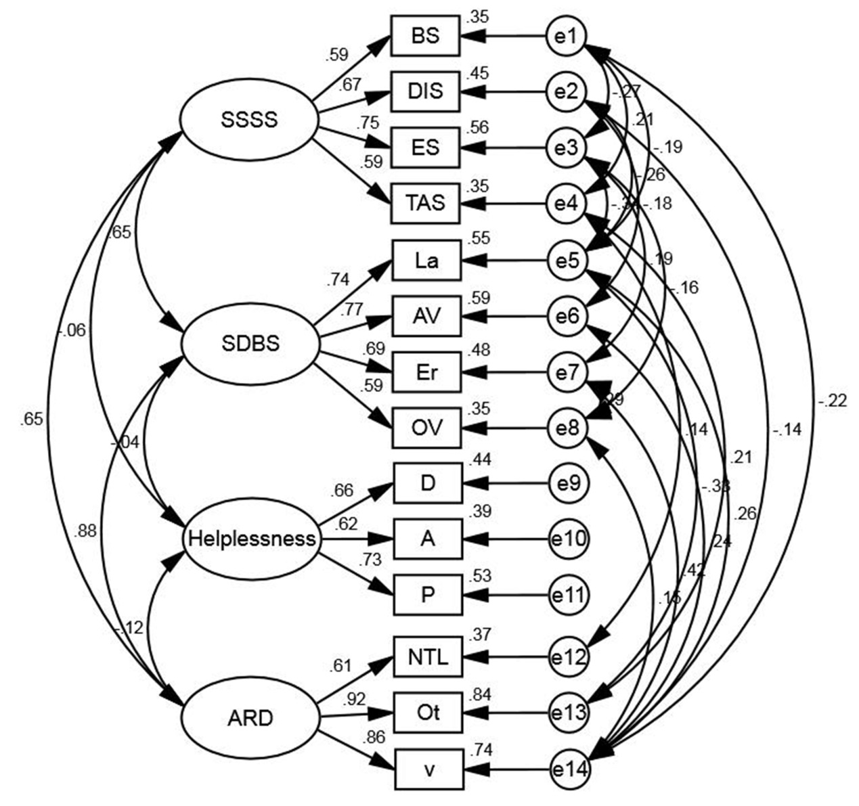
Figure S5 The CFA model for helplessness.
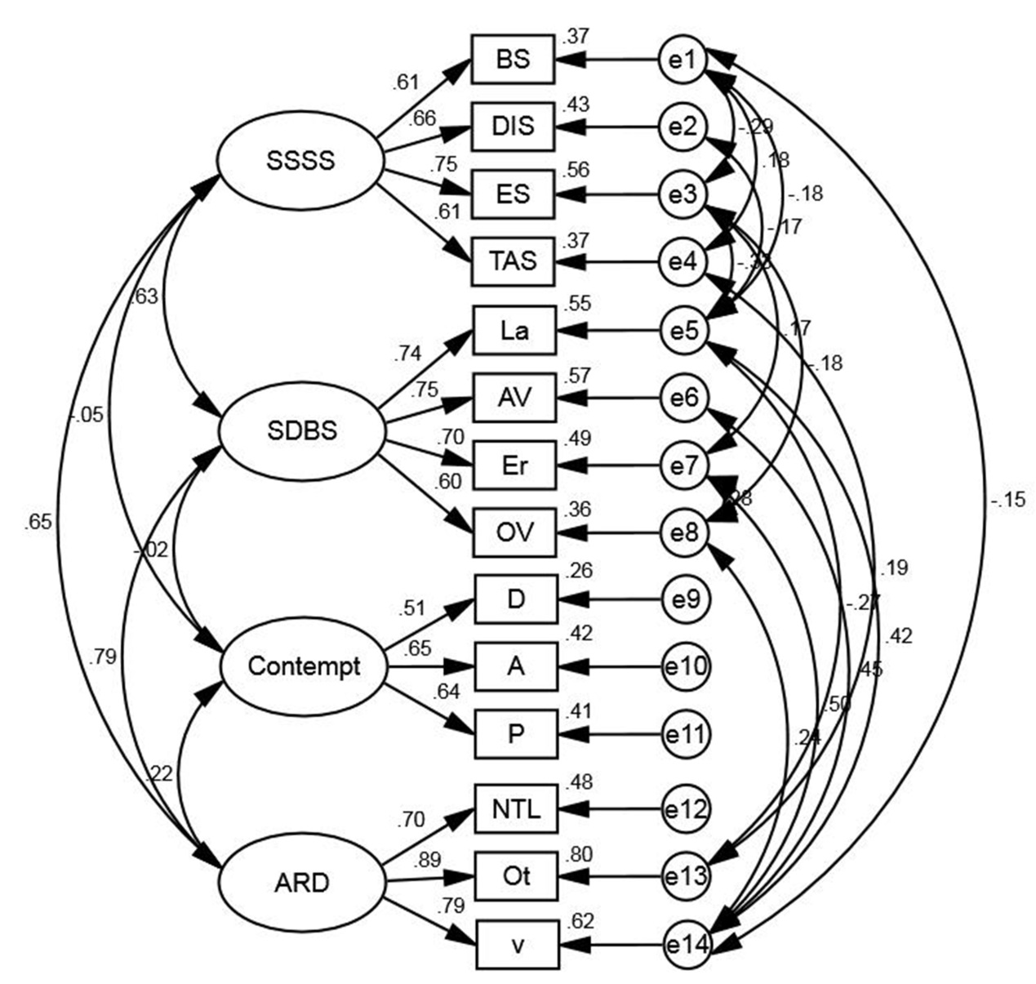
Figure S6 The CFA model for contempt.
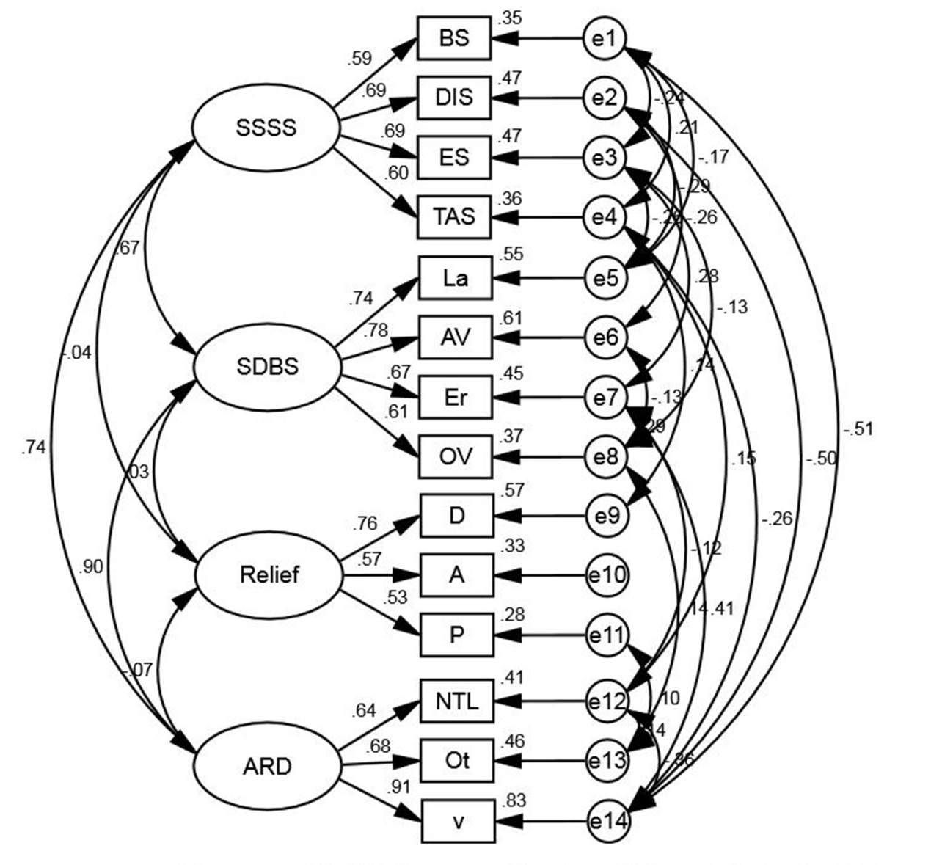
Figure S7 The CFA model for relief.
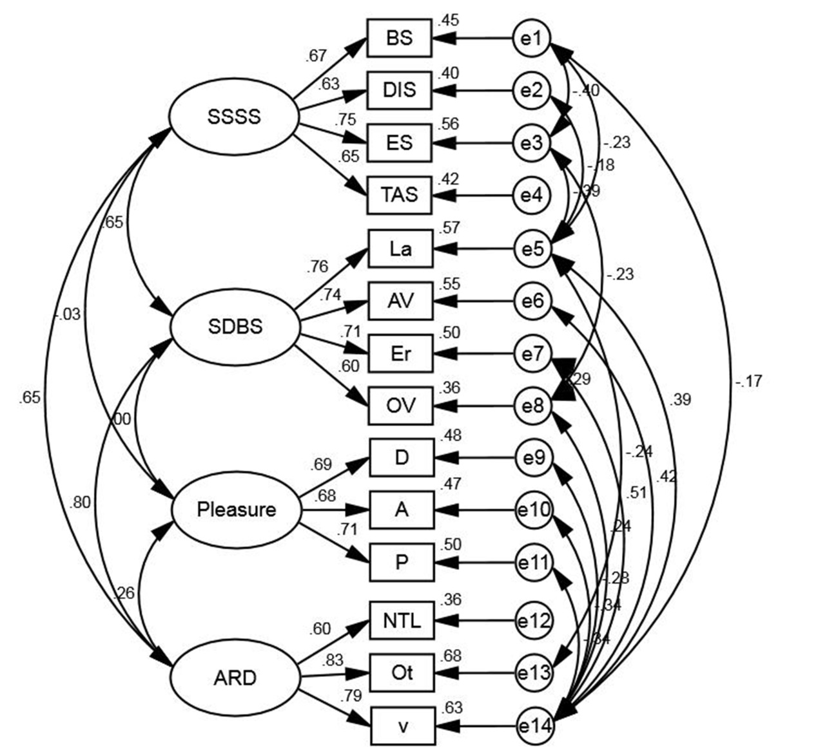
Figure S8 The CFA model for pleasure.

Table S1 CFA result (anger)
Path |  |  | NPC | SE | t | Sig | SPC | AVE | CR
BS | <--- | SSSS | 1.000 | - | - | - | 0.637 | 0.437 | 0.755
DIS | <--- | SSSS | 1.131 | 0.114 | 9.938 | *** | 0.639 | 0.437 | 0.755
ES | <--- | SSSS | 1.318 | 0.125 | 10.548 | *** | 0.741 | 0.437 | 0.755
TAS | <--- | SSSS | 1.044 | 0.089 | 11.681 | *** | 0.620 | 0.437 | 0.755
La | <--- | SDBS | 1.000 | - | - | - | 0.731 | 0.488 | 0.791
AV | <--- | SDBS | 0.670 | 0.043 | 15.463 | *** | 0.759 | 0.488 | 0.791
Er | <--- | SDBS | 0.967 | 0.066 | 14.645 | *** | 0.697 | 0.488 | 0.791
OV | <--- | SDBS | 0.858 | 0.069 | 12.457 | *** | 0.596 | 0.488 | 0.791
D | <--- | Anger | 1.000 | - | - | - | 0.743 | 0.444 | 0.704
A | <--- | Anger | 0.809 | 0.082 | 9.815 | *** | 0.615 | 0.444 | 0.704
P | <--- | Anger | 0.836 | 0.085 | 9.846 | *** | 0.633 | 0.444 | 0.704
NTL | <--- | ARD | 1.000 | - | - | - | 0.825 | 0.690 | 0.867
Ot | <--- | ARD | 1.306 | 0.052 | 24.879 | *** | 0.991 | 0.690 | 0.867
v | <--- | ARD | 4.487 | 0.255 | 17.579 | *** | 0.637 | 0.690 | 0.867
Notes: *** p<0.01, ** p<0.05, * p< 0.1.
Abbreviations: NPC, non-standard path coefficient; SE, standard error; Sig, significance; SPC, standard path coefficient; CR, combined reliability; AVE, average variance extracted.
BS, boredom susceptibility; DIS, disinhibition; ES, experience seeking; TAS, thrill and adventure seeking; La, lapses; AV, aggressive violations; Er, errors; OV, ordinary violations; P, Pleasure-displeasure; A, Arousal-nonarousal; D, Dominance-submissiveness; v, driving speed; Ot, number of overtaking; NTL, number of changing lane without turning light; SDBS, self-reported risky driving style; SSSS, self-reported sensation seeking; ARD, actual risky driving behaviors.

Table S2 CFA result (surprise)
Path |  |  | NPC | SE | t | Sig | SPC | AVE | CR
BS | <--- | SSSS | 1.000 | - | - | - | 0.636 | 0.441 | 0.759
DIS | <--- | SSSS | 1.143 | 0.109 | 10.473 | *** | 0.642 | 0.441 | 0.759
ES | <--- | SSSS | 1.302 | 0.120 | 10.823 | *** | 0.726 | 0.441 | 0.759
TAS | <--- | SSSS | 1.097 | 0.090 | 12.166 | *** | 0.647 | 0.441 | 0.759
La | <--- | SDBS | 1.000 | - | - | - | 0.725 | 0.494 | 0.795
AV | <--- | SDBS | 0.674 | 0.043 | 15.818 | *** | 0.758 | 0.494 | 0.795
Er | <--- | SDBS | 0.998 | 0.066 | 15.085 | *** | 0.713 | 0.494 | 0.795
OV | <--- | SDBS | 0.883 | 0.069 | 12.766 | *** | 0.607 | 0.494 | 0.795
D | <--- | Surprise | 1.000 | - | - | - | 0.541 | 0.377 | 0.643
A | <--- | Surprise | 1.287 | 0.153 | 8.421 | *** | 0.632 | 0.377 | 0.643
P | <--- | Surprise | 1.387 | 0.166 | 8.373 | *** | 0.662 | 0.377 | 0.643
NTL | <--- | ARD | 1.000 | - | - | - | 0.833 | 0.707 | 0.876
Ot | <--- | ARD | 1.301 | 0.047 | 27.978 | *** | 0.984 | 0.707 | 0.876
v | <--- | ARD | 4.418 | 0.236 | 18.726 | *** | 0.678 | 0.707 | 0.876
Notes: *** p<0.01, ** p<0.05, * p< 0.1.
Abbreviations: NPC, non-standard path coefficient; SE, standard error; Sig, significance; SPC, standard path coefficient; CR, combined reliability; AVE, average variance extracted.
BS, boredom susceptibility; DIS, disinhibition; ES, experience seeking; TAS, thrill and adventure seeking; La, lapses; AV, aggressive violations; Er, errors; OV, ordinary violations; P, Pleasure-displeasure; A, Arousal-nonarousal; D, Dominance-submissiveness; v, driving speed; Ot, number of overtaking; NTL, number of changing lane without turning light; SDBS, self-reported risky driving style; SSSS, self-reported sensation seeking; ARD, actual risky driving behaviors.

Table S3 CFA result (fear)
Path |  |  | NPC | SE | t | Sig | SPC | AVE | CR
BS | <--- | SSSS | 1.000 | - | - | - | 0.598 | 0.423 | 0.744
DIS | <--- | SSSS | 1.251 | 0.127 | 9.855 | *** | 0.660 | 0.423 | 0.744
ES | <--- | SSSS | 1.403 | 0.136 | 10.324 | *** | 0.739 | 0.423 | 0.744
TAS | <--- | SSSS | 1.073 | 0.094 | 11.415 | *** | 0.595 | 0.423 | 0.744
La | <--- | SDBS | 1.000 | - | - | - | 0.736 | 0.482 | 0.787
AV | <--- | SDBS | 0.665 | 0.044 | 15.153 | *** | 0.759 | 0.482 | 0.787
Er | <--- | SDBS | 0.947 | 0.066 | 14.346 | *** | 0.686 | 0.482 | 0.787
OV | <--- | SDBS | 0.831 | 0.069 | 12.125 | *** | 0.583 | 0.482 | 0.787
D | <--- | Fear | 1.000 | - | - | - | 0.748 | 0.512 | 0.758
A | <--- | Fear | 0.887 | 0.069 | 12.792 | *** | 0.650 | 0.512 | 0.758
P | <--- | Fear | 1.027 | 0.076 | 13.509 | *** | 0.744 | 0.512 | 0.758
NTL | <--- | ARD | 1.000 | - | - | - | 0.859 | 0.692 | 0.866
Ot | <--- | ARD | 1.263 | 0.045 | 27.753 | *** | 0.993 | 0.692 | 0.866
v | <--- | ARD | 3.664 | 0.225 | 16.310 | *** | 0.594 | 0.692 | 0.866
Notes: *** p<0.01, ** p<0.05, * p< 0.1.
Abbreviations: NPC, non-standard path coefficient; SE, standard error; Sig, significance; SPC, standard path coefficient; CR, combined reliability; AVE, average variance extracted.
BS, boredom susceptibility; DIS, disinhibition; ES, experience seeking; TAS, thrill and adventure seeking; La, lapses; AV, aggressive violations; Er, errors; OV, ordinary violations; P, Pleasure-displeasure; A, Arousal-nonarousal; D, Dominance-submissiveness; v, driving speed; Ot, number of overtaking; NTL, number of changing lane without turning light; SDBS, self-reported risky driving style; SSSS, self-reported sensation seeking; ARD, actual risky driving behaviors.

Table S4 CFA result (anxiety)
Path |  |  | NPC | SE | t | Sig | SPC | AVE | CR
BS | <--- | SSSS | 1.000 | - | - | - | 0.629 | 0.437 | 0.755
DIS | <--- | SSSS | 1.167 | 0.113 | 10.322 | *** | 0.651 | 0.437 | 0.755
ES | <--- | SSSS | 1.327 | 0.124 | 10.709 | *** | 0.734 | 0.437 | 0.755
TAS | <--- | SSSS | 1.062 | 0.089 | 11.961 | *** | 0.623 | 0.437 | 0.755
La | <--- | SDBS | 1.000 | - | - | - | 0.740 | 0.490 | 0.792
AV | <--- | SDBS | 0.662 | 0.042 | 15.852 | *** | 0.759 | 0.490 | 0.792
Er | <--- | SDBS | 0.960 | 0.064 | 14.937 | *** | 0.697 | 0.490 | 0.792
OV | <--- | SDBS | 0.840 | 0.067 | 12.599 | *** | 0.592 | 0.490 | 0.792
D | <--- | Anxiety | 1.000 | - | - | - | 0.658 | 0.495 | 0.746
A | <--- | Anxiety | 1.140 | 0.093 | 12.215 | *** | 0.704 | 0.495 | 0.746
P | <--- | Anxiety | 1.158 | 0.094 | 12.378 | *** | 0.746 | 0.495 | 0.746
NTL | <--- | ARD | 1.000 | - | - | - | 0.834 | 0.702 | 0.873
Ot | <--- | ARD | 1.244 | 0.046 | 27.075 | *** | 0.992 | 0.702 | 0.873
v | <--- | ARD | 4.154 | 0.230 | 18.045 | *** | 0.652 | 0.702 | 0.873
Notes: *** p<0.01, ** p<0.05, * p< 0.1.
Abbreviations: NPC, non-standard path coefficient; SE, standard error; Sig, significance; SPC, standard path coefficient; CR, combined reliability; AVE, average variance extracted.
BS, boredom susceptibility; DIS, disinhibition; ES, experience seeking; TAS, thrill and adventure seeking; La, lapses; AV, aggressive violations; Er, errors; OV, ordinary violations; P, Pleasure-displeasure; A, Arousal-nonarousal; D, Dominance-submissiveness; v, driving speed; Ot, number of overtaking; NTL, number of changing lane without turning light; SDBS, self-reported risky driving style; SSSS, self-reported sensation seeking; ARD, actual risky driving behaviors.

Table S5 CFA result (helplessness)
Path |  |  | NPC | SE | t | Sig | SPC | AVE | CR
BS | <--- | SSSS | 1.000 | - | - | - | 0.591 | 0.429 | 0.749
DIS | <--- | SSSS | 1.287 | 0.128 | 10.089 | *** | 0.673 | 0.429 | 0.749
ES | <--- | SSSS | 1.454 | 0.139 | 10.473 | *** | 0.749 | 0.429 | 0.749
TAS | <--- | SSSS | 1.075 | 0.095 | 11.318 | *** | 0.594 | 0.429 | 0.749
La | <--- | SDBS | 1.000 | - | - | - | 0.738 | 0.490 | 0.792
AV | <--- | SDBS | 0.670 | 0.042 | 15.970 | *** | 0.765 | 0.490 | 0.792
Er | <--- | SDBS | 0.961 | 0.065 | 14.844 | *** | 0.693 | 0.490 | 0.792
OV | <--- | SDBS | 0.845 | 0.066 | 12.826 | *** | 0.593 | 0.490 | 0.792
D | <--- | Helplessness | 1.000 | - | - | - | 0.664 | 0.453 | 0.712
A | <--- | Helplessness | 0.895 | 0.086 | 10.464 | *** | 0.622 | 0.453 | 0.712
P | <--- | Helplessness | 1.023 | 0.099 | 10.340 | *** | 0.729 | 0.453 | 0.712
NTL | <--- | ARD | 1.000 | - | - | - | 0.606 | 0.652 | 0.845
Ot | <--- | ARD | 2.091 | 0.130 | 16.027 | *** | 0.919 | 0.652 | 0.845
v | <--- | ARD | 8.075 | 0.513 | 15.744 | *** | 0.862 | 0.652 | 0.845
Notes: *** p<0.01, ** p<0.05, * p< 0.1.
Abbreviations: NPC, non-standard path coefficient; SE, standard error; Sig, significance; SPC, standard path coefficient; CR, combined reliability; AVE, average variance extracted.
BS, boredom susceptibility; DIS, disinhibition; ES, experience seeking; TAS, thrill and adventure seeking; La, lapses; AV, aggressive violations; Er, errors; OV, ordinary violations; P, Pleasure-displeasure; A, Arousal-nonarousal; D, Dominance-submissiveness; v, driving speed; Ot, number of overtaking; NTL, number of changing lane without turning light; SDBS, self-reported risky driving style; SSSS, self-reported sensation seeking; ARD, actual risky driving behaviors.

Table S6 CFA result (contempt)
Path |  |  | NPC | SE | t | Sig | SPC | AVE | CR
BS | <--- | SSSS | 1.000 | - | - | - | 0.610 | 0.435 | 0.753
DIS | <--- | SSSS | 1.221 | 0.120 | 10.208 | *** | 0.657 | 0.435 | 0.753
ES | <--- | SSSS | 1.411 | 0.133 | 10.596 | *** | 0.750 | 0.435 | 0.753
TAS | <--- | SSSS | 1.079 | 0.094 | 11.489 | *** | 0.611 | 0.435 | 0.753
La | <--- | SDBS | 1.000 | - | - | - | 0.745 | 0.493 | 0.794
AV | <--- | SDBS | 0.653 | 0.041 | 15.843 | *** | 0.753 | 0.493 | 0.794
Er | <--- | SDBS | 0.955 | 0.064 | 14.877 | *** | 0.698 | 0.493 | 0.794
OV | <--- | SDBS | 0.850 | 0.066 | 12.861 | *** | 0.602 | 0.493 | 0.794
D | <--- | Contempt | 1.000 | - | - | - | 0.507 | 0.362 | 0.627
A | <--- | Contempt | 1.469 | 0.185 | 7.954 | *** | 0.648 | 0.362 | 0.627
P | <--- | Contempt | 1.338 | 0.168 | 7.967 | *** | 0.639 | 0.362 | 0.627
NTL | <--- | ARD | 1.000 | - | - | - | 0.695 | 0.635 | 0.838
Ot | <--- | ARD | 1.491 | 0.082 | 18.109 | *** | 0.893 | 0.635 | 0.838
v | <--- | ARD | 5.302 | 0.311 | 17.035 | *** | 0.790 | 0.635 | 0.838
Notes: *** p<0.01, ** p<0.05, * p< 0.1.
Abbreviations: NPC, non-standard path coefficient; SE, standard error; Sig, significance; SPC, standard path coefficient; CR, combined reliability; AVE, average variance extracted.
BS, boredom susceptibility; DIS, disinhibition; ES, experience seeking; TAS, thrill and adventure seeking; La, lapses; AV, aggressive violations; Er, errors; OV, ordinary violations; P, Pleasure-displeasure; A, Arousal-nonarousal; D, Dominance-submissiveness; v, driving speed; Ot, number of overtaking; NTL, number of changing lane without turning light; SDBS, self-reported risky driving style; SSSS, self-reported sensation seeking; ARD, actual risky driving behaviors.

Table S7 CFA result (relief)
Path |  |  | NPC | SE | t | Sig | SPC | AVE | CR
BS | <--- | SSSS | 1.000 | - | - | - | 0.588 | 0.411 | 0.736
DIS | <--- | SSSS | 1.306 | 0.130 | 10.082 | *** | 0.685 | 0.411 | 0.736
ES | <--- | SSSS | 1.340 | 0.132 | 10.162 | *** | 0.686 | 0.411 | 0.736
TAS | <--- | SSSS | 1.087 | 0.094 | 11.592 | *** | 0.600 | 0.411 | 0.736
La | <--- | SDBS | 1.000 | - | - | - | 0.740 | 0.495 | 0.795
AV | <--- | SDBS | 0.684 | 0.039 | 17.586 | *** | 0.782 | 0.495 | 0.795
Er | <--- | SDBS | 0.930 | 0.061 | 15.139 | *** | 0.668 | 0.495 | 0.795
OV | <--- | SDBS | 0.869 | 0.063 | 13.692 | *** | 0.611 | 0.495 | 0.795
D | <--- | Relief | 1.000 | - | - | - | 0.756 | 0.395 | 0.657
A | <--- | Relief | 0.763 | 0.096 | 7.936 | *** | 0.574 | 0.395 | 0.657
P | <--- | Relief | 0.687 | 0.087 | 7.856 | *** | 0.533 | 0.395 | 0.657
NTL | <--- | ARD | 1.000 | - | - | - | 0.642 | 0.570 | 0.795
Ot | <--- | ARD | 1.516 | .108 | 14.073 | *** | 0.682 | 0.570 | 0.795
v | <--- | ARD | 17.177 | 1.172 | 14.654 | *** | 0.913 | 0.570 | 0.795
Notes: *** p<0.01, ** p<0.05, * p< 0.1.
Abbreviations: NPC, non-standard path coefficient; SE, standard error; Sig, significance; SPC, standard path coefficient; CR, combined reliability; AVE, average variance extracted.
BS, boredom susceptibility; DIS, disinhibition; ES, experience seeking; TAS, thrill and adventure seeking; La, lapses; AV, aggressive violations; Er, errors; OV, ordinary violations; P, Pleasure-displeasure; A, Arousal-nonarousal; D, Dominance-submissiveness; v, driving speed; Ot, number of overtaking; NTL, number of changing lane without turning light; SDBS, self-reported risky driving style; SSSS, self-reported sensation seeking; ARD, actual risky driving behaviors.

Table S8 CFA result (pleasure)
Path |  |  | NPC | SE | t | Sig | SPC | AVE | CR
BS | <--- | SSSS | 1.000 | - | - | - | 0.670 | 0.457 | 0.770
DIS | <--- | SSSS | 1.074 | 0.091 | 11.768 | *** | 0.635 | 0.457 | 0.770
ES | <--- | SSSS | 1.276 | 0.108 | 11.861 | *** | 0.746 | 0.457 | 0.770
TAS | <--- | SSSS | 1.041 | 0.087 | 11.983 | *** | 0.648 | 0.457 | 0.770
La | <--- | SDBS | 1.000 | - | - | - | 0.756 | 0.496 | 0.797
AV | <--- | SDBS | 0.631 | 0.040 | 15.803 | *** | 0.740 | 0.496 | 0.797
Er | <--- | SDBS | 0.957 | 0.063 | 15.157 | *** | 0.710 | 0.496 | 0.797
OV | <--- | SDBS | 0.840 | 0.065 | 12.884 | *** | 0.602 | 0.496 | 0.797
D | <--- | Pleasure | 1.000 | - | - | - | 0.690 | 0.481 | 0.735
A | <--- | Pleasure | 1.032 | 0.088 | 11.679 | *** | 0.684 | 0.481 | 0.735
P | <--- | Pleasure | 1.071 | 0.091 | 11.716 | *** | 0.706 | 0.481 | 0.735
NTL | <--- | ARD | 1.000 |  |  |  | 0.602 | 0.557 | 0.788
Ot | <--- | ARD | 1.879 | 0.131 | 14.376 | *** | 0.826 | 0.557 | 0.788
v | <--- | ARD | 6.873 | 0.501 | 13.724 | *** | 0.792 | 0.557 | 0.788
Notes: *** p<0.01, ** p<0.05, * p< 0.1.
Abbreviations: NPC, non-standard path coefficient; SE, standard error; Sig, significance; SPC, standard path coefficient; CR, combined reliability; AVE, average variance extracted.
BS, boredom susceptibility; DIS, disinhibition; ES, experience seeking; TAS, thrill and adventure seeking; La, lapses; AV, aggressive violations; Er, errors; OV, ordinary violations; P, Pleasure-displeasure; A, Arousal-nonarousal; D, Dominance-submissiveness; v, driving speed; Ot, number of overtaking; NTL, number of changing lane without turning light; SDBS, self-reported risky driving style; SSSS, self-reported sensation seeking; ARD, actual risky driving behaviors.

