Supplementary materials for: Altered extended locus coeruleus and ventral tegmental area networks in boys with autism spectrum disorders: a resting-state functional connectivity study

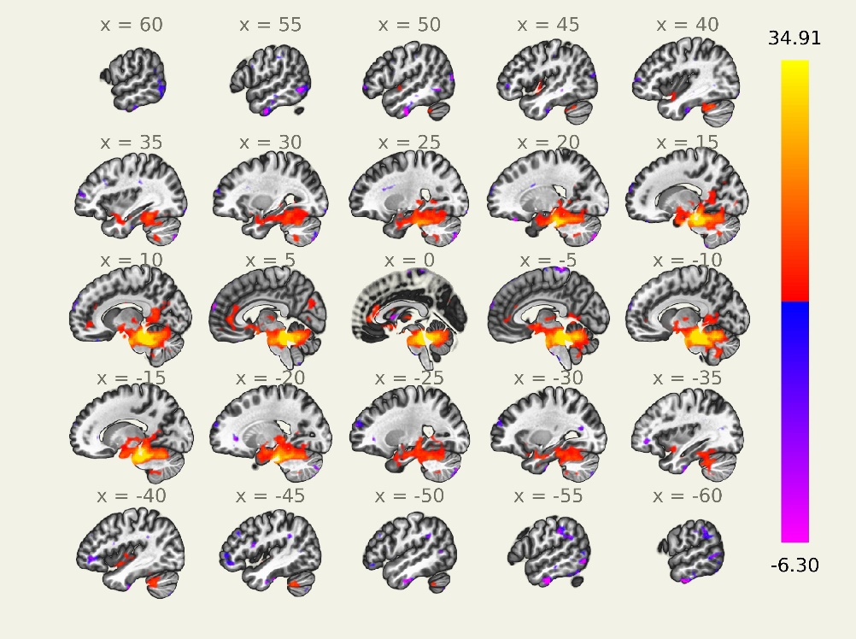
Figure S1 whole brain resting-state functional connectivity maps of LC seed for TD group (voxel threshold at p <0.005 with p<0.05 cluster level FDR-corrected). The color bar indicates the range of T values with red/yellow representing positive connectivity and blue/purple representing negative connectivity.
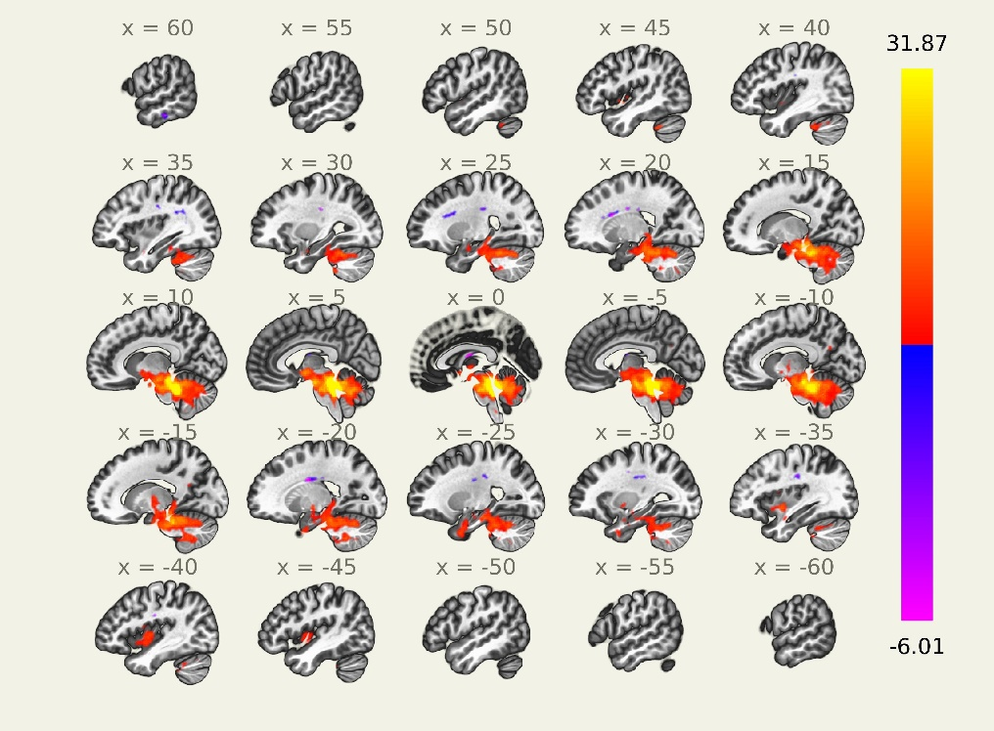
Figure S2 whole brain resting-state functional connectivity maps of LC seed for ASD group (voxel threshold at p <0.0005 with p<0.05 cluster level FDR-corrected). The color bar indicates the range of T values with red/yellow representing positive connectivity and blue/purple representing negative connectivity.
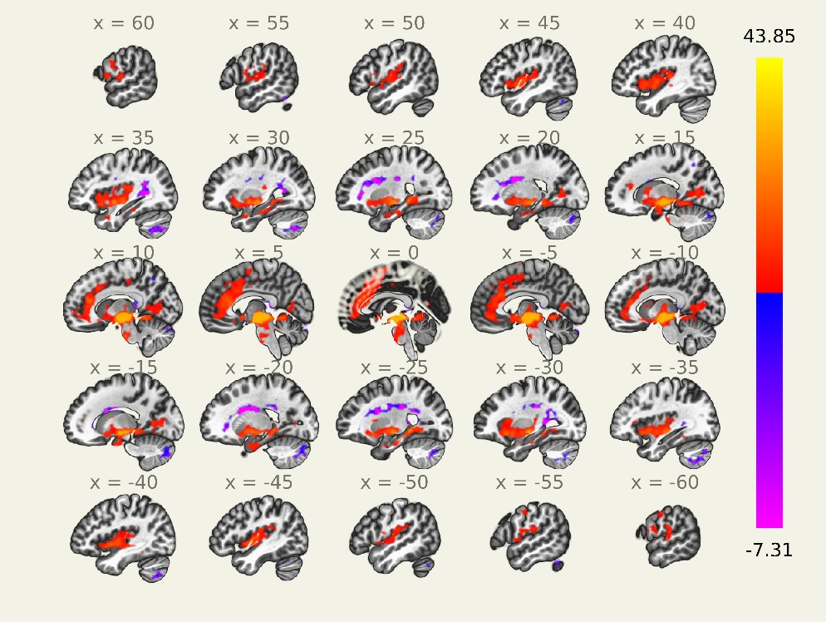
Figure S3 whole brain resting-state functional connectivity maps of VTA seed for TD group (voxel threshold at p <0.005 with p<0.05 cluster level FDR-corrected). The color bar indicates the range of T values with red/yellow representing positive connectivity and blue/purple representing negative connectivity.
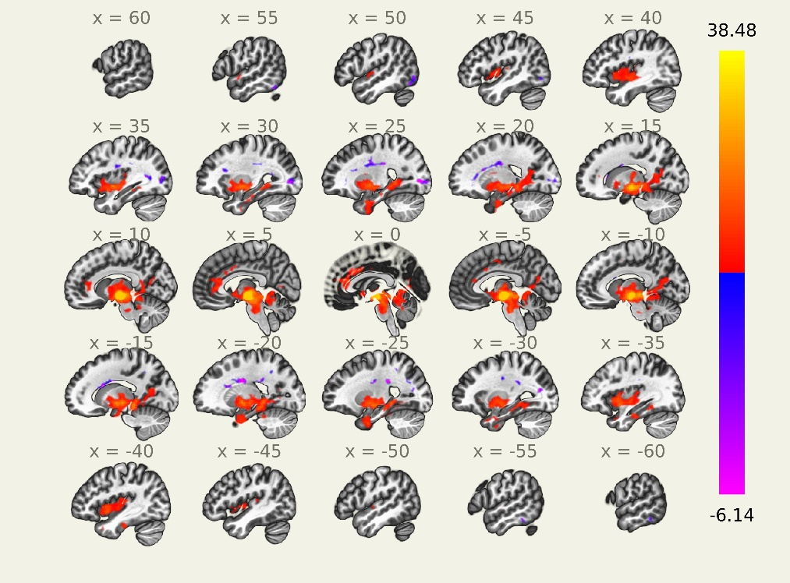
Figure S4 whole brain resting-state functional connectivity maps of VTA seed for ASD group (voxel threshold at p <0.005 with p<0.05 cluster level FDR-corrected). The color bar indicates the range of T values with red/yellow representing positive connectivity and blue/purple representing negative connectivity.

Table S1 regions of whole brain resting-state functional connectivity of LC and VTA seed for both TD and ASD group at voxel-wise threshold of p < 0. 005 with p < 0.05 cluster level FDR-corrected. LC: locus coeruleus; VTA: ventral tegmental area; R: right; L: left; (+): representing positive connectivity; (-): representing negative connectivity.
 |  | cluster | T value | MNI coordinates
Seed | group | cluster | T value | x | y | z | Regions
LC | TD(+) | 26356 | 34.91 | 6 | -38 | -26 | Bilateral brain stem/Cerebellum/Lingual/Fusiform gyrus/Parahippocampal/Hippocampus/Cuneus/Precuneus/Amygdala/Thalamus/Anterior cingulate cortex/Insula
LC | TD(-) | 905 | 6.3 | -58 | -14 | -36 | L_Inferior temporal gyrus
LC |  | 675 | 6.05 | 52 | -10 | -38 | R_Inferior temporal gyrus
LC |  | 459 | 6.04 | 22 | -82 | -48 | R_Cerebellum
LC |  | 346 | 5.39 | -22 | -84 | -44 | L_Cerebellum
LC |  | 179 | 5.13 | 18 | 32 | -24 | R_Medial orbital gyrus
LC |  | 335 | 5.12 | -4 | -36 | 76 | L_Precentral gyrus
LC |  | 978 | 5.04 | 4 | 68 | 22 | Bilateral middle frontal gyrus
LC |  | 694 | 4.89 | -56 | -68 | -6 | L_Middle temporal gyrus
LC |  | 603 | 4.53 | -58 | -30 | 36 | L_Supramarginal gyrus
LC |  | 127 | 4.48 | 50 | -78 | 14 | R_Middle occipital gyrus
LC |  | 177 | 4.41 | 48 | 48 | -2 | R_Middle frontal gyrus
LC |  | 192 | 4.16 | 36 | -30 | 32 | R_Postcentral gyrus
LC |  | 130 | 4.16 | -48 | 30 | 36 | L_Middle frontal gyrus
LC | ASD(+) | 18935 | 31.87 | 6 | -38 | -28 | Bilateral brain stem /Cerebellum/Hippocampus/Parahippocampus/Amygdala/Insula/Thalamus
LC |  | 148 | 4.38 | 42 | 2 | -6 | R_Insula
LC |  | 134 | 3.9 | 30 | -2 | -42 | R_Inferior temporal gyrus
LC |  | 111 | 3.85 | -4 | 34 | 16 | L_Anterior cingulate cortex
LC | ASD(-) | 190 | 4.39 | 62 | -26 | -22 | R_Middle temporal gyrus
LC |  | 357 | 4.22 | 38 | -90 | -4 | R_Inferior occipital gyrus/Fusiform gyrus
VTA | TD(+) | 28762 | 43.85 | -4 | -14 | -8 | Bilateral brain stem/Thalamus/Lingual/Cuneus/Insula/Putamen/Central operculum/Postcentral gyrus/Precentral gyrus/Anterior cingulate cortex/Medial prefrontal cortex/Supplementary motor area/Inferior frontal gyrus/Parahippocampus/Hippocampus/Putamen/Amygdala
VTA | TD(-) | 3092 | 5.35 | 32 | -74 | -46 | Bilateral cerebellum
VTA |  | 161 | 4.41 | 12 | -60 | 48 | R_Precuneus
VTA | ASD(+) | 20073 | 38.48 | 6 | -14 | -10 | Bilateral brain stem/Thalamus/Lingual/Cuneus/Anterior insula/Putamen/Central operculum
VTA |  | 1747 | 6.06 | 6 | 36 | 4 | Bilateral Anterior cingulate cortex
VTA | ASD(-) | 703 | 6.14 | 24 | -84 | 2 | R_Inferior occipital gyrus
VTA |  | 394 | 4.41 | 50 | -68 | -16 | R_Inferior temporal gyrus/Inferior occipital gyrus
VTA |  | 176 | 4.23 | -56 | -44 | -20 | L_Inferior temporal gyrus
VTA |  | 106 | 3.69 | -46 | -72 | -36 | L_Cerebellum

