Supplementary materials

Appendix

PTX exerted cytotoxicity on the ethanol-stimulated VX2 and SMMC-7721cell lines
Rabbit squamous cell cancer line VX2 and Human hepatoma cell line SMMC-7721 were cultured in the Dulbecco’s Modified Eagle Medium (DMEM) supplemented with 10% fetal bovine serum and incubated into 5% CO₂ at 37°C. The cells were dissociated with 0.25% trypsin for 3 minutes and then resuspended into cell suspensions for subsequent experiments.
Cells were seeded at 1 × 10⁴ in 30 wells of the 96-well plate and incubated for 8 h to make cells attached on the wall. After removing the serum-containing cell culture medium, the cells were divided into five groups (n=6): saline as control group, 5% ethanol group for pure ablation, three incremental dose groups: 2 nmol/l PTX in 5% ethanol; 4 nmol/l PTX in 5% ethanol group; 8 nmol/l PTX in 5% ethanol group. After incubation for 6 hours, PTX and ethanol in the medium were removed, and then all the cells were incubated with fresh complete medium for 72 hours. The incubation time in the first step (6 hours) and ethanol concertation was chosen according to the reference [1]. The MTT assay at 6 h and 72 h were measured respectively. In detail, 1% MTT was added to each well in the plates under dark conditions. After incubation for 4 h, the medium was extracted, and 100 µl DMSO was added to individual well in the plates. The optical density (OD) value at the wavelength of 490 nm was measured with a microplate reader after shaking the plates for 3 minutes. Cell viability of all the five tested group was calculated as (OD_{test}-OD_{control})/ OD_{test} *100%. Note that all the OD test values were averaged for three times.

Reference
- Wang Y, Tong J, Chang B, Wang B, Zhang D, and Wang B, Effects of alcohol on intestinal epithelial barrier permeability and expression of tight junction‑associated proteins. Molecular Medicine Reports 2014, 9, 2352-2356.

Figure S1. Cut surfaces of the resected specimen after therapy. Different partial viable cancer residues were left, depending on various treatments.

Sham group (16.05±2.61%)
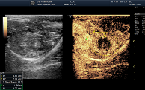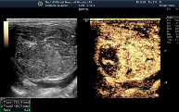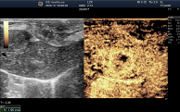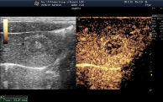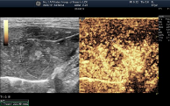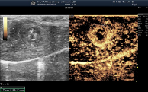
RNR  (%) | 15.0 | 21.0 | 16.9 | 14.8 | 14.4 | 14.2 | 14.2

2mL PEI group (30.4±6.80%)
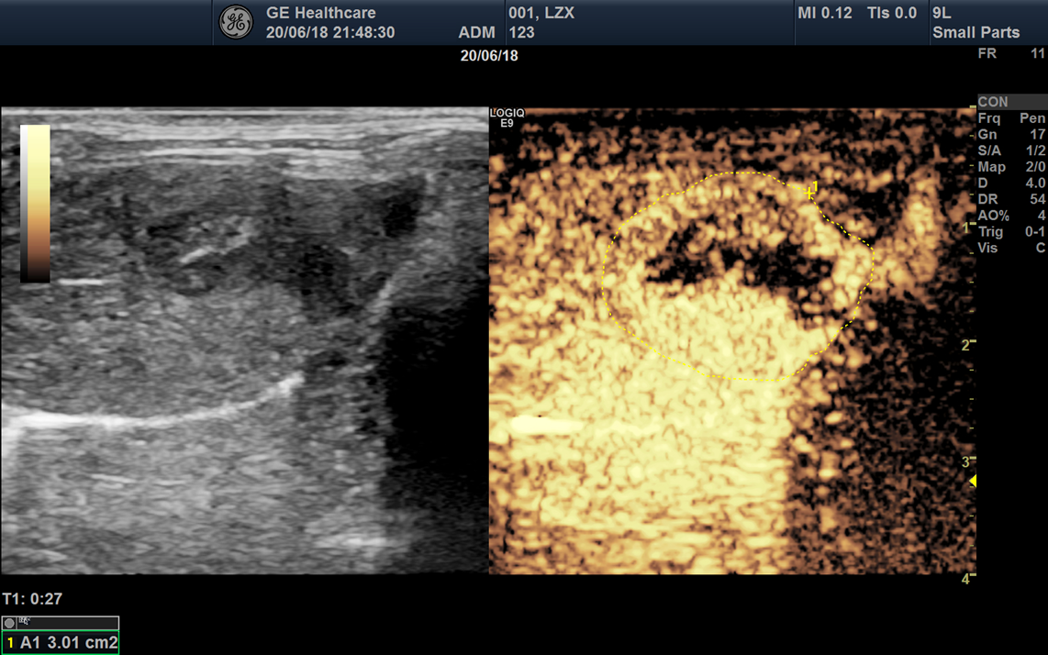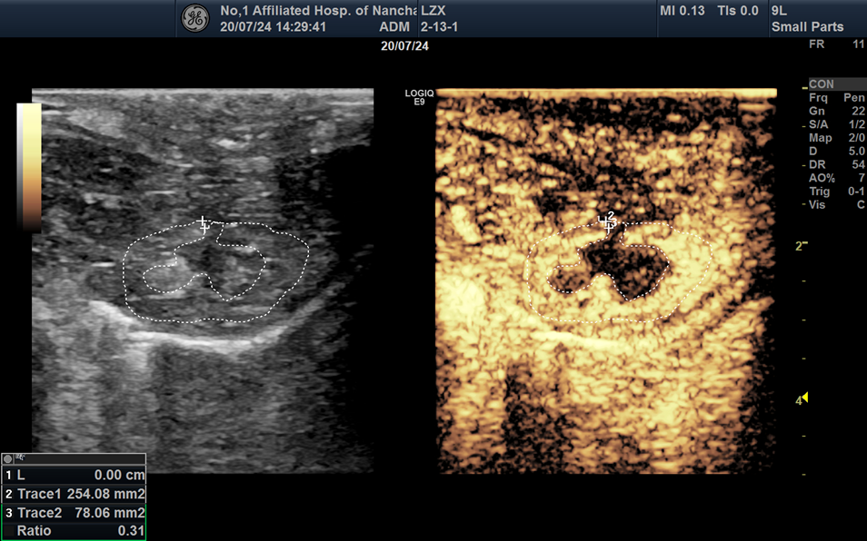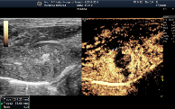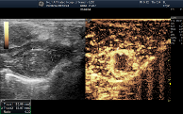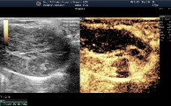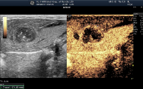
RNR  (%) | 40.2 | 31.0 | 35.5 | 28.1 | 20.8 | 27.0

C-PEI group (52.75±8.92%)
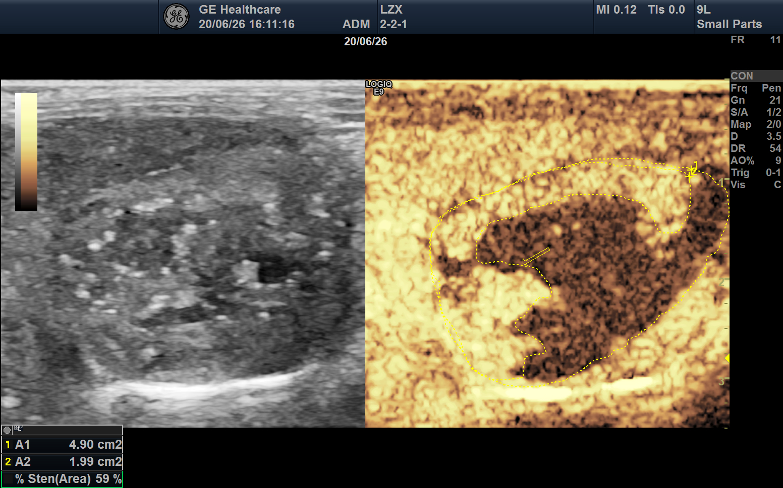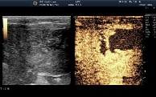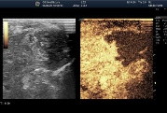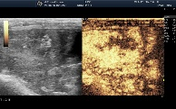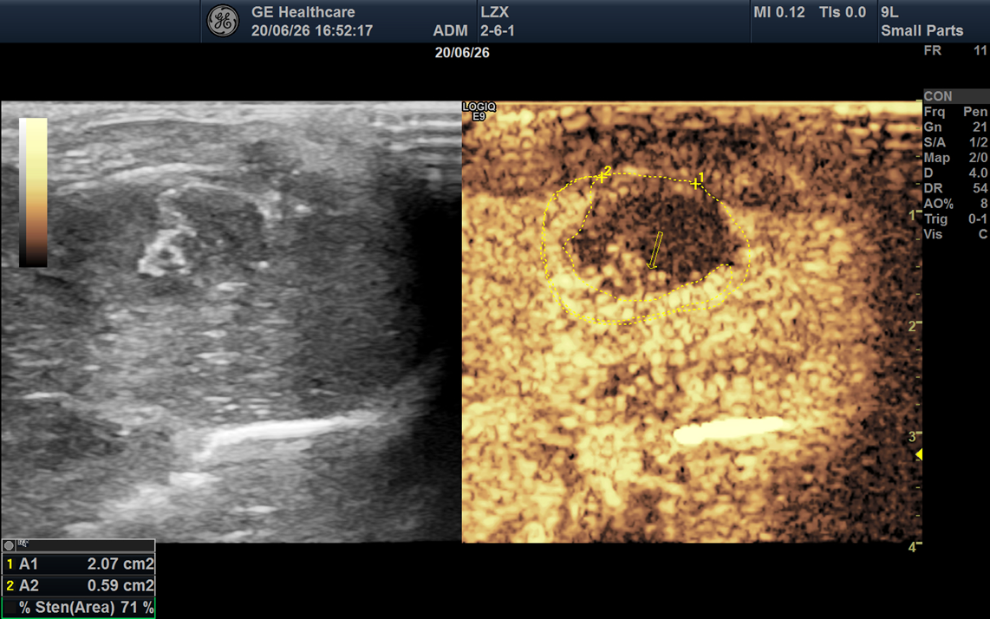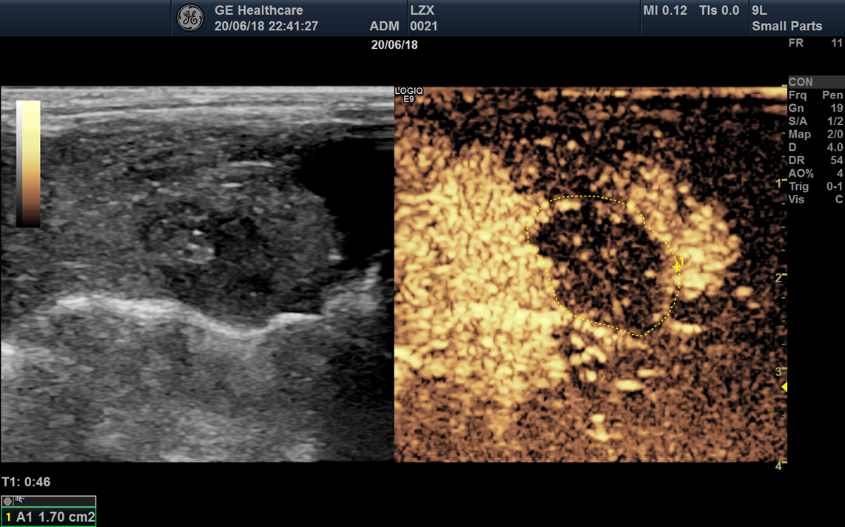
RNR  (%) | 44.1 | 58.0 | 54.7 | 64.9 | 54.0 | 40.8
Low dose group (63.35±15.76%)  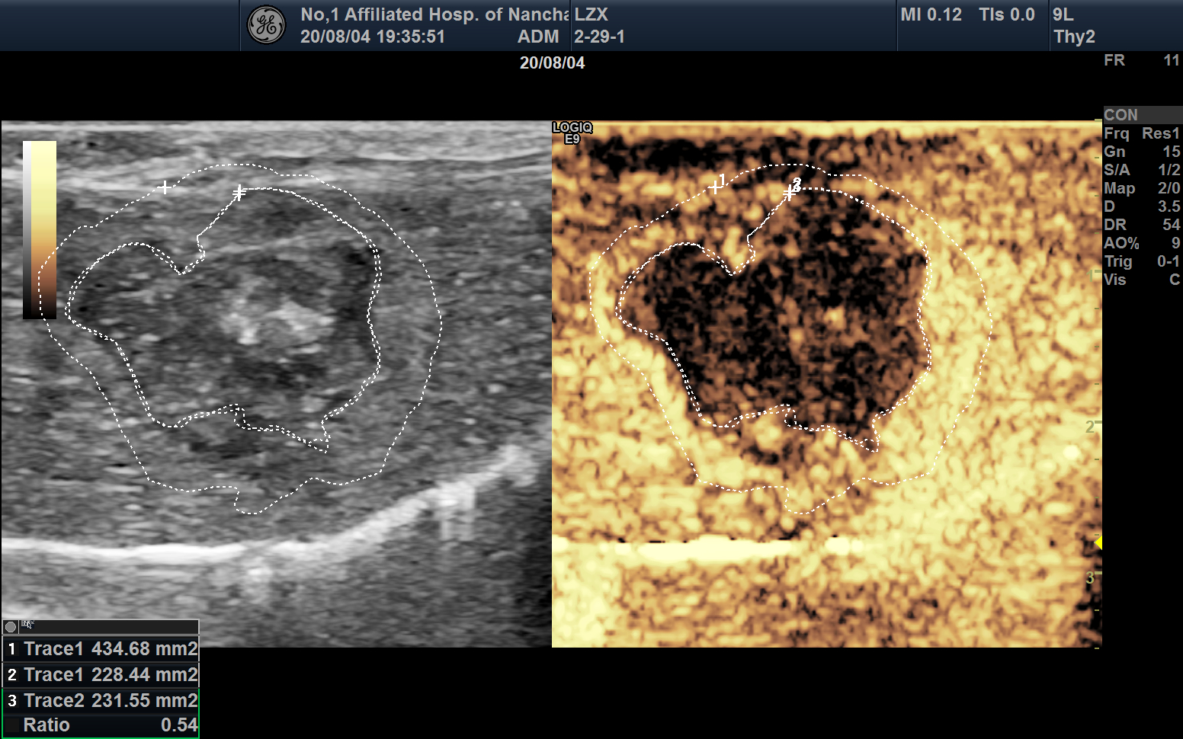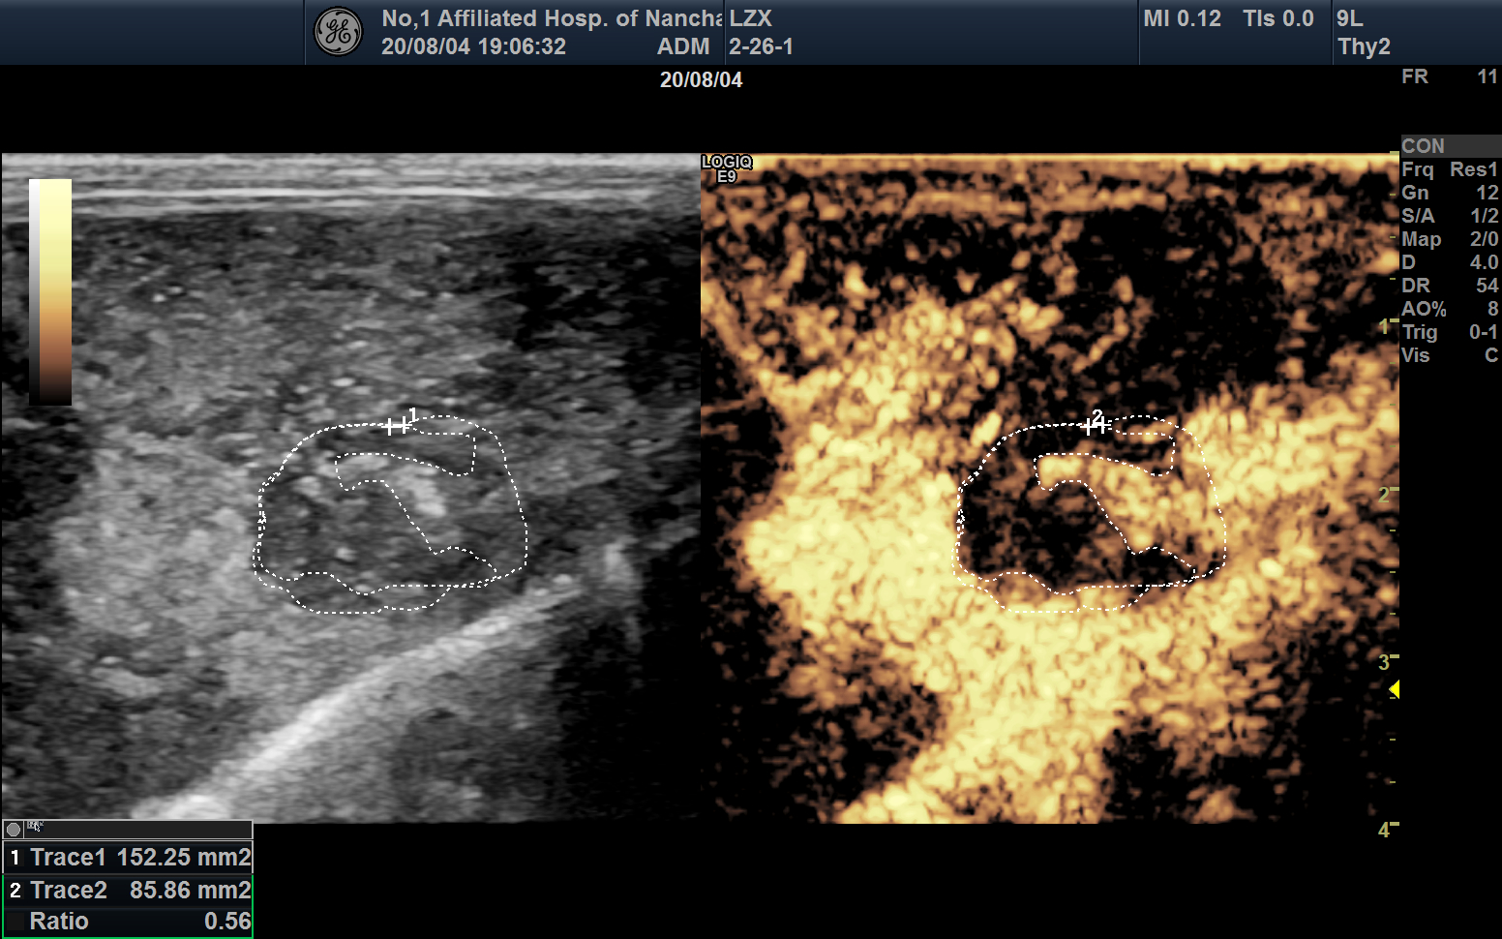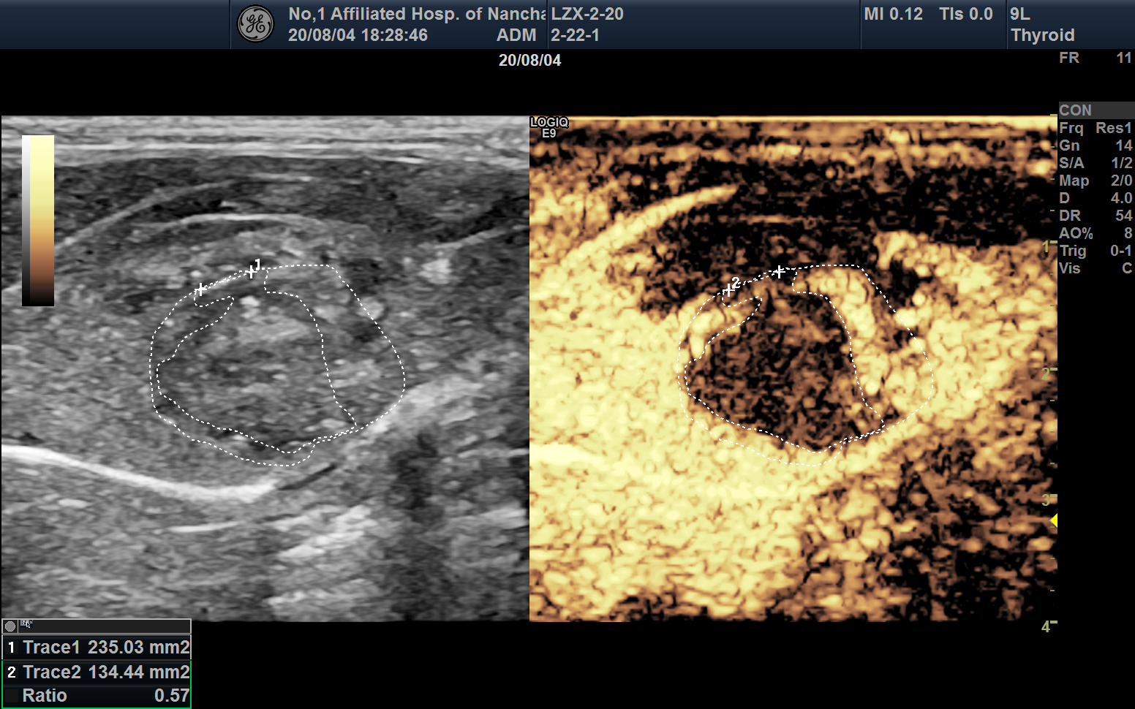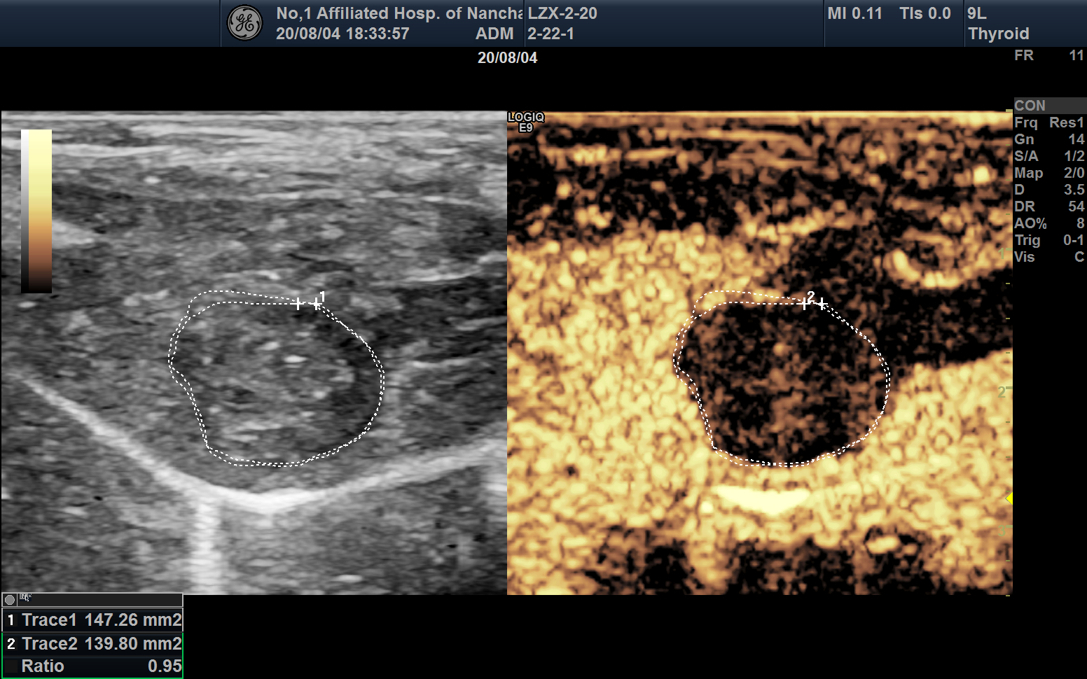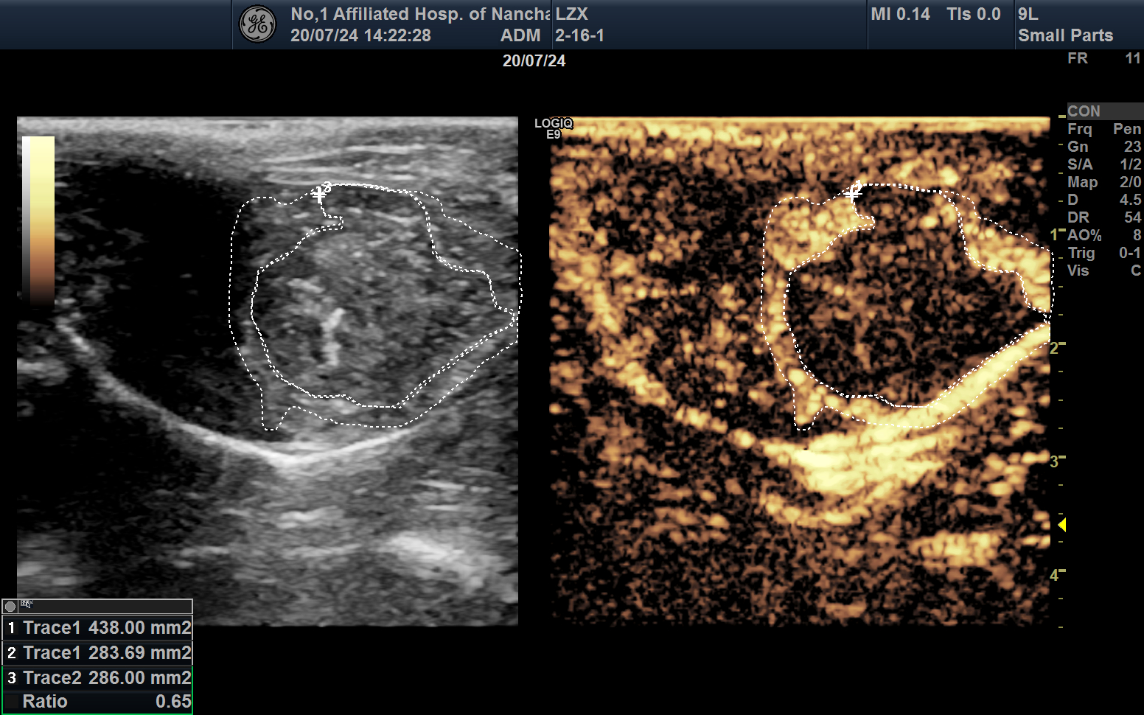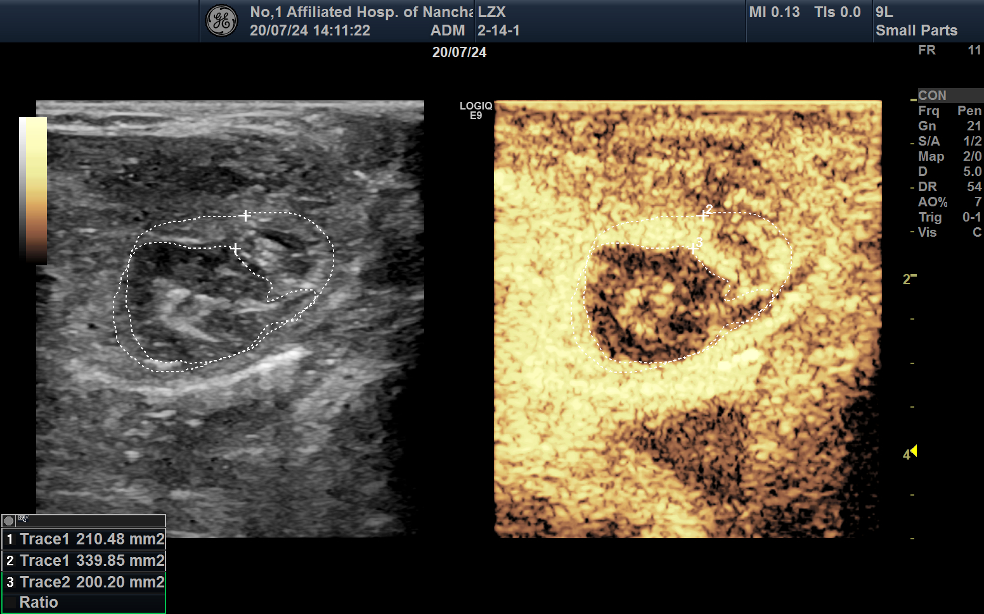  Medium dose group (77.97±8.17%)  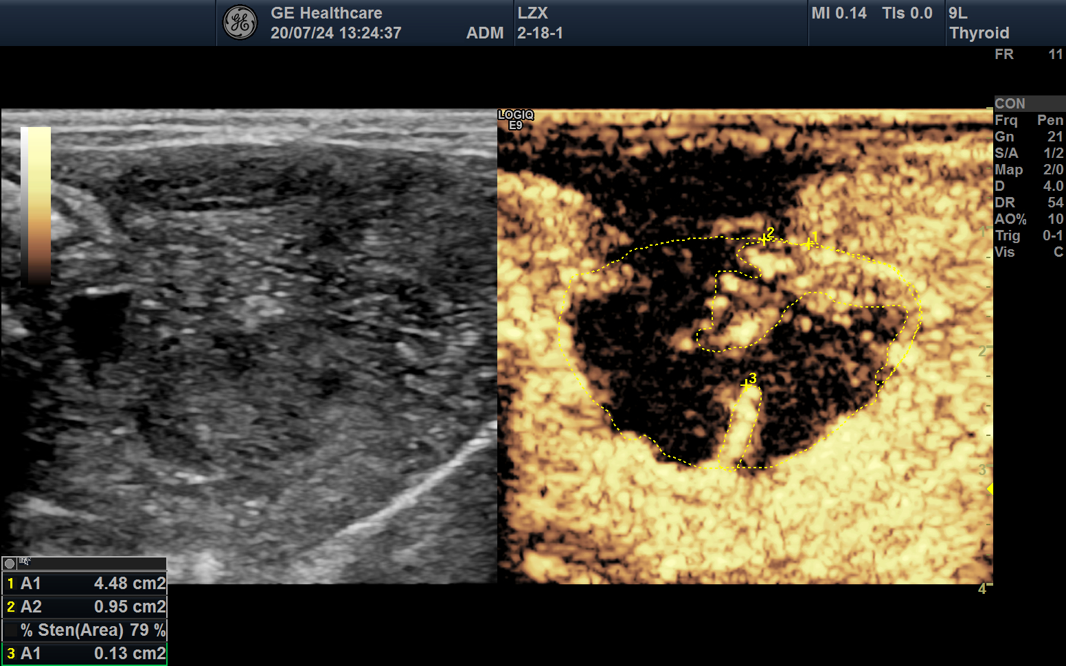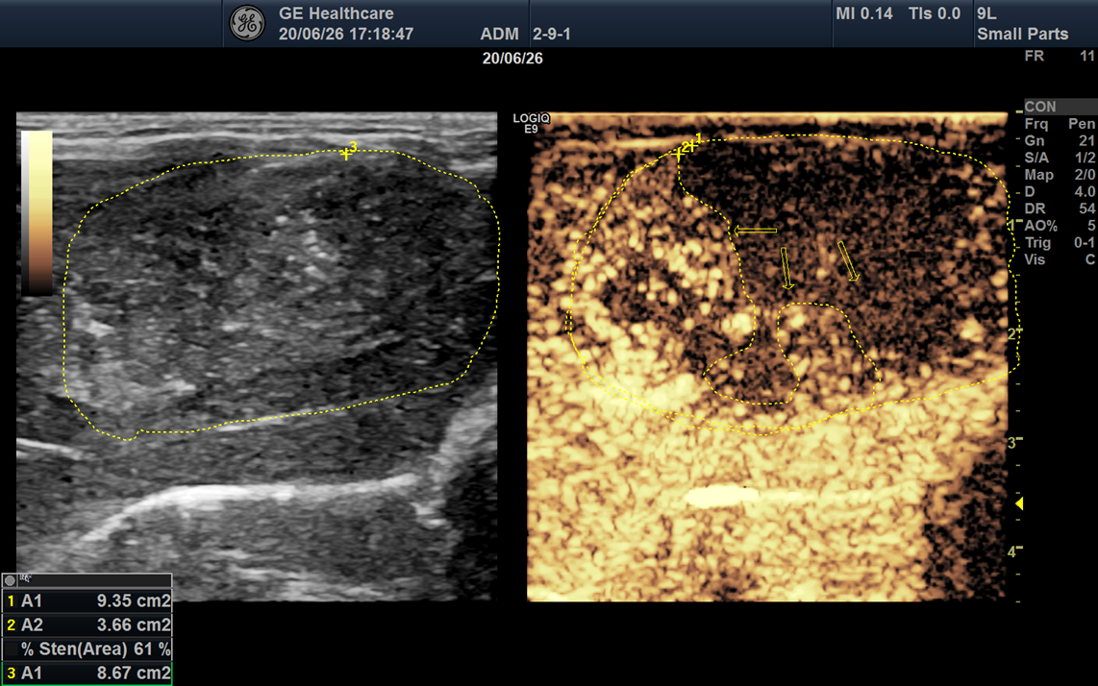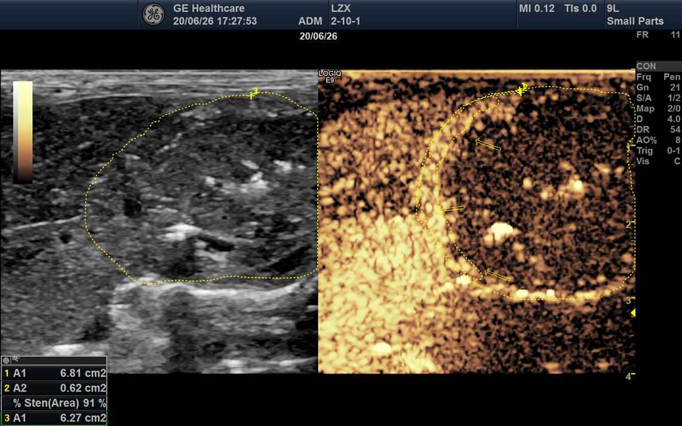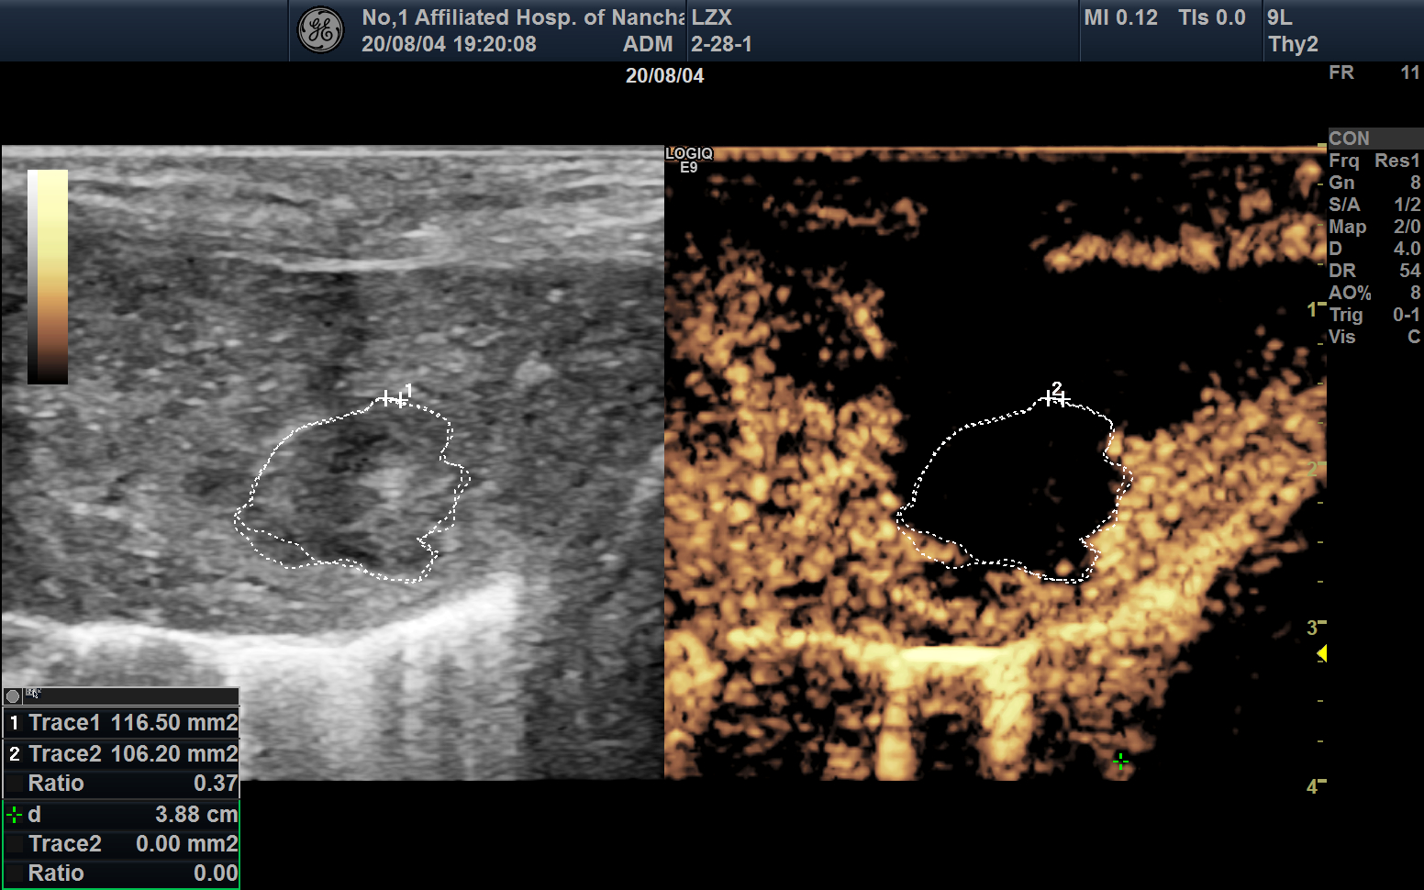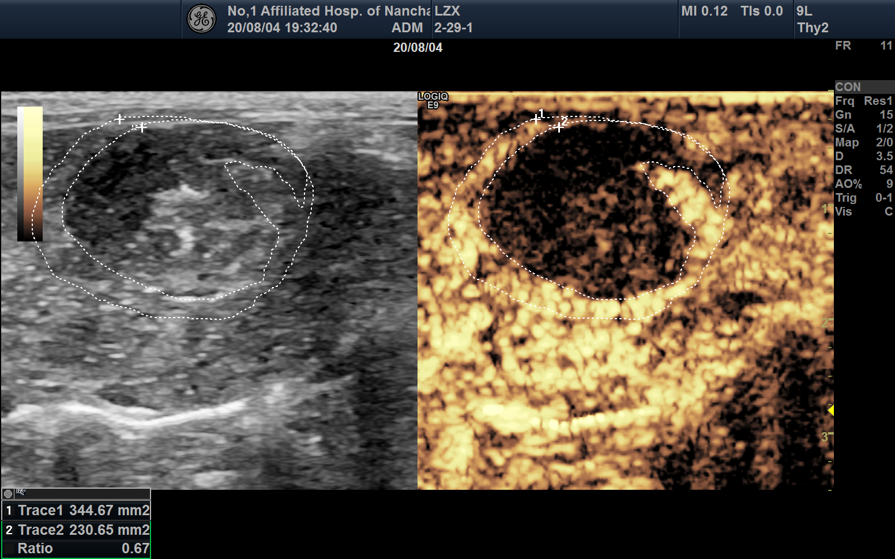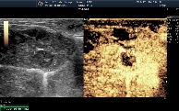  High dose group (95.00±3.58%)  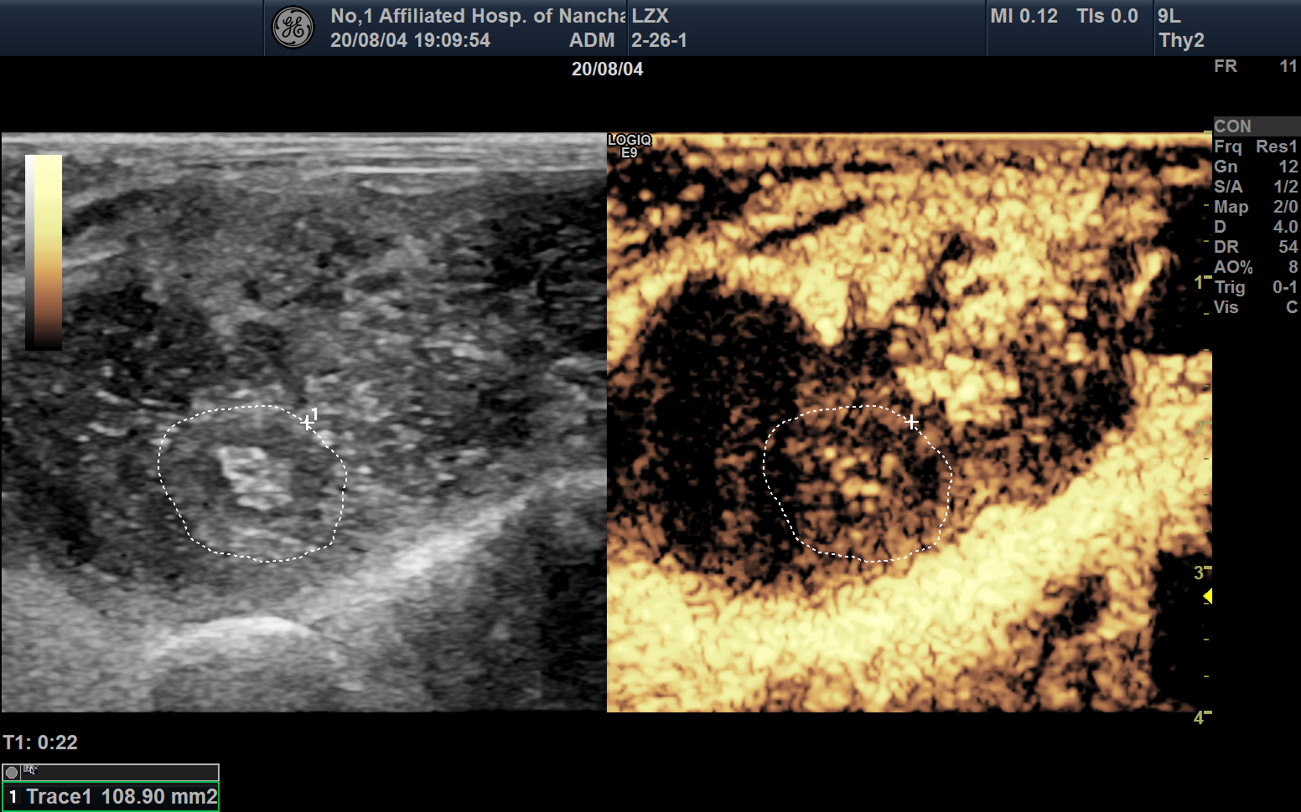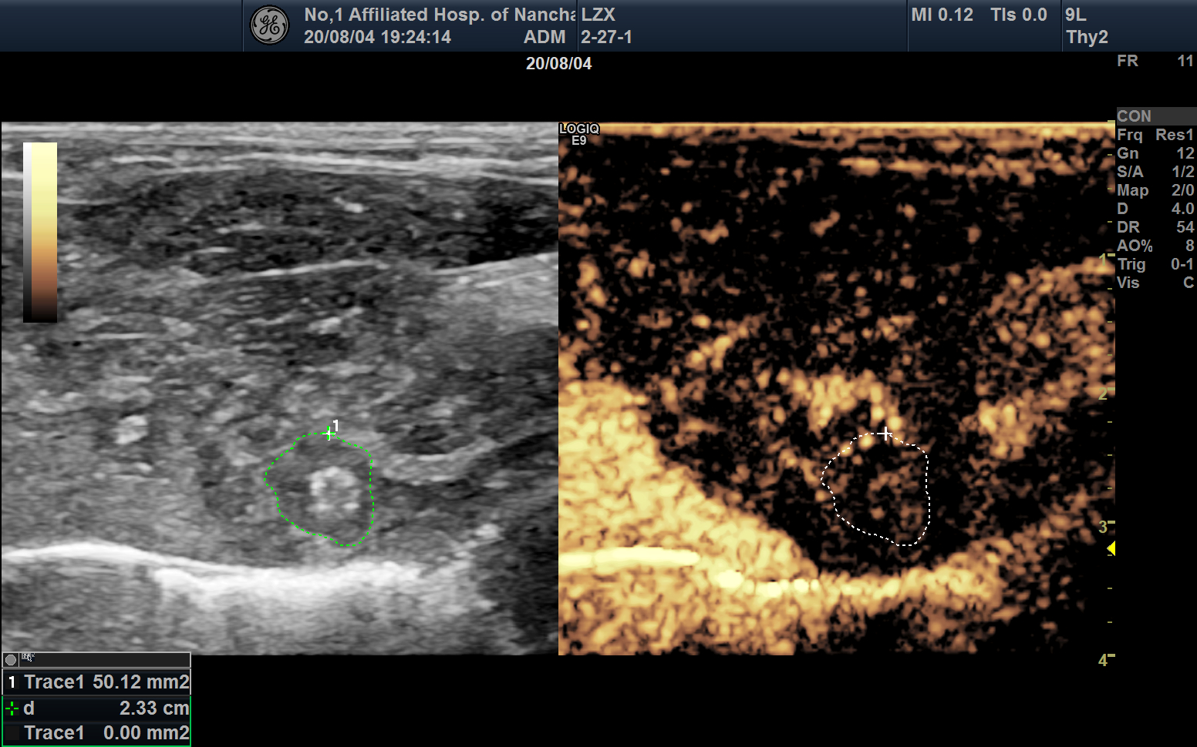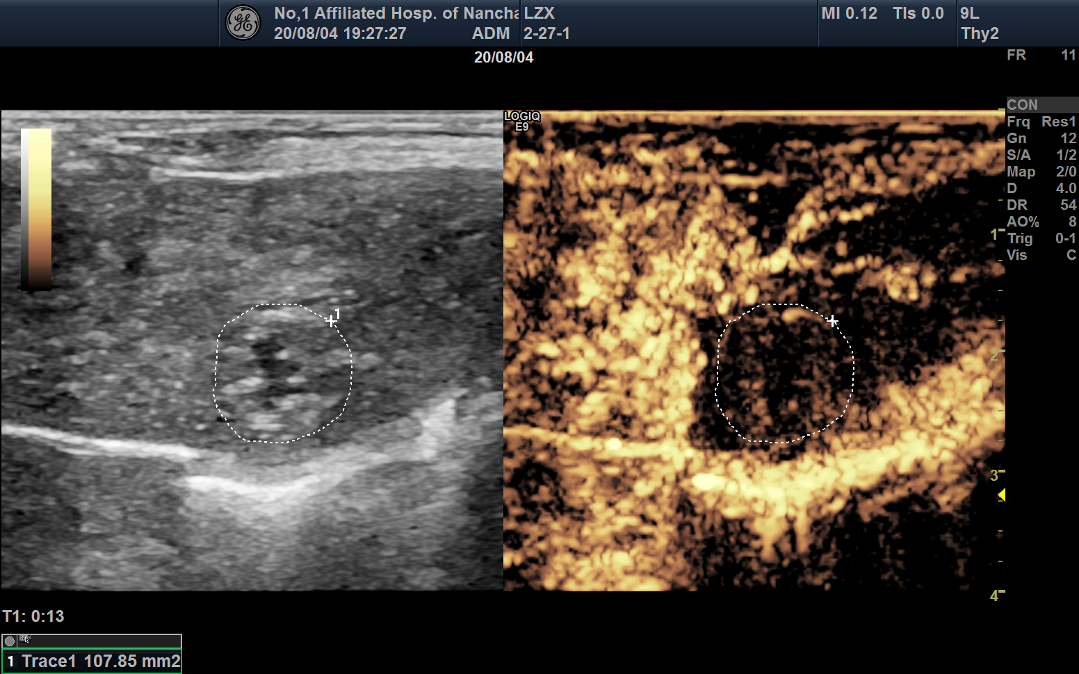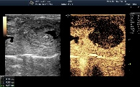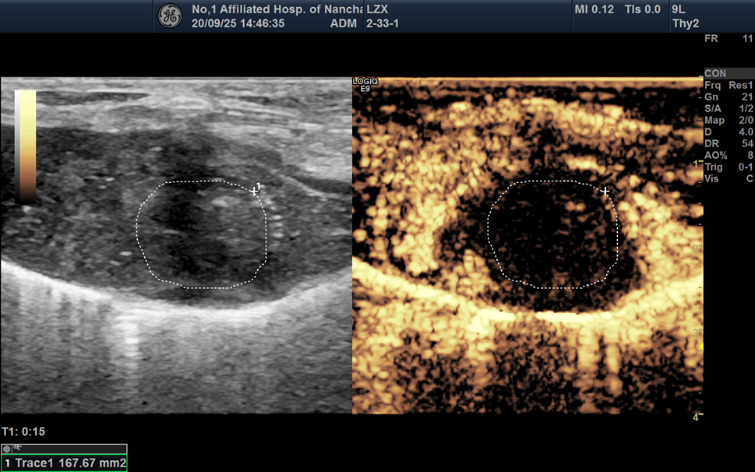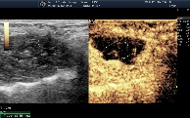 |  |  |  |  |  |  |  |  | 58.0 |  | 54.7 | 64.9 | 54.0 | 40.8
  RNR  (%) | 53.1 | 56.6 | 57.0 | 95.2 | 59.4 | 58.8
  RNR  (%) | 75.9 | 74.2 | 79.0 | 91.4 | 66.7 | 80.6
  RNR  (%) | 97.0 | 98.0 | 92.0 | 92.3 | 99.5 | 91.2
Figure S2. Individual and statistical (mean ± SD) radiological necrosis ratio (RNR) value.

Sham group (10.78±4.18%)
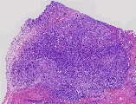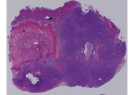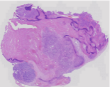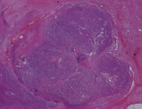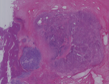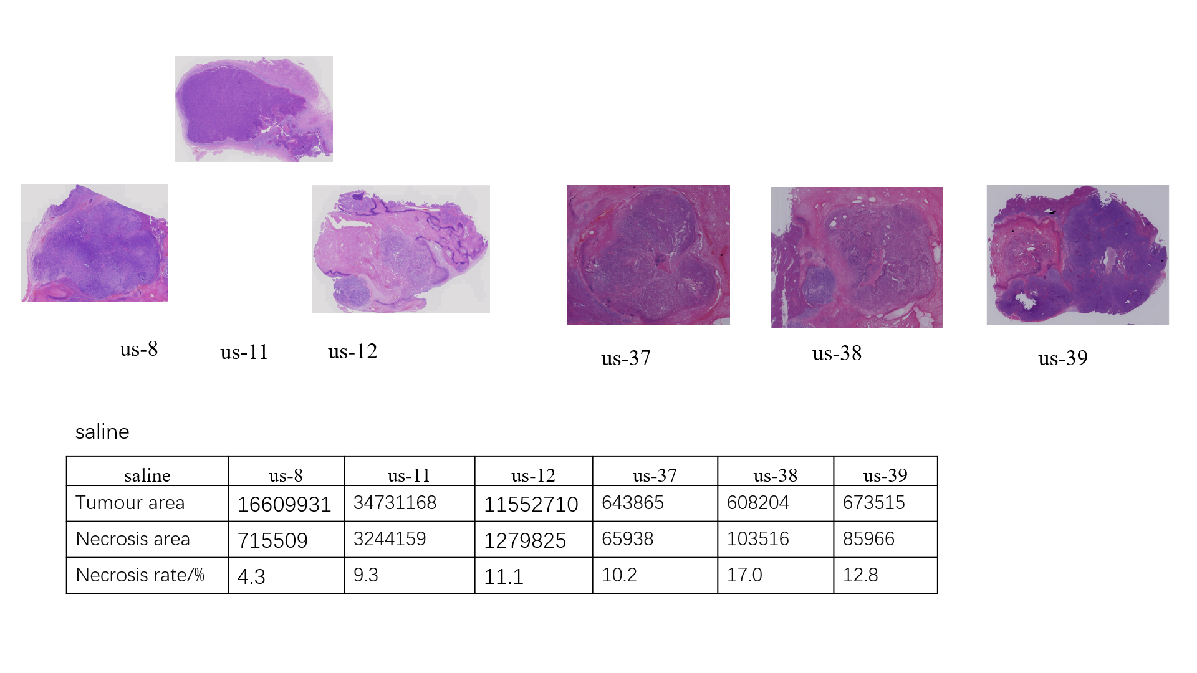
HNR  (%) | 4.3 | 12.8 | 11.1 | 10.2 | 17.0 | 9.3 | 14.2

2mL PEI group (27.62±7.59%)
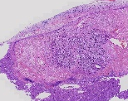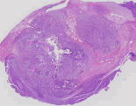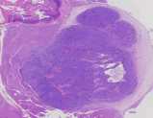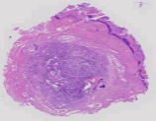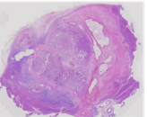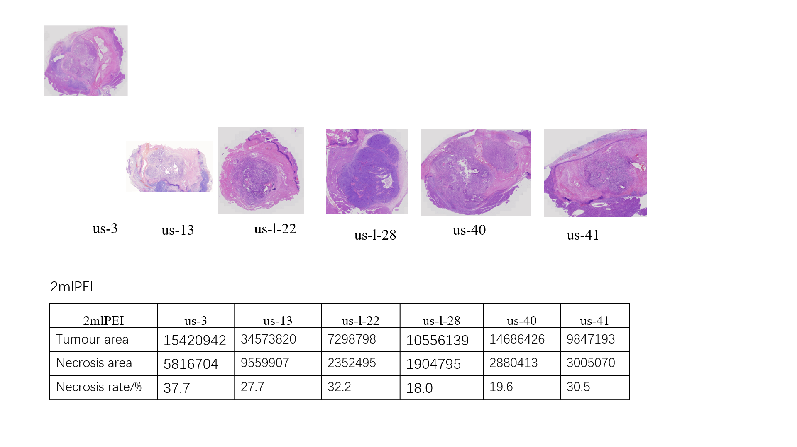
HNR  (%) | 30.5 | 19.6 | 18.0 | 32.2 | 37.7 | 27.7

C-PEI group (37.70±9.32%)
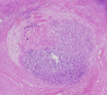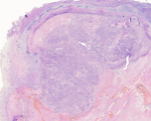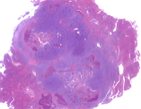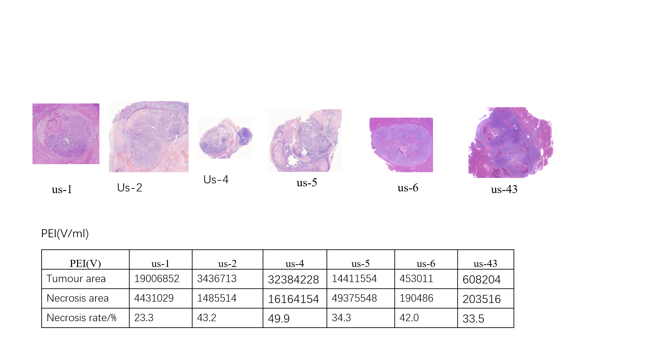
HNR  (%) | 23.3 | 43.2 | 33.5 | 49.9 | 34.3 | 42.0
Low dose group (39.92±1.73%)  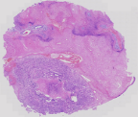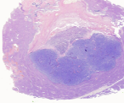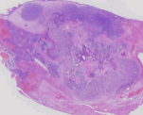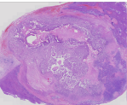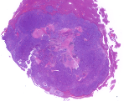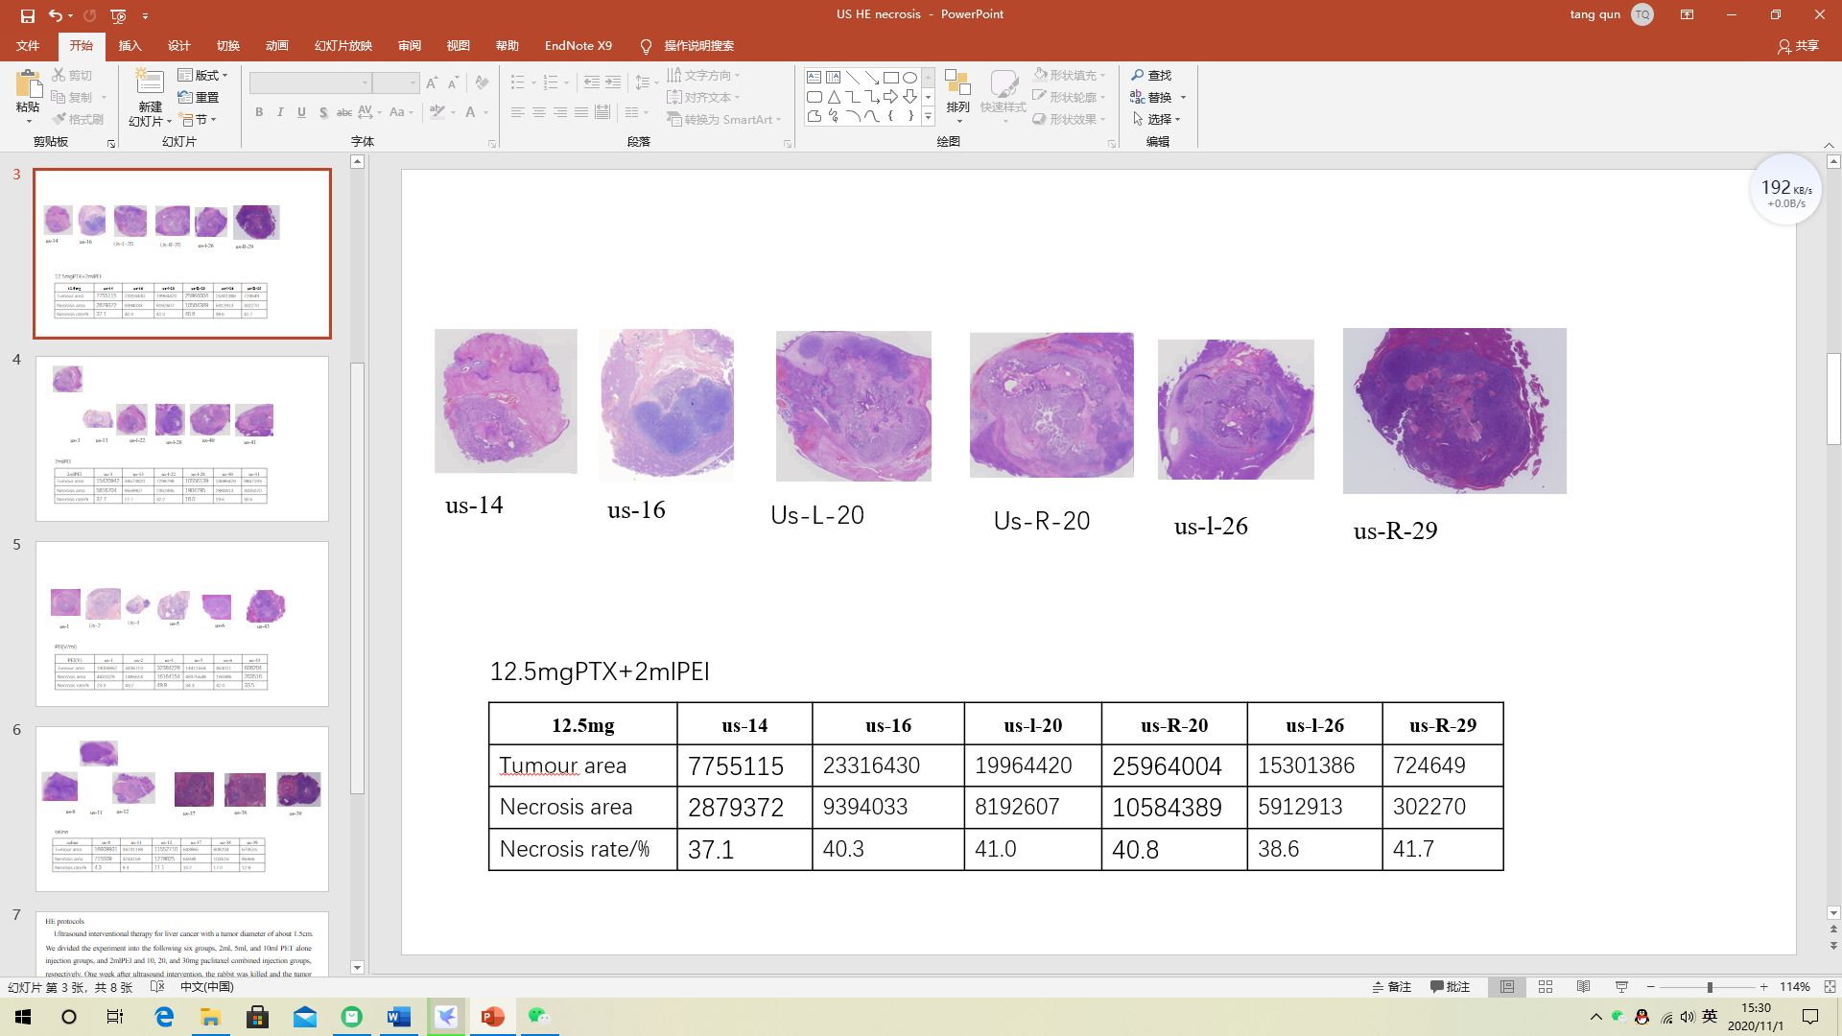  Medium dose group (48.53±7.00%)  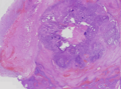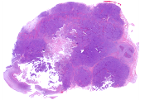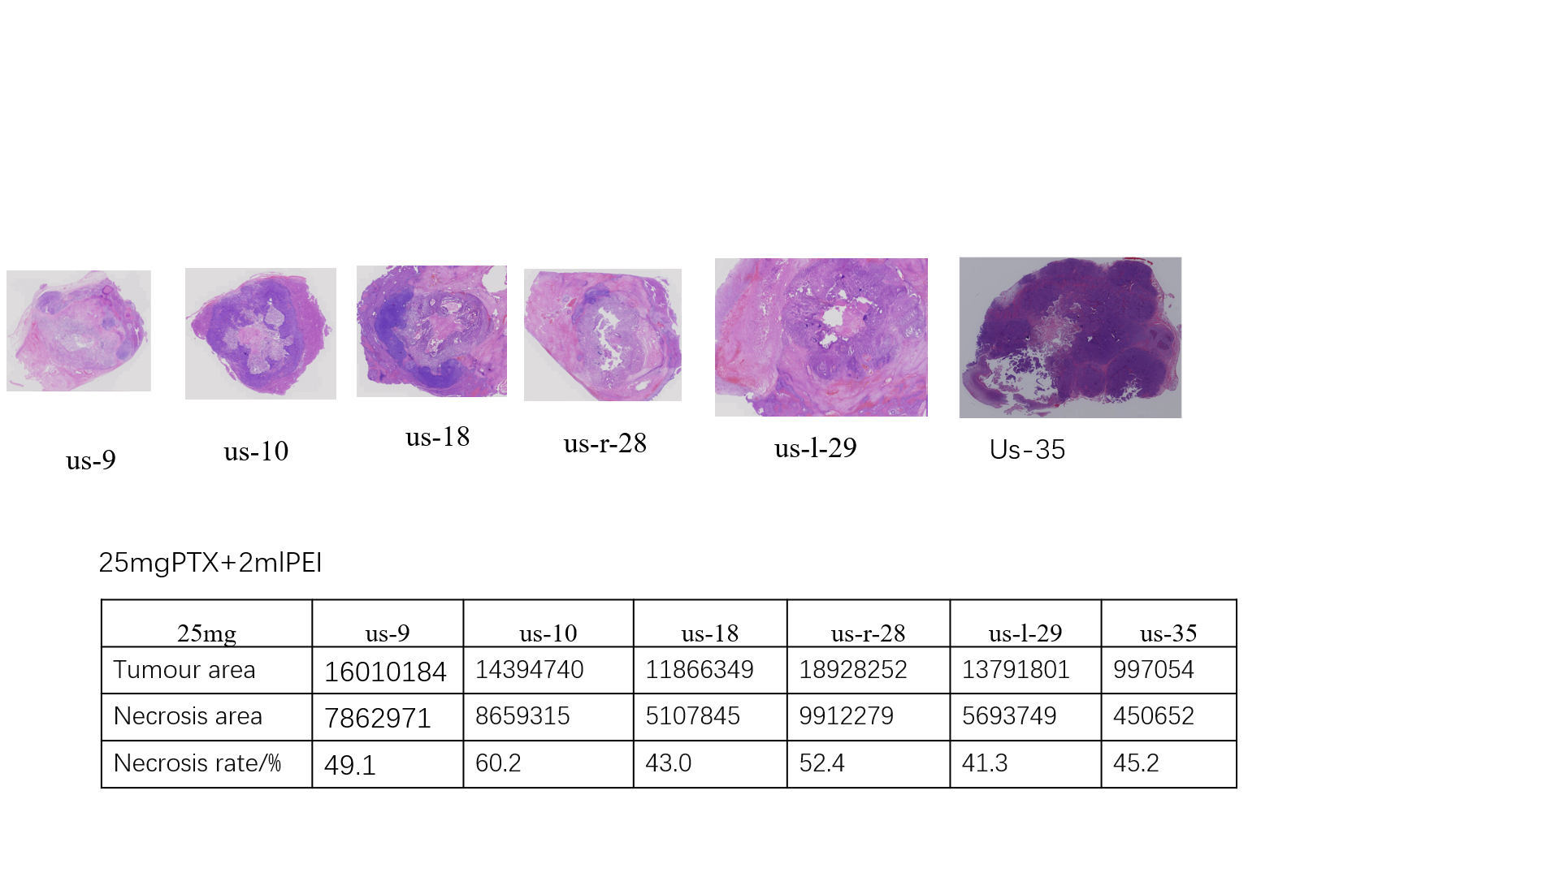  High dose group (82.12±6.92%)  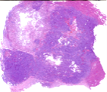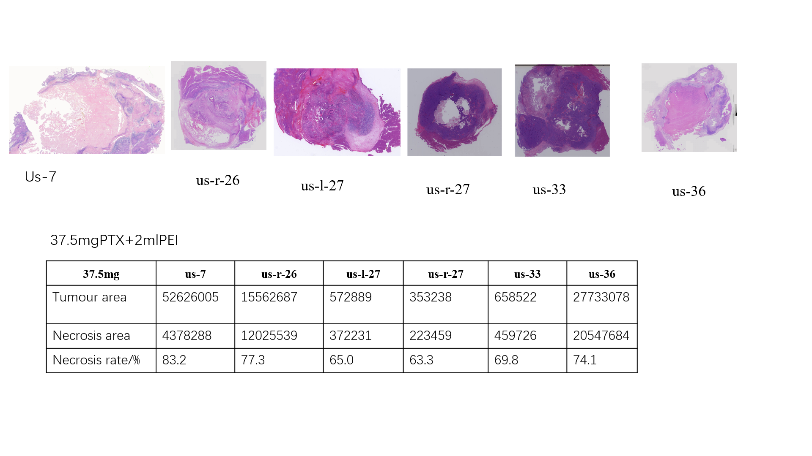 |  |  |  |  |  |  |  |  | 58.0 |  | 54.7 | 64.9 | 54.0 | 40.8
  HNR  (%) | 37.1 | 40.3 | 41.0 | 40.8 | 41.7 | 38.6
  HNR  (%) | 41.3 | 45.2 | 49.1 | 60.2 | 43.0 | 52.4
  HNR  (%) | 75.0 | 73.3 | 79.8 | 84.1 | 93.2 | 87.3
Figure S3. Individual and statistical (mean ± SD) histological necrosis ratio (HNR) value.

Figure S4. VX2 (a) and SMMC-7721 cell viability against in vitro PEPCT test.

