Supplementary materials
Definitions of the ten year’ cardiovascular risk 2
WHO risk chart 2
Supplemental Figure 1. WHO 2019 updated risk chart for western Sub-Saharan Africa 3
Framingham risk score (FRS) 3
Supplemental Table 1. Framingham risk score equation 4
Globorisk chart 5
Supplemental Figure 2. Globorisk chart for Burkina Faso 6
Definition of variables used to evaluate cardiovascular risk 6
Supplemental Table 2. factors used to evaluate cardiovascular risk 6
Framingham risk score 8
Supplemental Table 3. Mean of the 10-year cardiovascular risk (FRS) by socio-demographic characteristics by sex 8
Supplemental Table 4. Elevated risk of 10-year cardiovascular events (FRS≥ 10%) by socio-demographic characteristics by sex 9
Supplemental Table 5. Age and sex-standardized prevalence elevated risk of 10-year cardiovascular events (FRS≥ 10%) by socio-demographic characteristics 10
Supplemental Table 6. Factors associated with elevated risk using multivariate modified Poisson regression with GEE model (FRS>=10%) 11
Supplemental Figure 3: Age and sex standardized mean of absolute cardiovascular risk (left) and prevalence of elevated risk (FRS >=10%) (right) by region. The mean of absolute cardiovascular risk was significantly higher in the Centre region (p<0.001). The prevalence of elevated risk was also higher in Centre region (p<0.001). 12
Globorisk 13
Supplemental Table 7: Mean of 10-years cardiovascular risk (Globorisk) by socio-demographic characteristics by gender 13
Supplemental Table 8: Elevated risk of 10-years cardiovascular event (Globorisk ≥ 10%) by socio-demographic characteristics by gender 14
Supplemental Table 9: Age-standardized prevalence elevated risk of 10-years cardiovascular event (Globorisk≥ 10%) by socio-demographic characteristics by sex 15
Supplemental Table 10: Factors associated with elevated risk (Globorisk>=10%) using multivariate modified Poisson regression with GEE model 16
Supplemental Figure 4: Age and sex standardized mean of absolute cardiovascular risk (left) and prevalence of elevated risk (Globorisk >=10%) (right) by region. The mean of absolute cardiovascular risk was significantly higher in Centre region (p=0.016). The prevalence of elevated risk was also higher in Centre region followed (p<0.001). 17
Supplemental Table 11: Mean of 10-years cardiovascular risk (WHO risk) by socio-demographic characteristics by gender 18
Reference 18

Definitions of the ten year’ cardiovascular risk

WHO risk chart
We used the 2019 updated WHO risk chart to assign the absolute risk for each participant aged from 40 to 64 years. As presented in FRS, six variables were used to estimate WHO risk: gender, age, blood cholesterol level, systolic arterial pressure, diabetes and smoking ¹. This chart was developed and calibrated for 21 world regions including western Sub-Saharan Africa (SSA). It is adapted to our analysis because the equation is already applied to STEP database of Burkina Faso, but WHO revised ten year’ cardiovascular risk is limited to national prevalence of high risk (assessed at 0.3%) ¹. The risk is stratified in four groups: <5%, 5%to<10%, 10%to <20%, >=20%. In our analysis, we used two groups (<10%; >=10%) as recommended in the chart (https://ars.els-cdn.com/content/image/1-s2.0-S2214109X19303183-mmc2.pdf). For this analysis, we used the risk chart adapted to Western Sub-Saharan Africa.¹ The following chart is the risk chart for Western SSA as proposed by WHO. We used this chart to assign to each study participant their absolute WHO risk considered the level of each risk factors.

Supplemental Figure 1. WHO 2019 updated risk chart for western Sub-Saharan Africa
Notes: Reproduced from: Kaptoge S, Pennells L, Bacquer DD, et al. The WHO CVD Risk Chart Working Group. World Health Organization cardiovascular disease risk charts: revised models to estimate risk in 21 global regions. Lancet Glob Health. 2019;7(10):e1332-e1345.¹ © 2019 World Health Organization; licensee Elsevier. Creative Commons Attribution (CC BY 4.0; https://creativecommons.org/licenses/by/4.0/legalcode). Available from: https://ars.els-cdn.com/content/image/1-s2.0-S2214109X19303183-mmc2.pdf.

Framingham risk score (FRS)
The FRS is one of the most commonly used CVD risk tools. In 2008, the FRS was revised to take in to account a large number of cardiovascular events such as coronary death, myocardial infarction, coronary insufficiency, angina, ischemic stroke, hemorrhagic stroke, transient ischemic attack, peripheral artery disease or heart failure. It has been recalibrated for use in diverse populations across the world. Two versions are available: the laboratory FRS and the non-laboratory FRS. For the laboratory FRS assessment, six variables are used: gender, age, blood cholesterol level, systolic arterial pressure, diabetes and smoking.² The non-laboratory FRS is recalibrated for limited resource setting and the blood cholesterol measures are replaced by body mass index (BMI). Previous studies in SSA have shown good agreement between those two methods.³ In our study, blood cholesterol has been measured for each participant which offer an opportunity to used laboratory FRS. To assess individual absolute risk we used the coefficients of each variable as described in D’Agostino et al ² (https://www.framinghamheartstudy.org/fhs-risk-functions/cardiovascular-disease-10-year-risk). Then we classified participants into three groups: low, moderate or high risk, corresponding to < 10%, 10–20% and ≥ 20% respectively. Based on Grammer et al. ⁴, we re-categorized the FRS into two categories merging moderate and high risk into “elevated risk”. The FRS was assessed for participants from 30 to 64 years. The following table contains the coefficients and variables used to compute FRS.

Supplemental Table 1. Framingham risk score equation
variables | Beta** for men* | Beta** for women*
Baseline Survival (S0(10)) | 0.88936 | 0.95012
Log of Age | 3.06117 | 2.32888
Log of Total Cholesterol | 1.12370 | 1.20904
Log of HDL Cholesterol | -0.93263 | -0.70833
Log of SBP if not treated | 1.93303 | 2.76157
Log of SBP if treated | 1.99881 | 2.82263
Smoking | 0.65451 | 0.52873
Diabetes | 0.57367 | 0.69154
Notes: * The 10-year risk for women can be calculated as 1-0.95012^{exp(ΣßX – 26.1931)} where ß is the regression coefficient and X is the level for each risk factor; the risk for men is given as 1-0.88936^{exp(ΣßX-23.9802);} **beta is the regression coefficient. Framingham risk score equation from D’Agostino et al (https://www.framinghamheartstudy.org/fhs-risk-functions/cardiovascular-disease-10-year-risk).²

Globorisk chart
Glogorisk chart was developed in 2015 to assess ten-year cardiovascular risk for people aged from 40 to 74 years. It was recalibrated for 182 countries including Burkina Faso. An individual risk chart is available for each of these countries. We use the risk chart for Burkina Faso (http://www.globorisk.org/risk-charts) to assess cardiovascular risk among people 40-64 years old. The risk is stratified into seven groups (<5%, 5 to 9%; 10% to 19%; 20% to 29%, 30% to 39%; 40% to 49%; >=50%). People with absolute Globorisk less than 10% have a low risk ⁵. We used two groups (<10%= Low risk; >=10%=elevated risk) in our analysis. Globorisk team collabotors have proposed a risk chart for each of the 182 countries studied including Burkina Faso. The following chart is for Burkina Faso. We have used this chart to assign the absolute risk for each participant in our study taking into account their blood pressure levels, blood glucose levels, blood cholesterol levels, smoking status, age and sex.

Supplemental Figure 2. Globorisk chart for Burkina Faso.
Notes: Reprinted from Ueda P, Woodward M, Lu Y, et al. Laboratory-based and office-based risk scores and charts to predict 10-year risk of cardiovascular disease in 182 countries: a pooled analysis of prospective cohorts and health surveys. Lancet Diabetes Endocrinol. 2017;5(3):196–213. doi:10.1016/S2213-8587(17)30015-3. © 2017 Elsevier Ltd. All rights reserved. The risk chart of each country including Burkina Faso is available on this link: http://www.globorisk.org/risk-charts.

Definition of variables used to evaluate cardiovascular risk
As shown in previous section, the cardiovascular risk scores have been evaluated using six variables: age, sex, blood pressure, blood glycaemia, blood lipid and smoking. Blood pressure was systematically measured three times by the same technician at the right arm after a 15 minutes rest without crossing legs. The measurements were done with 5 minutes intervals. The mean of these three measurements was used as continue variable to compute the FRS and then categorized to compute WHO risk and Globorisk. The cut-off for categorization was defined for each risk chart. Fasting Blood glycaemia and the cholesterol level were assessed using a whole blood sample obtained from a finger prick. Their cut off were also defined in accordance to each risk chart. However, blood cholesterols (total and HDL) have been converted into mg/dL and used as continuous variables to compute the FRS (as proposed in FRS equation). We considered participants as smokers, when reported being current cigarette smokers.

Supplemental Table 2. factors used to evaluate cardiovascular risk
Characteristics | Women (n= 1533) | Men (n= 1548) | Total (n= 3081)
SBP (mmHG) (mean (sd)) | 123.2 (19.2) | 127.1 (17.9) | 125.2 (18.6)
DBP (mmHG) (mean (sd)) | 78.1 (11.1) | 78.4 (11.4) | 78.3 (11.2)
Total cholesterolemia (mg/dL) (mean (sd)) | 119.5 (34.9) | 114.4 (31.4) | 116.9 (33.3)
HDL Cholesterol (mg/dL) (mean (sd)) | 38.4 (19.3) | 33.9 (17.8) | 36.1 (18.7)
HBP treated (n; %)
No | 1515 (98.8) | 1537 (99.3) | 3052 (99.1)
Yes | 18 (1.2) | 11 (0.7) | 29 (0.9)
Diabetes (n; %)
No | 1450 (94.6) | 1453 (93.9) | 2903 (94.2)
Yes | 83 (5.4) | 95 (6.1) | 178 (5.8)
Smoking (n; %)
No | 1533 (100.0) | 1200 (77.5) | 2733 (88.7)
Yes | 0 (0.0) | 348 (22.8) | 348 (11.3)
SBP=systolic blood pressure, DBP= diastolic blood pressure, HBP=high blood pressure, IQR=interquartile range, HDL= high density lipoprotein

Framingham risk score

Supplemental Table 3. Mean of the 10-year cardiovascular risk (FRS) by socio-demographic characteristics by sex
Characteristics | Women | Men | Total
 | Mean [95%CI] | Mean [95%CI] | Mean [95%CI]
All participants | 2.9 [2.6-3.2] | 7.2 [6.7-7.7] | 5.0 [4.7-5.3]
Age (years)
30-39 | 1.3 [1.2-1.4] | 3.2 [2.8-3.6] | 2.2 [1.9-2.4]
40-49 | 2.7 [2.4-3.1] | 6.7 [6.0-7.3] | 4.7 [4.3-5.1]
50-59 | 5.5 [4.5-6.4] | 11.8 [10.7-12.9] | 8.5 [7.8-9.3]
≥ 60 | 8.5 [7.3-9.7] | 17.2 [15.3-19.1] | 13.7 [12.3-15.1]
Education
Unschooled | 2.8 [2.6-3.0] | 7.4 [6.8-8.0] | 4.9 [4.6-5.2]
Primary | 3.1 [1.8-4.5] | 6.6 [5.3-7.8] | 5.1 [4.2-6.1]
Secondary and higher | 4.2 [2.4-6.0] | 7.3 [4.9-9.7] | 6.1 [4.4-7.8]
Marital status
Single | 4.1 [3.5-4.7] | 5.4 [4.3-6.4] | 4.6 [4.1-5.1]
Married | 2.7 [2.4-3.0] | 7.4 [6.9-7.9] | 5.1 [4.7-5.4]
Residence
Urban | 3.5 [2.8-4.2] | 8.0 [6.8-9.2] | 5.5 [4.7-6.2]
Rural | 2.7 [2.4-2.9] | 7.0 [6.4-7.5] | 4.8 [4.5-5.1]
Occupational status
Paid worker | 2.7 [2.4-2.9] | 7.1 [6.6-7.6] | 5.4 [5.1-5.8]
Jobless | 3.2 [2.7-3.7] | 11.6 [8.3-14.9] | 3.8 [3.1-4.4]
FRS: Framingham risk score; CI= confidence interval

Supplemental Table 4. Elevated risk of 10-year cardiovascular events (FRS≥ 10%) by socio-demographic characteristics by sex
Characteristics | Men |  |  | Women
 | FRS<10% | FRS≥ 10%) | P | FRS<10% | FRS≥ 10%) | P
 | n(%*) | n(%*) |  | n(%*) | n(%*)
All participants | 1222 (100.0) | 326 (100.0) |  | 1471 (100.0) | 62 (100.0)
Age (years) |  |  | <0.001 |  |  | <0.001
30-39 | 625 (50.4) | 6 (1.9) |  | 713 (47.7) | 2 (2.2)
40-49 | 400 (34.7) | 59 (22.2) |  | 432 (30.1) | 8 (13.7)
50-59 | 164 (12.1) | 140 (42.7) |  | 262 (18.0) | 23 (40.7)
≥ 60 | 33 (2.8) | 121 (33.3) |  | 64 (4.2) | 29 (43.4)
Education |  |  | 0.40 |  |  | 0.035
Unschooled | 912 (75.2) | 265 (78.9) |  | 1234 (84.4) | 50 (73.7)
Primary | 222 (17.0) | 37 (12.6) |  | 165 (11.2) | 5 (11.5)
Secondary and higher | 88 (7.7) | 24 (8.6) |  | 72 (4.4) | 7 (14.8)
Marital status |  |  | 0.06 |  |  | 0.008
Single | 149 (10.8) | 26 (6.6) |  | 204 (12.6) | 19 (26.1)
Married | 1073 (89.2) | 300 (93.4) |  | 1267 (87.4) | 43 (73.9)
Residence |  |  | 0.12 |  |  | 0.019
Urban | 233 (23.3) | 77 (29.7) |  | 358 (29.2) | 23 (46.6)
Rural | 989 (76.7) | 249 (70.3) |  | 1113 (70.8) | 39 (53.4)
Occupational status |  |  | 0.006 |  |  | 0.039
Wage earner | 1187 (97.2) | 307 (96.1) |  | 845 (54.7) | 27 (41.0)
Jobless | 34 (2.8) | 19 (5.9) |  | 625 (45.3) | 32 (59.0)
FRS= Framingham risk score, n= number of participant *weighted proportion

Supplemental Table 5. Age and sex-standardized prevalence elevated risk of 10-year cardiovascular events (FRS≥ 10%) by socio-demographic characteristics
Characteristics | Menª | Womenª | All^{b}
 | %[95%CI] | %[95%CI] | %[95%CI]
All participants | 18.0 [16.5-19.5] | 4.2 [3.2-5.1] | 10.4 [9.6-11.2]
Age (years) | P<0.001 | P<0.001 | P<0.001
30-39 | 1.0 [0.4-2.3] | 0.2 [0.0-0.8] | 0.6 [0.2-0.9]
40-49 | 14.6 [10.9-19.3] | 1.8 [0.9-3.7] | 6.7 [5.2-8.2]
50-59 | 48.6 [41.8-55.4] | 8.5 [5.0-14.3] | 24.8 [21.8-27.8]
≥ 60 | 76.3 [67.1-83.6] | 29.8 [21.0-40.4] | 52.1 [46.1-58.1]
Education | P<0.001 | P<0.001 | P<0.001
Unschooled | 17.2 [15.6-18.9] | 3.7 [2.8-4.6] | 9.8 [8.9-10.7]
Primary | 16.9 [12.9-20.8] | 5.1 [1.0-9.1] | 10.4 [7.6-13.2]
Secondary and higher | 33.4 [29.1-37.7] | 13.8 [7.9-19.7] | 22.6 [18.8-26.4]
Marital status | 0.86 | 0.67 | 0.79
Single | 17.4 [12.5-22.3] | 3.7 [2.1-5.2] | 9.9 [7.6-12.3]
Married | 18.0 [16.4-19.5] | 4.2 [3.1-5.4] | 10.4 [9.5-11.4]
Residence | <0.001 | <0.001 | <0.001
Urban | 24.6 [20.6-28.6] | 7.3 [4.9-9.8] | 15.0 [12.8-17.3]
Rural | 16.4 [14.9-18.0] | 3.3 [2.4-4.3] | 9.3 [8.4-10.1]
Occupational status | 0.64 | 0.10 | 0.11
Paid worker | 17.9 [16.4-19.4] | 3.4 [2.2-4.6] | 9.9 [9.0-10.9]
Jobless | 20.6 [10.6-30.5] | 5.0 [3.5-6.5] | 12.0 [7.5-16.6]
FRS= Framingham risk score, ª Standardized by age only; ^{b} Standardized by age and sex.

Supplemental Table 6. Factors associated with elevated risk using multivariate modified Poisson regression with GEE model (FRS>=10%)
Characteristics | cPR [95%CI] | P value | aPR [95%CI] | P value
Sex |  | <0.001 |  | <0.001
Women | Ref. |  | Ref.
Men | 5.38 [4.06-7.12] |  | 4.14 [3.05-5.63]
Age (per ten years) | 3.30 [2.96-3.69] | <0.001 | 3.16 [2.82-3.52] | <0.001
Education |  | 0.11 |  | 0.033
Unschooled | Ref. |  | Ref.
Primary | 0.75 [0.54-1.04] |  | 0.96 [0.69-1.33]
Secondary and higher | 1.21 [0.82-1.77] |  | 1.71 [1.13-2.59]
Marital status |  | 0.40 |  | 0.93
Single | Ref. |  | Ref.
Married | 1.14 [0.83-1.56] |  | 1.01 [0.73-1.39]
Residence |  | 0.16 |  | 0.048
Urban | Ref |  | Ref.
Rural | 0.83 [0.64-1.08] |  | 0.76 [0.59-0.99]
Occupational status |  | <0.001 |  | 0.98
Paid worker | Ref |  | Ref.
Jobless | 0.51 [0.38-0.70] |  | 0.99 [0.71-1.38]
cPR: Crude Prevalence Ratio; aPR= Adjusted Prevalence Ratio, outcome variable is the high risk (FRS>=10%), CI: Confidence Interval, Ref: reference. FRS: Framingham risk score; GEE: General Estimating Equation

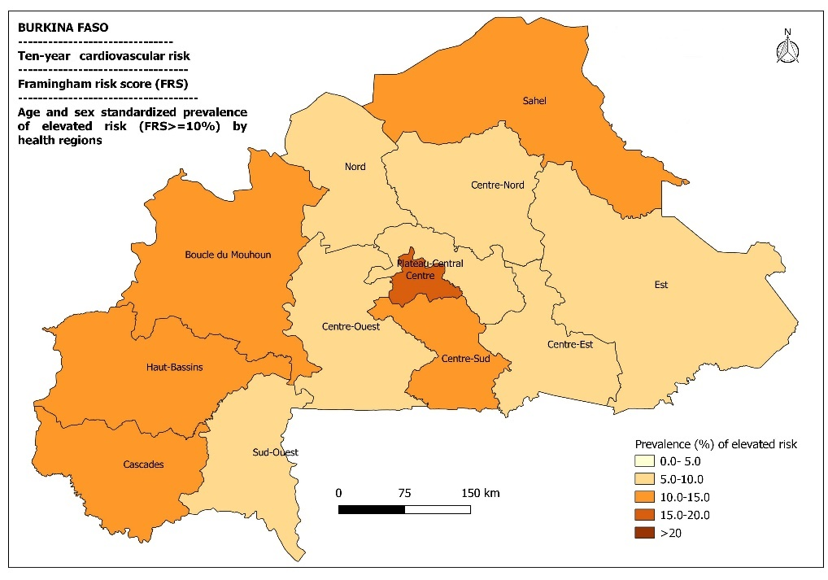

Supplemental Figure 3: Age and sex standardized mean of absolute cardiovascular risk (left) and prevalence of elevated risk (FRS >=10%) (right) by region. The mean of absolute cardiovascular risk was significantly higher in the Centre region (p<0.001). The prevalence of elevated risk was also higher in Centre region (p<0.001).

Globorisk

Supplemental Table 7: Mean of 10-years cardiovascular risk (Globorisk) by socio-demographic characteristics by gender
Characteristics | Women | Men | All
 | Mean [95%CI] | Mean [95%CI] | Mean [95%CI]
All participants | 3.4 [3.2-3.6] | 5.0 [4.7-5.3] | 4.2 [3.9-4.4]
Age (years)
30-39 | 2.3 [2.2-2.4] | 3.0 [2.9-3.2] | 2.6 [2.5-2.7]
40-49 | 2.7 [2.5-2.9] | 3.9 [3.6-4.1] | 3.3 [3.1-3.5]
50-59 | 4.8 [4.3-5.4] | 7.4 [6.8-7.9] | 6.1 [5.6-6.5]
≥ 60 | 10.1 [9.0-11.2] | 12.8 [11.8-13.7] | 11.7 [10.8-12.7]
Scholarship
Unschooled | 3.3 [3.1-3.5] | 5.0 [4.7-5.4] | 4.1 [3.9-4.3]
Primary | 3.4 [2.5-4.3] | 4.8 [4.2-5.4] | 4.2 [3.7-4.7]
Secondary and higher | 4.2-2.9-5.5] | 5.2 [3.8-6.6] | 4.8 [3.7-5.8]
Marital status
Single | 4.3 [3.8-4.9] | 4.3 [3.6-4.9] | 4.3 [3.9-4.7]
Married | 3.2 [3.0-3.4] | 5.1 [4.7-5.4] | 4.2 [3.9-4.4]
Residence
Urban | 3.7 [3.2-4.3] | 5.7 [4.7-6.7] | 4.6 [4.0-5.2]
Rural | 3.2 [3.0-3.4] | 4.8 [4.5-5.1] | 4.0 [3.8-4.2]
Occupational status
Paid worker | 3.1 [2.9-3.2] | 4.9 [4.6-5.2] | 4.2 [4.0-4.4]
Jobless | 3.7 [3.3-4.1] | 8.3 [5.0-11.6] | 4.0 [3.5-4.5]
CI=Confidence interval

Supplemental Table 8: Elevated risk of 10-years cardiovascular event (Globorisk ≥ 10%) by socio-demographic characteristics by gender
Characteristics | Women |  | Men
 | Globorisk <10% | Globorisk ≥10% | Globorisk <10% | Globorisk ≥10%
 | n (%*) | n (%*) | n (%*) | n (%*)
All participants | 1475 | 58
Age (years)
30-39 | 708 (47.3) | 7 (9.0) | 624 (44.4) | 7 (4.3)
40-49 | 430 (30.0) | 10 (14.4) | 446 (34.9) | 13 (8.7)
50-59 | 270 (18.3) | 15 (33.5) | 247 (16.2) | 57 (38.9)
≥ 60 | 67 (4.4) | 26 (43.1) | 73 (4.6) | 81 (48.1)
Scholarship
Unschooled | 1237 (84.2) | 47 (77.9) | 1053 (75.8) | 124 (77.7)
Primary | 166 (11.3) | 4 (9.6) | 238 (16.5) | 21 (12.9)
Secondary and higher | 72 (4.5) | 7 (12.5) | 99 (7.7) | 13 (9.3)
Marital status
Single | 211 (13.0) | 12 (17.9) | 169 (10.9) | 9 (3.3)
Married | 1264 (87.0) | 46 (82.1) | 1221 (89.1) | 149 (96.7)
Residence
Urban | 362 (29.5) | 19 (39.4) | 268 (23.2) | 42 (36.4)
Rural | 1113 (70.5) | 39 (60.6) | 1122 (76.8) | 116 (63.6)
Occupational status
Paid worker | 850 (54.8) | 22 (35.6) | 1348 (97.5) | 146 (88.5)
Jobless | 625 (45.2) | 36 (64.4) | 42 (2.5) | 12 (11.5)
*weighted percentage

Supplemental Table 9: Age-standardized prevalence elevated risk of 10-years cardiovascular event (Globorisk≥ 10%) by socio-demographic characteristics by sex
Characteristics | Menª | Womenª | All^{b}
All participants | 8.2 [7.1-9.4] | 3.9 [2.9-4.8] | 5.9 [5.1-6.6]
Age (years)
30-39 | 1.2 [0.5-2.6] | 0.7 [0.3-1.9] | 1.0 [0.5-1.6]
40-49 | 2.9 [1.5-5.5] | 1.8 [0.8-3.8] | 2.2 [1.5-3.5]
50-59 | 22.5 [16.3-30.1] | 6.5 [3.8-11.1] | 11.2 [8.7-13.6]
≥ 60 | 56.0 [46.4-65.2] | 27.4 [18.7-38.2] | 38.8 [32.6-45.0]
Education
Unschooled | 7.5 [6.3-8.7] | 3.5 [2.6-4.5] | 5.4 [4.6-6.1]
Primary | 9.2 [6.1-12.3] | 4.5 [5.7-8.4] | 6.6 [4.1-9.2]
Secondary and higher | 19.0 [11.6-26.4] | 13.1 [7.4-18.9] | 15.7 [11.1-20.4]
Marital status
Single | 5.5 [2.5-8.4] | 2.1 [1.0-3.2] | 3.6 [2.2-5.1]
Married | 8.5 [7.3-9.7] | 4.3 [3.2-5.5] | 6.2 [5.4-7.1]
Residence
Urban | 12.3 [9.1-15.6] | 6.0 [3.8-8.2] | 8.9 [7.0-10.7]
Rural | 7.3 [6.1-8.4] | 3.4 [2.4-4.4] | 5.2 [4.4-5.9]
Occupational status
Paid worker | 8.1 [7.0-9.3] | 2.7 [1.6-3.8] | 5.2 [4.4-6.0]
Jobless | 11.3 [3.2-19.4] | 5.2 [3.6-6.7] | 7.9 [4.2-11.6]
ª Standardized by age only; ^{b} Standardized by age and sex.

Supplemental Table 10: Factors associated with elevated risk (Globorisk>=10%) using multivariate modified Poisson regression with GEE model
Characteristics | cPR [95%CI] | P value | aPR [95%CI] | P value
Sexes |  | <0.001 |  | <0.001
Women | Ref. |  | Ref.
Men | 2.84 [2.08-3.87] |  | 2.06 [1.43-2.96]
Age (per ten-years) | 3.69 [3.12-4.36] | <0.001 | 3.60 [3.05-4.24] | <0.001
Education |  | 0.28 |  | 0.08
Unschooled | Ref. |  | Ref.
Primary | 0.80 [0.52-1.23] |  | 1.18 [0.76-1.82]
Secondary and higher | 1.32 [0.79-2.19] |  | 1.86 [1.07-3.22]
Marital status |  | 0.12 |  | 0.08
Single | Ref. |  | Ref.
Married | 1.44 [0.91-2.28] |  | 1.53 [0.95-2.47]
Residence |  | 0.11 |  | 0.84
Urban | Ref |  | Ref.
Rural | 0.74 [0.51-1.09] |  | 0.95 [0.60-1.51]
Occupational status |  | 0.80 |  | 0.38
Paid worker | Ref. |  | Ref.
Jobless | 0.83 [0.58-1.17] |  | 1.20 [0.80-1.80]
cPR: Crude Prevalence Ratio; aPR: Adjusted Prevalence Ratio, outcome variable is the high risk (Globorisk >=10%), CI: Confidence Interval, Ref: reference; GEE: General Estimating Equation

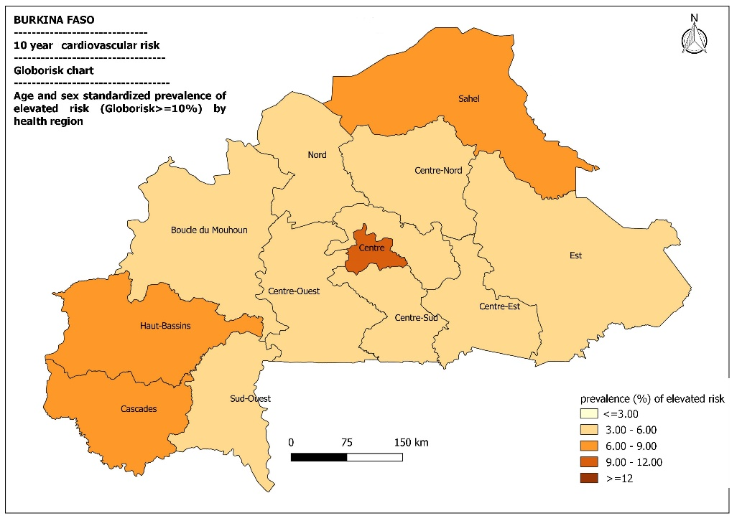

Supplemental Figure 4: Age and sex standardized mean of absolute cardiovascular risk (left) and prevalence of elevated risk (Globorisk >=10%) (right) by region. The mean of absolute cardiovascular risk was significantly higher in Centre region (p=0.016). The prevalence of elevated risk was also higher in Centre region followed (p<0.001).

Supplemental Table 11: Mean of 10-years cardiovascular risk (WHO risk) by socio-demographic characteristics by gender
Characteristics | Women | Men | All
 | Mean [95%CI] | Mean [95%CI] | Mean [95%CI]
All participants | 2.0 [1.9-2.2] | 3.2 [3.0-3.4] | 2.6 [2.5-2.7]
Age (years)
30-39 | 1.2 [1.1-1.2] | 2.1 [2.0-2.2] | 1.6 [1.5-1.7]
40-49 | 1.5 [1.4-1.7] | 2.5 [2.4-2.7] | 2.0 [1.9-2.2]
50-59 | 3.6 [3.3-3.9] | 4.6 [4.2-4.9] | 4.1 [3.8-4.3]
≥ 60 | 6.4 [5.8-6.9] | 8.0 [7.4-8.6] | 7.3 [6.8-7.9]
Scholarship
Unschooled | 2.1 [1.9-2.2] | 3.3 [3.0-3.5] | 2.6 [2.5-2.7]
Primary | 1.8 [1.4-2.2] | 3.1 [2.7-3.4] | 2.5 [2.3-2.8]
Secondary and higher | 2.3 [1.5-3.0] | 3.4 [2.5-4.2] | 3.0 [2.3-3.6]
Marital status
Single | 2.9 [2.5-3.2] | 2.8 [2.4-3.3] | 2.9 [2.6-3.1]
Married | 1.9 [1.8-2.0] | 3.3 [3.1-3.5] | 2.6 [2.5-2.7]
Residence
Urban | 2.2 [1.9-2.4] | 3.7 [3.1-4.2] | 2.8 [2.5-3.2]
Rural | 2.0 [1.9-2.1] | 3.1 [2.9-3.3] | 2.6 [2.4-2.7]
Occupational status
Paid worker | 1.9 [1.8-2.0] | 3.2 [3.0-3.3] | 2.7 [2.6-2.8]
Jobless | 2.2 [2.0-2.4] | 5.4 [3.5-7.4] | 2.4 [2.1-2.7]
CI: confidence interval

Reference
1. Kaptoge S, Pennells L, Bacquer DD, et al. World Health Organization cardiovascular disease risk charts: revised models to estimate risk in 21 global regions. The Lancet Global Health. 2019;7(10):e1332-e1345. doi:10.1016/S2214-109X(19)30318-3
2. D’Agostino Ralph B., Vasan Ramachandran S., Pencina Michael J., et al. General Cardiovascular Risk Profile for Use in Primary Care. Circulation. 2008;117(6):743-753. doi:10.1161/CIRCULATIONAHA.107.699579
3. Gaziano TA, Pandya A, Steyn K, et al. Comparative assessment of absolute cardiovascular disease risk characterization from non-laboratory-based risk assessment in South African populations. BMC Medicine. 2013;11(1):170. doi:10.1186/1741-7015-11-170
4. Grammer TB, Dressel A, Gergei I, et al. Cardiovascular risk algorithms in primary care: Results from the DETECT study. Sci Rep. 2019;9(1):1-12. doi:10.1038/s41598-018-37092-7
5. Hajifathalian K, Ueda P, Lu Y, et al. A novel risk score to predict cardiovascular disease risk in national populations (Globorisk): a pooled analysis of prospective cohorts and health examination surveys. The Lancet Diabetes & Endocrinology. 2015;3(5):339-355. doi:10.1016/S2213-8587(15)00081-9

