Supplementary Information

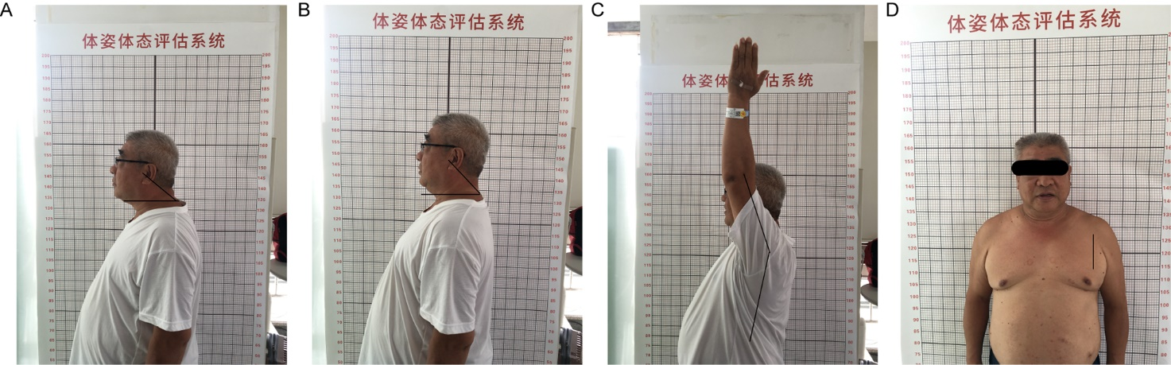
Supplementary Figure 1. Measurement of Neck/shoulder mobility. (A) maximum head protraction; (B) maximum head retraction; (C) shoulder flexion ROM; (D) the non-dominant PmM length.
Abbreviations: ROM, range of motion; PmM, pectoralis minor muscle.

