Table S1 Clinical variables determined by Lasso.
Table S2 Clinical variables determined by Boruta.
Table S3 Hyperparameters settings of the machine learning prediction algorithms.
Figure S1 Cross-validation statistical graph based on Lasso.
Figure S2 The results of clinical variables selected by Boruta.

Table S1 Clinical variables determined by Lasso.
Clinical variables | Variable coefficients
DBP | -0.022
Blood, Lactate | 0.170
Blood, pH | -1.090
Blood, Anion gap | 0.035
Blood, Creatinine | 0.124
Blood, RDW | 0.130
Age | 0.011
Abbreviations: DBP, diastolic blood pressure; RDW, red blood cell distribution width.

Table S2 Clinical variables determined by Boruta.
Clinical variables | Feature importance
Blood, Lactate | 12.147
Blood, Anion gap | 10.910
Blood, Creatinine | 10.501
SBP | 10.498
Blood, RDW | 9.287
DBP | 8.489
Blood, pH | 6.869
Age | 4.029
Blood, Urea Nitrogen | 3.442
Abbreviations: DBP, diastolic blood pressure; RDW, red blood cell distribution width; SBP,
systolic blood pressure.

Table S3 Hyperparameters settings of the machine learning prediction algorithms.
Models | SVM | XGBoost | ELM
hyperparameter settings | C = 1 | Depth = 10  Eta = 0.45 | Hidden neurons = 38

Figure S1 Cross-validation statistical graph based on Lasso.
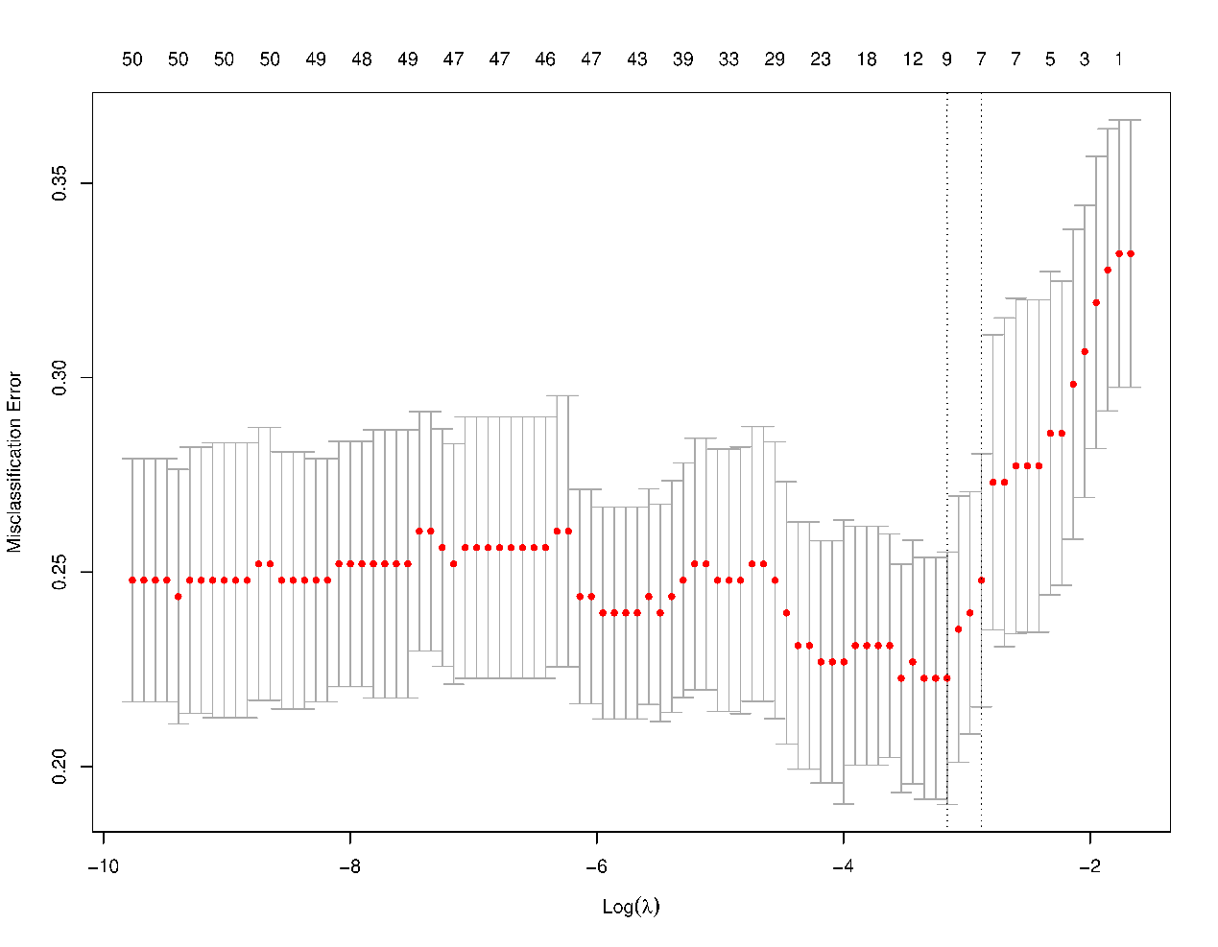Note: This picture shows the relationship among the penalty coefficient (λ) (the lower horizontal axis), the number of selected variables (the upper horizontal axis), and the misclassification error (vertical axis) through Lasso. The two vertical dashed lines represent the logλ with the minimum misclassification error (MSE) (the dashed line on the left) and the logλ with one standard error from the minimum value (the dashed line on the right). To reduce the over-fitting problem, the logλ at the position one standard error from the minimum value was selected in this study. Therefore, seven clinical variables were selected by Lasso.

Figure S2 The results of clinical variables selected by Boruta.
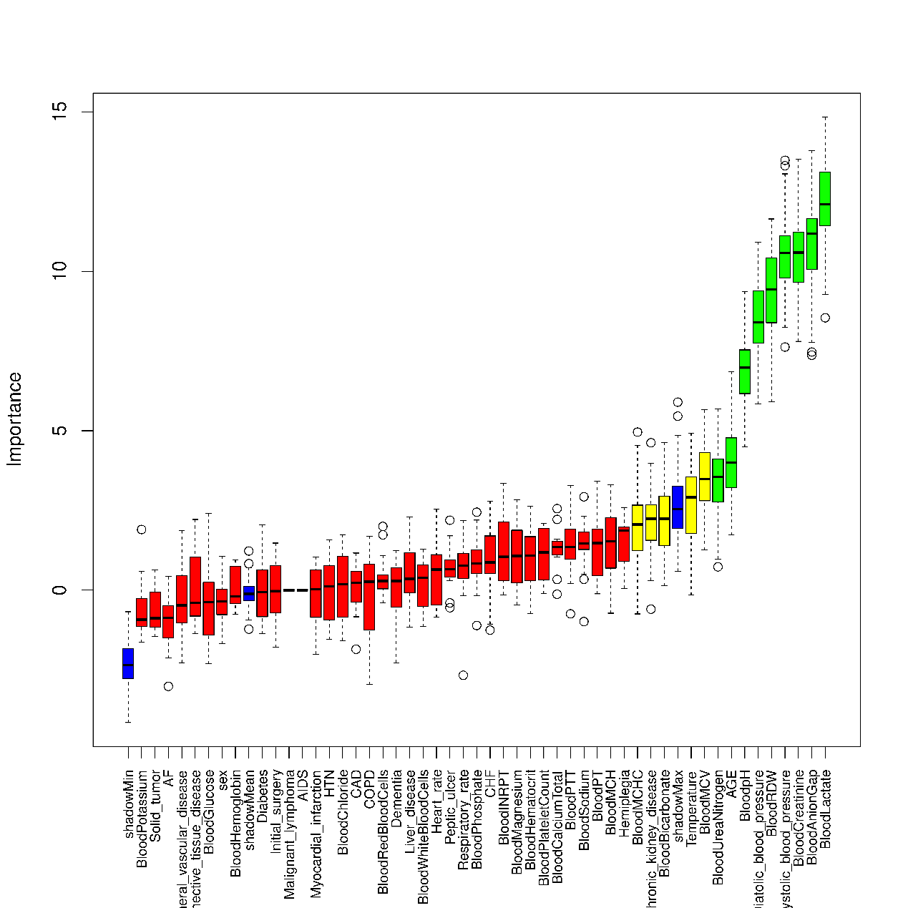
Notes: This picture shows the ranking of the importance of all clinical variables and shadow (virtual) variables generated by the Boruta method. The blue box plot represents the importance of shadow variables including minimum, mean, and maximum. The red, yellow, and green boxplots represent rejected, tentative, and confirmed clinical variables, respectively. Only confirmed clinical variables were considered to be selected by Boruta. Therefore, nine clinical variables were selected by Boruta.

