Supplementary S1. The AUC area for different makers for the colposcopy referral population (except for HSIL)

AUC
marker | AUC | SEM | p | 95% CI
 |  |  |  | Low | High
p16 | .770 | .015 | .000 | .740 | .800
Ki-67 | .736 | .018 | .000 | .701 | .771
RELA | .902 | .012 | .000 | .879 | .925
YAP1 | .877 | .013 | .000 | .852 | .902
SMAD3 | .897 | .014 | .000 | .870 | .923
p16, Ki-67 | .763 | .018 | .000 | .729 | .798
p16, RELA | .788 | .017 | .000 | .754 | .822
p16, YAP1 | .782 | .018 | .000 | .748 | .817
p16, SMAD3 | .653 | .020 | .000 | .614 | .691
p16, YAP1/RELA | .808 | .016 | .000 | .776 | .840
p16, YAP1/SMAD3/RELA | .802 | .016 | .000 | .771 | .834

Supplementary S2. The AUC area for different makers for HPV16/18+ group.
AUC
marker | AUC | SEM | p | 95% CI
 |  |  |  | Low | High
p16 | .736 | .021 | .000 | .694 | .778
Ki-67 | .745 | .022 | .000 | .702 | .788
RELA | .837 | .020 | .000 | .799 | .876
YAP1 | .768 | .023 | .000 | .724 | .813
SMAD3 | .649 | .025 | .000 | .599 | .699
p16, Ki-67 | .776 | .022 | .000 | .733 | .820
p16, RELA | .801 | .022 | .000 | .758 | .844
p16, YAP1 | .755 | .024 | .000 | .709 | .801
p16, SMAD3 | .644 | .026 | .000 | .593 | .694
p16, YAP1/RELA | .802 | .021 | .000 | .760 | .844
p16, YAP1/SMAD3/RELA | .796 | .021 | .000 | .754 | .837

Supplementary S3. The AUC area for different makers for other HPV+ combined with ASCUS group.
AUC
marker | AUC | SEM | p | 95% CI
 |  |  |  | Low | High
p16 | .791 | .031 | .000 | .731 | .851
Ki-67 | .705 | .038 | .000 | .631 | .778
RELA | .645 | .039 | .000 | .568 | .721
YAP1 | .759 | .035 | .000 | .691 | .828
SMAD3 | .596 | .040 | .013 | .517 | .676
p16, Ki-67 | .711 | .039 | .000 | .634 | .788
p16, RELA | .706 | .039 | .000 | .629 | .782
p16, YAP1 | .798 | .036 | .000 | .728 | .869
p16, SMAD3 | .608 | .041 | .005 | .527 | .690
p16, YAP1/RELA | .847 | .029 | .000 | .790 | .903
p16, YAP1/SMAD3/RELA | .813 | .030 | .000 | .755 | .872

Supplementary S4. The AUC area for different makers for LSIL group.
AUC
marker | AUC | SEM | p | 95% CI
 |  |  |  | Low | High
p16 | .798 | .026 | .000 | .747 | .848
Ki-67 | .721 | .034 | .000 | .655 | .787
RELA | .875 | .025 | .000 | .825 | .925
YAP1 | .751 | .031 | .000 | .691 | .811
SMAD3 | .669 | .035 | .000 | .600 | .739
p16, Ki-67 | .737 | .034 | .000 | .670 | .804
p16, RELA | .851 | .030 | .000 | .793 | .909
p16, YAP1 | .795 | .031 | .000 | .733 | .856
p16, SMAD3 | .697 | .036 | .000 | .626 | .767
p16, YAP1/RELA | .801 | .031 | .000 | .741 | .861
p16, YAP1/SMAD3/RELA | .784 | .031 | .000 | .724 | .844

Supplementary S5. Flowchart of the follow-up.
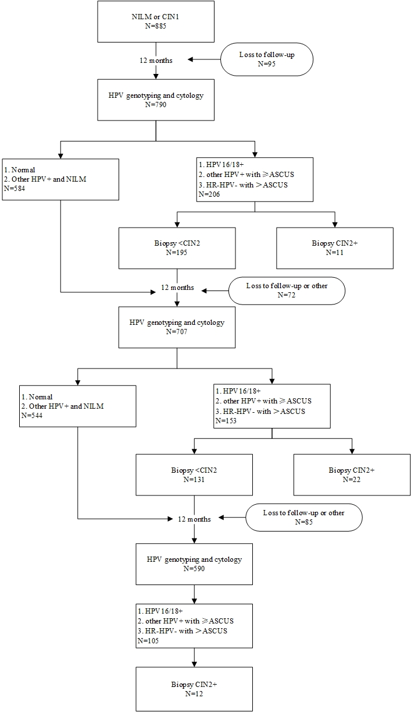
Supplementary S6. The AUC area for different makers for CIN2+ predicting during follow-up
AUC
marker | AUC | SEM | p | 95% CI
 |  |  |  | Low | High
p16 | .789 | .033 | .000 | .725 | .854
Ki-67 | .661 | .047 | .000 | .569 | .752
RELA | .821 | .038 | .000 | .747 | .896
YAP1 | .618 | .047 | .008 | .526 | .710
SMAD3 | .624 | .048 | .005 | .531 | .717
p16, Ki-67 | .621 | .048 | .006 | .526 | .715
p16, RELA | .839 | .041 | .000 | .759 | .919
p16, YAP1 | .632 | .049 | .003 | .536 | .729
p16, SMAD3 | .643 | .049 | .001 | .547 | .740
p16, YAP1/RELA | .878 | .034 | .000 | .812 | .944
p16, YAP1/SMAD3/RELA | .862 | .034 | .000 | .796 | .928

