Supplementary figure 1 DEMs in the GSE51674 dataset. Heat Map showing a distinguishable expression profile of miRNAs between kidney tissues from patients with mild and serious renal diseases.
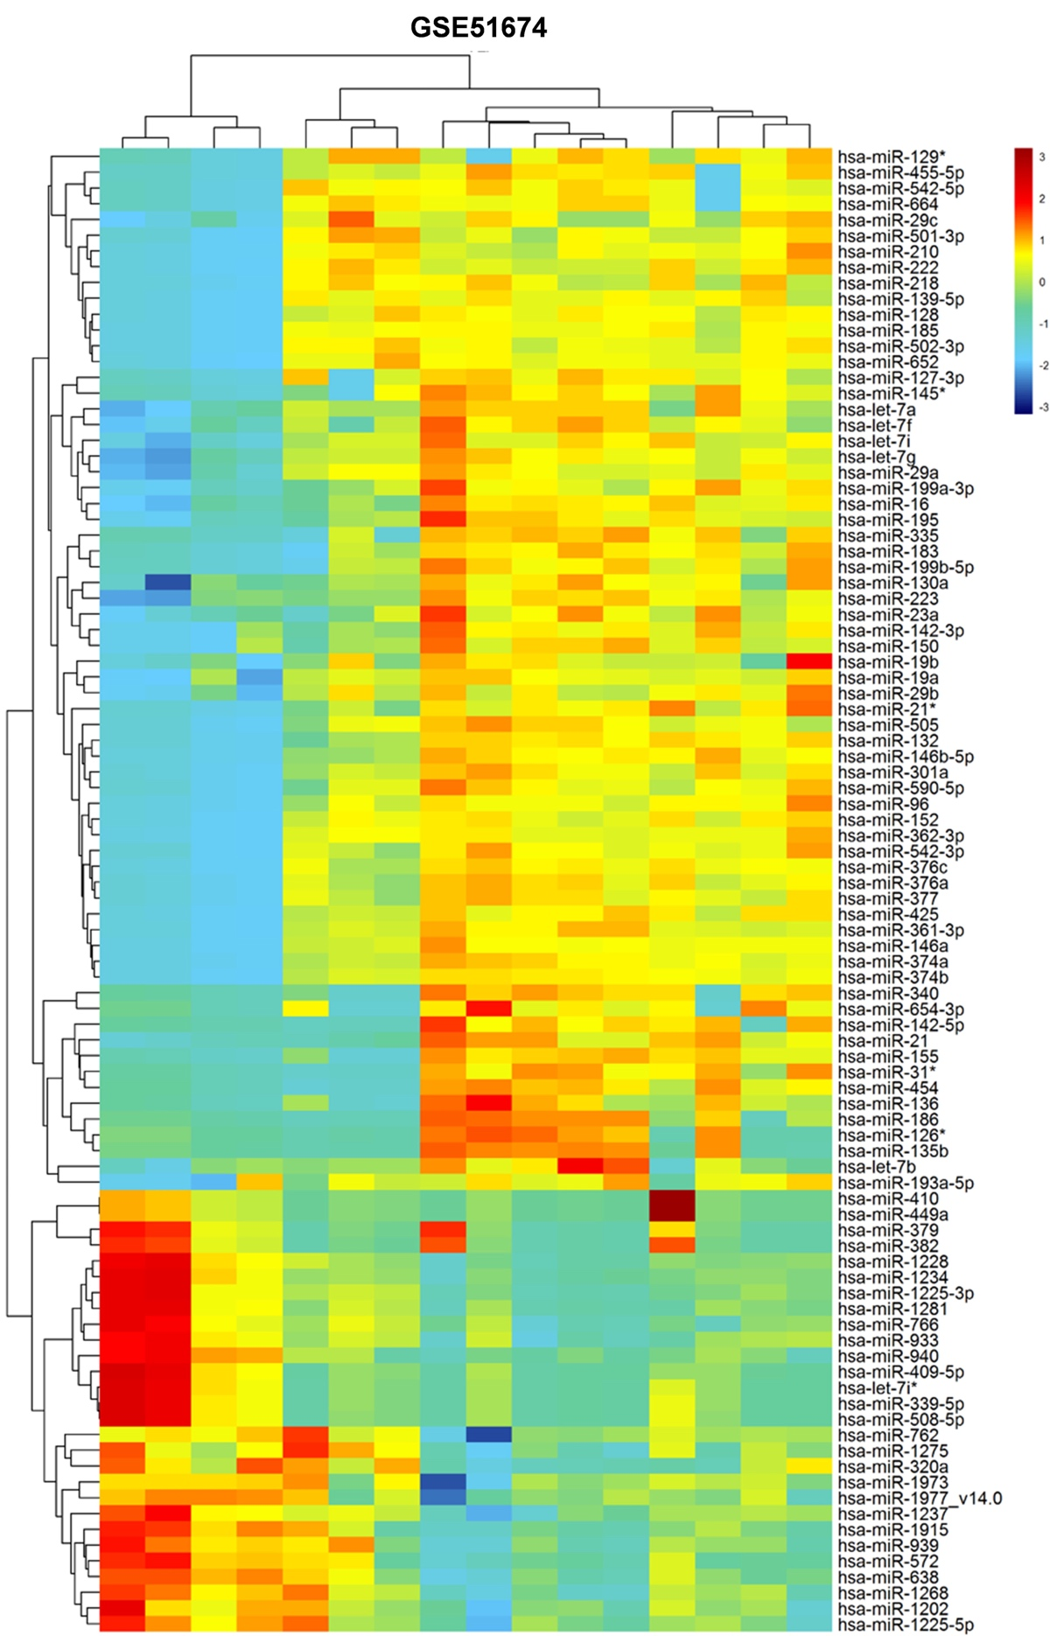
Supplementary figure 2 DEMs in the GSE42648 dataset. Heat Map showing a distinguishable expression profile of miRNAs between kidney tissues from patients with mild and serious renal diseases.
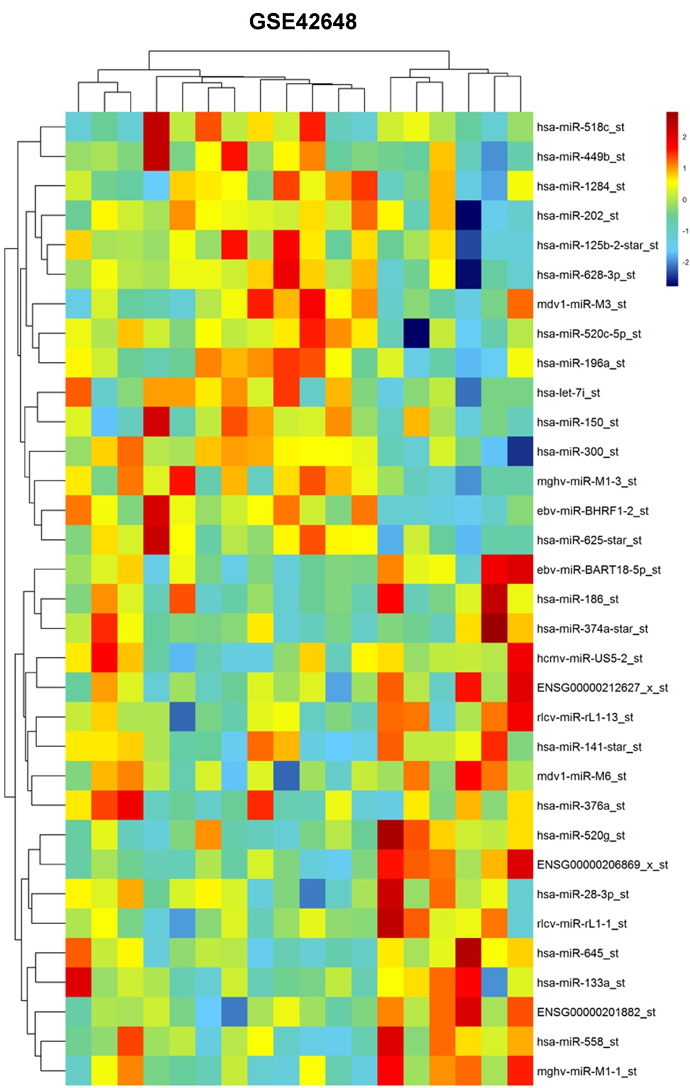

Supplementary figure 3 The existing pattern of extracellular let-7i-5p. RT-qPCR was used to detect the level of let-7i-5p in the CM of MSCs/let-7i-5p treated with RNase (2 mg/ml) alone or combined with Triton X-100 (0.1%) for 20 min (n = 3). **P < 0.01, compared with the control group.
