Supplementary material: Forecasting the tuberculosis incidence using a novel ensemble empirical mode decomposition based data-driven hybrid model in Tibet, China

Jizhen Li¹, Yuhong Li², Ming Ye³, Sanqiao Yao¹, Chongchong Yu¹, Lei Wang⁴, Weidong Wu¹, Yongbin Wang¹

¹ Department of Epidemiology and Health Statistics, School of Public Health, Xinxiang Medical University, Xinxiang, Henan Province, P.R. China; ² National Center for Tuberculosis Control and Prevention, China Center for Disease Control and Prevention, Beijing, P.R. China; ³ Preventive medicine clinic, Xinxiang Center for Disease Control and Prevention, Xinxiang, Henan Province, P.R. China; ⁴ Center for Musculoskeletal Surgery, Charité–Universitätsmedizin Berlin, Corporate Member of Freie Universität Berlin, Humboldt–Universität Zu Berlin and Berlin Institute of Health, Berlin, Germany

Correspondence: Yongbin Wang
Department of Epidemiology and Health Statistics, School of Public Health, Xinxiang Medical University, Xinxiang 453000, Henan Province, P.R. China
Email wybwho@163.com (Yongbin Wang)

Steps of the SARIMA, NARNN, and Traditional SARIMA-NARNN hybrid model are as below:

SARIMA model

Time series often shows significant correlations between the past values and the current values. The purpose of time series forecasting is to predict the future epidemic patterns using a mathematical method via identifying the internal rules over time inherent in a time series ¹. The classical SARIMA method under linear assumption has been regarded as the most frequently adopted prediction tool owing to its flexibility and usefulness in capturing long-trajectory epidemic patterns included in a time series ²⁻⁷. The SARIMA method types can be expressed as SARIMA(p, d, q)(P, D, Q)s, herein, p denotes the order of autoregression (AR), d signifies the order of integration, and q is the order of moving average (MA), P, D, and Q refer to their corresponding seasonal counterparts of the above three parameters ⁴. The SARIMA model is generally constructed with four steps. Firstly, an augmented Dickey-Fuller (ADF) test was applied to the TB incidence series to investigate its stationarity, differencing transformation would be used to achieve stationarity if there was a unit root in the time series ⁴. Secondly, inspecting the autocorrelation function (ACF) and partial ACF (PACF) graphs of the differenced series to identify the possible values of the key parameters ¹. Among all the candidate models, the one that produced such goodness of fit measures as a larger value of the log-likelihood, as well as lower values of the Akaike information criteria (AIC), consistent AIC (CAIC), and Bayesian information criterion (BIC), was considered the optimal. Thirdly, using statistical-based diagnostic indices including Ljung-Box Q test, residual ACF and PACF plots, and t-test to check the adequacy of the identified model, once the residuals behaved like a white-noise series under Ljung-Box Q test and the determined parameters were statistically significant under t-test, indicating this model is suitable ². Ultimately, the optimal SARIMA method can be employed to conduct out-of-sample forecasts.

NARNN model
Artificial neural networks (ANNs) can well enable arbitrarily intricate non-stationary series to attain any desired accuracy owing to their powerfully flexible nonlinear mapping capacity ⁸. Similarly, the NARNN model, as a leading dynamic recurrent neural network with the ability of the time-varying state of interconnected neurons, has such inherent attributes of ANNs as powerful nonlinear mapping capacity, self-learning and adaption ability, generalization and fault-tolerant ability ⁹. Moreover, by reserving the previous inputs, estimated outputs, and network structure with the assistance of the tapped delay line, the NARNN method can yield a long or short-term dependence to achieve the aim of dynamic modeling for the present dataset ¹⁰. The specified equation of a NARNN model can be defined as
(1)
whereis the estimates using the NARNN method based on the prior observations at lagged period d.
In our research, the utilization of a basic NARNN approach was as follows: To begin with, the in-sample observations were separated into training, validation, and testing subsets with the dividerand function in MATLAB software, followed by the ratios of 80%, 10%, and 10%, respectively. Then, the number of hidden neurons and delays d were examined over and again using the Levenberg-Marquardt algorithm in an open feedback form ¹⁰. Meanwhile, the response plot between outputs and targets, residual ACF plot, along with the mean square error (MSE) and correlation coefficient (R) were calculated until the best-stimulating model was chosen ⁹. Finally, the training open-loop form was closed to perform multi-step-ahead estimates.

Traditional SARIMA-NARNN hybrid model
Often, a time series includes both linear and nonlinear traits. The SARIMA method generally captures the linear component in the time series owing to its linear assumption, and thus the nonlinear component was retained in the residuals. NARNN technique based on the theory of nonlinear regression analysis is able to unearth what hides in the residuals with the aid of the time-varying state of interconnected neurons capable of dynamically relating the current inputs to prior data. Therefore, this technique is regarded as a useful and powerful tool to address nonlinear issues in the domain of prediction ¹¹.^{10, 12, 13} Considering its desirable nonlinear ability of the NARNN technique, some studies have developed the hybrid SARIMA-NARNN model to improve predictive performance. In this mixture model, the NARNN technique was used to forecast the residuals yielded by the SARIMA method, then the resulting results from the NARNN and SARIMA models were added together to generate the final predictive results of the hybrid SARIMA-NARNN model. As such, the underlying linear and nonlinear correlation structures between input variables and output variables can be considered by this hybrid technique. The general formula of the SARIMA-NARNN mixture model can be in the form below
(2)
(3)
Here f signifies a function relied on the structure and connection weights of the NARNN model,is the values modeled and projected by this combined model, refers to the estimates of the SARIMA approach, stands for the fitted and predicted points based only on the SARIMA residuals at lagged period d.
Figure S1 flow chart of the novel EEMD-ARIMA-NARANN hybrid model.

Figure S2 Time-series plot showing the original TB morbidity rate and the decomposed components with the STL method during the period 2004-2017 in Tibet. (A) TB morbidity series; (B) trend pattern; (C) seasonal pattern; (D) irregular pattern. As shown, the TB morbidity displayed a rising trend and had marked seasonal effects between January 2004 and December 2017.
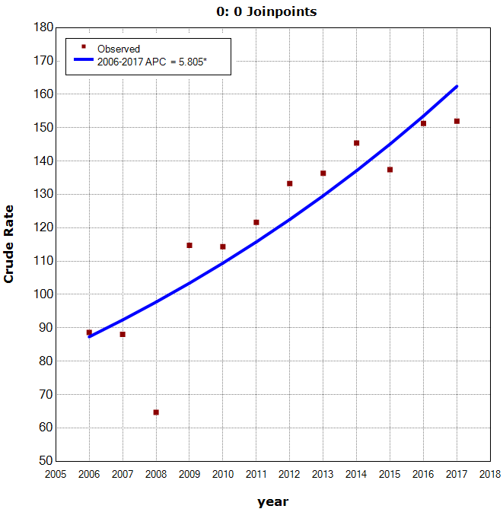
Figure S3 Joinpoint regression showing the TB incidence patterns during the period 2006–2017.
Figure S4 Monthly TB incidence plot averaged by season.

Figure S5 Autocorrelogram (ACF) and partial autocorrelogram (PACF) of the seasonally differenced once for the original TB incidence series. As shown, the autocorrelations at lags 1, 2 and 3 and partial autocorrelations at lags 1 and 2 were touching the significance levels, and thus the seasonal orders of the SARIMA model could be determined crudely based on the ACF and PACF plots. Generally, the orders of seasonal autoregression (AR) and moving average (MA) or nonseasonal AR and MA may be between 0 and 2, and hence we can model the data based on these possible parameters until the best-fitting model was found.

Figure S6 Regression plot displaying the relationship between outputs and targets in the training dataset, validation dataset, testing dataset, and entire dataset. R=1, meaning an exact linear relationship between outputs and targets; R=0, meaning no linear relationship between outputs and targets. Generally, the R value greater than 0.8 suggests that the model gives a sufficient fit to the original data. As seen above, the best-fitting NARNN model produces R values greater than 0.8 in the training dataset, validation dataset, testing dataset, and entire dataset, which implies a good fit to the original TB incidence series.

Figure S7 Response plot of the output element from the basic NARNN model developed on the basis of the TB incidence series. It can be seen that most errors are relative small, so the identified model can capture the dependence structure of the TB incidence series.
Figure S8 Response plot of the output element from the basic NARNN model developed on the basis of the six intrinsic mode functions (IMFs) decomposed by the EEMD method. (A) IMF1, (B) IMF2, (C) IMF3, (D) IMF4, (E) IMF5, and (F) IMF6. It can be seen that most errors are relative small, so the identified model can capture the dependence structure of the different IMFs components.
Figure S9 Regression plot displaying the relationship between outputs and targets in the training dataset, validation dataset, testing dataset, and entire dataset of the IMF1 component decomposed by the EEMD method. R=1, meaning an exact linear relationship between outputs and targets; R=0, meaning no linear relationship between outputs and targets. Generally, the R value greater than 0.8 suggests that the model gives a sufficient fit to the original data. As seen above, the best-fitting NARNN model produces R values greater than 0.8 in the training dataset, validation dataset, testing dataset, and entire dataset, which implies a good fit to the original TB incidence series.
Figure S10 Regression plot displaying the relationship between outputs and targets in the training dataset, validation dataset, testing dataset, and entire dataset of the IMF2 component decomposed by the EEMD method. R=1, meaning an exact linear relationship between outputs and targets; R=0, meaning no linear relationship between outputs and targets. Generally, the R value greater than 0.8 suggests that the model gives a sufficient fit to the original data. As seen above, the best-fitting NARNN model produces R values greater than 0.97 in the training dataset, validation dataset, testing dataset, and entire dataset, which implies a good fit to the original TB incidence series.
Figure S11 Regression plot displaying the relationship between outputs and targets in the training dataset, validation dataset, testing dataset, and entire dataset of the IMF3 component decomposed by the EEMD method. R=1, meaning an exact linear relationship between outputs and targets; R=0, meaning no linear relationship between outputs and targets. Generally, the R value greater than 0.8 suggests that the model gives a sufficient fit to the original data. As seen above, the best-fitting NARNN model produces R values greater than 0.8 in the training dataset, validation dataset, testing dataset, and entire dataset, which implies a good fit to the original TB incidence series.
Figure S12 Regression plot displaying the relationship between outputs and targets in the training dataset, validation dataset, testing dataset, and entire dataset of the IMF4 component decomposed by the EEMD method. R=1, meaning an exact linear relationship between outputs and targets; R=0, meaning no linear relationship between outputs and targets. Generally, the R value greater than 0.8 suggests that the model gives a sufficient fit to the original data. As seen above, the best-fitting NARNN model produces R values greater than 0.99 in the training dataset, validation dataset, testing dataset, and entire dataset, which implies a good fit to the original TB incidence series.
Figure S13 Regression plot displaying the relationship between outputs and targets in the training dataset, validation dataset, testing dataset, and entire dataset of the IMF5 component decomposed by the EEMD method. R=1, meaning an exact linear relationship between outputs and targets; R=0, meaning no linear relationship between outputs and targets. Generally, the R value greater than 0.8 suggests that the model gives a sufficient fit to the original data. As seen above, the best-fitting NARNN model produces R values greater than 0.99 in the training dataset, validation dataset, testing dataset, and entire dataset, which implies a good fit to the original TB incidence series.

Figure S14 Regression plot displaying the relationship between outputs and targets in the training dataset, validation dataset, testing dataset, and entire dataset of the IMF6 component decomposed by the EEMD method. R=1, meaning an exact linear relationship between outputs and targets; R=0, meaning no linear relationship between outputs and targets. Generally, the R value greater than 0.8 suggests that the model gives a sufficient fit to the original data. As seen above, the best-fitting NARNN model produces R values greater than 0.99 in the training dataset, validation dataset, testing dataset, and entire dataset, which implies a good fit to the original TB incidence series.

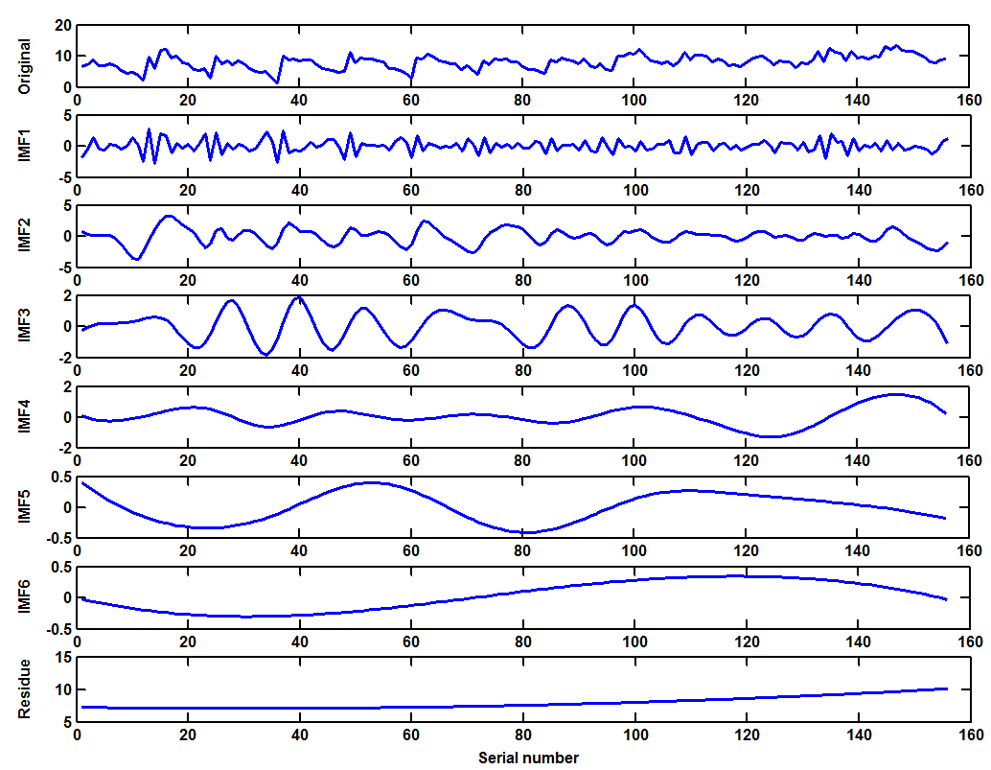
Figure S15 Intrinsic mode functions (IMFs) and residue components of the original TB incidence series in Qinghai using the EEMD.
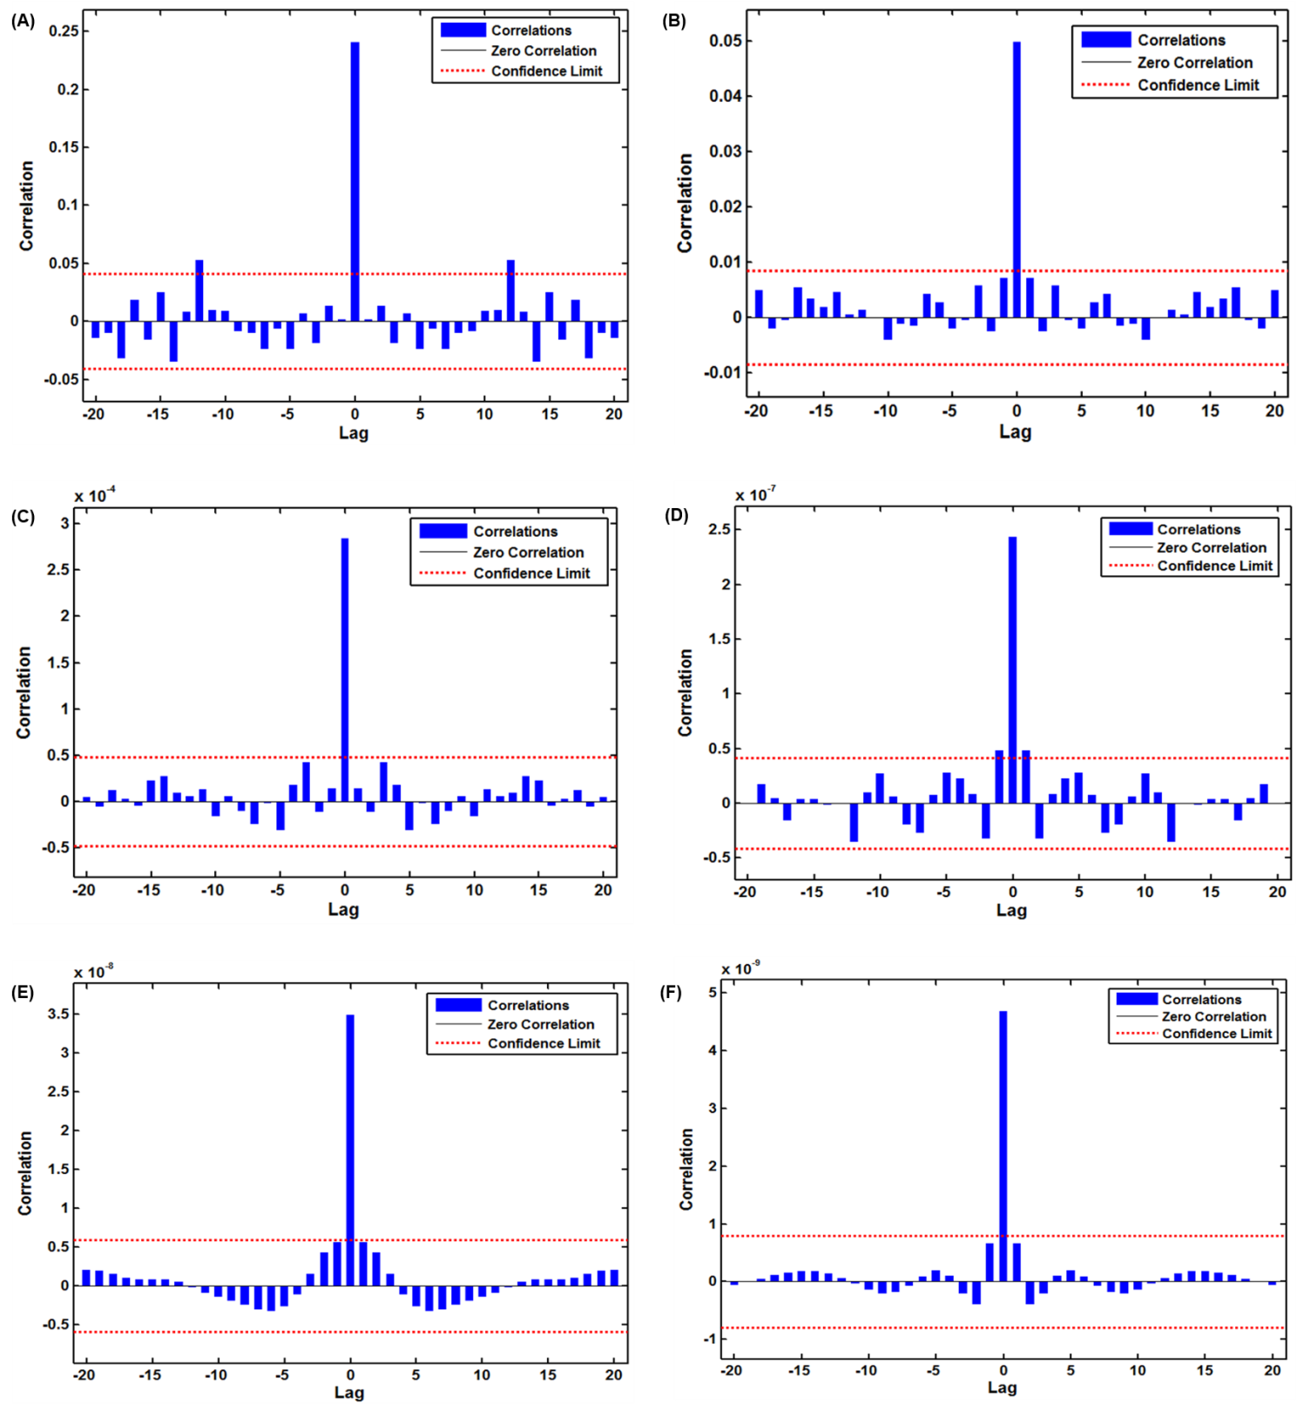
Figure S16 Estimated autocorrelogram of the residual sequence to forecast the six intrinsic mode functions (IMFs) decomposed by the EEMD method using the SARIMA-NARNN hybrid model. (A) IMF1, (B) IMF2, (C) IMF3, (D) IMF4, (E) IMF5, and (F) IMF6. For the estimated autocorrelations of the residual series from the different IMFs, all of them are inside of the 95 CIs except for the one at lag zero, meaning that there is no correlated serial in the residuals of the best-fitting SARIMA-NARNN hybrid model. Thereby, there appears to be adequate and reasonable for forecasting upcoming epidemiological trends using these best-fitting models.

Table S1 Box-Ljung Q statistics for the residual sequence of the selected optimal four methods

Lags | SARIMA  model |  | NARNN  model |  | SARIMA-NARNN  hybrid model |  | EEMD-SARIMA-NARNN  hybrid model
Lags |  | p |  | p |  | p |  | p
1 | 0.031 | 0.861 | 0.096 | 0.757 | 1.568 | 0.210 | 0.018 | 0.893
4 | 6.248 | 0.181 | 2.588 | 0.629 | 6.811 | 0.146 | 2.628 | 0.622
8 | 12.073 | 0.148 | 7.797 | 0.454 | 6.991 | 0.538 | 3.228 | 0.919
12 | 13.208 | 0.354 | 10.103 | 0.607 | 9.765 | 0.637 | 9.826 | 0.631
16 | 21.168 | 0.172 | 13.149 | 0.662 | 15.773 | 0.469 | 13.485 | 0.637
20 | 29.826 | 0.072 | 15.308 | 0.759 | 18.853 | 0.531 | 19.485 | 0.491
24 | 34.391 | 0.078 | 19.094 | 0.747 | 20.445 | 0.671 | 23.744 | 0.476
28 | 38.003 | 0.122 | 23.702 | 0.688 | 21.369 | 0.810 | 27.93 | 0.468
32 | 38.191 | 0.209 | 36.487 | 0.268 | 25.278 | 0.795 | 30.631 | 0.536
36 | 44.181 | 0.164 | 38.205 | 0.370 | 28.909 | 0.793 | 35.505 | 0.492

Abbreviation: SARIMA seasonal autoregressive integrated moving average method, EEMD ensemble empirical mode decomposition, NARNN nonlinear autoregressive artificial neural network.

Table S2 LM-test statistics for the residual sequence of the selected optimal four methods

Lags | SARIMA  model |  | NARNN  model |  | SARIMA-NARNN  hybrid model |  | EEMD-SARIMA-NARNN  hybrid model
Lags |  | p |  | p |  | p |  | p
1 | 0.269 | 0.604 | 0.133 | 0.716 | 0.010 | 0.753 | 0.139 | 0.710
4 | 1.104 | 0.894 | 3.733 | 0.443 | 0.494 | 0.974 | 1.096 | 0.895
8 | 2.836 | 0.944 | 8.159 | 0.418 | 12.614 | 0.116 | 2.245 | 0.973
12 | 4.177 | 0.980 | 12.593 | 0.399 | 19.751 | 0.072 | 10.714 | 0.554
16 | 6.857 | 0.976 | 13.317 | 0.650 | 19.536 | 0.242 | 13.097 | 0.666
20 | 8.330 | 0.989 | 17.722 | 0.606 | 15.988 | 0.717 | 13.686 | 0.846
24 | 10.612 | 0.992 | 22.601 | 0.543 | 19.427 | 0.729 | 15.264 | 0.913
28 | 18.041 | 0.925 | 25.862 | 0.633 | 25.293 | 0.612 | 19.668 | 0.876
32 | 26.315 | 0.750 | 36.272 | 0.276 | 26.902 | 0.722 | 19.752 | 0.967
36 | 28.409 | 0.812 | 40.391 | 0.282 | 30.425 | 0.7306 | 22.512 | 0.961

Abbreviation: SARIMA seasonal autoregressive integrated moving average method, EEMD ensemble empirical mode decomposition, NARNN nonlinear autoregressive artificial neural network.

Table S3 Statistical test of the estimated parameters for the optimal SARIMA (0,3,0)(0,1,1)₁₂ method

Variables | Estimates | Standard error | t | p
SMA1 | 0.664 | 0.084 | 7.882 | <0.001

Abbreviation: SARIMA seasonal autoregressive integrated moving average method, SMA1 seasonal moving average method at lag 1.

Table S4 The estimated parameters of the optimal NARNN models for the original series and decomposed series using the EEMD method

Target  components | Hidden units | Delays | MSE |  |  | R
Target  components | Hidden units | Delays | Training | Validation | Testing | Training | Validation | Testing
IMF1 | 16 | 5 | 0.152 | 0.579 | 0.603 | 0.918 | 0.807 | 0.781
IMF2 | 15 | 5 | 0.032 | 0.114 | 0.123 | 0.989 | 0.984 | 0.979
IMF3 | 14 | 4 | 0.000 | 0.001 | 0.000 | 1.000 | 0.999 | 1.000
IMF4 | 16 | 5 | 0.000 | 0.000 | 0.000 | 1.000 | 1.000 | 1.000
IMF5 | 15 | 4 | 0.000 | 0.000 | 0.000 | 1.000 | 1.000 | 1.000
IMF6 | 13 | 4 | 0.000 | 0.000 | 0.000 | 1.000 | 1.000 | 1.000

Abbreviation: SARIMA seasonal autoregressive integrated moving average method, NARNN nonlinear autoregressive artificial neural network.
Table S5 Comparisons of the mimic and predictive performance measures among the best-performing four models

Models | Fitting power |  |  |  | Projected power
Models | MAE | MAPE | RMSE | MER | MAE | MAPE | RMSE | MER
SARIMA model | 0.746 | 9.525 | 1.008 | 0.095 | 0.972 | 8.685 | 1.153 | 0.091
NARNN model | 0.463 | 6.767 | 0.625 | 0.058 | 1.238 | 11.176 | 1.558 | 0.116
SARIMA-NARNN hybrid model | 0.424 | 5.610 | 0.564 | 0.053 | 0.803 | 7.649 | 0.979 | 0.075
EEMD-SARIMA-NARNN hybrid model | 0.383 | 5.286 | 0.271 | 0.049 | 0.739 | 6.903 | 0.884 | 0.069
Reduced percentages (%)
D vs. A | 48.660 | 44.504 | 73.115 | 48.421 | 23.971 | 20.518 | 23.330 | 24.176
D vs. B | 17.279 | 21.886 | 56.640 | 15.517 | 40.307 | 38.234 | 43.261 | 40.517
D vs. C | 9.670 | 5.775 | 51.950 | 7.547 | 7.970 | 9.753 | 9.704 | 8.000

Abbreviations: SARIMA seasonal autoregressive integrated moving average method, EEMD ensemble empirical mode decomposition, NARNN nonlinear autoregressive artificial neural network, MAD mean absolute deviation, MAPE mean absolute percentage error, RMSE root mean square error, MER mean error rate, RMSPE root mean square percentage error, A refers to the SARIMA method, B takes for the NARNN method, C signifies the traditional SARIMA-NARNN mixture method, D is the novel EEMD-SARIMA-NARNN mixture method. Besides, the fitted and forecasted results from the SARIMA model, NARNN model, and traditional SARIMA-NARNN hybrid model can be found in our prior study¹⁴.

Table S6 The possible ETS model developed based on the training data from January 2006 to December 2016

Model | Compact LL | Likelihood | AIC | BIC | HQ | AMSE
A,AD,A | -334.173 | -199.208 | 702.345 | 751.353 | 722.26 | 1.00E+100
A,MD,A | -334.192 | -199.227 | 702.385 | 751.392 | 722.299 | 3.430
A,N,A | -338.432 | -203.467 | 704.864 | 745.223 | 721.264 | 3.422
A,A,A | -338.167 | -203.202 | 708.334 | 754.459 | 727.077 | 3.439
A,M,A | -338.353 | -203.388 | 708.706 | 754.830 | 727.449 | 3.432
M,N,A | -343.693 | -208.728 | 715.385 | 755.744 | 731.785 | 3.483
M,A,A | -342.654 | -207.689 | 717.309 | 763.434 | 736.052 | 3.546
M,M,A | -343.482 | -208.517 | 718.965 | 765.090 | 737.708 | 3.510
M,MD,A | -343.693 | -208.728 | 721.385 | 770.393 | 741.300 | 3.483
M,AD,A | -343.693 | -208.728 | 721.385 | 770.393 | 741.300 | 1.00E+100
A,A,M | -375.171 | -240.206 | 782.343 | 828.468 | 801.086 | 3.961
A,N,M | -378.399 | -243.434 | 784.798 | 825.158 | 801.199 | 4.101
A,MD,M | -375.603 | -240.638 | 785.206 | 834.213 | 805.120 | 4.451
A,M,M | -377.268 | -242.303 | 786.536 | 832.661 | 805.279 | 4.031
A,AD,M | -378.399 | -243.434 | 790.798 | 839.806 | 810.713 | 1.00E+100
M,N,M | -396.191 | -261.226 | 820.383 | 860.742 | 836.783 | 5.623
M,A,M | -394.797 | -259.832 | 821.595 | 867.72 | 840.338 | 6.133
M,M,M | -395.466 | -260.501 | 822.932 | 869.057 | 841.675 | 6.076
M,MD,M | -395.347 | -260.382 | 824.694 | 873.701 | 844.608 | 5.792
M,AD,M | -396.191 | -261.226 | 826.383 | 875.39 | 846.297 | 1.00E+100
A,N,N | -459.364 | -324.399 | 922.729 | 928.494 | 925.072 | 11.903
A,MD,N | -456.487 | -321.522 | 922.973 | 937.387 | 928.831 | 12.083
A,M,N | -458.408 | -323.443 | 924.815 | 936.347 | 929.501 | 11.644
A,AD,N | -458.330 | -323.365 | 926.661 | 941.075 | 932.518 | 1.00E+100
A,A,N | -459.358 | -324.393 | 926.717 | 938.248 | 931.403 | 11.904
M,A,N | -472.803 | -337.838 | 953.607 | 965.138 | 958.292 | 8.956
M,M,N | -472.882 | -337.917 | 953.764 | 965.295 | 958.45 | 8.985
M,N,N | -480.690 | -345.725 | 965.381 | 971.146 | 967.724 | 10.149
M,MD,N | -480.690 | -345.725 | 971.381 | 985.795 | 977.238 | 10.149
M,AD,N | -480.690 | -345.725 | 971.381 | 985.795 | 977.238 | 1.00E+100

Abbreviation: ETS error-trend-seasonal model, LL Likelihood, AIC Akaike information criterion, BIC Bayesian information criterion, HQ Hannan-Quinn criterion, AMSE average mean square error

Table S7 The initial parameters for the best-undertaking ETS(A,AD,A) framework

Parameters | Values
Alpha | 0.604
Beta | 0.000
Gamma | 0.000
Phi | 0.104
Initial level | 40.744
Initial trend | -300.814
Initial state 1 | -5.876
Initial state 2 | -3.458
Initial state 3 | -1.852
Initial state 4 | -1.627
Initial state 5 | -0.816
Initial state 6 | 0.489
Initial state 7 | 1.302
Initial state 8 | 1.595
Initial state 9 | 2.263
Initial state 10 | 3.001
Initial state 11 | 2.033
Initial state 12 | 2.946

Table S8 Comparisons of the fitted and forecasted accuracy levels among the optimal five methods

Models | Simulated part |  |  |  |  | Predicted part
Models | MAE | MAPE | RMSE | MER | RMSPE | MAE | MAPE | RMSE | MER | RMSPE
SARIMA model | 0.977 | 11.222 | 1.216 | 0.100 | 2.702 | 1.444 | 11.486 | 1.658 | 0.114 | 3.805
NARNN model | 0.770 | 12.301 | 1.170 | 0.078 | 0.258 | 1.183 | 9.335 | 1.309 | 0.093 | 0.101
SARIMA-NARNN hybrid model | 0.648 | 8.634 | 0.856 | 0.066 | 0.155 | 1.443 | 11.281 | 1.803 | 0.114 | 0.143
ETS model | 0.811 | 9.747 | 1.047 | 0.083 | 2.063 | 1.394 | 10.855 | 2.750 | 0.110 | 3.876
EEMD-SARIMA-NARNN hybrid model | 0.438 | 6.814 | 0.669 | 0.045 | 0.141 | 0.965 | 7.958 | 1.133 | 0.076 | 0.096
Reduced percentage (%)
D vs. A | 55.169 | 39.280 | 44.984 | 55.000 | 94.782 | 33.172 | 30.716 | 31.665 | 33.333 | 97.477
D vs. B | 43.117 | 44.606 | 42.821 | 42.308 | 45.349 | 18.428 | 14.751 | 13.445 | 18.280 | 4.950
D vs. C | 32.407 | 21.079 | 21.846 | 31.818 | 9.032 | 33.125 | 29.457 | 37.160 | 33.333 | 32.867
D vs. E | 45.993 | 30.091 | 36.103 | 45.783 | 93.165 | 30.775 | 26.688 | 58.800 | 30.909 | 97.523

Abbreviation: SARIMA seasonal autoregressive integrated moving average method, EEMD ensemble empirical mode decomposition, NARNN nonlinear autoregressive artificial neural network, ETS Error-Trend-Seasonal model, MAD mean absolute deviation, MAPE mean absolute percentage error, RMSE root mean square error, MER mean error rate, RMSPE root mean square percentage error, A refers to the SARIMA method, B takes for the NARNN method, C signifies the traditional SARIMA-NARNN mixture method, D is the novel EEMD-SARIMA-NARNN mixture method, E is the ETS model

Reference
- Li ZQ, Pan HQ, Liu Q, Song H, Wang JM. Comparing the performance of time series models with or without meteorological factors in predicting incident pulmonary tuberculosis in eastern China. Infectious diseases of poverty. 2020;9(1):151. doi:10.1186/s40249-020-00771-7
- Li Z, Wang Z, Song H, et al. Application of a hybrid model in predicting the incidence of tuberculosis in a Chinese population. Infection and drug resistance. 2019;12:1011-1020. doi:10.2147/idr.s190418
- Liu Q, Li Z, Ji Y, et al. Forecasting the seasonality and trend of pulmonary tuberculosis in Jiangsu Province of China using advanced statistical time-series analyses. Infection and drug resistance. 2019;12:2311-2322. doi:10.2147/idr.s207809
- Wang Y, Xu C, Ren J, et al. Secular Seasonality and Trend Forecasting of Tuberculosis Incidence Rate in China Using the Advanced Error-Trend-Seasonal Framework. Infection and drug resistance. 2020;13:733-747. doi:10.2147/IDR.S238225
- Qiu H, Zeng D, Yi J, et al. Forecasting the incidence of acute haemorrhagic conjunctivitis in Chongqing: a time series analysis. Epidemiol Infect. 2020;148:e193. doi:10.1017/S095026882000182X
- Weng RX, Fu HL, Zhang CL, et al. Time series analysis and forecasting of chlamydia trachomatis incidence using surveillance data from 2008 to 2019 in Shenzhen, China. Epidemiol Infect. 2020;148:e76. doi:10.1017/s0950268820000680
- Chen Y, Leng K, Lu Y, et al. Epidemiological features and time-series analysis of influenza incidence in urban and rural areas of Shenyang, China, 2010-2018. Epidemiol Infect. 2020;148:e29. doi:10.1017/S0950268820000151
- Zhang GP. Time series forecasting using a hybrid ARIMA and neural network model. Neurocomputing. 2003;50(1):159-175.
- Wang KW, Deng C, Li JP, Zhang YY, Li XY, Wu MC. Hybrid methodology for tuberculosis incidence time-series forecasting based on ARIMA and a NAR neural network. Epidemiol Infect. 2017;145(6):1118-1129. doi:10.1017/S0950268816003216
- Wu W, Guo J, An S, et al. Comparison of Two Hybrid Models for Forecasting the Incidence of Hemorrhagic Fever with Renal Syndrome in Jiangsu Province, China. PLoS One. 2015;10(8):e0135492. doi:10.1371/journal.pone.0135492
- Wang Y, Xu C, Zhang S, et al. Development and evaluation of a deep learning approach for modeling seasonality and trends in hand-foot-mouth disease incidence in mainland China. Sci Rep. 2019;9(1):8046. doi:10.1038/s41598-019-44469-9
- Zhou L, Yu L, Wang Y, et al. A hybrid model for predicting the prevalence of schistosomiasis in humans of Qianjiang City, China. PLoS One. 2014;9(8):e104875. doi:10.1371/journal.pone.0104875
- Zhou L, Jing X, Yu L, et al. Using a Hybrid Model to Forecast the Prevalence of Schistosomiasis in Humans. Int J Environ Res Public Health. 2016;13(4):355. doi:10.3390/ijerph13040355.
- Wang Y, Xu C, Li Y, et al. An Advanced Data-Driven Hybrid Model of SARIMA-NNNAR for Tuberculosis Incidence Time Series Forecasting in Qinghai Province, China. Infection and drug resistance. 2020;13:867-880. doi:10.2147/IDR.S232854

