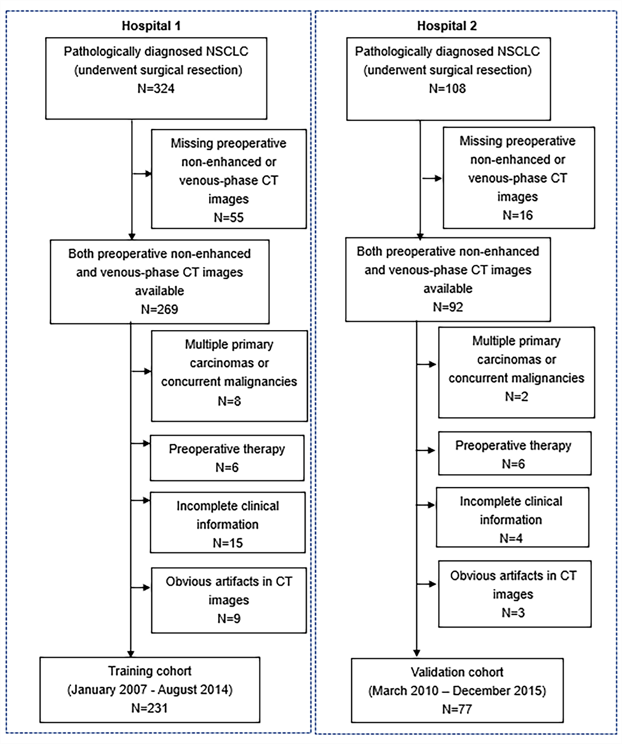
Figure A1 Patient recruitment process.
Appendix A1: CT image acquisition parameters
CT images from Hospital 1 used one of two multi-detector row CT scanners (GE Light-speed Ultra 8; GE Healthcare; 64-slice LightSpeed VCT, GE Medical systems). Images form Hospital 2 were using one of two multi-detector row CT scanners (Brilliance iCT 256; Philips Healthcare; Brilliance 64-slice CT; Philips Healthcare). The CT images acquisition parameters were as follows: tube voltage, 120K Vp; auto tube current; detector collimation: 8×2.5mm or 64×0.625mm or 128×0.625mm; field of view, 350mm×350mm; matrix, 512×512. Images were reconstructed with a slice thickness of 1.25mm in Hospital 1 and 1 or 5mm slice thickness in Hospital 2. Nonionic iodinated contrast material (370 mg iodine/mL, Ultravist, Bayer Schering Pharma) was injected into the antecubital vein at a dose of 1.5mL/kg of body weight at a rate of 2.5mL/s with a pump injector (Ulrich CT Plus 150, Ulrich Medical). Contrast-enhanced CT scanning was performed with 35-40s delay after contrast agent injection.
Appendix A2: Deep learning signature construction
The deep learning signature was constructed, with a risk score calculated by using the following formula: Signature score= 0.040 * C_Resnet18_pool5_v214 + 0.182 * C_Resnet18_res4b_relu_v14 + 0.061 * C_Resnet18_res4b_relu_v136 - 0.298 * C_Resnet18_res4b_relu_v174 + 0.014 * C_Resnet18_res4b_relu_v180 + 0.220 * C_Resnet18_res4b_relu_v211+0.056 * U_Resnet18_res4b_relu_v71 - 0.069 * U_Resnet18_res3b_relu_v23 + 0.054 * C_Resnet18_res4b_relu_v103

Appendix A3: Estimation of the Constructed Deep Learning Signature in Patients within Subgroups as Defined by Clinical Risk Factors
The deep learning signature successfully classify high-risk and low-risk patients within stage Ⅰ-Ⅲ disease, which suggests that heterogeneity existed in the survival outcomes even within the same stage. Deep learning signature could further successfully stratified patients within subgroups as defined clinical factors with regard to age (<=60 or >60 years), gender (female or male), smoking status (yes or no), lymphatic vessel invasion (no), differentiation grade (well, moderate) except for differentiation grade (poor) and lymphatic vessel invasion (yes) (shown in Figure A2).
Appendix A4: Figure A2 legend
Kaplan-Meier survival analysis according to the deep learning signature and stratified by clinical risk factors. A significant association of the deep learning signature with OS was found in the following subgroups: age ≤60 and >60 (P<0.001, both), gender female and male (P<0.001, both), smoke yes and no (P=0.004 and <0.001, respectively), TNM stage I (P<0.001), stage II (P=0.024) and stage III (P=0.02), no lymphatic vessel invasion (P<0.001), well differentiation grade and moderate grade (P <0.001, both). The deep learning signature failed to stratified patients within the lymphatic vessel invasion subgroup and poor differentiation grade subgroup. OS, overall survival.
Figure A2 Kaplan-Meier survival analysis according to the deep learning signature and stratified by clinical risk factors. A significant association of the deep learning signature with OS was found in the following subgroups: age ≤60 and >60 (P<0.001, both), gender female and male (P<0.001, both), smoke yes and no (P=0.004 and <0.001, respectively), TNM stage I (P<0.001), stage II (P=0.024) and stage III (P=0.02), no lymphatic vessel invasion (P<0.001), well differentiation grade and moderate grade (P <0.001,both). The deep learning signature failed to stratified patients within the lymphatic vessel invasion subgroup and poor differentiation grade subgroup. OS, overall survival.
Appendix A5: Univariate and multivariate Cox regression analysis of prognostic factors for OS
 | Univariate analysis |  |  | Multivariate analysis
Variables | HR | 95% CI | P | HR | 95% CI | P
Age | 0.99 | 0.97-1.02 | 0.59
Gender | 0.58 | 0.31-1.07 | 0.08
Smoking status | 1.22 | 0.69-2.17 | 0.49
Pathological type | 0.81 | 0.42-1.54 | 0.51
SC | Reference
ADC | 0.81 | 0.42-1.54 | 0.51
Other | <0.001 | 0-Inf | 0.99
Location | 0.97 | 0.35-2.69 | 0.95
TNM stage | 2.07 | 1.55-2.77 | <0.001 | 1.58 | 1.12-2.22 | 0.01
Lymphatic vessel invasion | 3.94 | 2.18-7.13 | <0.001 | 2.02 | 1.09-3.75 | 0.03
Differentiation grade | 2.89 | 1.71-4.89 | <0.001 | 1.77 | 0.99-3.14 | 0.06
Signature score | 5.46 | 3.39-8.77 | <0.001 | 3.71 | 2.17-6.33 | <0.001

Abbreviations：SC, squamous carcinoma; ADC, adenomatous carcinoma
 | AIC
TNM stage + Lymphatic vessel invasion + Differentiation grade + Signature score | 466.71
TNM stage + Lymphatic vessel invasion + Signature score | 468.32
TNM stage + Differentiation grade + Signature score | 469.24
Lymphatic vessel invasion + Differentiation grade + Signature score | 471.47
TNM stage + Lymphatic vessel invasion + Differentiation grade | 486.03
Appendix A6：Multivariate model was built performing the stepwise model selection by Akaike information criterion (AIC)

