Supplementary Figure Legend

Figure S1: Normal probability plots of the standardized residual (A) and Pareto charts of the standardized effect (B).
Note: The red dotted line represents α = 0.05.
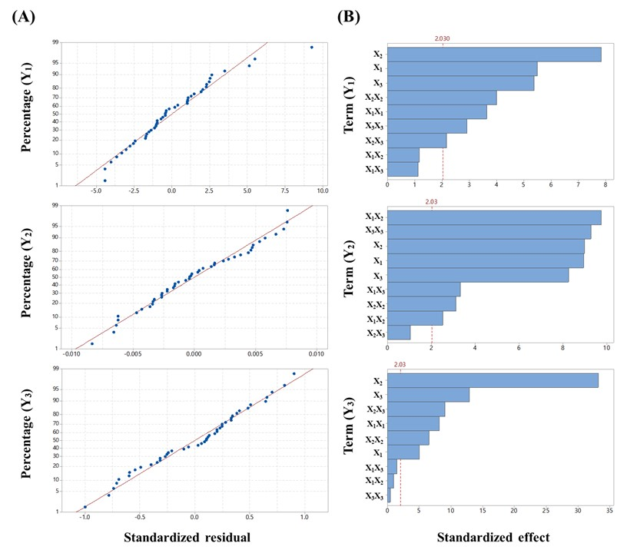

Table S1 Result of analysis of variance for each parameter
Source | DF | Y₁ (DE₃₀) |  |  |  | Y₂ (DEC) |  |  |  | Y₃ (CI)
Source | DF | SS | F | p-value |  | SS | F | p-value |  | SS | F | p-value
Model | 9 | 1576.29 | 18.57 | < 0.001 |  | 0.009534 | 48.30 | < 0.001 |  | 402.43 | 164.55 | < 0.001
X₁ | 1 | 284.69 | 30.19 | < 0.001 |  | 0.001751 | 79.84 | < 0.001 |  | 6.93 | 25.52 | < 0.001
X₂ | 1 | 578.50 | 61.35 | < 0.001 |  | 0.001768 | 80.62 | < 0.001 |  | 298.92 | 1100.03 | < 0.001
X₃ | 1 | 273.17 | 28.97 | < 0.001 |  | 0.001488 | 67.86 | < 0.001 |  | 45.38 | 166.98 | < 0.001
X₁² | 1 | 124.28 | 13.18 | 0.001 |  | 0.002077 | 94.72 | < 0.001 |  | 18.01 | 66.27 | < 0.001
X₂² | 1 | 151.13 | 16.03 | < 0.001 |  | 0.000213 | 9.73 | 0.004 |  | 11.34 | 42.83 | < 0.001
X₃² | 1 | 80.33 | 8.52 | 0.006 |  | 0.00188 | 85.72 | < 0.001 |  | 0.05 | 0.18 | 0.673
X₁X₂ | 1 | 13.06 | 1.39 | 0.247 |  | 0.00014 | 6.39 | 0.016 |  | 0.27 | 0.99 | 0.326
X₁X₃ | 1 | 12.04 | 1.28 | 0.266 |  | 0.000243 | 11.08 | 0.002 |  | 0.61 | 2.24 | 0.144
X₂X₃ | 1 | 44.58 | 4.73 | 0.037 |  | 0.000024 | 1.10 | 0.302 |  | 22.14 | 81.48 | < 0.001
Residual | 35 | 330.03 | - | - |  | 0.000768 | - | -- |  | 9.51 | - | --
Pure error | 32 | 321.40 | - | - |  | 0.000706 | - | - |  | 8.10 | - | -
Total | 44 | 1906.32 | - | - |  | 0.010302 | - | - |  | 411.97 | - | -

Notes: X₁: G44:BL4, X₂: FLO, X₃: VP105.
Abbreviations: DF, degrees of freedom; SS, sum of squares, DE₃₀, dissolution efficiency at 30 min; DEC, dissolution enhancing capacity; CI, Carr’s index.

