Supplementary Table 1 Comparison of baseline characteristics between 34 subjects with and without EE in the MS group
 | Subjects without  EE  (n=7) | Subjects with  EE  (n=27) | p-value
Sex (M/F) (%M) | 3/4 (57.1%) | 6/21 (77.8%) | 0.534
Age (years) | 56.4 ± 2.6 | 55.0 ± 4.8 | 0.733
BMI (kg/m²) | 28.9 ± 3.7 | 28.2 ± 5.5 | 0.297
WC (cm) | 97.1 ± 10.8 | 96.6 ± 10.7 | 1.000
Smoker, n (%) | 1 (14.3%) | 5 (18.5%) | 0.768
Drinker, n (%) | 2 (28.6%) | 15 (55.6%) | 0.396
SBP (mmHg) | 141 ± 19 | 141 ± 22 | 0.865
DBP (mmHg) | 95 ± 12 | 94 ± 12 | 0.701
Hypertension, n (%) | 5 (71.4%) | 23 (85.2%) | 0.768
T-CHO (mg/dL) | 207.1 ± 35.0 | 213.3 ± 45.7 | 0.831
TG (mg/dL) | 114.7 ± 36.5 | 161.6 ± 120.5 | 0.360
HDL-C (mg/dL) | 59.0 ± 6.6 | 59.8 ± 13.0 | 0.882
LDL-C (mg/dL) | 131.4 ± 34.7 | 131.4 ± 43.4 | 0.882
Dyslipidemia, n (%) | 5 (71.4%) | 16 (59.3%) | 0.878
FPG (mg/dL) | 107.1 ± 18.6 | 109.2 ± 26.2 | 0.915
HbA1c (%) | 5.9 ± 0.4 | 6.0 ± 0.7 | 0.916
IGT, n (%) | 2 (28.6%) | 9 (33.3%) | 0.831
UA (mg/dL) | 5.7 ± 1.2 | 6.1 ± 1.6 | 0.201
AST (IU/L) | 30.1 ± 7.4 | 30.6 ± 12.5 | 0.798
ALT (IU/L) | 44.3 ± 18.8 | 31.7 ± 14.3 | 0.088
GGT (IU/L) | 75.0 ± 53.5 | 98.9 ± 132.1 | 0.749
Positivity of H. pylori, n (%) | 1 (14.3%) | 2 (7.4%) | 0.860
Hiatal hernia, n (%) | 3 (42.9%) | 16 (59.3%) | 0.672
Notes: Data represent the mean ± standard deviation (SD) and number for categorical variables. All p-values are based on the χ²-test or Mann-Whitney U-test. Significant is at the 5% level.
Abbreviations: ALT, alanine aminotransferase; AST, aspartate aminotransferase; BMI, body mass index; DBP, diastolic blood pressure; EE, erosive esophagitis; F, female; FPG, fasting plasma glucose; GGT, gamma-glutamyl transpeptidase; HbA1c, hemoglobin A1c; H. pylori, Helicobacter pylori; HDL-C, high-density lipoprotein cholesterol; IGT, impaired glucose tolerance; LDL-C, low-density lipoprotein cholesterol; M, male; MS, metabolic syndrome; SBP, systolic blood pressure; T-CHO, total cholesterol; TG, triglyceride; UA, uric acid; WC, waist circumference.
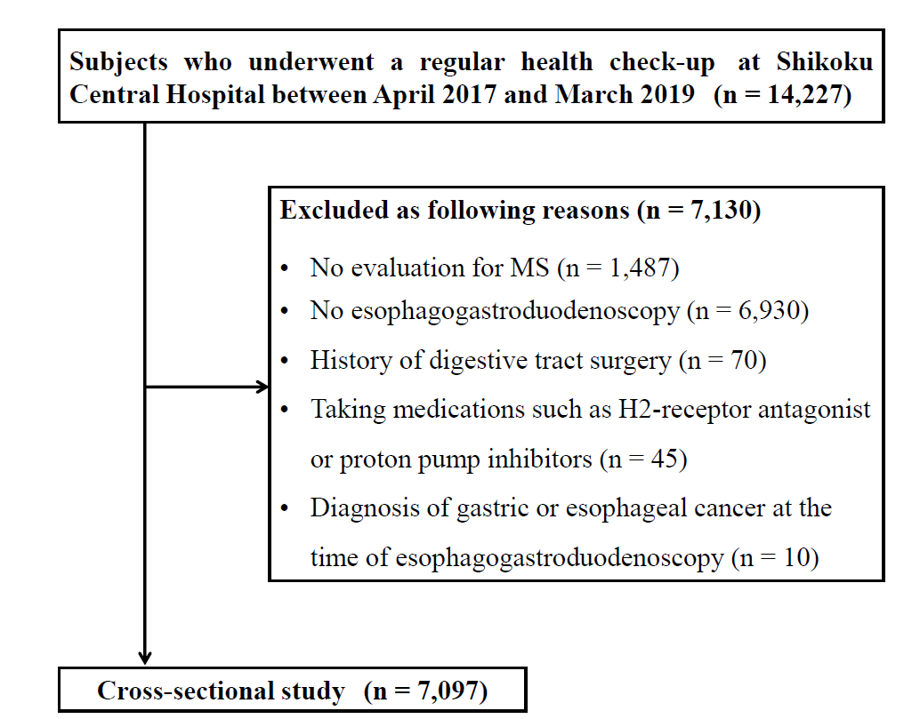

Supplementary Figure 1 Flow diagram of the enrolment of subjects in this study.
Abbreviations: H, Histamine; MS, metabolic syndrome.

