SUPPLEMENTARY INFORMATION
Polymeric nanocarriers with luminescent colloidal nanoplatelets as hydrophilic and non-toxic
two-photon bioimaging agents
Katarzyna C. Nawrotª, Jan K. Zarębaª, Monika Toporkiewicz^{b}, Grzegorz Chodaczek^{b}, Dominika Wawrzyńczykª, Julita Kulbacka^{c}, Urszula Bazylińska^{d}*, Marcin Nykª*
ª Advanced Materials Engineering and Modelling Group, Faculty of Chemistry, Wroclaw University
of Science and Technology, 50-370 Wroclaw, Poland
^{b} Łukasiewicz Research Network - PORT Polish Center for Technology Development, Wroclaw,
54-066, Poland
^{c} Department of Molecular and Cellular Biology, Faculty of Pharmacy, Wroclaw Medical University, Wroclaw, 50-556, Poland
^{d} Department of Physical and Quantum Chemistry, Faculty of Chemistry, Wroclaw University of Science and Technology, Wroclaw, 50-370, Poland

*corresponding authors:
Urszula Bazylińska,
Department of Physical and Quantum Chemistry, Faculty of Chemistry, Wroclaw University of Science and Technology, Wroclaw, 50-370, Poland
Tel +48 713202183, Email: urszula.bazylinska@pwr.edu.pl

Marcin Nyk,
Advanced Materials Engineering and Modelling Group, Faculty of Chemistry, Wroclaw University of Science and Technology, 50-370 Wroclaw, Poland
Tel +48 713202316, Email: marcin.nyk@pwr.edu.pl

Table S1
Samples composition
Nr | CdSe NPLs chloroform solution [μl] | Pluronic P-123 dichloromethane solution [ml] | Water [ml] | Ratio
1 | 500 | 5 | 5 | 1:10:10
2 | 500 | 10 | 5 | 1:20:10
3 | 750 | 5 | 5 | 1:6.7:6.7
4 | 750 | 10 | 5 | 1:13.3:6.7
5 | 1000 | 5 | 5 | 1:5:5
6 | 1000 | 10 | 5 | 1:10:5

Figure S1. PL spectrum of NPLs after ligand-exchange process with cysteine in comparison to as-synthesised NPLs and NPLs loaded in polymeric NCs.

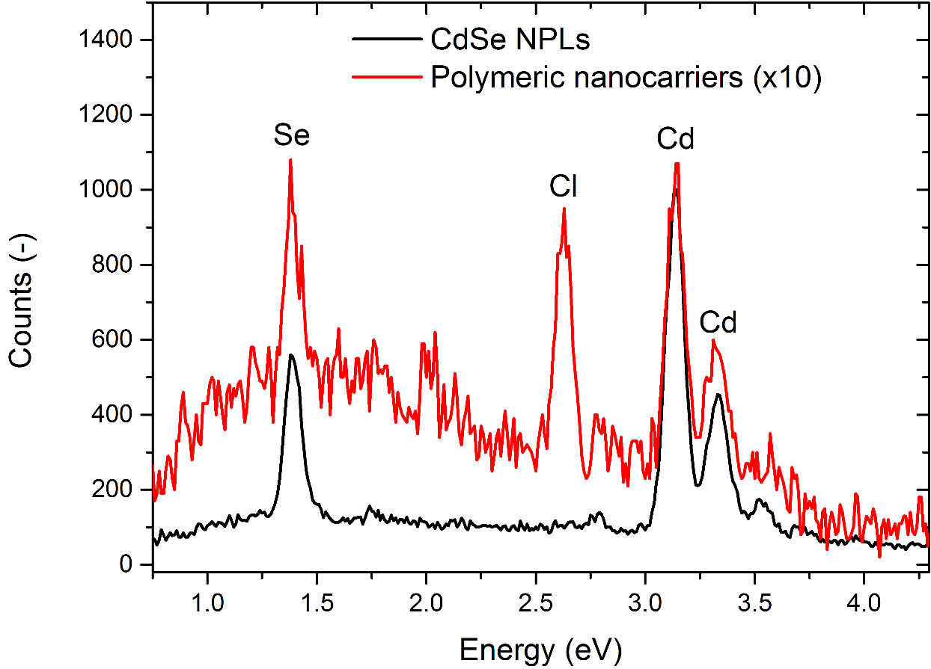
Figure S2. Energy-dispersive X-ray (EDX) spectra of raw CdSe NPLs (black plot) and NPLs encapsulated in Pluronic NCs (red plot). Note that the presence of Cl in the latter is due to concomitant co-encapsulation of chloroform during synthesis of loaded nanocarriers.

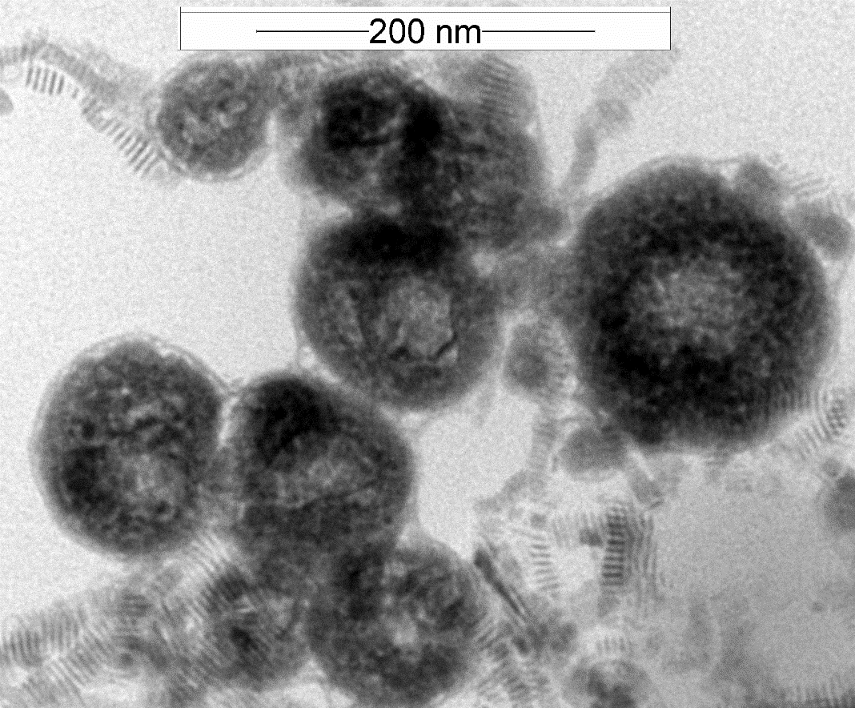
Figure S3. Exemplary TEM images of CdSe NPLs encapsulated in Pluronic NCs with larger concentration of Pluronic P-123 (sample 6).

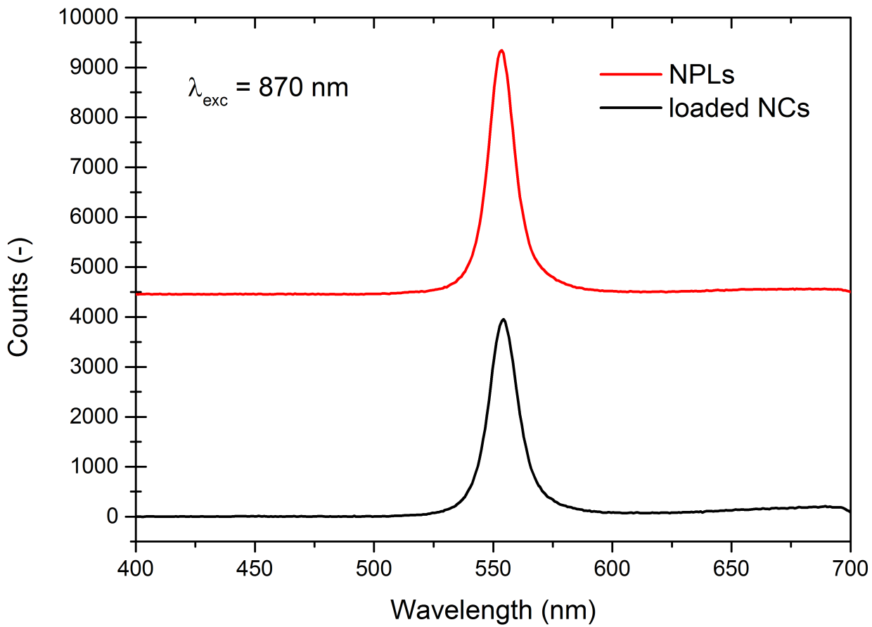
Figure S4. A comparison of emission spectra of raw NPLs (red line) and of NCs loaded with NPLs (black line). Emissions were obtained by two-photon excitation with 870 nm femtosecond laser radiation.

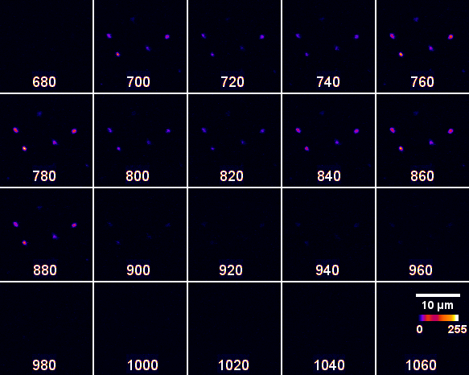
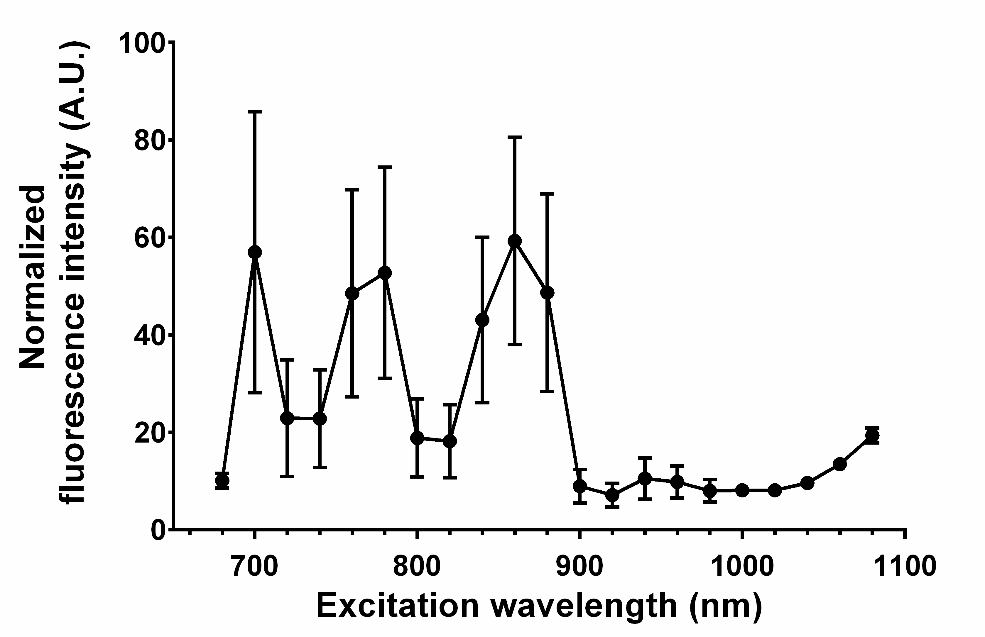
Figure S5. Two-photon microscopy analysis of NPL excitation spectrum. NPL fluorescence of NCs within 500-600 nm emission range is presented in fire look-up table (upper panel). The graph is based on image analysis and normalized (laser power-corrected) fluorescence intensity of NPLs measured in at least 40 identified objects. Each spot represents mean value ± standard deviation.

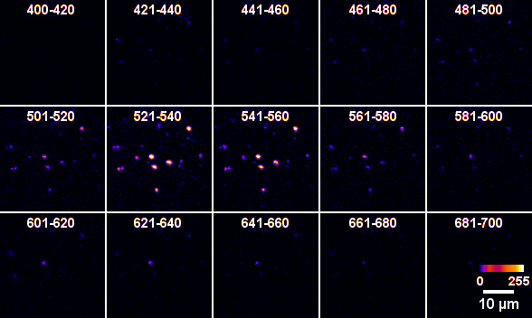
Figure S6. Two-photon microscopy analysis of NPL emission spectrum. NPL fluorescence of NCs excited at 870 nm is presented in fire look-up table (upper panel). The graph is based on image analysis of NPL fluorescence intensity measured in at least 40 identified objects. Each spot represents mean value ± standard deviation.

