Supplement Table S1. Summary of accuracy, precision and stability of ticagrelor in human plasma by LC-MS/MS using ticagrelor-D7 as the internal standard.
Parameters | Conditions | Concentration (N=6^{c})
Parameters | Conditions | LLOQ QC | LQC | GMQC | MQC | HQC
Parameters | Conditions | (1.00 ng/mL) | (3.00 ng/mL) | (45.00 ng/mL) | (300.00 ng/mL) | (450.00 ng/mL)
Accuracyª (RE, %) | Intra-assay | 8.0 | 4.0 | -4.4 | -4.7 | -4.7
Accuracyª (RE, %) | Inter-assay | 6.0 | 3.7 | 0.0 | -2.7 | -2.0
Precision^{b} (CV, %) | Intra-assay | 3.2 | 3.3 | 3.6 | 2.4 | 4.1
Precision^{b} (CV, %) | Inter-assay | 3.3 | 2.6 | 4.2 | 2.8 | 3.7
Stability, with accuracy (RE, %) | room temperature (25 h) | - | 3.3 | - | - | -1.3
Stability, with accuracy (RE, %) | –80 °C (131 d) | - | -0.3 | - | - | -2.2
Stability, with accuracy (RE, %) | Freeze–thaw process (–80 °C, 5 cycles) | - | 3.7 | - | - | -0.2
Notes: Standard curve of ticagrelor was linear and ranged from 1.00-600.00 ng/ml; ª expressed in percentage largest difference from the actual value in three batches; ^{b} expressed in percentage largest difference from the mean value in three batches; ^{c} each concentration of QC had a sample size of N=6.
Abbreviations: LC-MS/MS, liquid chromatography-tandem mass spectrometry; QC, quality controls; LLOQ, lowest limit of quantitation; LQC, low-quality control; GMQC, geometric mean-quality control; MQC, middle-quality control; HQC, high-quality control; RE, relative error; CV, coefficient of variation.

Supplement Table S2. Summary of accuracy, precision and stability of AR-C124910XX in human plasma by LC-MS/MS using AR-C124910XX-D7 as the internal standard.
Parameters | Conditions | Concentration (N=6^{c})
Parameters | Conditions | LLOQ QC | LQC | GMQC | MQC | HQC
Parameters | Conditions | (1.00 ng/mL) | (3.00 ng/mL) | (45.00 ng/mL) | (300.00 ng/mL) | (450.00 ng/mL)
Accuracyª (RE, %) | Intra-assay | 10.0 | 4.7 | 2.7 | -4.3 | -6.7
Accuracyª (RE, %) | Inter-assay | 7.0 | 2.7 | 1.1 | -3.3 | -3.3
Precision^{b} (CV, %) | Intra-assay | 5.3 | 4.5 | 3.4 | 4.4 | 3.3
Precision^{b} (CV, %) | Inter-assay | 4.5 | 3.6 | 3.0 | 3.4 | 3.9
Stability, with accuracy (RE, %) | room temperature (25 h) | - | 7.0 | - | - | -1.1
Stability, with accuracy (RE, %) | –80 °C (131 d) | - | 0.0 | - | - | -2.0
Stability, with accuracy (RE, %) | Freeze–thaw process (–80 °C, 5 cycles) | - | 2.0 | - | - | -2.7
Notes: Standard curve of ticagrelor was linear and ranged from 1.00-600.00 ng/ml; ª expressed in percentage largest difference from the actual value in three batches; ^{b} expressed in percentage largest difference from the mean value in three batches; ^{c} each concentration of QC had a sample size of N=6.
Abbreviations: LC-MS/MS, liquid chromatography-tandem mass spectrometry; QC, quality controls; LLOQ, lowest limit of quantitation; LQC, low-quality control; GMQC, geometric mean-quality control; MQC, middle-quality control; HQC, high-quality control; RE, relative error; CV, coefficient of variation.

Supplement Table S3. Summary of PK parameters of ticagrelor and AR-C124910XX in the male and female subjects after administration of T under fasting and fed conditions-PKPS
Parameters | Fasting |  |  |  |  |  | Fed
Parameters | Ticagrelor |  |  | AR-C124910XX |  |  | Ticagrelor |  |  | AR-C124910XX
Parameters | Male (N=27^{c}) | Female (N=12) | P | Male (N=27^{c}) | Female (N=12) | P | Male (N=28) | Female (N=12) | P | Male (N=28) | Female (N=12) | P
AUC_{0-t}, h*ng/mlª | 3327.36±1066.04 | 3894.34±1433.38 | 0.234 | 1487.23±317.51 | 2139.60±410.96 | ＜0.001 | 3660.06±995.14 | 4243.34±1699.57 | 0.325 | 1108.95±261.34 | 1351.20±274.58 | 0.02
AUC_{0-∞}, h*ng/mlª | 3399.73±1116.89 | 3985.30±1503.69 | 0.244 | 1543.42±338.08 | 2219.70±429.80 | ＜0.001 | 3741.21±1033.84 | 4354.81±1799.13 | 0.329 | 1161.35±279.82 | 1425.54±293.97 | 0.018
C_{max}, ng/mlª | 496.04±137.27 | 677.00±232.56 | 0.008 | 167.59±37.03 | 225.00±58.97 | 0.003 | 430.50±89.93 | 456.92±164.64 | 0.862 | 94.10±23.69 | 97.99±26.23 | 0.672
T_{max,} h^{b} | 2.00(1.00, 4.50) | 1.75(1.50, 4.50) | 0.538 | 2.5(1.50, 4.50) | 2.5(2.00, 6.00) | 0.776 | 4.00(1.00, 6.00) | 4.25(2.00, 4.50) | 0.439 | 4.5(1.75, 6.00) | 4.50(4.00, 8.00) | 0.57
t_{1/2}, hª | 8.46±1.27 | 8.35±1.55 | 0.822 | 9.56±1.67 | 9.18±1.81 | 0.558 | 8.72±0.96 | 8.31±1.51 | 0.236 | 9.94±1.33 | 9.96±1.94 | 0.896
λ_{z,} 1/hª | 0.08±0.01 | 0.09±0.02 | 0.700 | 0.07±0.01 | 0.08±0.02 | 0.412 | 0.08±0.01 | 0.09±0.02 | 0.174 | 0.07±0.01 | 0.07±0.01 | 0.778
Notes: P<0.05 indicated statistically significant, where Student's t-test was applied to calculate P values of C_{max}, AUC and λ_{z} between gender groups, with Wilcoxon rank-sum test for t_{1/2} and t_{max}. ªValues were presented as mean ± SD; ^{b}Values were presented as median (minimum, maximum); ^{c}One male subject was excluded from PKPS because of low plasma concentration less than the LLOQ (1.00 ng/ml).
Abbreviations: PK, pharmacokinetics; T, test drug of ticagrelor; PKPS, Pharmacokinetics Analysis Parameter Set; AUC_{0-t}, area under the curve (AUC) from zero to last quantifiable concentration point; AUC_{0-∞}, AUC from zero to infinity; C_{max}, the peak concentration; T_{max}, time to C_{max}; t_{1/2}, the elimination half-life; λ_{z,} the elimination rate constant; SD, standard deviation; LLOQ, lowest limit of quantitation.

Supplement Table S4. Summary of PK parameters of ticagrelor and AR-C124910XX in the male and female subjects after administration of R under fasting and fed conditions-PKPS
Parameters | Fasting |  |  |  |  |  | Fed
Parameters | Ticagrelor |  |  | AR-C124910XX |  |  | Ticagrelor |  |  | AR-C124910XX
Parameters | Male (N=27^{c}) | Female (N=12) | P | Male (N=27^{c}) | Female (N=12) | P | Male (N=28) | Female (N=11^{d}) | P | Male (N=28) | Female (N=11^{d}) | P
AUC_{0-t}, h*ng/mlª | 3286.80±1064.53 | 3836.06±1378.96 | 0.226 | 1467.07±317.20 | 2279.12±461.88 | ＜0.001 | 3565.95±904.00 | 3935.25±1620.16 | 0.62 | 1087.89±258.31 | 1310.38±321.48 | 0.047
AUC_{0-∞}, h*ng/mlª | 3366.34±1132.86 | 3923.10±1455.14 | 0.247 | 1526.89±338.16 | 2363.86±484.14 | ＜0.001 | 3640.99±940.60 | 4073.76±1775.86 | 0.583 | 1138.54±279.80 | 1396.01±355.26 | 0.037
C_{max}, ng/mlª | 453.52±77.34 | 688.50±173.11 | ＜0.001 | 157.25±41.62 | 246.58±49.56 | ＜0.001 | 415.21±95.33 | 405.55±115.09 | 0.696 | 92.37±25.24 | 88.21±23.47 | 0.696
T_{max,} h^{b} | 1.75(1.00, 6.00) | 1.63(1.25, 2.00) | 0.298 | 2.00(1.75, 6.00) | 2.50(1.50, 3.00) | 0.642 | 3.25(1.00, 4.50) | 4.00(2.00, 4.50) | 0.109 | 4.50(1.50, 8.00) | 4.50(3.50, 10.00) | 0.59
t_{1/2}, hª | 8.77±1.46 | 8.50±1.93 | 0.443 | 10.06±1.77 | 9.24±2.10 | 0.168 | 8.41±1.35 | 8.29±1.99 | 0.701 | 9.84±1.24 | 10.33±2.24 | 0.678
λ_{z,} 1/hª | 0.08±0.01 | 0.09±0.02 | 0.454 | 0.07±0.01 | 0.08±0.02 | 0.102 | 0.08±0.01 | 0.09±0.02 | 0.505 | 0.07±0.01 | 0.07±0.01 | 0.629
Notes: P<0.05 indicated statistically significant, where Student's t-test was applied to calculate P values of C_{max}, AUC and λ_{z} between gender groups, with Wilcoxon rank-sum test for t_{1/2} and t_{max}. ªValues were presented as mean ± SD; ^{b}Values were presented as median (minimum, maximum); ^{c} One male subject withdrew from the study for personal reason; ^{d}One female subject withdrew from the study at the baseline of the second period, without taking R due to advanced menstruation.
Abbreviations: PK, pharmacokinetics; R, reference drug of ticagrelor; PKPS, Pharmacokinetics Analysis Parameter Set; AUC_{0-t}, area under the curve (AUC) from zero to last quantifiable concentration point; AUC_{0-∞}, AUC from zero to infinity; C_{max}, the peak concentration; T_{max}, time to C_{max}; t_{1/2}, the elimination half-life; λ_{z,} the elimination rate constant; SD, standard deviation.

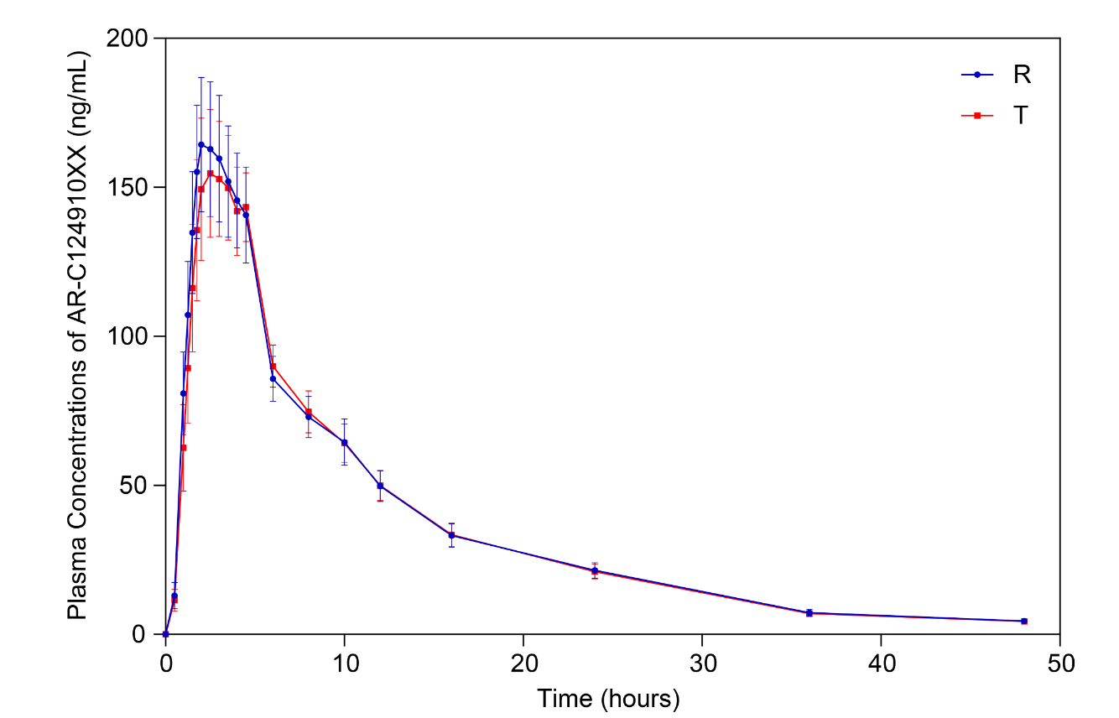
Supplement Figure S1. Mean plasma concentration-time curves of AR-C124910XX under fasting condition–Pharmacokinetics Analysis Concentration Set (PKCS).
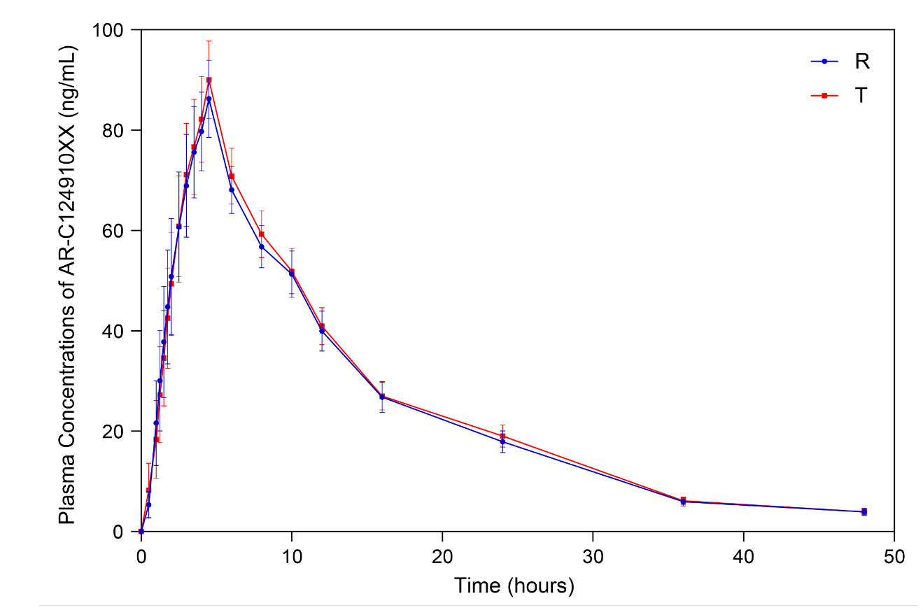
Supplement Figure S2. Mean plasma concentration-time curves of AR-C124910XX under fed condition–Pharmacokinetics Analysis Concentration Set (PKCS).

