Objective and subjective sleep in rheumatoid arthritis and severe seasonal allergy - the role of sickness, central and peripheral inflammation
Sandra Tamm, Catarina Lensmar, Anna Andreasson, John Axelsson, Anton Forsberg Morén, Johan Grunewald, Pär Gyllfors, Bianka Karshikoff, Eva Kosek, Jon Lampa, Caroline Olgart Höglund, Viktoria Strand, Simon Cervenka, Mats Lekander

Supplementary materials

Supplementary figure 1. Diary data for visualization (RA).
Supplementary figure 2. Diary data for visualization (allergy).

Supplementary table 1. Possible predictors of sleep variables across allergy patients, RA patients and healthy controls, investigated in a linear mixed effects model which included sex and age as fixed effects.
Predictor | Intercept | Allergy |  | RA |  | Predictor |  | Allergy*Predictor |  | RA*Predictor
 | Estimate + CI | Estimate + CI | p | Estimate + CI | p | Estimate + CI | p | Estimate + CI | p | Estimate + CI | p
Cytokines
Deep sleep | 98.88 (73.29-124.47) | -19.65 (-42.14-2.85) | 0.085 | -15.67 (-42.09-10.75) | 0.239 | -8.7 (-21.19-3.79) | 0.171 | 15.45 (-2.11-33) | 0.084 | 1.81 (-15.87-19.49) | 0.837
Total sleep time (EEG) | 435.67 (380.41-490.93) | -17.52 (-83.56-48.53) | 0.596 | -3.05 (-65.22-59.12) | 0.922 | 15.08 (-24.64-54.8) | 0.455 | -11.44 (-72.43-49.56) | 0.712 | -20.71 (-70.31-28.88) | 0.405
Sleep quality | 4.35 (3.77-4.92) | -0.23 (-0.85-0.38) | 0.449 | 0.12 (-0.49-0.73) | 0.689 | 0.01 (-0.4-0.42) | 0.958 | -0.05 (-0.6-0.5) | 0.85 | -0.17 (-0.64-0.3) | 0.465
PBR-28 binding
Deep sleep | 87.23 (56.87-117.58) | -9.05 (-35.34-17.25) | 0.491 | -7.15 (-42.08-27.77) | 0.681 | 2.64 (-1.07-6.34) | 0.163 | 1.71 (-4.99-8.41) | 0.616 | -2.32 (-11.68-7.05) | 0.62
Total sleep time (EEG) | 489.4 (428.19-550.61) | -44.02 (-113.68-25.64) | 0.209 | -29.07 (-100.42-42.29) | 0.415 | -4.88 (-15.89-6.12) | 0.383 | 1.36 (-19.22-21.94) | 0.897 | 1.84 (-17.65-21.33) | 0.85
Sleep quality | 4.54 (3.89-5.19) | -0.34 (-1.02-0.33) | 0.312 | -0.23 (-0.94-0.48) | 0.517 | -0.04 (-0.15-0.06) | 0.405 | 0.02 (-0.17-0.21) | 0.84 | 0.04 (-0.16-0.23) | 0.705
Sickness
Deep sleep | 93.19 (68.18-118.2) | -11.15 (-28.06-5.76) | 0.191 | -26.06 (-47.81--4.3) | 0.02 | -1.39 (-3.1-0.32) | 0.11 | 1.87 (-0.15-3.88) | 0.069 | 2.21 (-0.74-5.16) | 0.138
Total sleep time (EEG) | 454.08 (406.88-501.28) | -48.32 (-85.6--11.05) | 0.012 | -25.19 (-67.51-17.13) | 0.237 | -1.29 (-6.26-3.68) | 0.61 | 4.42 (-1.81-10.66) | 0.164 | 1.09 (-5.82-8) | 0.752
Sleep quality | 4.35 (3.94-4.75) | -0.21 (-0.51-0.1) | 0.177 | 0.36 (0-0.72) | 0.051 | 0.03 (-0.02-0.07) | 0.195 | -0.03 (-0.09-0.02) | 0.194 | -0.12 (-0.18--0.06) | 0

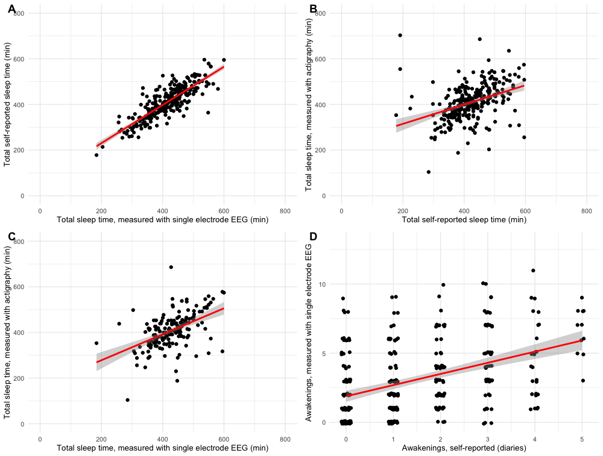
Supplementary figure 3. Associations between different sleep measures. Results reported as effect estimates from mixed effects models with 95 % confidence intervals. A. Association between sleep diaries and single EEG electrode for TST (0.81 CI[0.75, 0.87], p < 0.001). 300 observations from 51 individuals. B. Association between actigraphy and sleep diaries for TST (0.42 CI[0.29, 0.54], p < 0.001). 280 observations from 38 individuals. C. Association between actigraphy and single EEG for TST (0.52 CI[0.37, 0.68], p < 0.001). 164 observations from 30 individuals. D. Association between number of awakenings measured with single electrode EEG and sleep diaries (0.55 CI[0.36, 0.73], p < 0.001), jittered for visualization. 320 observations from 51 subjects.

