Biodegradable nanosonosensitizers with the multiple modulation of tumor microenvironment for enhanced sonodynamic therapy

Hang Zhou^{1,2}, Jiawei Sun¹, Jiaqi Wu¹, Hong Wei¹, Xianli Zhou^{1,} *

¹ In-patient Ultrasound Department, Second Affiliated Hospital of Harbin Medical University, Harbin, Heilongjiang, 150081, China; ² Department of Ultrasound, Second Affiliated Hospital of Zhejiang University, Hangzhou, Zhejiang, 310058, China.

*Corresponding authors: Xianli Zhou
In-patient Ultrasound Department, Second Affiliated Hospital of Harbin Medical University, Harbin, Heilongjiang, 150081, China
Tel: +86-0451-86605362
Fax: +86-0451-86605362
E-mail address: hrbzhouxl@163.com

Author information
Hang Zhou and Jiawei Sun contributed equally to this work.

Materials:
Triethanolamine (TEAH₃), etyltrimethylammonium tosylate (CTAT), bis[3-(triethoxysilyl) propyl]tetrasulfide (BTESPT), Tetraethyl orthosilicate (TEOS), 3-aminopropyltriethoxysilane (APTES), reduced glutathione (GSH), carbodiimide hydrochloride (EDC), and sulfo-N-hydroxy succunimide (sulfo-NHS) were obtained from Sigma-Aldrich Co. (St Louis, MO, USA). Fetal bovine serum (FBS) and RPMI-1640 medium were purchased from GIBCO. CD 206 antibody, iNOS antibody and antipimonidazole/FITC were obtained from Abcam.The kits for aspartate aminotransferase (AST), blood urea nitrogen (BUN), phosphocreatine kinase, alanine aminotransferase, creatinine was obtained from Nanjing Jiancheng Bioengineering Institute (Jiangsu, China). The other chemical reagents and solvents were obtained from Beijing Chemical Reagent Co. (Beijing, China) and used without further purification.

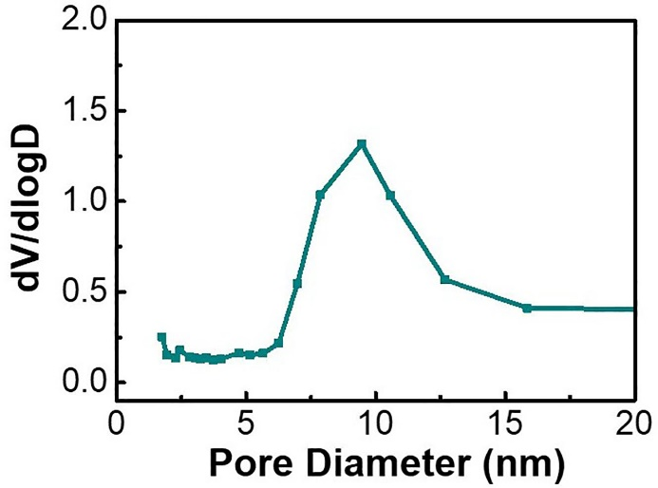
Figure S1. Pore size distribution of MONs.

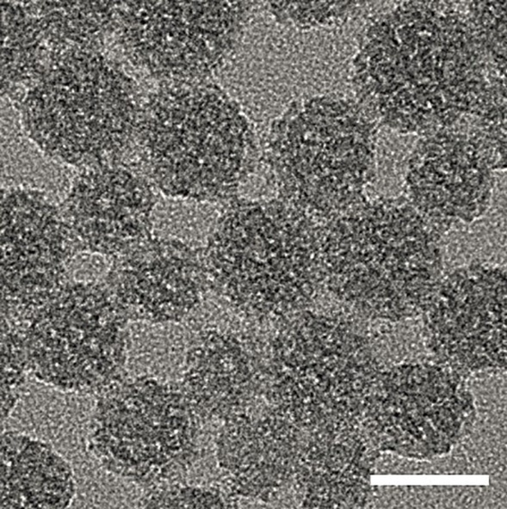

Figure S2. TEM images of HA-MON@Ce6/CAT, scale bar = 50 nm.

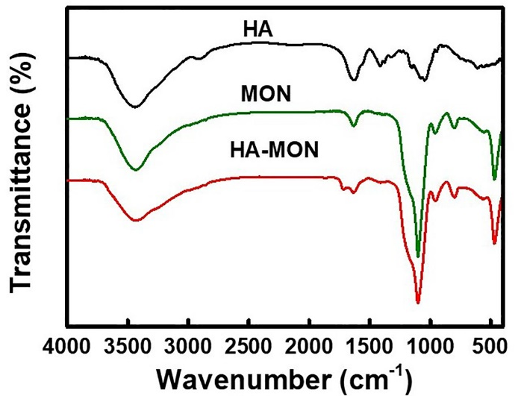
Figure S3. FTIR spectra of HA, MON and HA-MON@Ce6/CAT.

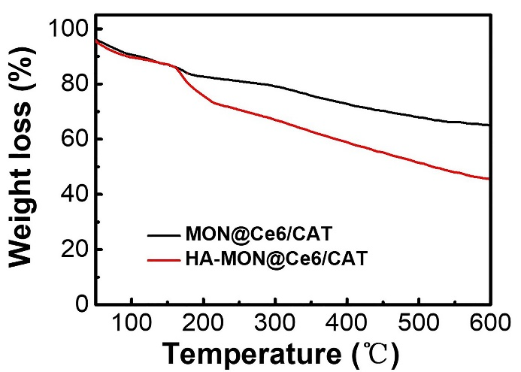
Figure S4. Thermogravimetric analysis of MON@Ce6/CAT and HA- MON@Ce6/CAT.

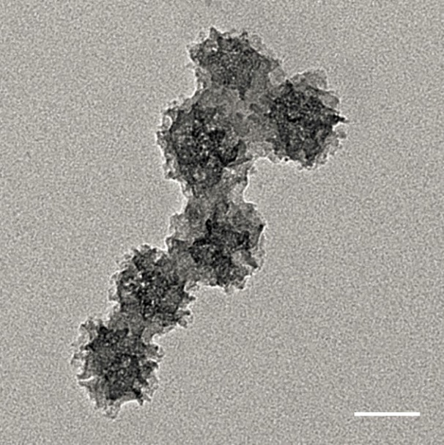
Figure S5. TEM images of HA-MON@Ce6/CAT after immersed in the medium without GSH for 3 days.

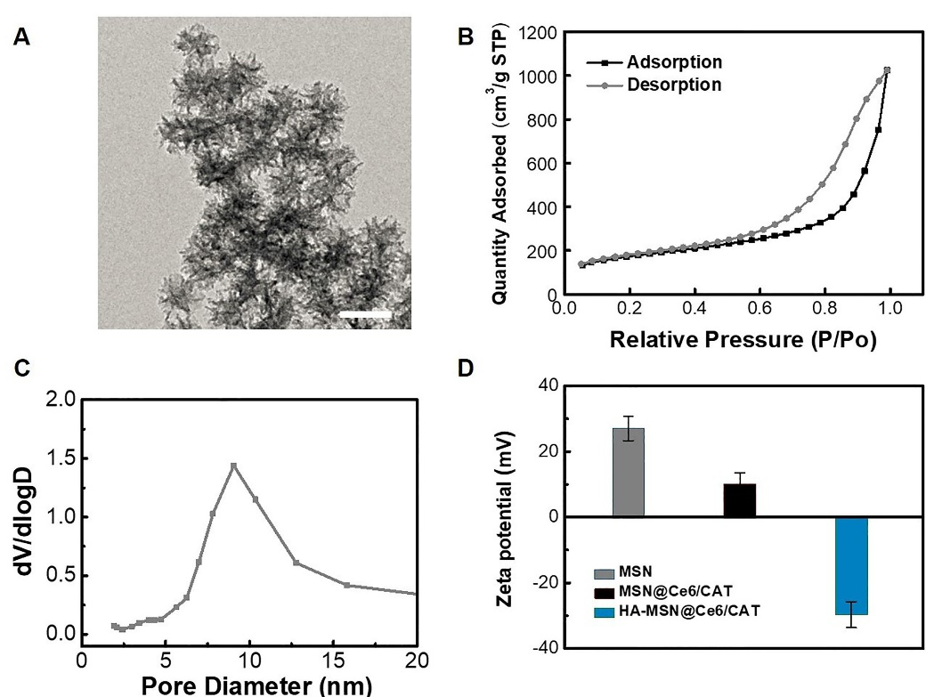
Figure S6. Characterization of MSNs. (A) TEM images of MSNs, scale bar=30 nm. (B) N₂ adsorption−desorption isotherms of MSNs. (C) Pore size distribution of MONs. (D) Zeta potential of MSNs, MSN@Ce6/CAT and HA-MSN@Ce6/CAT. Data represent the mean ± SD (n = 3).

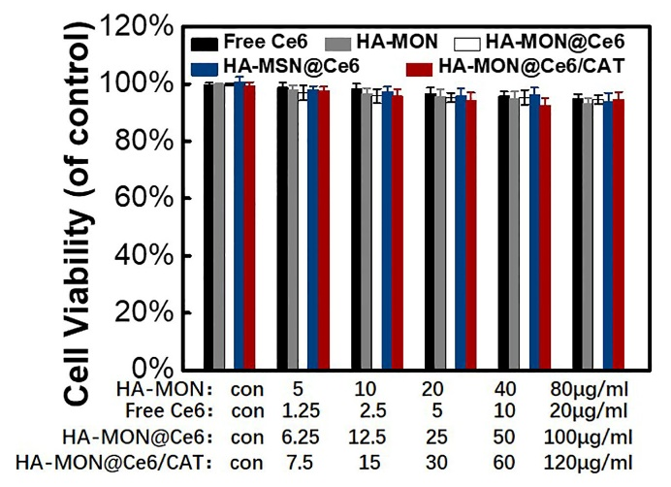
Figure S7. Cytotoxicity of these nanoparticles towards 4T1 cells. Data represent the mean ± SD (n = 6).

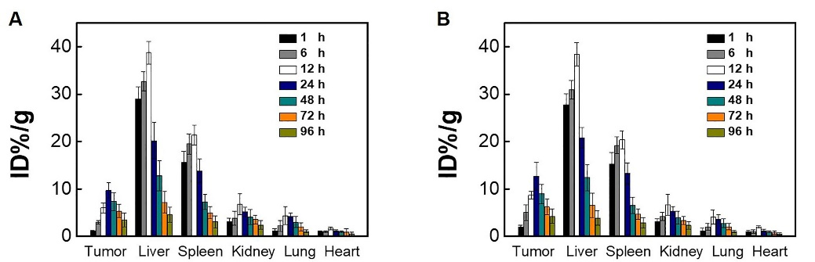
Figure S8. Biodistribution of cy5.5-labeled MON@Ce6/CAT(A) and HA-MON@Ce6/CAT after various time of intravenous injection to 4T1-tumor-bearing nude mice (n=3).

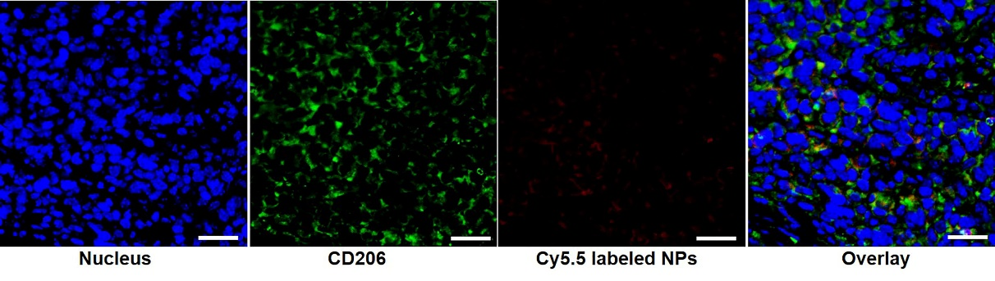
Figure S9. Representative immunofluorescence images of tumor sections after injection with cy 5.5 labeled HA-MON@Ce6/CAT, scale bar = 20 μm.

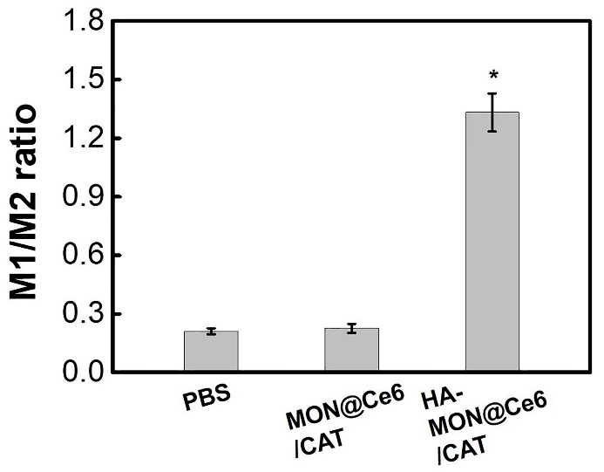
Figure S10. The ratio of M1/M2 macrophages in the MON@Ce6/CAT treatment group and HA-MON@Ce6/CAT treatment group, *p < 0.05 versus PBS groups.

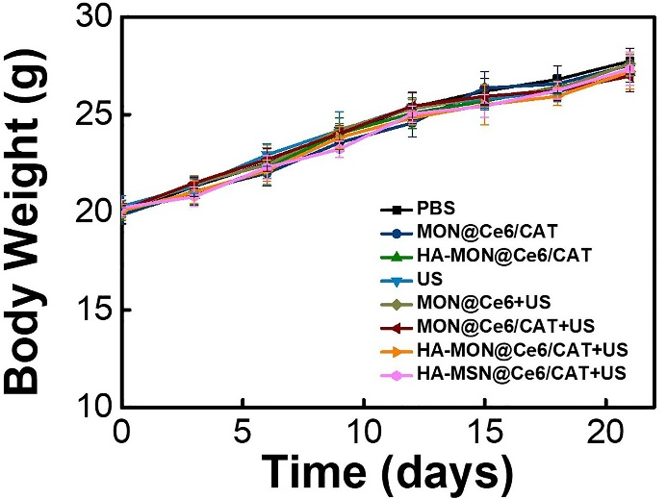
Figure S11. Body weights of the mice in each group. All the data represent the mean ± SD (n = 3).

