Supplementary Materials: Supplementary materials can be found at www.mdpi.com/xxx/s1.
Supplement Table 1. Clinicopathologic parameters for the 9 patients for t-SNE.
Patients | Age, years | Gender | Grade | pT stage | Tumor histology
3# | 64 | Male | Low | < T2 | Papillary
8# | 84 | Male | High | < T2 | Papillary
15# | 84 | Male | High | < T2 | Papillary
17# | 79 | Female | High | > T2 | Non-papillary
18# | 61 | Male | Low | < T2 | Papillary
37# | 77 | Male | High | < T2 | Non-papillary
38# | 65 | Male | High | < T2 | Non-papillary
42# | 66 | Female | High | > T2 | Non-papillary
54# | 69 | Male | High | > T2 | Papillary

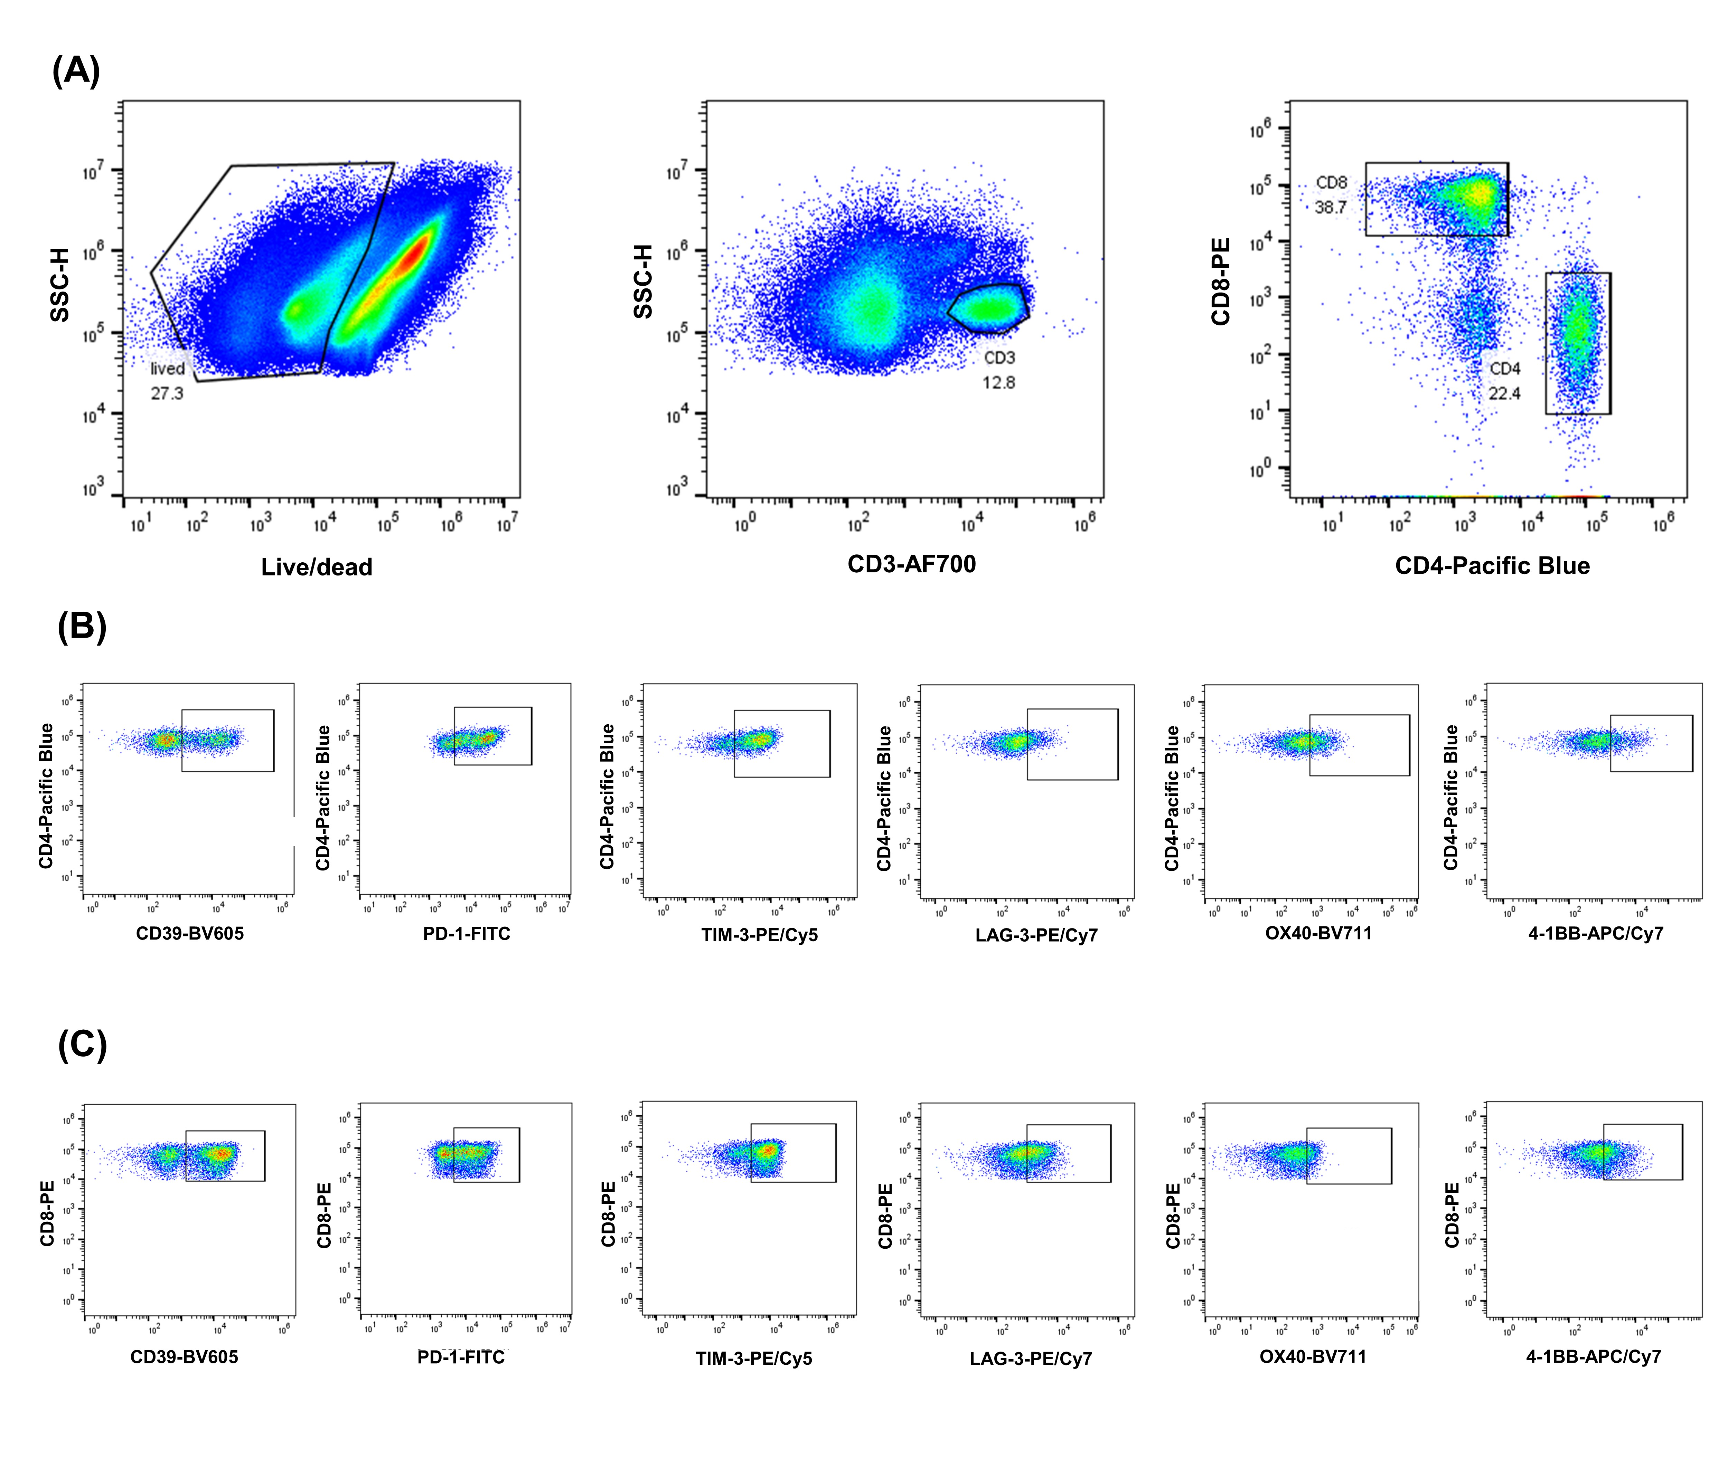Supplement Figure 1. The gated strategy of different population T cells. (A) Gated the CD4+ T cells and CD8+ T cells; (B) Gated the CD4+CD39+ T cells, CD4+PD-1+ T cells, CD4+TIM-3+ T cells, CD4+LAG-3+ T cells, CD4+OX40+ T cells, and CD4+4-1BB+ T cells; (C) Gated the CD8+CD39+ T cells, CD8+PD-1+ T cells, CD8+TIM-3+ T cells, CD8+LAG-3+ T cells, CD8+OX40+ T cells, and CD8+4-1BB+ T cells.

