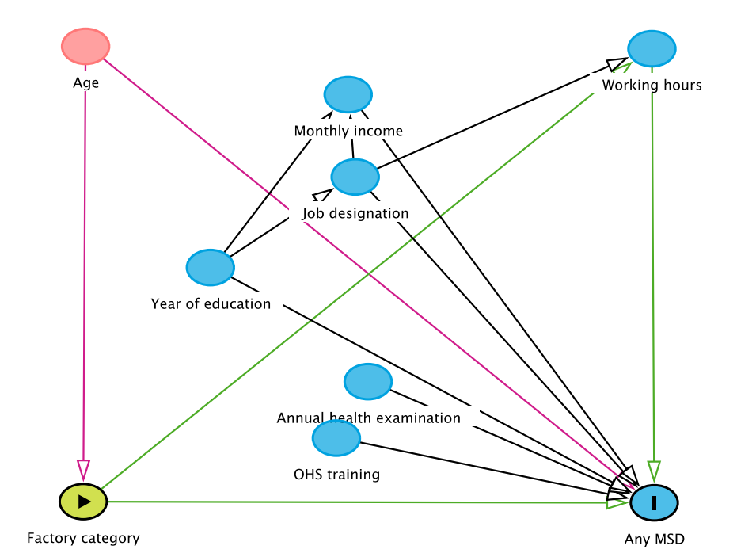
Supplementary Figure 1 Directed Acyclic Graph (DAG) to adjust confounders.

