Supplementary Figure 1
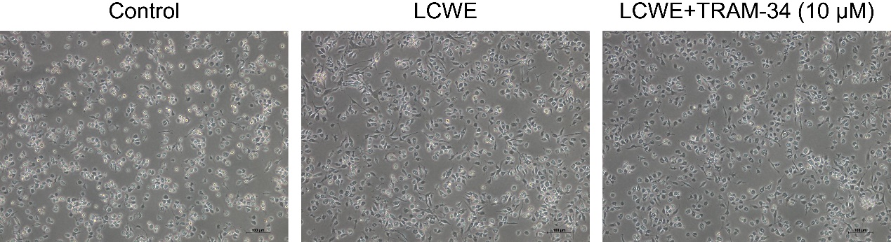
Supplementary Figure 1. Effects of KCa3.1 inhibition by TRAM-34 on LCWE-induced activation in mouse primary peritoneal macrophages. Mouse primary peritoneal macrophages were stimulated by LCWE (1 μg/mL) for 12 h in the presence or absence of TRAM-34 (10 μM). The representative pictures of mouse were showed for the phenotypic changes of mouse primary peritoneal macrophages. Magnification = 100×. Scale bar = 100 µm

