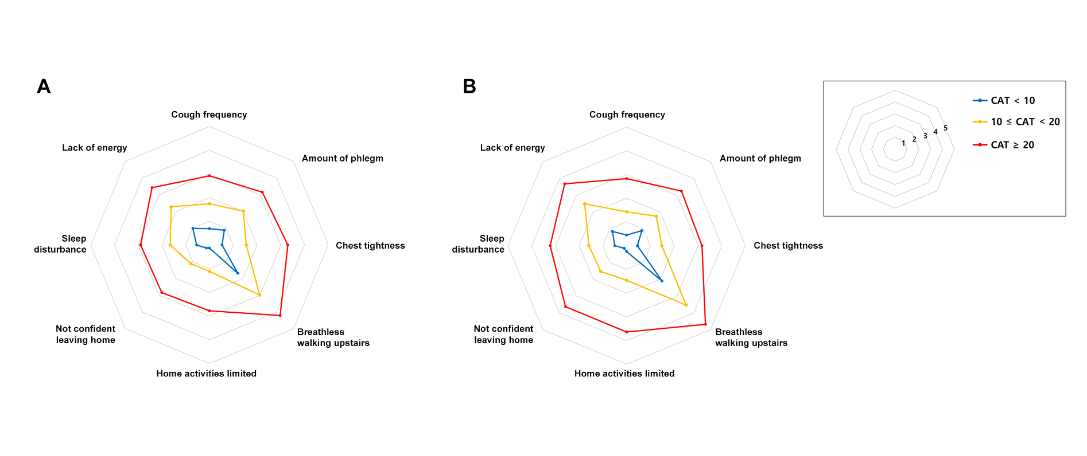
Supplementary Figure 1. Distribution of mean score for each CAT items according to impact severity group in subjects with (A) FEV₁ ≥ 50% (N = 636) and (B) FEV₁ < 50% (N = 179).

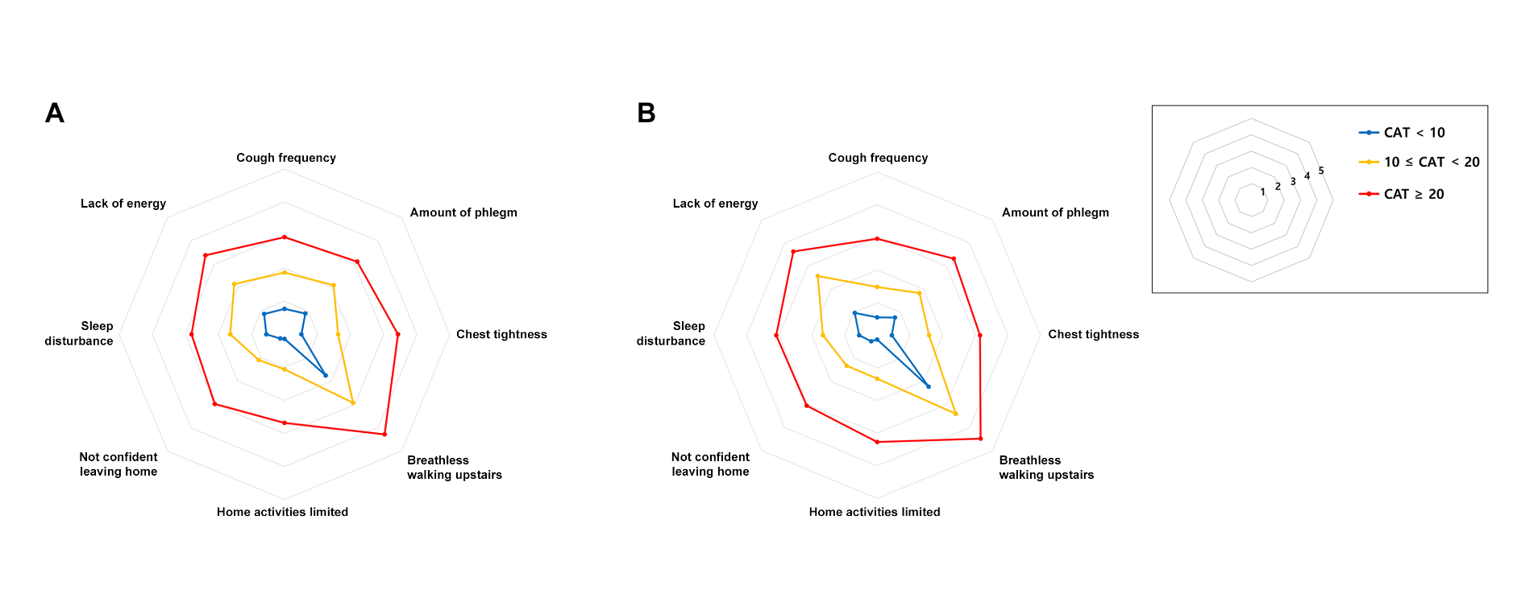
Supplementary Figure 2. Distribution of mean score for each CAT items according to impact severity group in subjects with (A) DLco > 60% (N = 350) and (B) DLco ≤ 60% pred (N = 241).
Supplementary Table E1. Mean scores of each CAT item according to total CAT score groups (absolute values of Figure 4 and Figure 5)
 | Total | CAT < 10* | 10 ≤ CAT < 20 | CAT ≥ 20 | P-trend | P-trend#
CLUE registry | N = 815 | N = 182 | N = 333 | N = 300
CAT 1 (Cough) | 1.90 (1.46) | 0.66 (0.77) | 1.69 (1.15) | 2.89 (1.40) | <0.001 | <0.001
CAT 2 (Sputum) | 2.19 (1.44) | 0.88 (0.93) | 1.99 (1.10) | 3.19 (1.31) | <0.001 | <0.001
CAT 3 (Chest tightness) | 1.94 (1.55) | 0.52 (0.69) | 1.54 (1.12) | 3.25 (1.31) | <0.001 | <0.001
CAT 4 (Dyspnea) | 3.26 (0.89) | 1.74 (1.21) | 3.07 (1.17) | 4.39 (0.89) | <0.001 | <0.001
CAT 5 (Activities) | 1.65 (1.58) | 0.14 (0.42) | 1.16 (1.03) | 3.10 (1.31) | <0.001 | <0.001
CAT 6 (Confidence) | 1.68 (1.61) | 0.18 (0.44) | 1.17 (0.99) | 3.14 (1.43) | <0.001 | <0.001
CAT 7 (Sleep) | 1.90 (1.56) | 0.54 (0.89) | 1.64 (1.27) | 3.02 (1.38) | <0.001 | <0.001
CAT 8 (Energy) | 2.46 (1.42) | 0.98 (0.93) | 2.31 (1.06) | 3.52 (1.12) | <0.001 | <0.001
KOCOSS cohort | N = 2,162 | N = 662* | N = 941 | N = 559
CAT 1 (Cough) | 1.75 (1.37) | 0.72 (0.80) | 1.74 (1.11) | 2.98 (1.30) | <0.001 | <0.001
CAT 2 (Sputum) | 2.02 (1.40) | 0.97 (0.93) | 2.02 (1.14) | 3.27 (1.22) | <0.001 | <0.001
CAT 3 (Chest tightness) | 1.54 (1.44) | 0.38 (0.64) | 1.48 (1.14) | 3.00 (1.28) | <0.001 | <0.001
CAT 4 (Dyspnea) | 3.22 (1.39) | 2.05 (1.25) | 3.34 (1.08) | 4.40 (0.75) | <0.001 | <0.001
CAT 5 (Activities) | 1.22 (1.43) | 0.15 (0.45) | 0.99 (1.04) | 2.87 (1.30) | <0.001 | <0.001
CAT 6 (Confidence) | 1.22 (1.44) | 0.15 (0.43) | 1.01 (1.07) | 2.85 (1.34) | <0.001 | <0.001
CAT 7 (Sleep) | 1.27 (1.46) | 0.27 (0.64) | 1.13 (1.20) | 2.69 (1.47) | <0.001 | <0.001
CAT 8 (Energy) | 2.24 (1.38) | 1.13 (1.09) | 2.35 (1.08) | 3.36 (1.12) | <0.001 | <0.001

Values are mean (SD).
* Six patients and thirteen patients of CLUE registry and KOCOSS cohort had zero score in CAT, respectively.
# Adjusted for age, sex, smoking, body mass index, and post-bronchodilator FEV1 < 50%.
CAT, COPD assessment test; CLUE, COPD LUng Evolution; KOCOSS, Korean COPD Subgroup Study.

Supplementary Table E2. Baseline characteristics and pulmonary function parameters of patients according to total CAT score groups in KOCOSS (N = 2,162)
 | Total  (N = 2,162) | CAT < 10  (N = 662) | 10 ≤ CAT < 20  (N = 941) | CAT ≥ 20  (N = 559) | P for trend | Adjusted* P for trend
Age, years | 69.0 (7.7) | 68.6 (7.6) | 69.4 (7.7) | 68.7 (7.9) | 0.732 | –
Sex, male | 2,016 (93.3) | 622 (94.0) | 883 (93.8) | 511 (91.4) | 0.088 | –
Smoking status (n = 2,159) |  |  |  |  | 0.206 | 0.048
Never | 158 (7.3) | 54 (8.2) | 53 (5.6) | 51 (9.1)
Former | 1,416 (65.6) | 450 (68.1) | 617 (65.6) | 349 (62.5)
Current | 585 (27.1) | 157 (23.8) | 270 (28.7) | 158 (28.3)
BMI (kg/m²) (n = 2,155) | 23.0 (3.4) | 23.3 (3.4) | 23.1 (3.3) | 22.4 (3.6) | <0.001 | <0.001
mMRC (n = 639)
≥ 2 | 732 (33.9) | 102 (15.4) | 312 (33.2) | 318 (57.0) | <0.001 | <0.001
Moderate or severe AE in previous year (n = 2,093) | 420 (20.1) | 77 (12.1) | 188 (20.6) | 155 (28.6) | <0.001 | <0.001
BDI (n = 1,225) | 6.9 (8.2) | 3.7 (5.9) | 6.5 (6.8) | 12.1 (10.4) | <0.001 | <0.001
≥ 16 | 171 (14.0) | 23 (5.4) | 53 (10.3) | 96 (33.1) | <0.001 | <0.001
Post-bronchodilator spirometry
FVC, L | 3.32 (0.81) | 3.48 (0.79) | 3.31 (0.79) | 3.13 (0.84) | <0.001
FVC, % pred | 81.2 (16.6) | 84.3 (15.7) | 80.8 (16.0) | 78.0 (17.8) | <0.001
FEV₁, L | 1.69 (0.59) | 1.89 (0.58) | 1.68 (0.56) | 1.46 (0.56) | <0.001
FEV₁, % pred | 58.4 (18.2) | 64.3 (17.1) | 58.4 (17.1) | 51.5 (18.9) | <0.001
≥ 50 % | 1,434 (66.3) | 526 (79.5) | 631 (67.1) | 277 (49.6) | <0.001
FEV₁/FVC | 50.9 (11.9) | 54.1 (10.9) | 51.0 (11.4) | 46.8 (12.6) | <0.001
DLco, % pred (n = 1767) | 64.0 (20.7) | 68.7 (20.5) | 64.0 (19.6) | 58.4 (21.5) | <0.001
≤ 60 % | 780 (44.1) | 177 (33.6) | 345 (43.8) | 258 (56.9) | <0.001
RV/TLC (n = 1066) | 42.0 (11.7) | 39.4 (10.7) | 41.6 (10.6) | 45.7 (13.7) | <0.001
> 40% | 594 (55.7) | 146 (49.2) | 268 (53.8) | 180 (66.4) | <0.001
Data are mean (standard deviation) or number (%).
*Adjusted for age and sex.
AE, acute exacerbation; BDI, Beck depression index; CAT, COPD assessment test; DLco, Diffusing capacity of the lung for carbon monoxide; FVC, Forced vital capacity; FEV₁, Forced expiratory volume in 1s; mMRC, modified medical research council; RV, Residual volume; TLC, Total lung capacity

