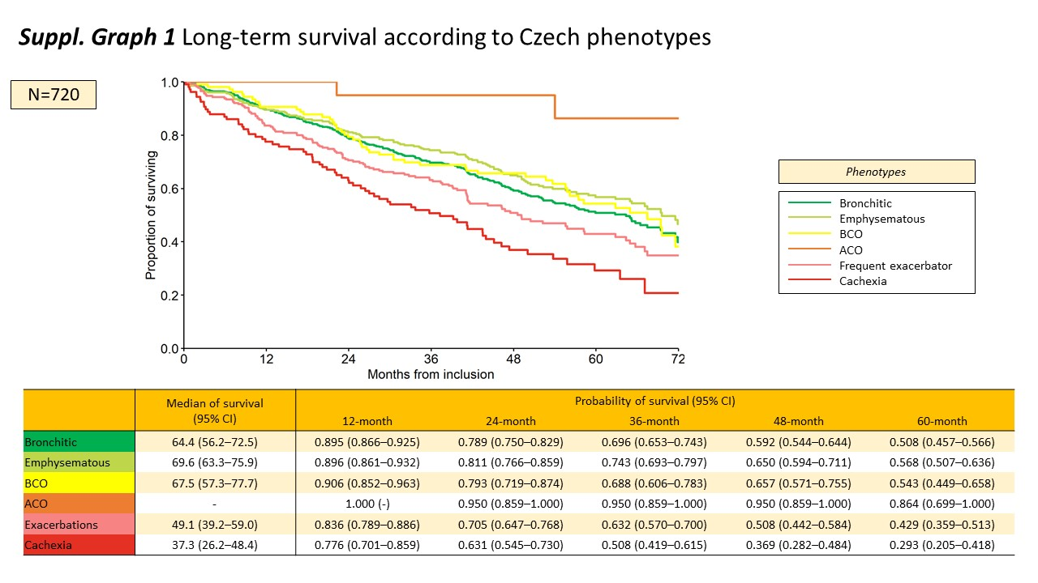
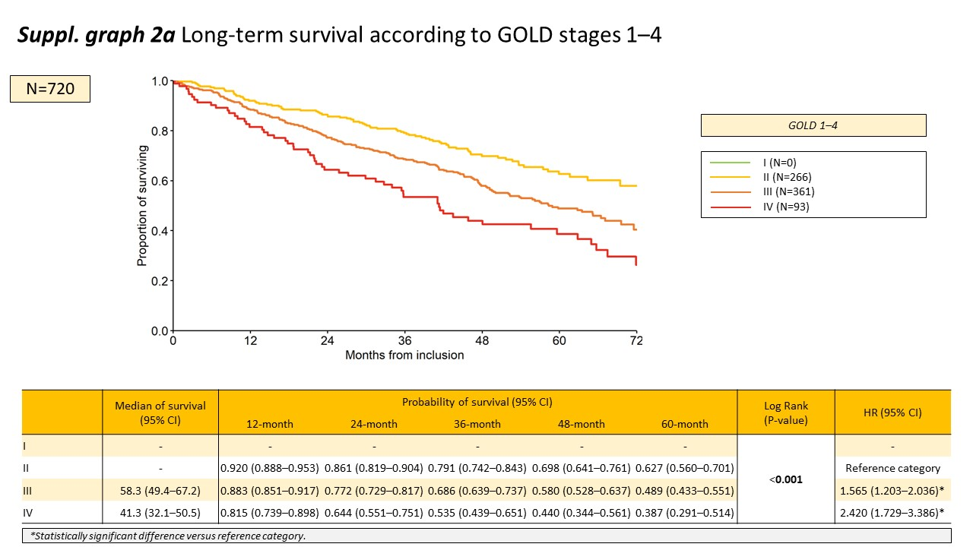
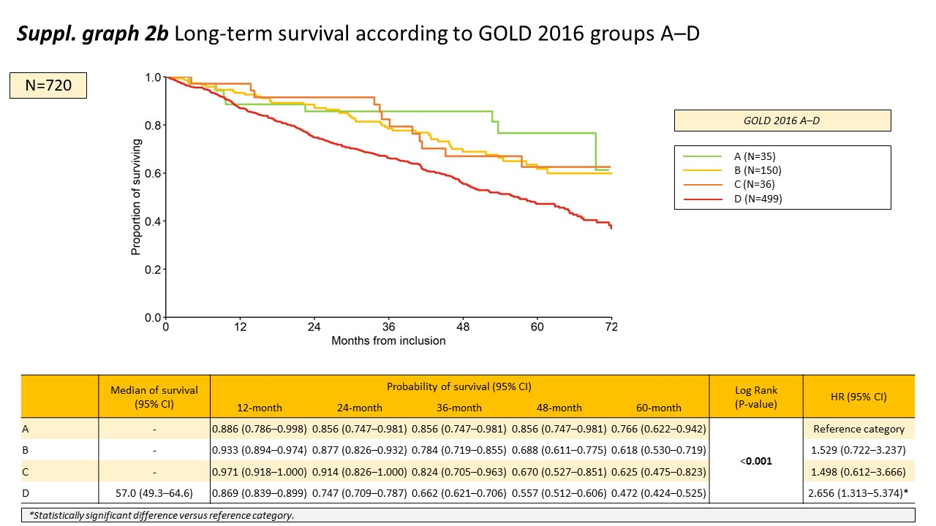
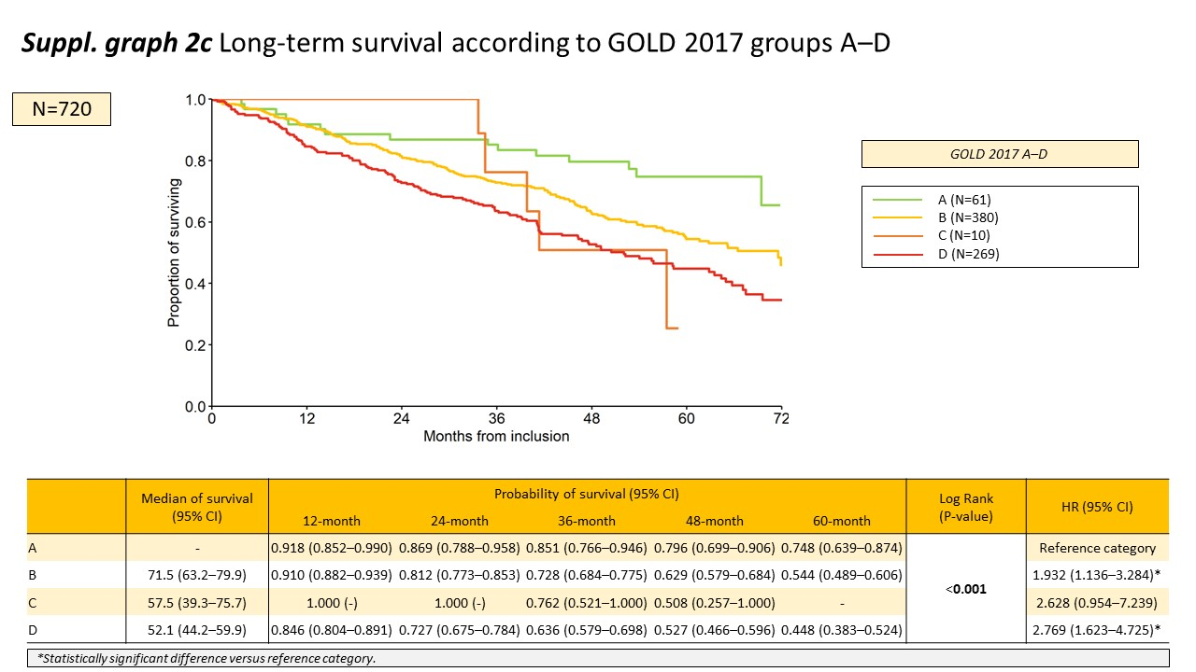
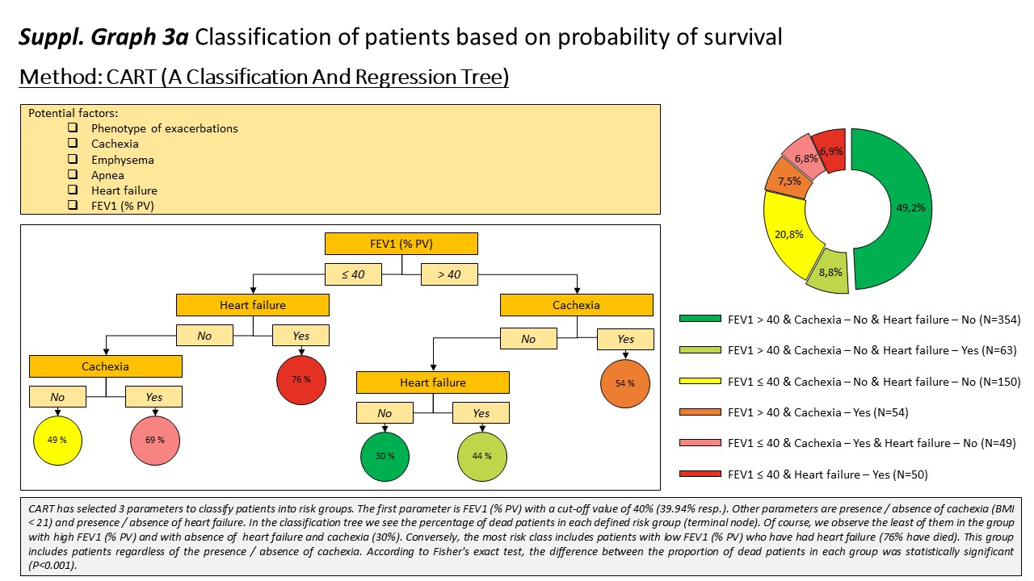
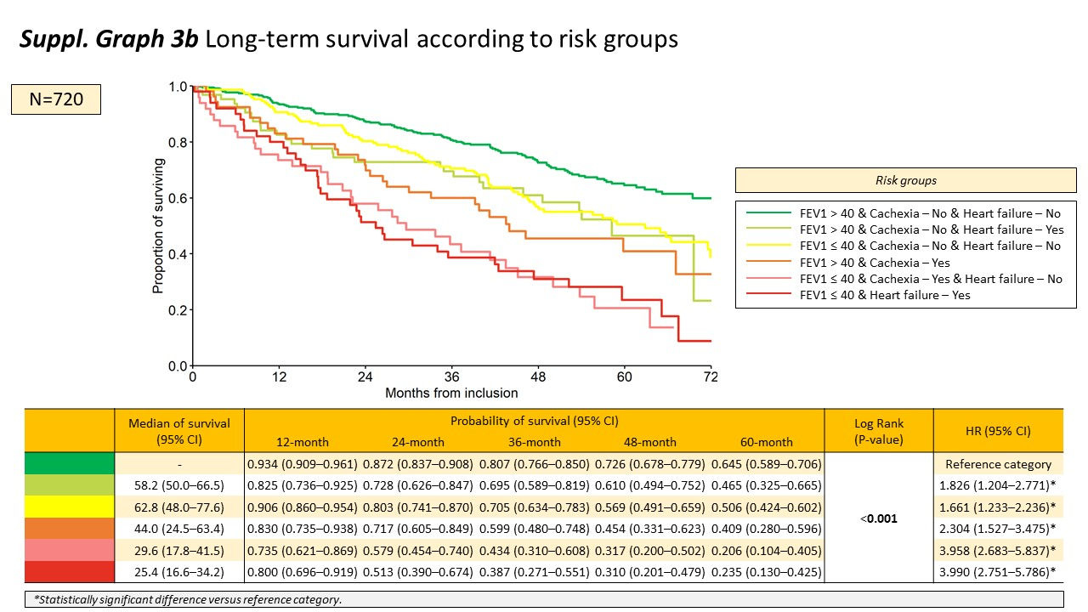
Supplementary Table 1. Prediction of mortality (univariate and multivariate Cox models – adjusted by age).
 | Univariate model |  | Multivariate model  (adjusted by age)
 | HR (95% CI) | P | HR (95% CI) | P
GOLD (2–4) (Ref. category = 2)
3 | 1.565 (1.203–2.036) | <0.001 | 1.607 (1.235–2.091) | <0.001
4 | 2.420 (1.729–3.386) | <0.001 | 2.786 (1.984–3.913) | <0.001
GOLD16 (A–D) (Ref. category = A)
B | 1.529 (0.722–3.237) | 0.267 | 1.424 (0.672–3.017) | 0.356
C | 1.498 (0.612–3.666) | 0.376 | 1.543 (0.630–3.776) | 0.342
D | 2.656 (1.313–5.374) | 0.007 | 2.545 (1.257–5.151) | 0.009
GOLD17 (A–D) (Ref. category = A)
B | 1.932 (1.136–3.284) | 0.015 | 1.751 (1.029–2.978) | 0.039
C | 2.628 (0.954–7.239) | 0.062 | 2.079 (0.754–5.734) | 0.158
D | 2.769 (1.623–4.725) | <0.001 | 2.541 (1.489–4.337) | <0.001
Spanish phenotypes (Ref. category = ACO)
NE | 1.195 (0.802–1.781) | 0.381 | 1.115 (0.748–1.662) | 0.593
AE CB | 1.787 (1.155–2.766) | 0.009 | 1.630 (1.053–2.525) | 0.028
AE NON-CB | 2.001 (1.200–3.337) | 0.008 | 1.754 (1.051–2.928) | 0.031
Czech phenotypes (Ref. category = Without phenotype)
Bronchitic | 1.114 (0.886–1.401) | 0.357 | 1.071 (0.851–1.348) | 0.559
Emphysematous | 1.786 (1.111–2.871) | 0.017 | 1.902 (1.181–3.061) | 0.008
BCO | 1.425 (1.006–2.019) | 0.046 | 1.422 (1.004–2.015) | 0.047
ACO | 0.170 (0.042–0.682) | 0.012 | 0.192 (0.048–0.773) | 0.020
Frequent exacerbator | 1.580 (1.255–1.989) | <0.001 | 1.546 (1.228–1.946) | <0.001
Cachexia | 2.262 (1.726–2.965) | <0.001 | 2.251 (1.717–2.952) | <0.001
Emphysema and Cachexia | 2.156 (1.505–3.088) | <0.001 | 2.259 (1.576–3.236) | <0.001
Emphysema and Cachexia and Frequent Exacerbator | 3.075 (1.928–4.905) | <0.001 | 3.222 (2.019–5.140) | <0.001
Risk groups (Ref. category = FEV₁ >40 & Cachexia=no & HF=no)
FEV₁ >40 & Cachexia=no & HF=yes | 1.826 (1.204–2.771) | 0.005 | 1.711 (1.127–2.598) | 0.012
FEV₁ ≤40 & Cachexia=no & HF=no | 1.661 (1.233–2.236) | <0.001 | 1.715 (1.273–2.310) | <0.001
FEV₁ >40 & Cachexia=yes | 2.304 (1.527–3.475) | <0.001 | 2.248 (1.489–3.392) | <0.001
FEV₁ ≤40 & Cachexia=yes & HF=no | 3.958 (2.683–5.837) | <0.001 | 4.088 (2.770–6.034) | <0.001
FEV₁ ≤40 & HF=yes | 3.990 (2.751–5.786) | <0.001 | 3.764 (2.595–5.461) | <0.001

Footnote: Statistically significant differences are in bold.
GOLD = Global Initiative for Chronic Obstructive Lung Disease; ACO = Asthma/COPD Overlap; AE CB = Exacerbator with Chronic Bronchitis; AE non-CB = Exacerbator with Emphysema; BCO = Bronchiectases/COPD Overlap; FEV₁ = Forced Expiratory Volume in 1 Second

Supplementary Table 2. Prediction of mortality (univariate and multivariate Cox models – adjusted by sex and age)
 | Univariate model |  | Multivariate model  (adjusted by age)
 | HR (95% CI) | P | HR (95% CI) | P
GOLD (2–4) (Ref. category = 2)
3 | 1.565 (1.203–2.036) | <0.001 | 1.614 (1.240–2.100) | <0.001
4 | 2.420 (1.729–3.386) | <0.001 | 2.758 (1.963–3.877) | <0.001
GOLD16 (A–D) (Ref. category = A)
B | 1.529 (0.722–3.237) | 0.267 | 1.411 (0.666–2.991) | 0.368
C | 1.498 (0.612–3.666) | 0.376 | 1.522 (0.622–3.726) | 0.358
D | 2.656 (1.313–5.374) | 0.007 | 2.537 (1.253–5.135) | 0.010
GOLD17 (A–D) (Ref. category = A)
B | 1.932 (1.136–3.284) | 0.015 | 1.743 (1.025–2.966) | 0.040
C | 2.628 (0.954–7.239) | 0.062 | 2.054 (0.745–5.666) | 0.164
D | 2.769 (1.623–4.725) | <0.001 | 2.564 (1.502–4.378) | <0.001
Spanish phenotypes (Ref. category = ACO)
NE | 1.195 (0.802–1.781) | 0.381 | 1.100 (0.737–1.640) | 0.642
AE CB | 1.787 (1.155–2.766) | 0.009 | 1.609 (1.038–2.492) | 0.033
AE NON-CB | 2.001 (1.200–3.337) | 0.008 | 1.748 (1.047–2.917) | 0.033
Czech phenotypes (Ref. category = Without phenotype)
Bronchitic | 1.114 (0.886–1.401) | 0.357 | 1.064 (0.845–1.339) | 0.598
Emphysematous | 1.786 (1.111–2.871) | 0.017 | 1.945 (1.205–3.139) | 0.006
BCO | 1.425 (1.006–2.019) | 0.046 | 1.427 (1.007–2.022) | 0.045
ACO | 0.170 (0.042–0.682) | 0.012 | 0.197 (0.049–0.794) | 0.022
Frequent exacerbator | 1.580 (1.255–1.989) | <0.001 | 1.553 (1.233–1.955) | <0.001
Cachexia | 2.262 (1.726–2.965) | <0.001 | 2.455 (1.855–3.250) | <0.001
Emphysema and Cachexia | 2.156 (1.505–3.088) | <0.001 | 2.522 (1.741–3.654) | <0.001
Emphysema and Cachexia and Frequent Exacerbator | 3.075 (1.928–4.905) | <0.001 | 3.623 (2.244–5.850) | <0.001
Risk groups (Ref. category = FEV₁ >40 & Cachexia=no & CHF=no)
FEV₁ >40 & Cachexia=no & CHF=yes | 1.826 (1.204–2.771) | 0.005 | 1.704 (1.122–2.586) | 0.012
FEV₁ ≤40 & Cachexia=no & CHF=no | 1.661 (1.233–2.236) | <0.001 | 1.705 (1.266–2.297) | <0.001
FEV₁ >40 & Cachexia=yes | 2.304 (1.527–3.475) | <0.001 | 2.407 (1.578–3.672) | <0.001
FEV₁ ≤40 & Cachexia=yes & CHF=no | 3.958 (2.683–5.837) | <0.001 | 4.220 (2.852–6.244) | <0.001
FEV₁ ≤40 & CHF=yes | 3.990 (2.751–5.786) | <0.001 | 3.648 (2.509–5.303) | <0.001

Footnote: Statistically significant differences are in bold.
GOLD = Global Initiative for Chronic Obstructive Lung Disease; ACO = Asthma/COPD Overlap; AE CB = Exacerbator with Chronic Bronchitis; AE non-CB = Exacerbator with Emphysema; BCO = Bronchiectases/COPD Overlap; FEV₁ = Forced Expiratory Volume in 1 Second

