Supplementary TABLE 1 Gene panel associated with leukodystrophies
AARS2 | ABAT | ABCD1 | ACOX1 | ADGRG1 | AIMP1 | ALDH3A2
AMACR | APP | ARSA | ARSE | ASPA | ATP13A2 | AUH
BCAP31 | BCS1L | C19orf12 | CLCN2 | COASY | COX15 | COX6B1
CSF1R | CTC1 | CYP27A1 | DARS2 | DCAF17 | DDC | DLD
EARS2 | EIF2B1 | EIF2B2 | EIF2B3 | EIF2B4 | EIF2B5 | ERCC6
ERCC8 | ETHE1 | FA2H | FAM126A | FASTKD2 | FKTN | FOLR1
FOXRED1 | FTL | FUCA1 | GALC | GAN | GCDH | GFAP
GJA1 | GJB1 | GJC2 | HEPACAM | HIKESHI | HSPD1 | HTRA1
L2HGDH | LMNB1 | MCCC1 | MGP | MLC1 | MPV17 | NAXE
NDUFA1 | NDUFA10 | NDUFA11 | NDUFA12 | NDUFA2 | NDUFA9 | NDUFAF1
NDUFAF2 | NDUFAF3 | NDUFAF4 | NDUFB3 | NDUFS1 | NDUFS2 | NDUFS3
NDUFS4 | NDUFS6 | NDUFS7 | NDUFS8 | NDUFV1 | NDUFV2 | NOTCH3
NUBPL | PANK2 | PC | PEX1 | PEX10 | PEX12 | PEX13
PEX14 | PEX16 | PEX19 | PEX2 | PEX26 | PEX3 | PEX5
PEX6 | PEX7 | PHYH | PLA2G6 | PLEKHG2 | PLP1 | POLR1C
POLR3A | POLR3B | PSAP | PYCR2 | RARS | RNASET2 | RPIA
SAMHD1 | SCP2 | SDHA | SDHAF1 | SLC16A2 | SLC17A5 | SNORD118
SOX10 | SUMF1 | SURF1 | TREM2 | TREX1 | TUBB4A | TUFM
TYMP | TYROBP | VPS11 | WDR45

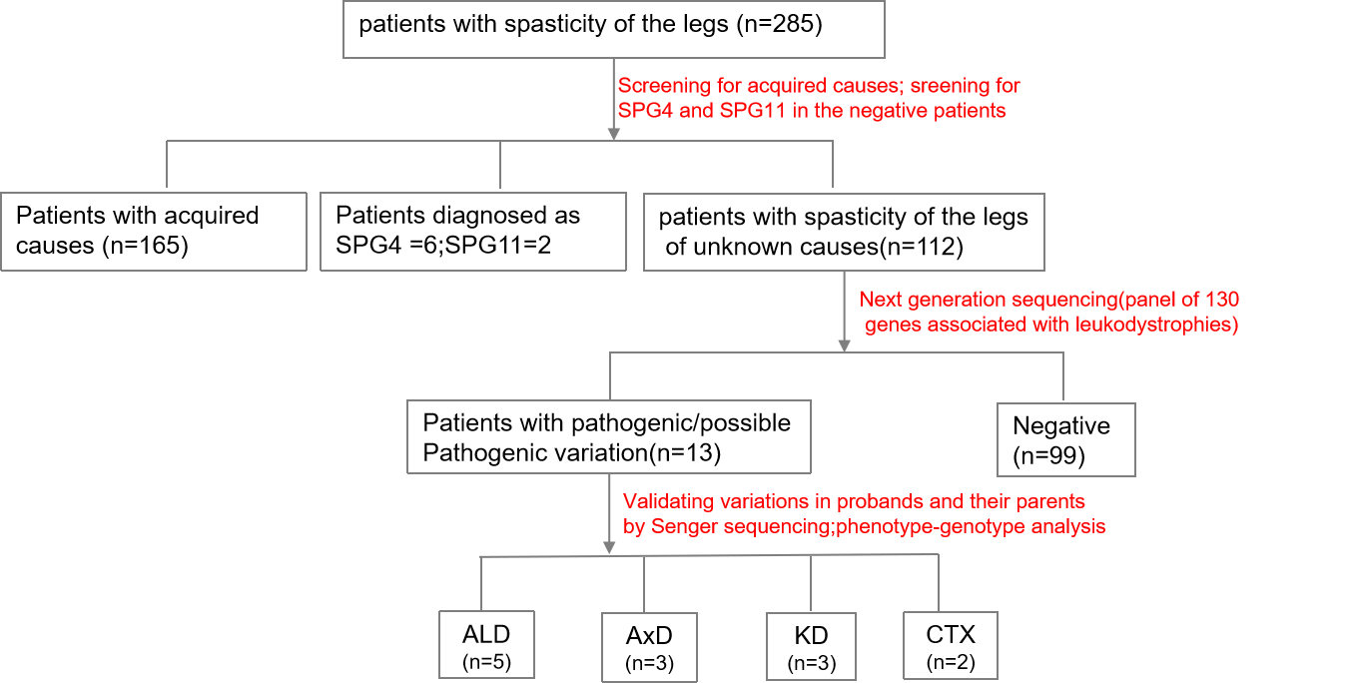
Supplementary Figure 1 Flow chart showing workﬂow and results in this cohort. SPG：Hereditary spastic paraplegia; ALD: adrenoleukodystrophy; AxD: Alexander disease; KD: Krabbe disease; CTX: cerebrotendinous xanthomatosis.

