Supplementary material
Synthesis of Fe₃O₄@PDA NPs
- Preparation of OA-stabilized Fe₃O₄ nanoparticles.
2 mmol of Fe(acac)₃, 5 mmol of 1,2-hexadecanediol, 6 mmol of OA, and 6 mmol of OLA were mixed in 20 mL of benzyl ether. After the mixture was stirred for 15 min under nitrogen atmosphere, it was heated to 200°C at a heating rate of 20°C min⁻¹, maintained at this temperature for 30 min, and subsequently refluxed for an additional 30 min under 265 °C. Following the reaction, the solution was cooled to room temperature. The OA-stabilized Fe3O4 NPs were extracted using a magnet and washed with ethanol three times before being dispersed in toluene.
- Preparation of SDS-Capped Fe₃O₄ NPs.
Under mechanical stirring and nitrogen atmosphere at room temperature, 4.0 mL of 7.0 mg/mL OA-stabilized Fe3O4NPs was injected into SDS aqueous solution (2.8 mg/mL, 12.5 mL). Following ultrasonic treatment, the emulsions were further heated at 60°C to evaporate the toluene.
- The Fe₃O₄ nanoparticles coated with SDS were centrifugally dispersed in Tris-Bufffer solution (10 mm pH 8.5), then the DA monomer was added to make the concentration of DA in the total solution 0.3 mg/ml, after stirring for 3 hours, the product was washed by centrifugation, and the excess self-polymerized DA in the solution was removed to obtain Fe₃O₄@PDA.
Supplementary figure S1
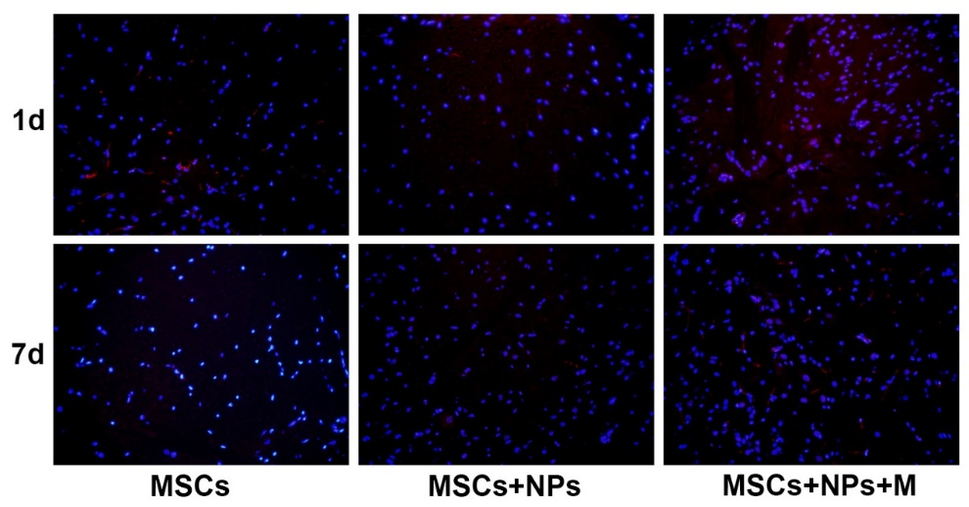
Figure S1. Fluorescent photograph of the spinal cord
The blue fluorescence is the nucleus; the red fluorescence was not observed under the microscope. The exposure time was increased on taking the photograph so that the blood vessels in the background and the spinal cord revealed dark red fluorescence; however, stem cells were not observed.

