Supporting Information
The effects of luminescent CdSe quantum dot-functionalized antimicrobial peptides nanoparticles on antibacterial activity and molecular mechanism
Wanzhen Li^{a,1}, Ping Song^{a,1}, Ying Xinª, Zhao Kuangª, Qin Liuª, Fei Geª, Longbao Zhuª, Xuguang Zhang^{b}, Yugui Tao^{a,⁎}, Weiwei Zhang^{a,b,⁎}
a School of Biochemical Engineering, Anhui Polytechnic University, Wuhu, Anhui 241000, People’s Republic of China
b Bankpeptide Biological Technology Company, Hefei, Anhui 230031
¹ The authors contributed equally to this work
⁎ Corresponding authors. E-mail address: zwwjcf0908@163.com and swgctaoyg@126.com
Methods and materials
1.1 Characterization of AP
Synthesis of antibacterial peptide (Periplanetasin-4, LRHKVYGYCVLGP-NH₂) used Fmoc-protected solid-phase synthesis. The Fmoc-protected amino acid is used as a monomer. DIC is used as a catalyst. High Performance Liquid Chromatography (HPLC) was used for separation and purification of AP. The liquid-mass spectrometry (ESI-MS, LCMS-8030, Thermo) to analyze molecular weight of AP.
1.2 Photographs of the inhibition zone test
The antibacterial activities of the Ap-CdSe NPs were evaluated qualitatively by the modified agar disk diffusion method that was recommended. Approximately 10⁶ CFU/mL was inoculated on modified LB. Filter papers with a diameter of 1.5 cm sucked with AP-CdSe NPs (40 µg/mL) suspension were placed on the surface of seeded agar plate. After 4 h of incubation at 37 °C, the diameters of the inhibition zones were measured and optical images of the plates were taken. AP solution (40 µg/mL) and CdSe NPs solution (40 µg/mL) were set as control group. The PBS was set as blank group.

Table S1 The drug loading rate of AP-CdSe NPs
 | AP-CdSe NPs
Drug loading (%) | 85±3.7

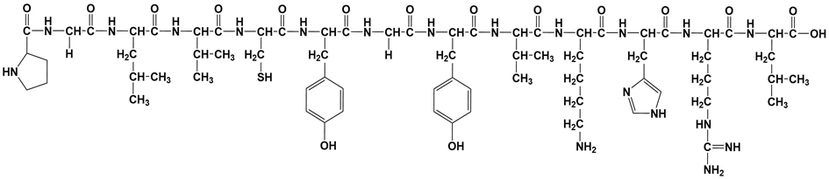
Figure S1 The structure of AP.

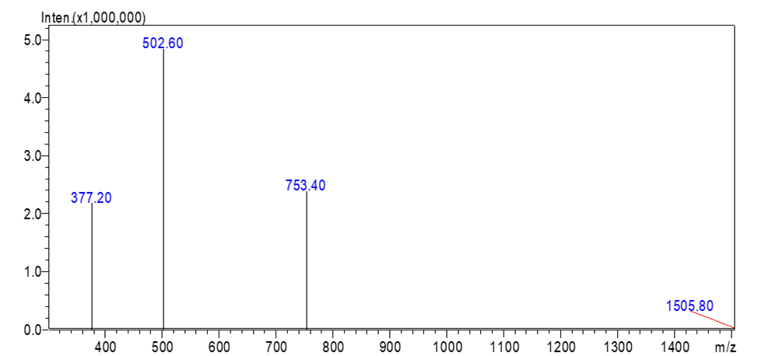
Figure S2 ESI-MS of AP.

Figure S3 The ¹H-NMR of AP. ¹H NMR (D₂O, 400MHz) δ 8.56 (s, 1H), 7.23 (s, 1H), 7.13-6.96 (m, 4H), 6.84-6.67 (m, 4H), 4.65-4.59 (m, 2H), 4.53-4.45 (m, 2H), 4.43-4.23 (m, 5H), 4.18-4.08 (m, 1H), 4.02-3.89 (m, 3H), 3.85-3.71 (m, 2H), 3.44-3.28 (m, 2H), 3.26-3.04 (m, 5H), 3.03-2.88 (m, 5H), 2.87-2.58 (m, 4H), 2.12-1.93 (m, 3H), 1.92-1.81 (m, 2H), 1.80-1.23 (m, 17H), 1.04-0.53 (m, 24H).

Figure S4 The ¹³C-NMR of AP. ¹³C NMR (D₂O,100 MHz) δ 177.2, 174.5, 173.4, 173.4, 172.9, 172.8, 172.6, 171.3, 171.0, 170.8, 170.6, 170.1, 163.1, 162.7, 156.7, 154.5, 154.5, 133.5, 130.5, 130.5, 130.4, 130.4, 128.2, 128.0, 127.8, 117.8, 117.3, 115.5, 115.5, 114.9, 59.8, 59.5, 59.3, 55.4, 55.2, 55.2, 53.6, 53.4, 52.8, 52.7, 52.5, 52.2, 46.5, 42.5, 42.3, 40.6, 39.9, 39.6, 39.2, 38.8, 36.1, 30.3, 30.3, 30.0, 29.6, 28.3, 26.5, 26.3, 25.3, 24.5, 24.3, 23.8, 22.2, 22.2, 22.0, 21.0, 20.6, 18.3, 18.3, 18.0, 17.9, 17.9.

Figure S5. Profile of AP release from AP-CdSe NPs complexes prepared at PBS buffer at 37°C. The percentage of cumulative AP release was measured at 0, 3, 6, 9, 12, 15, 18, 21, 24, 30, 35, 40, and 50 h.

Figure S6. Stability of different nanomaterial. (A) Changes in the hydrodynamic size of AP-CdSe NPs in PBS (100 µM,) and (B) bacterial culture medium.

Figure S7 Typical size distribution of CdSe NPs and AP-CdSe NPs.

Figure S8 Photographs of the inhibition zone in cultures of MDR E. coil and S. aureus after treatment with AP-CdSe NPs (40 µg/mL). AP solution (40 µg/mL) and CdSe NPs solution (40 µg/mL) were set as control group. The PBS was set as blank group.

Figure S9. Fluorescence microscopy images of MDR E. coli and MDR S. aureus bacterial culture treated with AP-CdSe NPs at 10 µg/mL and at various time (1 hour and 3 hour). Cells were stained with DAPI for 30 min are fluorescent blue, and those stained with AP-CdSe NPs are fluorescent red, while those with fluorescent pink color appearance represent merged images of cells. Fluorescence images were captured using an UV illuminator with a 365 nm emission filter for AP-CdSe NPs and a 461 nm emission filters for DAPI. Scale bar = 10 μm.

