Supplementary file for:

Treatment of COPD with long-acting bronchodilators: association between early and longer-term clinically important improvement
Claus F. Vogelmeier, Ian P. Naya, François Maltais, Leif Bjermer, Edward M. Kerwin, Lee Tombs, Paul W. Jones, Chris Compton, David A. Lipson, Isabelle H. Boucot
Corresponding author: Claus F. Vogelmeier
Email: claus.vogelmeier@med.uni-marburg.de

Supplementary Figure 1: Combinations of PRO responses at Week 4
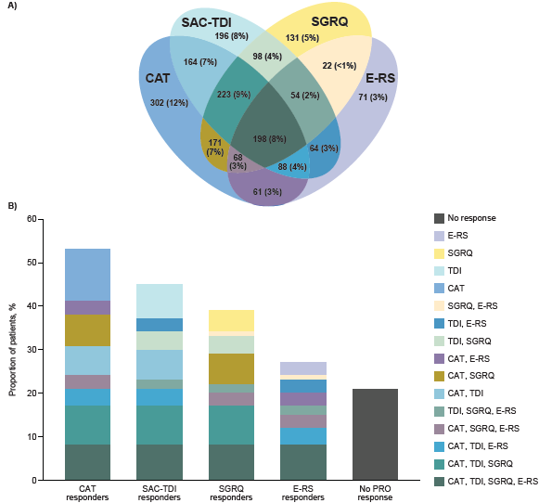
CAT, COPD Assessment Test; COPD, chronic obstructive pulmonary disease; E-RS, Evaluating Respiratory Symptoms:COPD; PRO, patient-reported outcome; SAC-TDI, self-administered computerized-Transition Dyspnea Index; SGRQ, St George’s Respiratory Questionnaire.
Supplementary Figure 2: Proportion of patients with a moderate/severe exacerbation event after Day 30 by: (A) achievement of a CII at Week 4 and (B) the number of PRO responses at Week 4
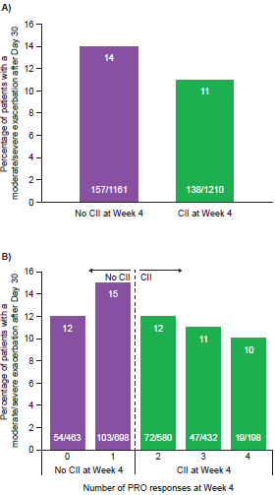
CII, clinically important improvement; PRO, patient-reported outcome.
Supplementary File 1. IEC/IRB committees that approved the EMAX trial
Comité de Ética en Investigación. INAER, Arenales 3146 1° B, Ciudad Autónoma de Buenos Aires, C1425BEN, Argentina
CEICI, Italia 424, Rosario, Santa Fe, 2000, Argentina
CEMER, Esmeralda 1550, Florida, Buenos Aires, 1602, Argentina
CECIC Comité de Ética de CER Investigaciones Clínicas, Vicente Lopez 1441, Quilmes, Buenos Aires, 1878, Argentina
Comité Independiente de ética Fundación Rusculleda, Avenida Colón 2057, Córdoba, Córdoba, X5003DCE, Argentina
Framingham Centro Médico, Calle 9 Número 431, La Plata, Buenos Aires, B1902COS, Argentina
Comité Independiente de ética para ensayos en Farmacología Clínica del centro Médico Dra. De Salvo, Avenida Cabildo 1536 5° B, Ciudad Autónoma de Buenos Aires, Buenos Aires, C1426ABP, Argentina
Instituto Argentino de Investigación Neurológica, Uruguay 824 1st floor, Ciudad Autónoma de Buenis Aires, C1015ABR, Argentina
FUMELIT, Av. Gdor. Freyre 3074, Santa Fe, 3000, Argentina
CIDEA, 3er Cuerpo - 2do Subsuelo, Paraguay 2035, Ciudad Autónoma de Buenos Aires, C1121ABE, Argentina
Comite de Etica de San Isidro-CESI, Avenue Libertador 169581, San Isidro, Buenos Aires, CP 1643, Argentina
Comité de ética para la investigación Clínica Fundación Dr. J.R. Villavicencio, Alvear 854, Rosario, Santa Fe, 2000QGB, Argentina
Comité de Etica Iniciativa y Reflexión Bioética Rosario, Rioja 2926, Rosario, S2002OJN, Argentina
CESIM, Urquiza 646, Santa Rosa, 6300, Argentina
Instituto de Investigación Clínica de Mar del Plata, Av. Colón 3364 PB, Mar del Plata, Buenos Aires, B7600FZN, Argentina
Centro de Osteopatías Médicas, Azcuénaga 1860, Buenos Aires, C1128AAF, Argentina
Comité de Etica en Investigación Clínica - CEIC, Larrea 1381, Ciudad Autónoma de Buenos Aires, Buenos Aires, C1117ABK, Argentina
Comitó de Etica en Investigación, Instituto Ave Pulmo, Carlos M. Alvear 3345, Mar del Plata,
Buenos Aires, B7602DCK, Argentina
Bellberry Limited, 129 Glen Osmond Rd, Eastwood, South Australia, 5063, Australia
INSTITUTIONAL REVIEW BOARD Services, Suite 300, 372 Hollandview Trail, Aurora, Ontario, L4G 0A5, Canada
Comité d'éthique de la recherche de l'Institut universitaire de cardiologie et de pneumologie de Qué, 2725 Chemin Ste-Foy, Quebec, G1V 4G5, Canada
CHU Pontachaillou, Comité de Protection des Personnes, 9 Avenue de la Bataille Flandres-Dunkerque Mai 1940, Rennes, 35000, France
Ethik-Kommission der Landesaerztekammer Hessen, Im Vogelsgesang 3, Frankfurt, Hessen, 60488, Germany
Comitato Etico IRCCS Istituto Tumori "G.Paolo II", V.le Orazio Flacco 65, Bari, Puglia, 70124, Italy
Comitato Etico Campania Nord c/o A.O. San Giuseppe Moscati di Avellino, Segreteria Scientifico- Amministrativa, Città Ospedaliera -Pal. Uffici, Contrada Amoretta, Avellino, Campania, Italy
Com. Etico Reg. Toscano "Area Vasta Nord Ovest", Segreteria Scientifico-Amministrativa -Azienda Ospedaliero-Universitaria Pisana, Via Roma, 67, Pisa, Toscana, 56126, Italy
Comitato Etico Palermo 1, c/o Azienda Ospedaliera Universitaria Policlinico "Paolo Giaccone", Segreteria Scientifico-Amministrativa, Via del Vespro 129, Palermo, Sicilia, 90127, Italy
Comitato Etico Univ. Studi Campania L.Vanvitelli – AOU L.Vanvitelli - AORN Osp. dei Colli, Sede AORN Ospedali dei Colli, Via Leonardo Bianchi snc, Napoli, Campania, 80131, Italy
C.E.ROM. Comitato Etico della Romagna, c/o Ist. Scientifico Romagnolo per lo Studio e la Cura dei Tumori, IRST - IRCCS Srl, Via Piero Maroncelli 40, Meldola (FC), Emilia-Romagna, 47014, Italy
Comitato Etico Unico Regionale del Friuli Venezia Giulia, Segreteria Tecnico-Scientifica c/o Dir. Scientifica, IRCCS CRO di Aviano, Via Gallini, 2, Aviano (PN), Friuli-Venezia-Giulia, 33081, Italy
Comitato Etico dell'Area Vasta Emilia Nord, Via Vertoiba, 10A, Reggio Emilia, Emilia-Romagna,
42124, Italy
Comitato Etico Aziende Sanitarie dell'Umbria, Segreteria Scientifico-Amministrativa, Via della Rivoluzione, 16, Ellera di Corciano (PG), Umbria, 6070, Italy
Comitato Etico Area 4 – ASL Brindisi, Segreteria Scientificoamministrativa, Via Napoli, 8, Brindisi, Puglia, 72100, Italy
Comitato Etico Univ. Studi Campania L.Vanvitelli – AOU L.Vanvitelli - AORN Osp. dei Colli, Sede AORN Ospedali dei Colli, Via Leonardo Bianchi snc, Napoli, Campania, 80131, Italy
Comitato Etico degli Istituti Clinici Scientifici Maugeri SpA – SB, Via Salvatore Maugeri 4, Pavia, Lombardia, 27100, Italy
Comitato Etico Campania Sud c/o ASL Napoli 3 Sud, Segreteria Scientifico-Amministrativa, Piazza San Giovanni, 7, Brusciano (NA), Campania, 80031, Italy
Hospital Real San José, Av Lázaro Cárdenas 4149 Colonia Jardines de San Ignacio, Zapopan, Jalisco, 45040, Mexico
Instituto Jalisciense de Investigación Clínica, S.A. de C.V., Penitenciaria 20, Guadalajara, Jalisco, 44100, Mexico
St. Antonius Ziekenhuis, Koekoekslaan 1, NIEUWEGEIN, 3435 CM, Netherlands
Pharma Ethics, 123 Amcor Road, Lyttelton Manor, 157, South Africa
University of Cape Town, Human Research Ethics Committee, Room E52.24, Old Main Building, Groote Schuur Hospital, Main Road, Observatory, 7925, South Africa
Fundació Unió Catalana d’Hospitals, 1ºA, C/Bruc 72-74, Barcelona, 8009, Spain
Regionala Etikprövningsnämnden I Göteborg, Guldhedsgatan 5A, GÖTEBORG, SE-413 20, Sweden
Advarra Institutional Review Board, Suite 110, 6940 Columbia Gateway Drive, Columbia, Maryland, 21046, United States
Saint Luke’s Hospital Institutional Review Board, 232 South Woods Mill Road, Chesterfield, Missouri, 63017, United States
South Carolina Pharmaceutical Research, 141 Harold Fleming Court, Spartanburg, South Carolina, 29303, United States
EMAX, Early MAXimization of bronchodilation for improving COPD stability; IEC, independent ethics committee; IRB, institutional review board.
_

