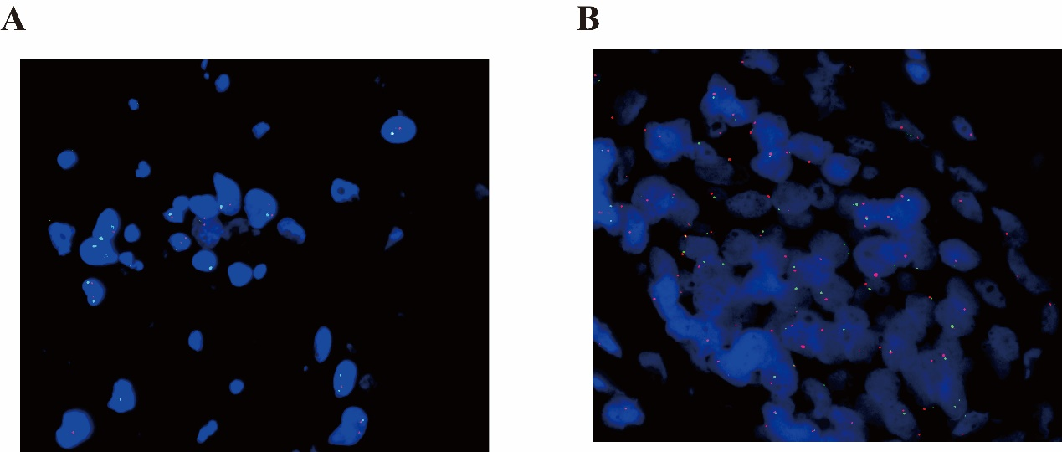
Supplementary Figure 1 Red fluorescence marks the CDKN2A gene, and green fluorescence marks the chromosome 16 mitotic region. (A) CDKN2A gene deletion was seen in the whole section, and about 53% of the cells were missing 1 red signal, and some cells were in haploid form. (B) No significant CDKN2A gene deletion was seen in the whole section, and about 12% of the epithelial cells were seen in haploid form.

