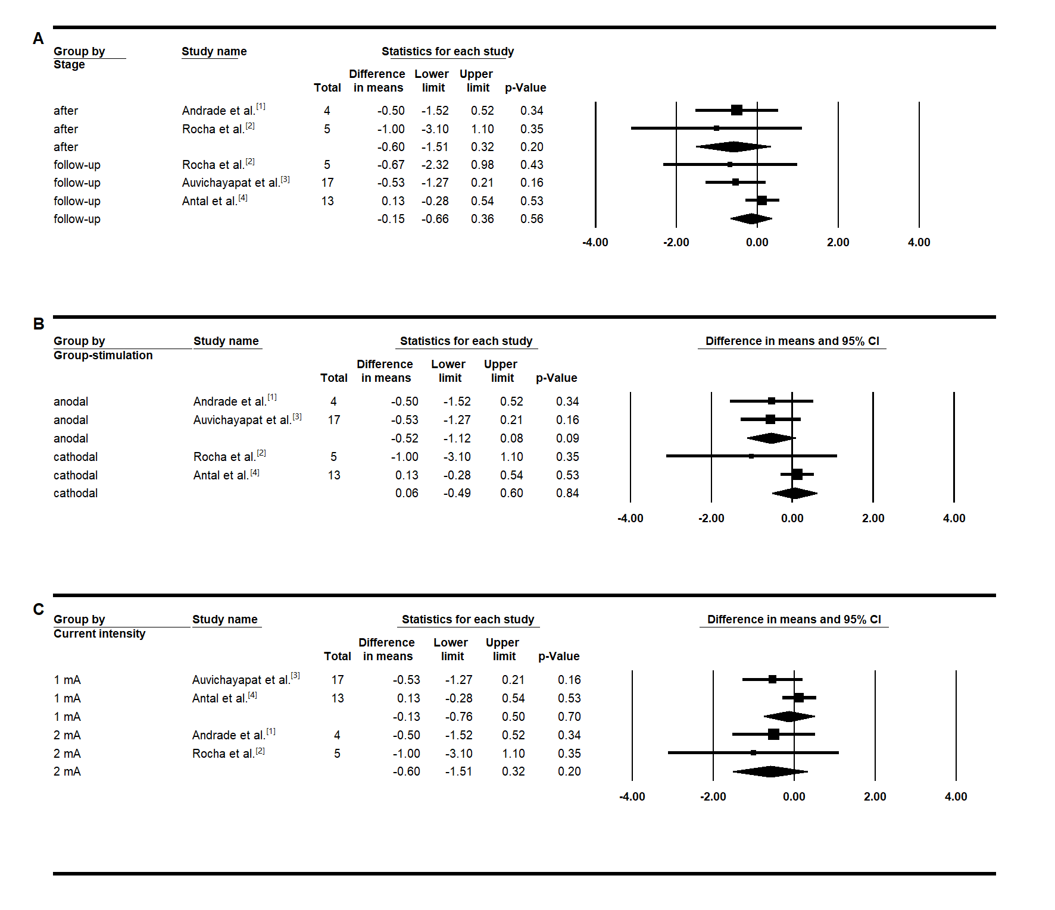
Figure S1. Pain intensity Meta-analysis in sham group. (A) After versus baseline and follow-up versus baseline; (B) Subgroup analysis considering type of stimulation; (C) Subgroup analysis considering current intensity.

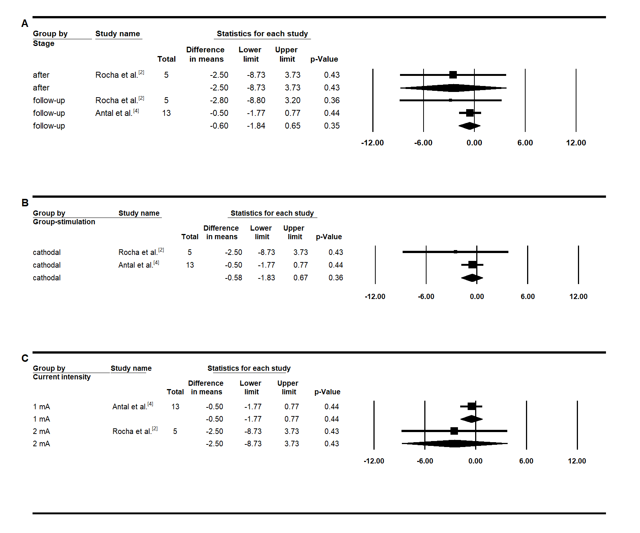
Figure S2. Duration of each migraine episode Meta-analysis in sham group. (A) After versus baseline and follow-up versus baseline; (B) Subgroup analysis considering type of stimulation; (C) Subgroup analysis considering current intensity.

Reference
- Andrade SM, de Brito Aranha REL, de Oliveira EA, de Mendonça CTPL, Martins WKN, Alves NT, et al. Transcranial direct current stimulation over the primary motor vs prefrontal cortex in refractory chronic migraine: A pilot randomized controlled trial. J Neurol Sci. 2017;378:225–32.
- Rocha S, Melo L, Boudoux C, Foerster Á, Araújo D, Monte-Silva K. Transcranial direct current stimulation in the prophylactic treatment of migraine based on interictal visual cortex excitability abnormalities: A pilot randomized controlled trial. J Neurol Sci. 2015;349(1–2):33–9.
- Auvichayapat P, Janyacharoen T, Rotenberg A, Tiamkao S, Krisanaprakornkit T, Sinawat S, et al. Migraine prophylaxis by anodal transcranial direct current stimulation, a randomized, placebo-controlled trial. J Med Assoc Thail. 2012;95(8):1009–12.
- Antal A, Kriener N, Lang N, Boros K, Paulus W. Cathodal transcranial direct current stimulation of the visual cortex in the prophylactic treatment of migraine. Cephalalgia. 2011 May 1;31(7):820–8.

