Supplementary materials

Supplementary Table S1 The clinicopathologic features of colorectal cancer patients with low or high circ-PI4KA expression. Circular RNA phosphatidylinositol 4-kinase alpha (circ-PI4KA).

 | Characteristics  n=27 | circ-PI4KA expression |  | P valueª
 | Characteristics  n=27 | Low(n=13) | High(n=14) | P valueª
Gender |  |  |  | 0.5812
Female | 11 | 6 | 5
Male | 16 | 7 | 9
Age (years) |  |  |  | 0.0814
≤60 | 10 | 7 | 3
>60 | 17 | 6 | 11
TNM grade |  |  |  | 0.0700
I+II | 8 | 6 | 2
III+IV | 19 | 7 | 12
Lymph node metastasis |  |  |  | 0.0341*
Positive | 16 | 5 | 11
Negative | 11 | 8 | 3
Tumor size |  |  |  | 0.0027*
≤3 cm | 9 | 8 | 1
>3 cm | 18 | 5 | 13
TNM, tumor-node-metas-tasis; *P < 0.05 ªChi-square test

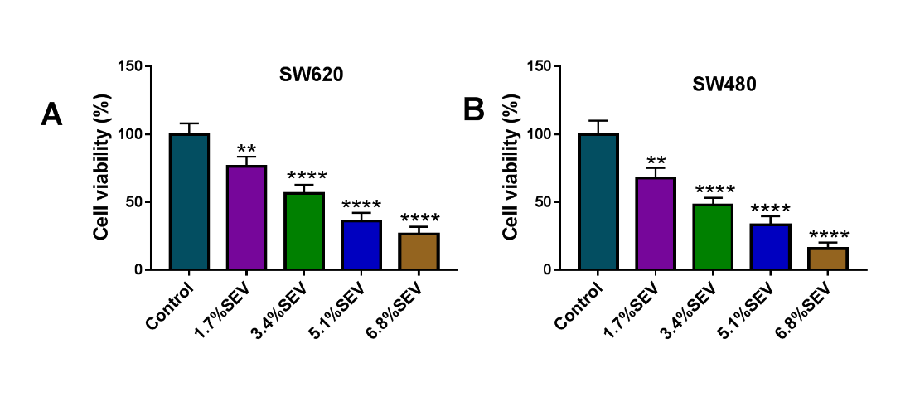
Supplementary Figure S1 MTT assay was employed to detect the IC50 values of SEV in both the SW620 and SW480 cells. **P<0.01 and ****P<0.0001. Sevoflurane (SEV); 3-(4,5)-dimethylthiahiazo (-z-y1)-3,5-di-phenytetrazoliumromide (MTT).

Supplementary Figure S2 Circ-PI4KA overexpression promoted the cell malignancy of colon cancer. (A and B) The impact of circ-PI4KA overexpression on cell viability and colony-forming ability were demonstrated by MTT and cell colony formation assays, respectively. (C) EDU assay was performed to detect cell proliferation in SW620 and SW480 cells. (D and E) The effects of circ-PI4KA overexpression on the migration and invasion of SW620 and SW480 cells were presented by transwell assay. **P<0.01, ***P<0.001 and ****P<0.0001. Circular RNA phosphatidylinositol 4-kinase alpha (circ-PI4KA); 3-(4,5)-dimethylthiahiazo (-z-y1)-3,5-di-phenytetrazoliumromide (MTT); 5-Ethynyl-29-deoxyuridine (EdU).
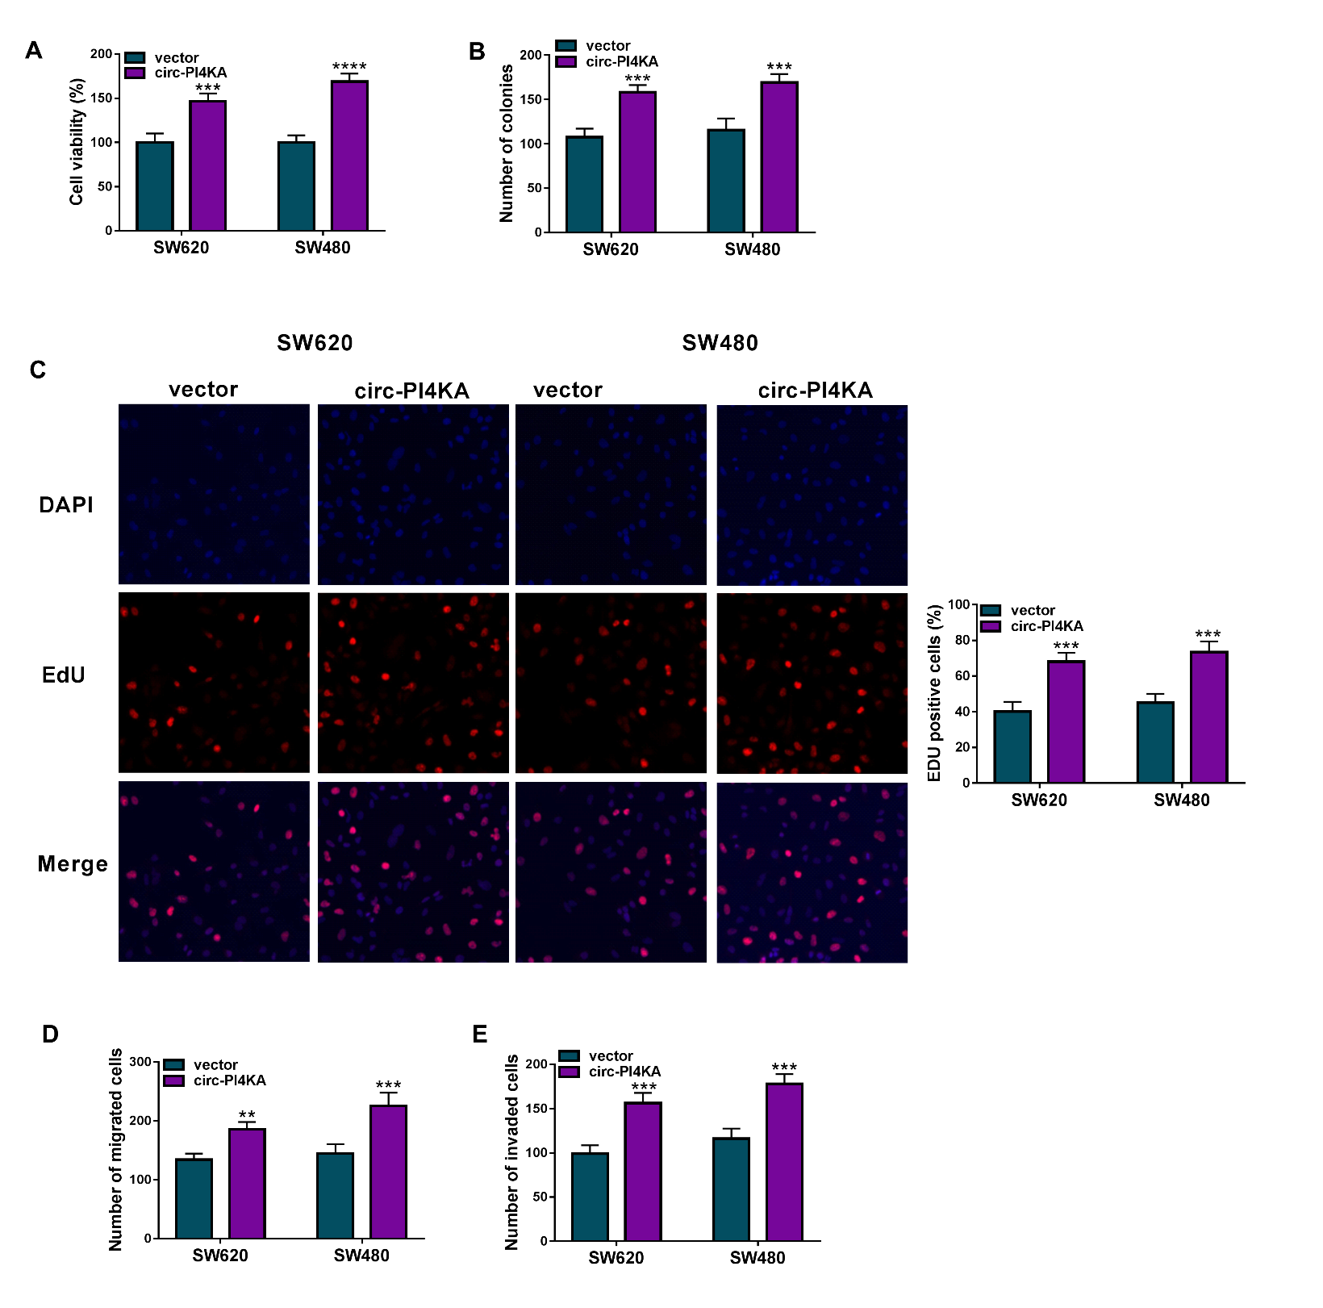
Supplementary Figure S3 MiR-331-3p depletion promoted the cell malignancy of colon cancer. (A and B) The impact of miR-331-3p inhibitor on cell viability and colony-forming ability were demonstrated by MTT and cell colony formation assays, respectively. (C and D) The effects of miR-331-3p knockdown on the migration and invasion of SW620 and SW480 cells were presented by transwell assay. *P<0.05, **P<0.01 and ***P<0.001. 3-(4,5)-dimethylthiahiazo (-z-y1)-3,5-di-phenytetrazoliumromide (MTT).
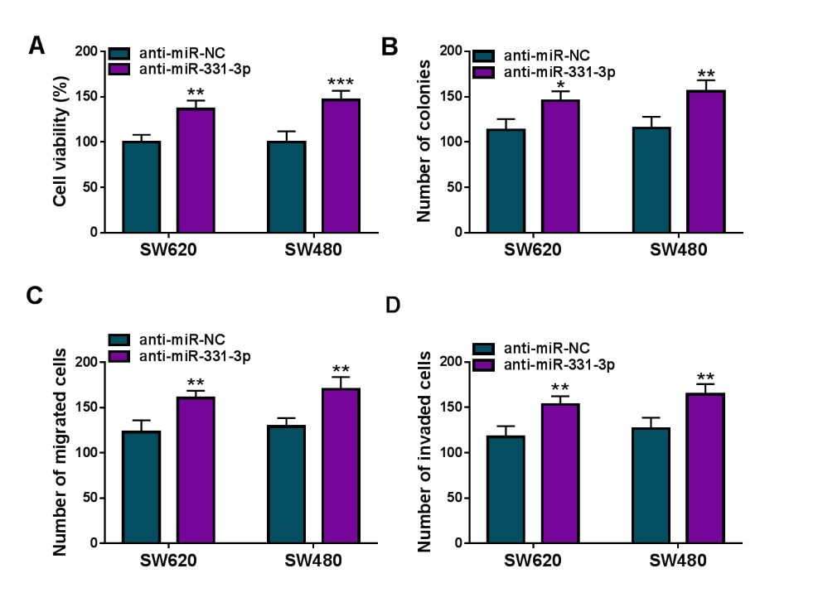
Supplementary Figure S4 Circ-PI4KA silencing repressed tumor formation in vivo. (A and B) The effects of circ-PI4KA silencing on tumor volume and weight were revealed. (C) The impact of circ-PI4KA knockdown on circ-PI4KA expression was determined by qRT-PCR. **P<0.01 and ****P<0.0001. Circular RNA phosphatidylinositol 4-kinase alpha (circ-PI4KA); quantitative real-time polymerase chain reaction (qRT-PCR).
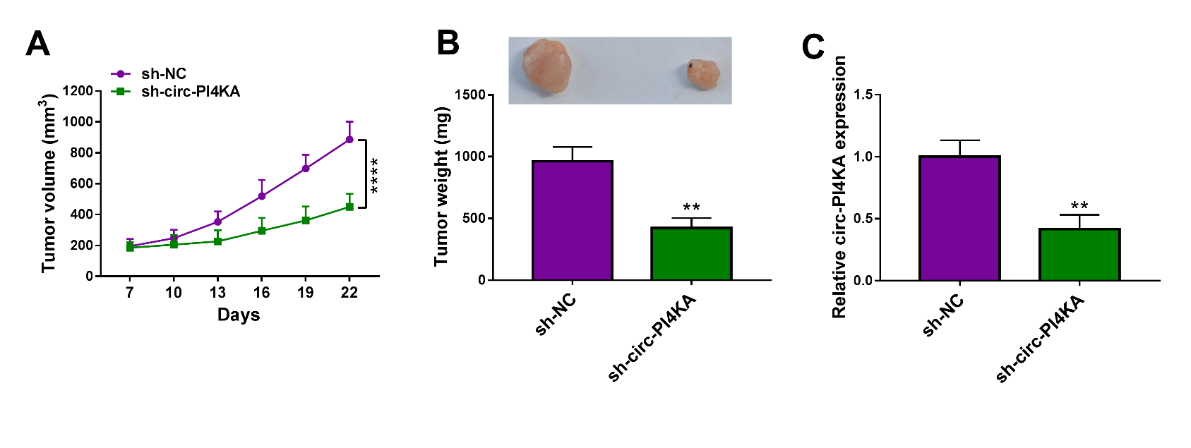
Supplementary Figure S5 Circ-PI4KA overexpression contributed to tumor formation in vivo. (A and B) The effects of circ-PI4KA overexpression on tumor volume and weight were revealed. (C) The impact of circ-PI4KA on circ-PI4KA expression was determined by qRT-PCR. **P<0.01. Circular RNA phosphatidylinositol 4-kinase alpha (circ-PI4KA); quantitative real-time polymerase chain reaction (qRT-PCR).
